
Teaching notes

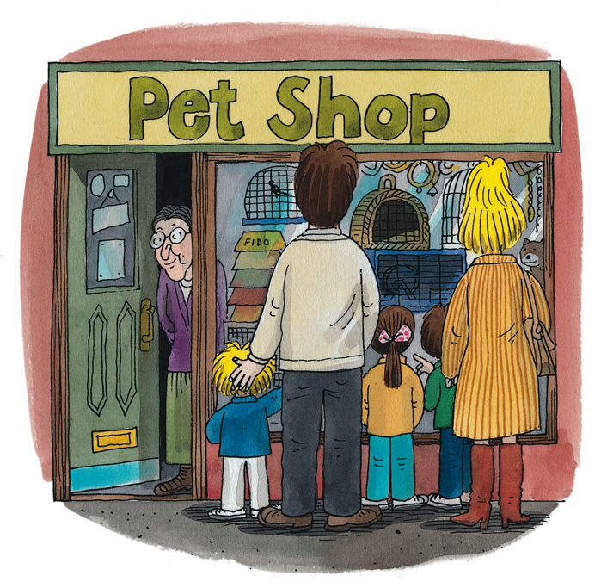
- Ask the children to recall the pets included in the story.
Who wants each pet?
Why does everyone disagree?
Encourage reference to images in the text and to the children’s own experiences.

- Give each child a copy of the following page. Explain to the children that in the first three boxes they need to draw a picture of each character’s preferred pet and complete the sentences by writing each pet name in the space given. The pet names are included on the sheet.

- In the last box ask the children to draw the pet they would most like to own and complete the sentence underneath.

- Discuss the children’s choices of pet with them, asking them to give their reasons. Would everyone in their family agree to have this pet?

Which pet does everyone choose at the pet shop?

spider | rat |  | snake
  Chip wants a |  |   Biff wants a
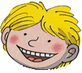  Kipper wants a |  | I want a

