
Teaching notes

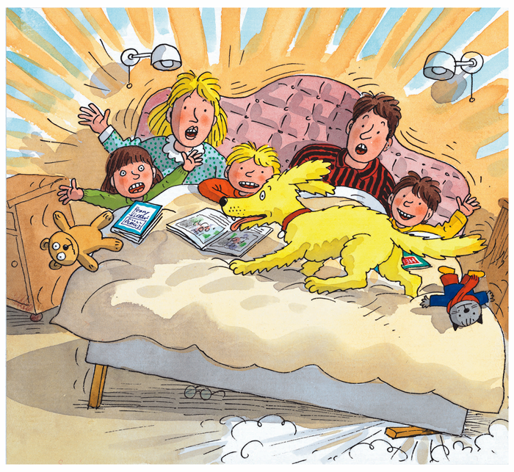
- Before the lesson, print the two resource sheets and cut out the characters.
- Read the story with the children. Discuss the fact that eventually all the characters end up in the bed.
- Use this activity to develop the children’s understanding of the language used in ordinal sequencing. Ask the children to tell you who is first to get into the bed, who is second, etc. The children place the character tiles on the resource sheet as they do so.
- Extend using words such as then, after and before in your questioning, e.g. ‘Who gets in before Kipper?’

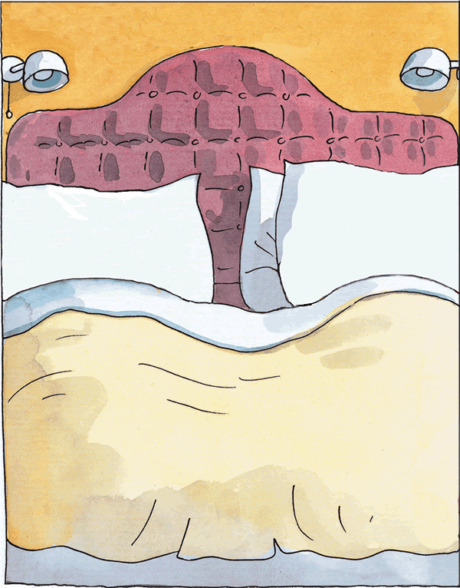

 | 
 | 
 | 

