Teaching notes


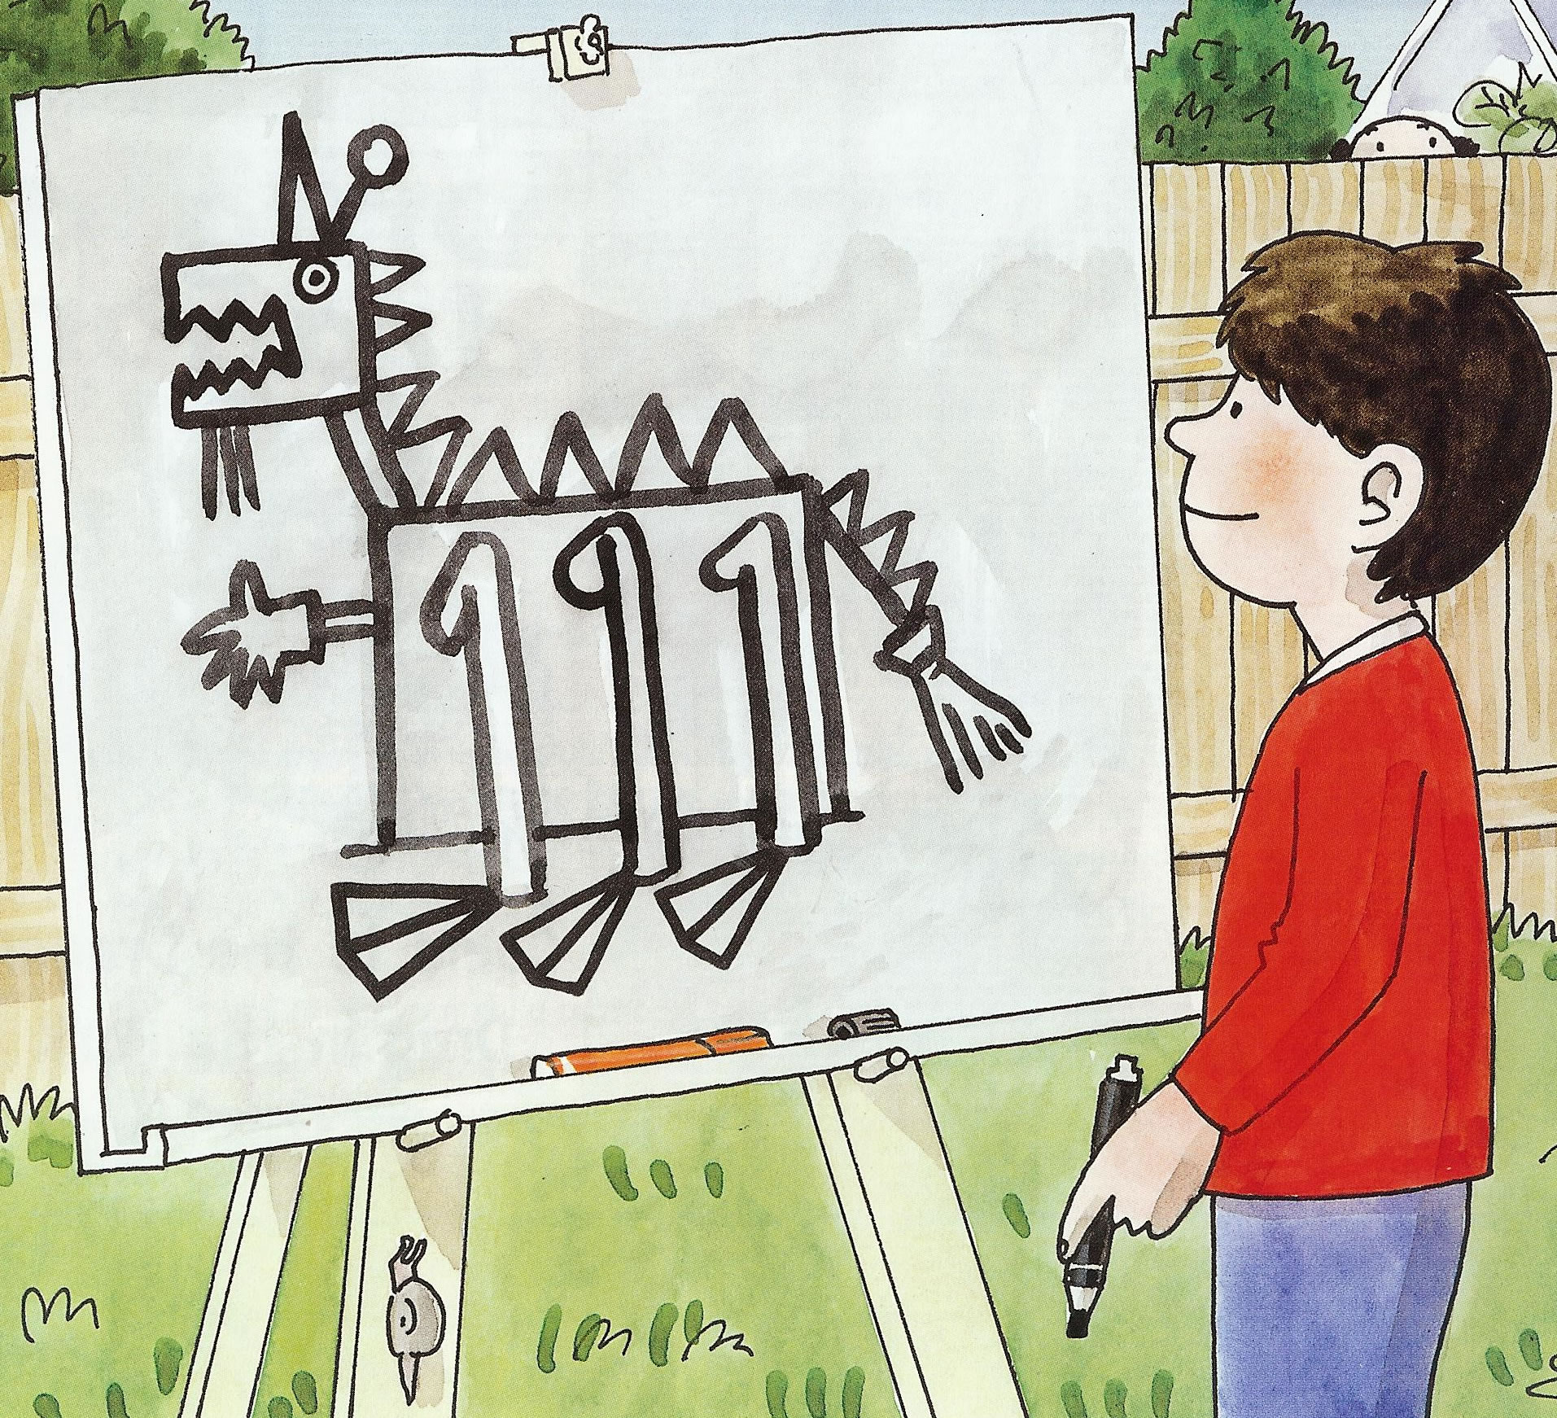
- Photocopy the following pages and cut out the individual sound cards. One copy of the text per child is required.
- Share the story with the children and check that the children can blend the adjacent consonants: br, cr, dr, gr, bl, fl, pl, sh, sp, st, str, th
- In small groups turn over a sound card. The children then have to search through the book for a word beginning with that sound. Please note that some of the words can be found in speech bubbles not just the body of the text. The first child that finds a word gets to keep the card.
The answers can be found below:

Letters and Sounds: Phase 4
br: brill bring broom brown  bl: black  cr: crab  dr: drag dragon  fl: flippers  gr: green | pl: plan  sh: shall sharp shock  sp: spoons  st: stuck stick  str: string  th: the there they thick thin think
br | br
br | br
gr | cr
bl | pl
fl | st
st | sp
sh | str
sh | sh
th | th
th | th
th | th
dr | dr

