Teaching notes
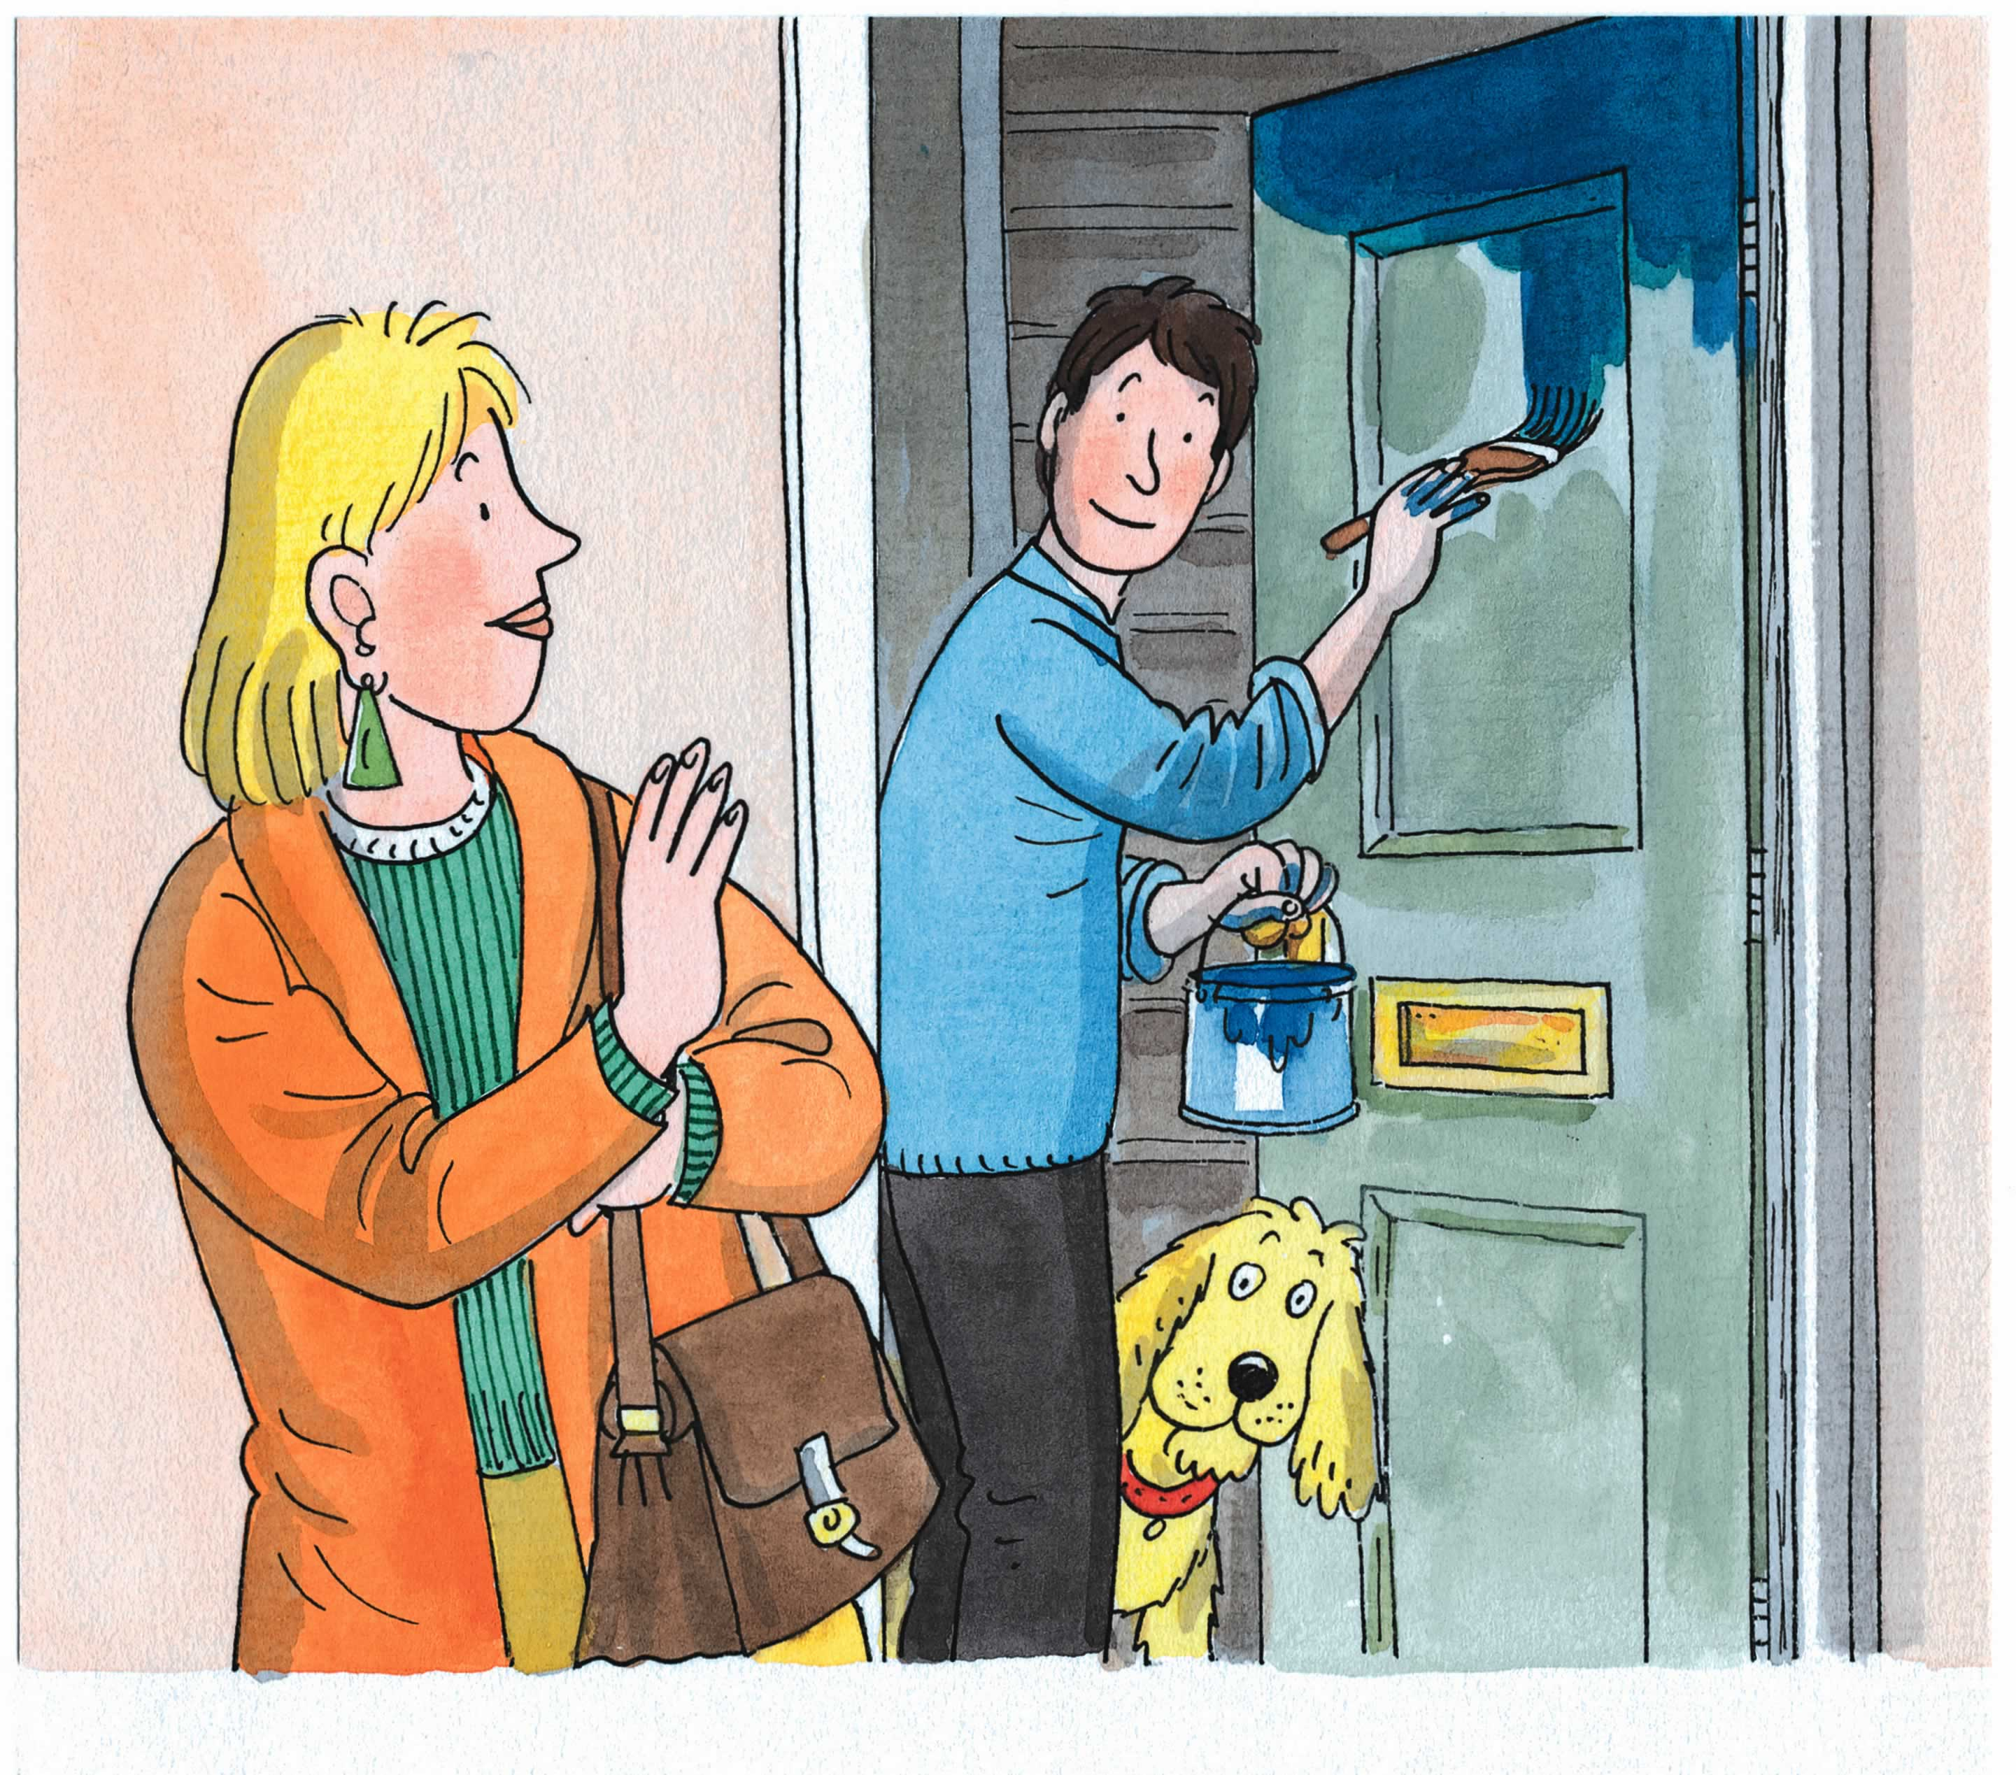
- This activity requires a mirror and a set of 2 Knock Knock! sheets per child.
- Read the story with the children. Turn to page 2; ask the children ‘who has come to play?’ How would they describe each character? Turn over to page 4. What do they notice about the children who have come to play? Prompt the children to use the pictures to describe both the appearance of each visitor and any clues about their likes or dislikes. Turn over to page 6 and repeat the activity. Repeat the activity again for page 8.
- Tell the children that you are going to be one of the characters from the pictures they have explored and that you will give the children 3 clues to help them guess which one. For example: ‘I am a boy wearing blue shoes who likes skateboarding.’ The child who correctly identifies the character you have become can now take a turn to be a character, providing the rest of the class with 3 clues.
- Continue the game as above with other characters.
Now try this…
- As an extension activity the children can make a ‘Knock! Knock!’ display.
- Provide each child with the attached ‘Knock Knock!’ sheets and a mirror. Each child needs to draw a picture of him or herself on the second sheet, being careful to include specific features such as hair and eye colour, length of hair etc. An alternative would be to take a photograph of each child.
- Now ask the children to complete three sentences that they think best describe themselves for the first sheet. The first two sentences need to describe physical characteristics. The third sentence might describe something more personal about the child, perhaps something they like to do.
- Next, stick the two sheets back-to-back. Ask the children to guess which of their friends is behind each door.
Knock Knock!
Who’s there?

I have

I have

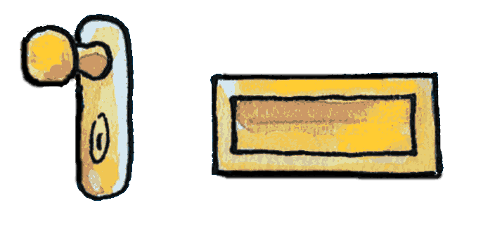

I like
Come in!

I am

