Teaching notes

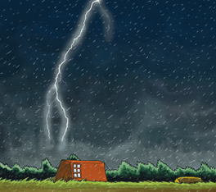
- Prior to the lesson print and cut out the storm words and phrases. Print and enlarge to A3 the ‘degrees of meaning target board’.
- Share the story with the children. Ask them to find words and phrases in the text that relate to and describe the weather.
- Discuss with the children the ‘degrees of meaning’ target board. Explain that the words and phrases that are very strongly linked to a storm e.g. lashing rain are placed closest to the centre of the board whereas those that are more readily associated with standard day-to-day weather e.g. rain are to be placed further away from the centre.
- Ask the children to think of other ‘stormy’ words. These can be recorded on the blank storm word cards and then placed onto the target board.
- Using the poem pro-forma encourage the children to write a weather poem using some of the words and phrases from the target board.
- Discuss with the children how the weather can be described using onomatopoeias e.g. a ‘crack’ of lightening sounds like the noise we actually heard. Children then explore using percussion instruments to recreate the actual storm sounds. These could be included in a performance of their poems.

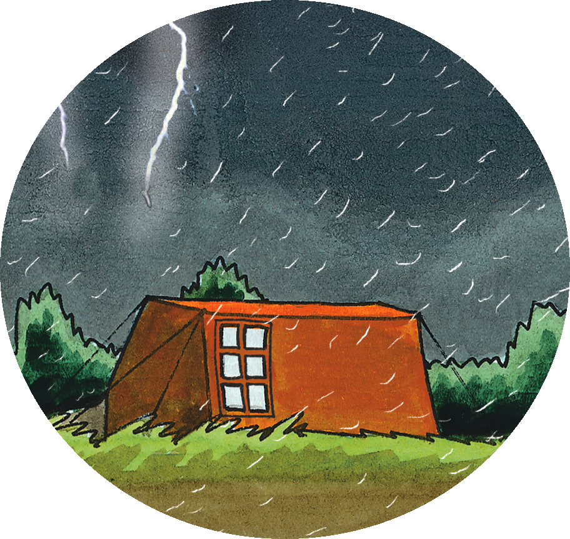

grey day |  | strong wind | gale
wind came up |  | rain came lashing down | wind began to wail
hail |  | sun came out | began to rain

Then the storm came…
Use some of the stormy words and your own ideas to complete the poem below.
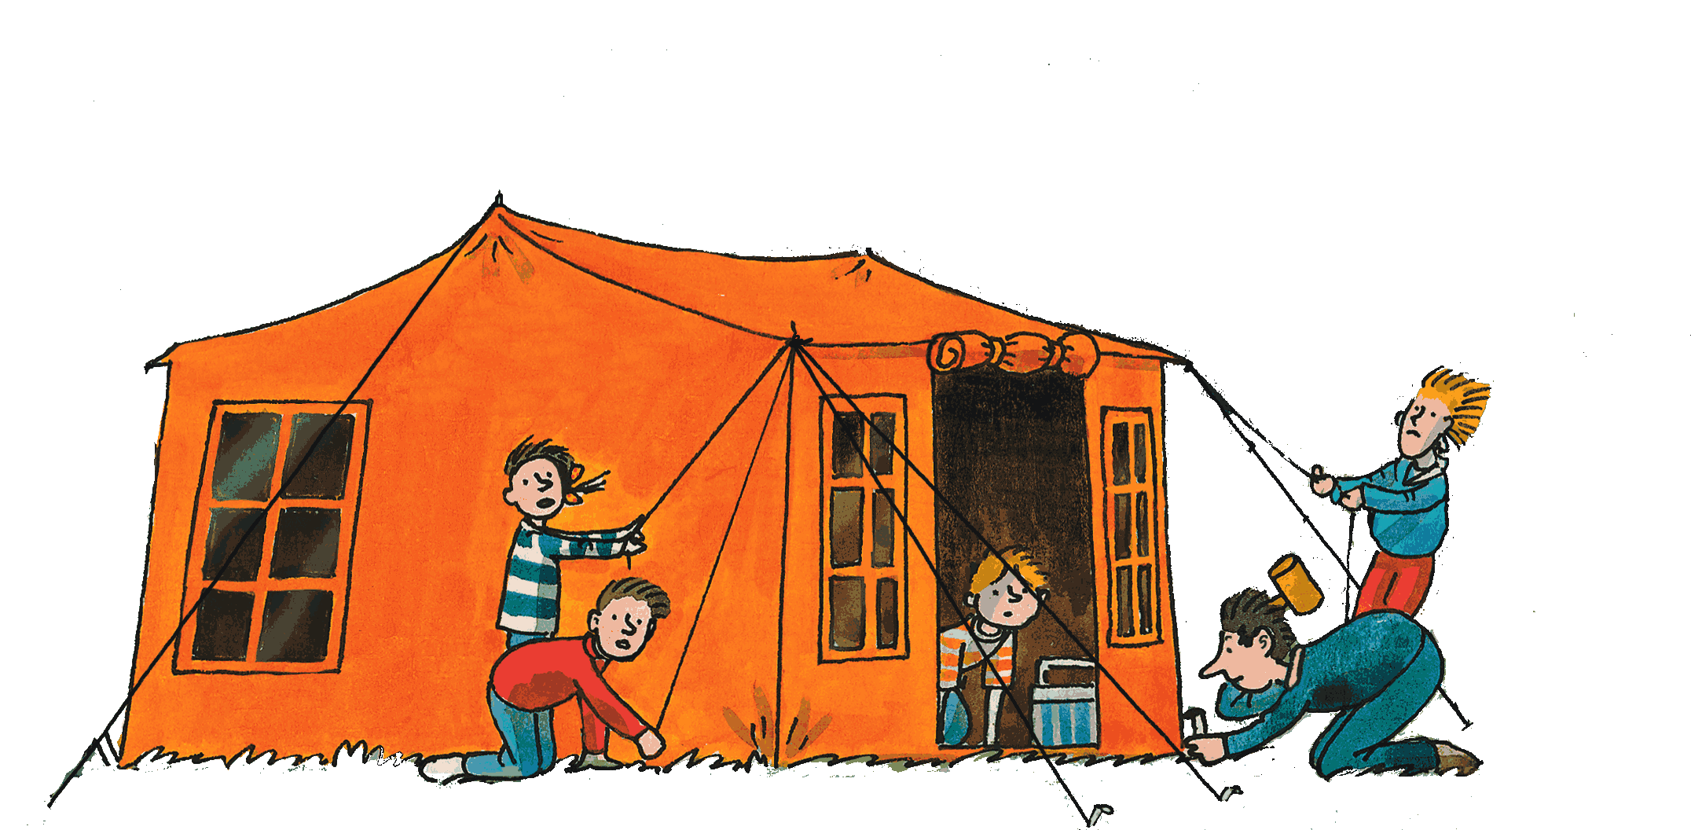

Then the storm came

The wind

And the rain

The wind

And the rain

The thunder

And the lightning

The storm had come!

