Teaching notes

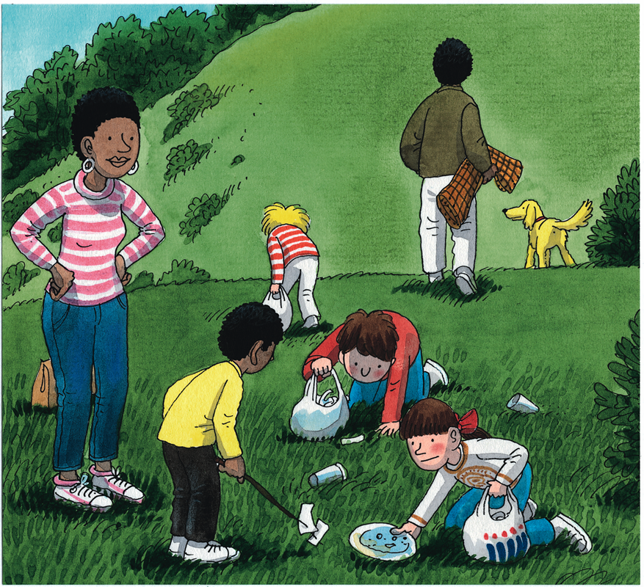
- After sharing the story with the children, focus on pages 26-27. What litter can the children see in the picture? Make a note of all the examples they find on a large sheet of sugar paper or interactive whiteboard.
- Point to one of the litter words. Can the children think of a descriptive word beginning with the same letter or sound as the chosen litter word? E.g. crushed cans, colourful cans, cracked cans. Explain that this word usage is known as alliteration and that they are going to use this technique to create their own ‘A-litter-ation’ poems!
- Select five examples of litter to start with and record on an A3 copy of the pupil sheet (see below). Ask for words that begin with the same letter or sound as each of the litter words. Record their suggestions on the chart.
- Model simple phrases using a series of three of the suggested describing words and, if needed, small linking words. E.g. Broken and battered old brown bottles. Record on the A3 copy of the pupil sheet. Repeat to create a series of five sentences. A completed example is provided below. Cut out each sentence and explore which order gives ‘the best’ effect when reading the poem allowed.
- Children then complete the activity independently, sticking the completed poem into their books after having decided on ‘the best’ order for their sentences.

Choose five litter words. Now list as many words as you can that could be used to describe each piece of litter using the same initial letter or sound.

Litter
Words to describe using the same initial sound or letter.

Look through your lists of words. Highlight your three favourite words for each piece of litter.

Now use your word lists to create five sentences, one for each piece of litter. Once you have completed your sentences cut them out. Try arranging them in a different order. Read each version of your poem out loud until you have decided which you like the best! Stick the final version of the poem into your book.
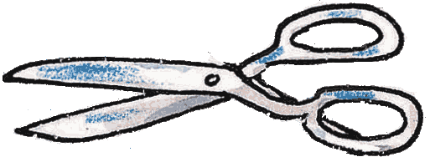
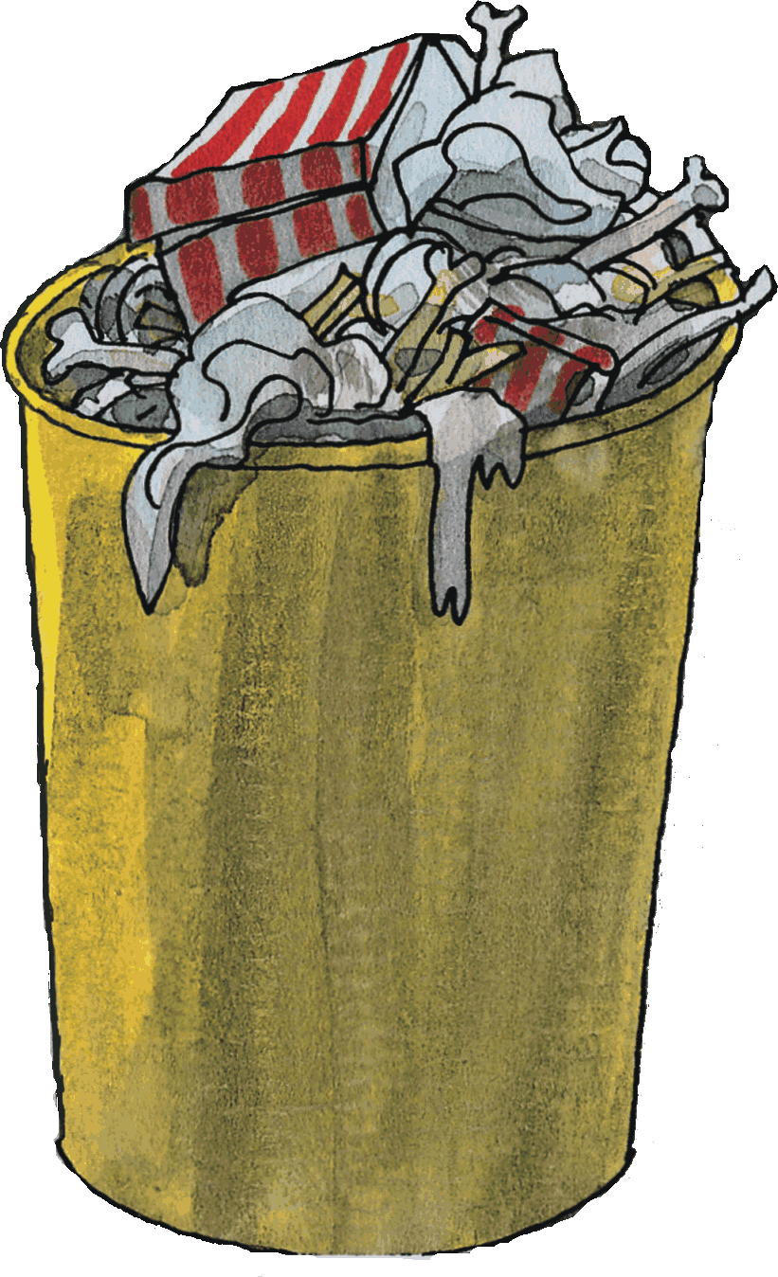

Bag it! Bin it!
Choose five litter words. Now list as many words as you can that could be used to describe each piece of litter using the same letter or sound.

Litter | can | bottle | glass | paper | cardboard box
Words to describe using the same initial sound or letter. | crumpled  crusty  cracked  cold  crinkled  crazed | beautiful  broken  bashed  battered  brown  blue | glimmering  glistening  green  grooved  glowing  glorious | prickly  pretty  plain  pulpy
Look through your lists of words. Highlight your three favourite words for each piece of litter.

