Teaching notes

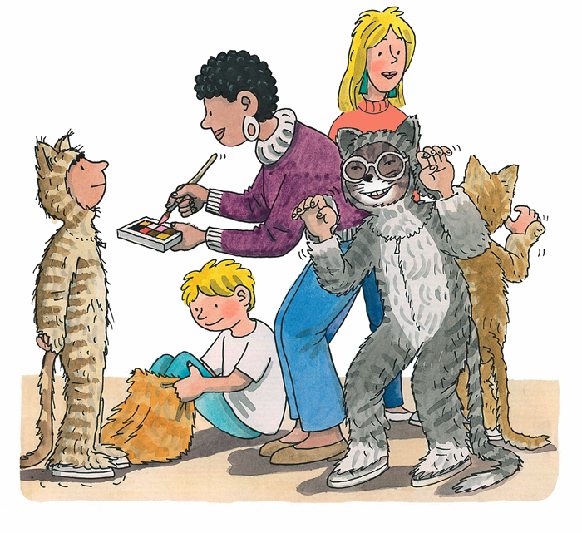
- Prior to the lesson create name cards for each of the children in the group. Do they recognise their own name? Can they tell you the sound that their name begins with? Does anyone else in the group have the same initial sound for their name? Explain that they will be writing their name to complete the sentence ‘ I am....’ on the first pupil sheet.

- Establish the children’s understanding of events in the story by asking: Who is dressed up? Why are they dressed up? What are they dressed up as? Ask the children to imagine that they are in they play dressed up as a cat. What would they look like? Referring to the pupil sheet read with the children the sentence ‘I am a cat.’ Ask the children to suggest what features would they have if dressed up as a cat. Pointy ears? Whiskers? A long tail? Children then draw a picture of themselves dressed as a cat, encourage to include features discussed.

- Perhaps they do not want to be a cat! Ask the children which animal they would like to be from the suggestions on the animal word cards. When they have selected an animal ask them to tell you the initial sound for their chosen animal. Then ask each child to suggest key features for their animal. Referring to pupil sheet 2, ask the children to complete the sentence ‘I am...’ using their name card. Together read the sentence ‘I am not a cat.’ Then complete the sentence ‘I am a ...’ using their chosen animal name card. Children then draw a picture of themselves dressed as their chosen, encourage them to include features they have identified.

 | 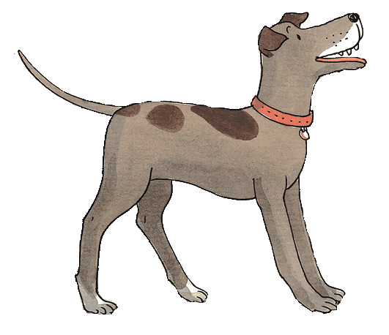 | dog
 | 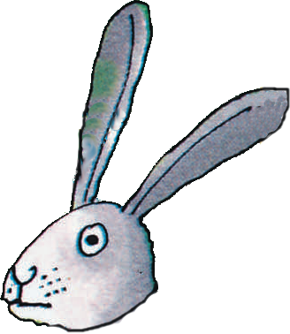 | rabbit
 | 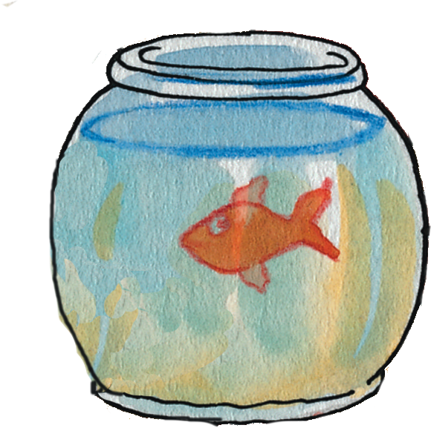 | fish
 | 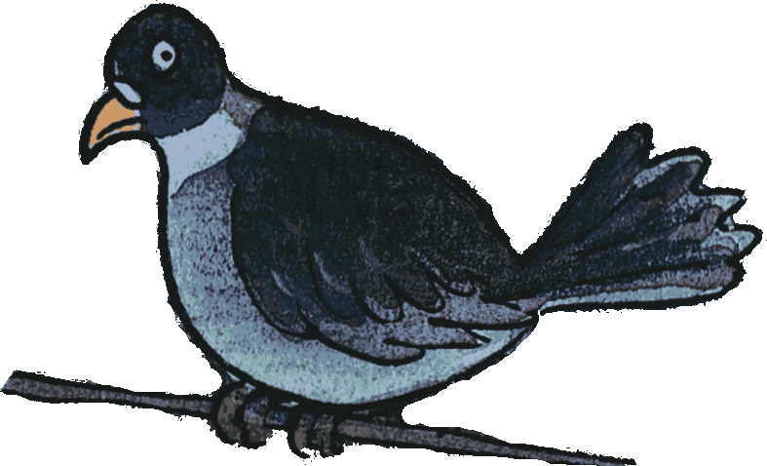 | bird
 | 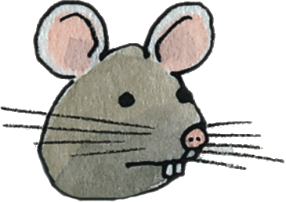 | mouse
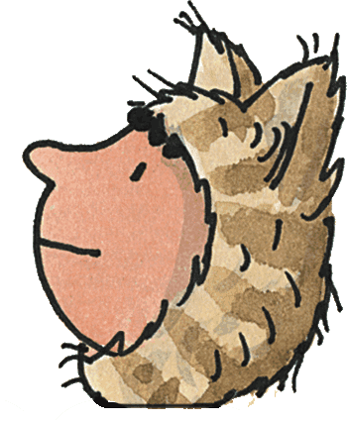
Kipper and his friends dress up as cats. Imagine if you dressed up as a cat. What would you look like?

I am
I am a cat.

Kipper and his friends dress up as cats. Which animal would you like to dress up as? What would you look like?

I am
I am not a cat.
I am a

