Teaching notes
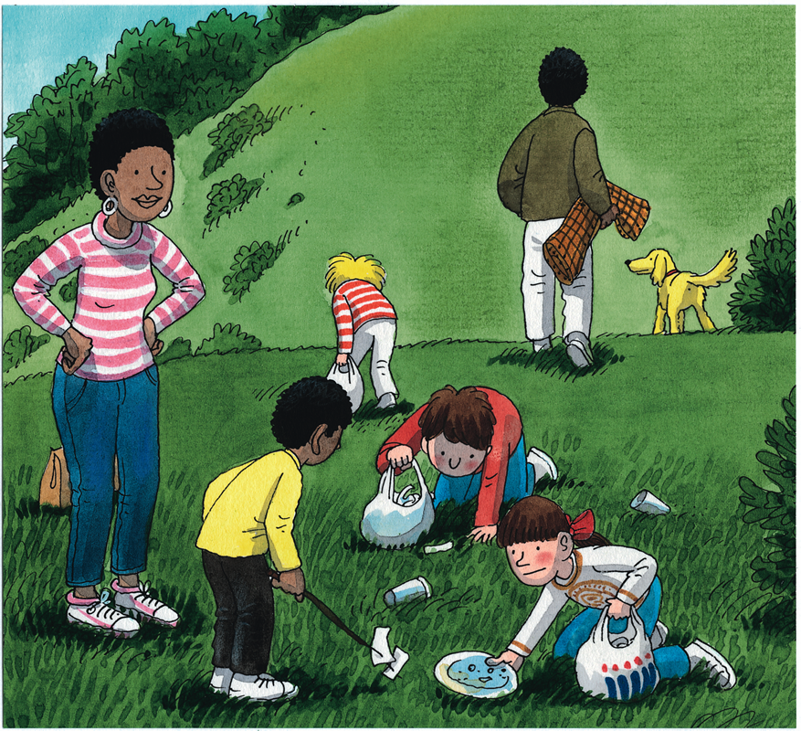
- You will need to have the interactive version of the resource open and a copy of the pupil sheet for each child.
- Look at page 21. Ask the children to identify the word that describes how the Litter Queen is speaking when she says ‘Come on! Come on!’ Can the children think of other words to describe how the Litter Queen is speaking?
- Open the Magnet activity and ask the children to turn to pages 18-19 of the book. Explain to the children that they need to sort the words into those which could be used to describe how Chip is speaking and those which could be used to describe how the Litter Queen is speaking. They may decide that some words don’t describe how either is speaking or they may want to use the same one for both characters! Explain that as they will be using a Venn diagram to sort the words there is a place for all of these possibilities! Read each word and discuss where they want to place it on the diagram, discussing its suitability for each character. Click and drag the tile onto the agreed section of the Venn diagram.
- Once all of the words are sorted click on each word in turn to reveal the adverbial version of each adjective. Talk about how adjectives can be changed into adverbs - words that describe how something is done by adding the suffix ‘ly’. Ask the children to look closely as you flip the tiles; can they spot the spelling patterns?
- Consolidate children’s understanding of the spelling pattern by asking them to complete the pupil sheet by creating words to describe how the family ate their picnic.

Look at the picture taken from pages 2-3 of the story. Choose six adjectives from the word box that you think best describe how the family are eating their picnic. Change the adjectives into adverbs by adding ‘ly’. Take care to remember what happens if the adjective already ends with ‘y’!

Word box

happy | angry | slow | quick | cheerful
greedy | sad | funny | cross | quiet
clumsy | noisy | hungry | grumpy | excited

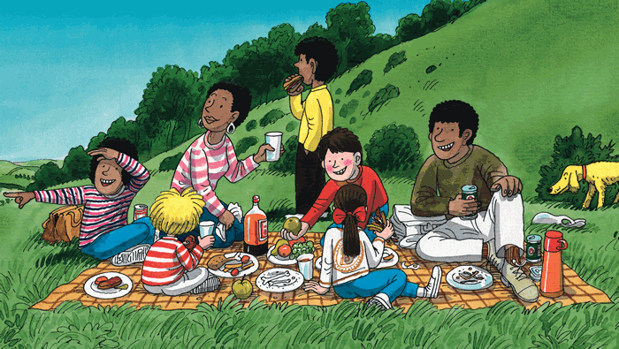

I think the family are eating their picnic ...

