You have probably heard of the Richter scale, which measures the magnitude (strength) of earthquakes, but have you heard of the Mercalli scale, which measures the amount of damage?
You can get the descriptions of the Mercalli scale from http://en.wikipedia.org/wiki/Mercalli_intensity_scale or from http://earthquake.usgs.gov/learn/topics/mercalli.php.

Why might we need two different scales to measure earthquakes? Under what conditions might you have an earthquake which is high on the Richter scale and low on the Mercalli scale and low on the Richter scale and high on the Mercalli scale?
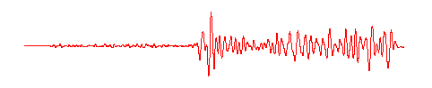 |  | 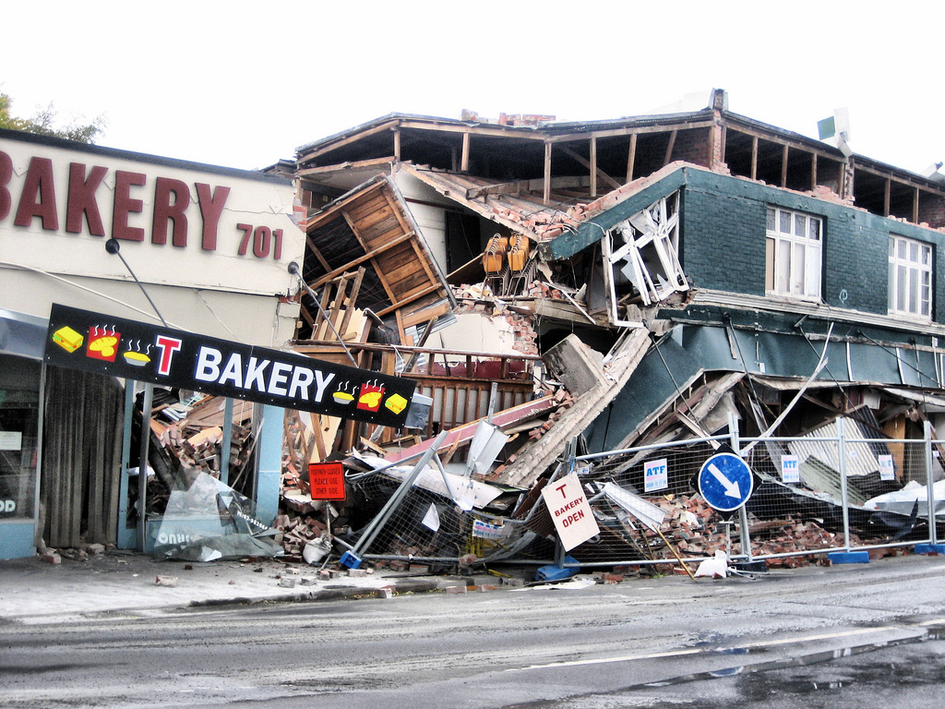
A seismogram from Germany of the 1906 San Francisco earthquake, showing how the ground moved 9100 kilometres away from the earthquake epicentre. |  | Earthquake damage in Christchurch, New Zealand, 2011.
© USGS http://earthquake.usgs.gov/regional/nca/1906/18april/seismogram.php |  | © 2011 martinluff http://www.flickr.com/photos/martinluff/5500731372/in/  photostream

- As a class you are going to make the Mercalli scale out of shoe boxes! Your challenge is to make a scene in your shoe box which illustrates the description of the Mercalli scale for the number you have been given. For example, if you have been given the number 5 you will need to create a scene in your shoe box which illustrates …
‘Felt inside by most, may not be felt by some outside in non-favourable conditions. Dishes and windows may break and large bells will ring. Vibrations like large train passing close to house.’

- Once you have all completed your shoe boxes, line them up so that you can see the whole Mercalli scale.

- Your next job is to create a case study on one side of A4 which includes one map, one image and key details such as where the earthquake occurred, when it occurred and what the primary and secondary effects were.

- When you have completed your case study, each group should decide where to place it on the Mercalli shoe box scale. Once everyone has placed their case studies, try and answer the following questions as a class:
- Is there any link between the magnitude of your case study earthquakes and the damage caused?
- Can you explain why this might be?
- Does the level of economic development of the country in which the earthquake occurs affect the damage caused?
- Why might this be?

Teaching notes

Real time seismograms are available online for thirty locations in the UK from http://www.earthquakes.bgs.ac.uk/helicorder/heli.html.

Task 1

Students may need an explanation that the Mercalli scale is also referred to as the Modified Mercalli Scale or the Modified Mercalli Intensity Scale. A full version of the Mercalli scale is available on the last page of this resource.

This activity will require twelve shoe boxes. Each pair or small group should be given one of these and a number from 1 – 12 on the Mercalli scale.

Task 3

Each group should then be given one of the following case studies of an earthquake which are measured at a variety of different strengths on the Richter scale. Students may need clarification that different internet sites and reference books may report slightly different Richter scale measurements for the same earthquake.
Christchurch, New Zealand, 2011 (7.1) | Northridge, USA, 1994 (6.7) | Lincolnshire, UK, 2008 (5.2)
Haiti, 2010 (7.0) | Chile, 2010 (8.8) | Kashmir, 2005 (5.2)
Prince William Sound, Alaska, 1964 (9.2) | San Francisco, USA, 1906 (7.9) | Sichuan, China, 2008 (7.9)
Sumatra, Indonesia, 2005 (8.6) | Kobe, Japan, 1995 (7.2) | L’Aquila, Italy, 2009 (5.8)
Tangshan, China, 1976 (7.5) | Tokyo, Japan, 1921 (7.9) | Bam, Iran, 2003 (6.6)

Information for case studies of individual earthquakes is readily available on the internet. However, for able and gifted and talented pupils very detailed information is available on the USGS website http://earthquake.usgs.gov/earthquakes/eqarchives/epic/.

Task 4

It may be possible to make use of prior knowledge if the students are studying GCSE Statistics (Higher tier) in examining the Spearman Rank correlation between magnitude of the earthquake case studies and the cost of the damage caused.

The Mercalli scale

The Mercalli scale measures the effects of an earthquake on the Earth's surface in twelve increasing levels of intensity. It was developed in 1931 by the American seismologists Harry Wood and Frank Neumann based on intensity scales devised and modified by Rossi-Forel, Mercalli, Cancani and Sieberg, and later improved by Richter.

The scale ranges from imperceptible shaking through to catastrophic destruction. Unlike the Richter scale it does not have a mathematical basis but is an arbitrary ranking using observed effects of severity.

The following is an abbreviated description of the 12 levels (Roman numerals) of Modified Mercalli intensity from http://earthquake.usgs.gov/learn/topics/mercalli.php:

I. Not felt except by a very few under especially favourable conditions.
II. Felt only by a few persons at rest, especially on upper floors of buildings.
III. Felt quite noticeably by persons indoors, especially on upper floors of buildings. Many people do not recognize it as an earthquake. Standing motor cars may rock slightly. Vibrations similar to the passing of a truck. Duration estimated.
IV. Felt indoors by many, outdoors by few during the day. At night, some awakened. Dishes, windows, doors disturbed; walls make cracking sound. Sensation like heavy truck striking building. Standing motor cars rocked noticeably.
V. Felt by nearly everyone; many awakened. Some dishes, windows broken. Unstable objects overturned. Pendulum clocks may stop.
VI. Felt by all, many frightened. Some heavy furniture moved; a few instances of fallen plaster. Damage slight.
VII. Damage negligible in buildings of good design and construction; slight to moderate in well-built ordinary structures; considerable damage in poorly built or badly designed structures; some chimneys broken.
VIII. Damage slight in specially designed structures; considerable damage in ordinary substantial buildings with partial collapse. Damage great in poorly built structures. Fall of chimneys, factory stacks, columns, monuments, walls. Heavy furniture overturned.
IX. Damage considerable in specially designed structures; well-designed frame structures thrown out of plumb. Damage great in substantial buildings, with partial collapse. Buildings shifted off foundations.
X. Some well-built wooden structures destroyed; most masonry and frame structures destroyed with foundations. Rails bent.
XI. Few, if any (masonry) structures remain standing. Bridges destroyed. Rails bent greatly.
XII. Damage total. Lines of sight and level are distorted. Objects thrown into the air.

