Questions

- What AA was the furthest south reached by the ice, between circa 480,000 and 420,000 years ago?
- What S is present in deposits laid down by meltwater streams?
- What D produces a ‘basket of eggs’ topography?
- What G is a deposit laid down in lakes?
- What sub-glacial LT is a deposit left on the base and sides of a valley?
- What F is a deposit laid down by meltwater streams?
- What TS is a monotonous landscape of boulders, pebbles and clay?
- What PB is a description of a glacial erratic?
- What GM is another name for boulder clay?
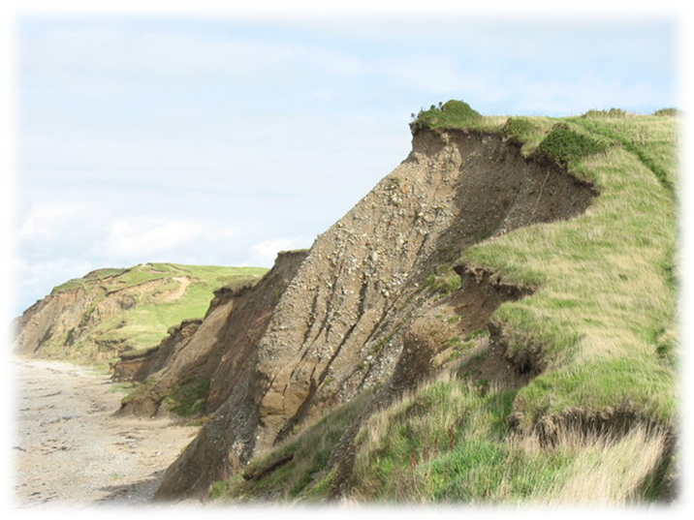
Boulder clay cliffs in Gwynedd, North Wales
© 2006 Eric Jones and licensed for reuse under this Creative Commons Licence
http://www.geograph.org.uk/photo/250110
- What E is material inside the ice which is later deposited?
- What A is the loss of snow and ice from the glacial system?
- What K is an irregularly shaped mound of sands, gravels and boulder clay which has accumulated in a depression on a retreating glacier?
- What B is a common feature of meltwater streams?
- What V are laminated clay deposits found in pro-glacial lakes?
- What S is probably the most widespread meltwater deposit?

Answers

- Anglian Advance – This is also known as the Anglian Stage. It was the most extreme of the Pleistocene Ice Ages of the last 2 million years. In Britain, the ice sheet reached as far south as northeast London and was responsible for diverting the River Thames to its present position.
- Stratification or sorting - Till is generally a poorly sorted material; however, moraine deposited from running meltwater or in a lake exhibits layering known as stratification and generally the sediments in each layer tend to be well sorted by size.
- Drumlin - A drumlin is an elongated hill in the shape of an inverted spoon or half-buried egg formed under the ice. The glacial ice, acting on underlying unconsolidated till or ground moraine forms drumlins but usually the drumlins have layers indicating that the material was repeatedly added to a core.
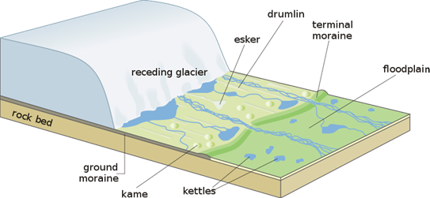
Landscape produced by a receding glacier
© 2006 Hans Hillewaert
http://en.wikipedia.org/wiki/Glacier#Alluvial_stratification

- Glacio-lacustrine – This term refers to a depositional environment where glacial drift is laid down in a lake. Consequently, there is a high degree of sorting and stratification.
- Sub-glacial lodgement till - Till is an unsorted sediment deposited directly by the glacier plastering the base and sides of the valley. The deposition, which occurs at the base and sides of the moving ice of a glacier, is called sub-glacial lodgement till.
- Fluvio-glacial - Fluvio-glacial deposits are laid down by meltwater streams. This results in both sorting and stratification.
- Till sheet – This is a lodgement landform composed of boulders, pebbles and clay blanketing the previously ice eroded topography beneath. Till sheets cover vast areas of North America and Europe and may be a single layer of till or several layers separated by other fluvio-glacial deposits.
- Perched block - A glacial erratic or perched block is a piece of rock which differs from the size and type of rock native to the area in which it rests. They have been carried by ice, often over distances of hundreds of kilometres. Erratics can range in size from pebbles to large boulders. The Norber erratics in the Yorkshire Dales have boulders of Lower Palaeozoic age resting on the later Carboniferous Limestone bedrock.

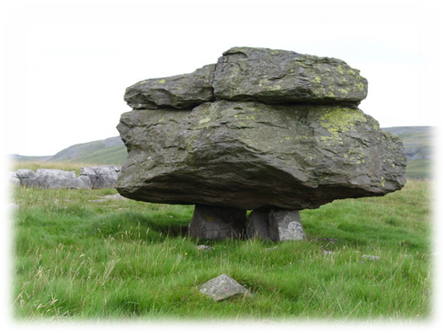
A perched block or glacial erratic at Norber, near Austwick, Yorkshire.
© 2009 Gordon Hatton and licensed for reuse under this Creative Commons Licence
http://www.geograph.org.uk/photo/150334

- Ground moraine - Ground moraines is a till deposited across the valley floor. It accumulates at the base of the ice as a lodgment till, but may also be left in situ as the glacier retreats. Ground moraine may be modified into drumlins by the overriding ice.
- En-glacial moraine – This moraine refers to any material trapped within the ice. This can include material which has fallen down crevasses and the rocks being scraped along the valley floor at the glacier’s base. The moraine is frequently both well sorted and rounded.
- Ablation – Ablation is a combination of the loss of snow and ice i.e. a loss of mass near to the snout and margins of the ice mass. The glacier ‘retreats’ when ablation is greater than accumulation.
- Kame – A kame is an irregularly shaped hill or mound composed of sand, gravel and till which accumulates in a depression on a retreating glacier, and is then deposited on the land surface after further melting of the glacier.
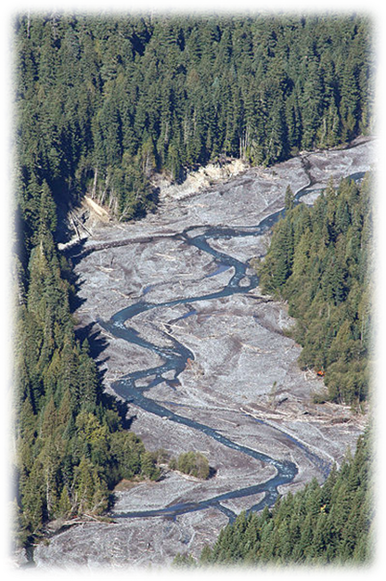
White River in Washington, USA
© 2008 Walter Siegmund
http://en.wikipedia.org/wiki/Braided_river

- Braiding - A braided stream or river stream consists of multiple small, shallow channels which divide and recombine numerous times. Braided streams form where the sediment load is so heavy that some of the sediments are deposited to form temporary shifting islands or bars between the channels.
- Varves - A varve is a series of light/dark coloured layers representing a single year’s deposition in a glacial lake. The light layer is usually composed of coarser silts and fine sands, deposited under the high energy conditions associated with meltwater. The dark layer is usually a fine clay-size sediment deposited during the winter months, when meltwater input is considerably reduced.
- Sandur – A sandur is also known as an outwash plain. It has formed by meltwater transporting material away from the glacier and depositing it on a broad plain of glacial sediments. The material in the outwash plain is often well sorted. The largest material is found closest to the original terminus of the glacier and the finest materials e.g. silt, are re-deposited at the greatest distance.

Teaching notes
Although this is designed primarily as an interactive Blockbuster game, it can be used as a set of questions for class use. The short answers from the Blockbuster are expanded above to provide additional detail concerning glacial deposition.

