Week 1 Lesson 1
An introduction to biomimicry
Aim: To explore the many ways in which the design of materials and structures are modelled on biological forms and processes.
Keywords: biomimicry, forces, base units, compound units, lift, thrust, drag, weight, gravity
Starter activities
- Velcro survey
Students carry out a survey of who has any Velcro with them today. The activity can be found on Slide 2 of the PowerPoint ‘Introduction to biomimicry – starter activities’. They could draw up a tally chart using categories such as:
Shoes, clothes (including coats/jackets), school bags, miscellaneous.
Ask them to discuss how they recorded their results, what they found and what type of graph they could construct from the results.
- History of Velcro
Firstly, ask if anyone knows the history of Velcro or whether they can suggest what might have inspired its design. Use the PowerPoint ‘Introduction to biomimicry – starter activities’ to describe the observations that led to the development of Velcro.
Explain that this is a famous example of biomimicry.
Burdock, Arctium lappa, is a widespread plant of rough, weedy habitats. Its burrs can often be found from Sept – March. You may like to collect some to show students.
- What is biomimicry?
Watch the TED-talk about biomimicry (there is also a link on slide 7 of the PowerPoint ‘Introduction to biomimicry – starter activities).
www.ted.com/talks/janine_benyus_biomimicry_in_action?language=en
The whole clip is 17 minutes long. Leave the clip after the bullet train or after the shark/bacteria section (approx. 6 minutes). Ask students for examples of how people have looked to nature for ideas.
You could return to this video during subsequent lessons to illustrate the link to biomimicry.
Explain that students are going to do a series of lessons which cover many aspects of science, many of which were inspired in some way by the natural world.
Main activities
- Cayley’s glider
Humans have always been fascinated with flying. There are many examples of flying in nature. Students can explore early exploration of flight by making a model of one of the first gliders. See the resource ‘Trying to fly: making a model of Cayley's glider’. The activity could be extended to allow students to investigate the effects of modifications on the flight of the glider.
- Units and equations
There is follow on work (resource ‘Units and equations’) that introduces the common units of measurement that scientists use and gives students opportunities to develop their understanding of mathematical equations in Science.
Differentiation
Work through the examples with the class or groups of students who need more support. Other students may be able to work through independently. See the resource ‘Units and equations’ for more details.

Extension
There is a suggested extension activity in which pairs of students are encouraged to create their own problems using compound units that they can swap with another pair. See the resource ‘Units and equations’ for more details.

Assessment opportunity
This exercise provides an ideal opportunity to assess students’ confidence when dealing with mathematical equations.

Plenary activities
- Summarise a summary
Ask students to summarise the lesson in five bullet points, then three, then one and then finally in one word.
- Units bingo
Ask students to draw a 3 x 2 grid and put into each square an abbreviated unit of measurement, these could be just base units (e.g. J or kg) or compound units (e.g. m/s) as well. Call out the name of a unit (for more challenge read out an equation e.g. distance ÷ time). Students cross out a square on their grids if they have the matching abbreviated unit.
- Trying to fly
Show students images of early designs of flying machines. Ask students to put them in the order they were invented and explain the reasons for their choice. NASA has a useful website on the history of aviation:
www.grc.nasa.gov/WWW/k-12/UEET/StudentSite/historyofflight.html.
- Overarching plenary/homework
If you are following all the lessons in the teaching pack you may decide to encourage students to make a 'Collections' booklet. This could be completed at the end of each lesson. Suggested 'collections':
- keywords list
- list examples of bio-mimicry included in lessons e.g. fire flies, whale fins
- list and brief outline of some of scientific concepts included in lessons
- list and brief description of scientific concepts students are already familiar with
- description of how examples of bio-mimicry are being used
- an explanation of the potential of 2-3 examples of bio-mimicry
- an evaluation of the benefits of 2-3 examples of bio-mimicry
- examples of bio-mimicry not covered in lessons.

Week 1 homework activity
Ask students to bring in an old pair of over-the-knee length socks or tights. These will be used in Week 4, lesson 1: Neural networks.
The following homework is in preparation for Week 2, lesson 2: What can we learn from termite mounds? Ask students to research African mound-building termites. There is a handout sheet with a video link and questions. Depending on the ability of the students they could be assigned one or all of the questions to research.

Starter 1, 2 and 3
Velcro survey? / History of Velcro / What is biomimicry? — PowerPoint

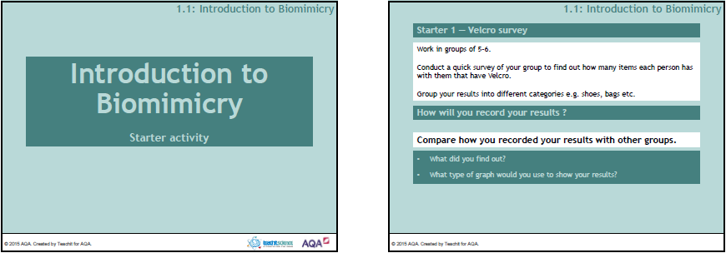

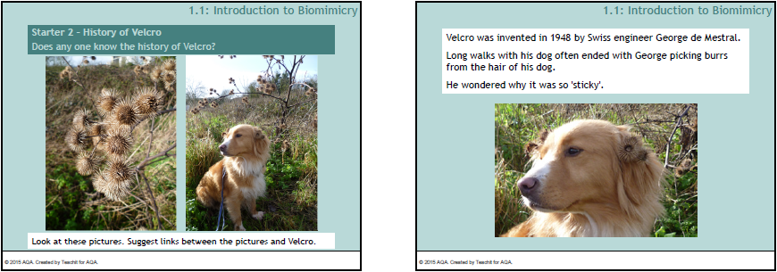

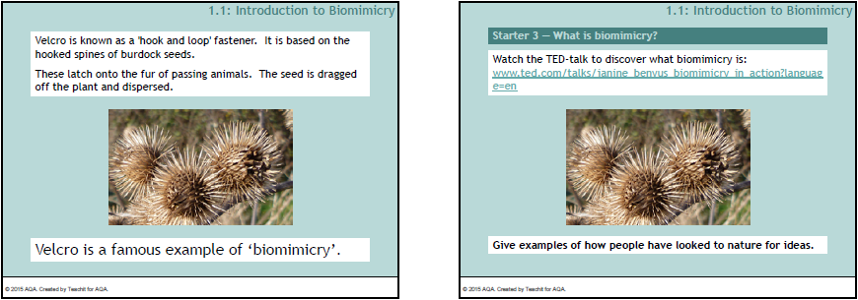

Main 1
Trying to fly: making a model of Cayley's glider —
Teaching notes
The pieces could be cut out before the lesson for the students to assemble. Test the gliders by seeing which travels the furthest. Time could be allowed for students to suggest and make modifications to the design.
This short YouTube video shows a similar model of the glider:
www.youtube.com/watch?v=nKZwEIRxJOc
The How things fly website from the Smithsonian National Air and Space Museum is useful for background information:
howthingsfly.si.edu/forces-flight/four-forces.

Trying to fly: making a model of Cayley's glider
Sir George Cayley 1773 – 1857
- Regarded as one of the most important people in the history of aeronautics.
- He was the first person to understand some of the forces which interact during flight.
- He applied the scientific methods of investigation to his research work.
- In 1804 he designed and built a model monoplane glider on which the glider you are about to build, is based.
- In 1849 he built a large gliding machine and tested it with a 10 year-old boy on board - the boy survived (but not his name!).
Task 1 – making the model monoplane glider
Apparatus
- 1 drinking straw (3mm diameter if possible)
- Blu tack
- 2 clear plastic lids (8cm diameter, e.g. yoghurt pot lids)
- scissors
- indelible pen
Method
Before starting, test the straws on their own – how well do they fly?
You will need 3 spheres of Blu tack – diameters as shown in diagram.
If using clear plastic lay it on the diagram, trace the shapes from the diagram onto the clear plastic and cut out.
Cut out 2 kite shapes. Cut one in half lengthways.
Attach the spheres of Blu tack as shown in the diagram.
A should stand proud of the straw by 5mm. The centre of the edge of the wide end of the 'wing' rests on this. A small flap of Blu tack can be pressed on top to secure it.
B is used to secure the end of the 'wing'.
C can be pushed into and wrapped around the end of the straw. The Blu tack needs to project beyond the end of the straw so the 3 tail fins can be pushed in.
Tail fins need to be at right angles to each other.
Now decide how you will test your glider – remember to throw it like a dart not like a javelin!
Task 2 – forces of flight
The four forces of flight are:
lift thrust drag weight
Each force has an opposite force which works against it.

- Can you pair up the four forces?

- Draw a diagram of your model glider and label the four forces which act on it. Use arrows to show the direction of each force.

- Complete these sentences:
The glider goes upwards if and are greater than
and .
The glider maintains a level flight and constant speed when the forces are

Words to choose from:
- balanced
- unbalanced
- thrust
- gravity
- lift
- weight
- drag

Trying to fly: making a model of Cayley's glider — Template
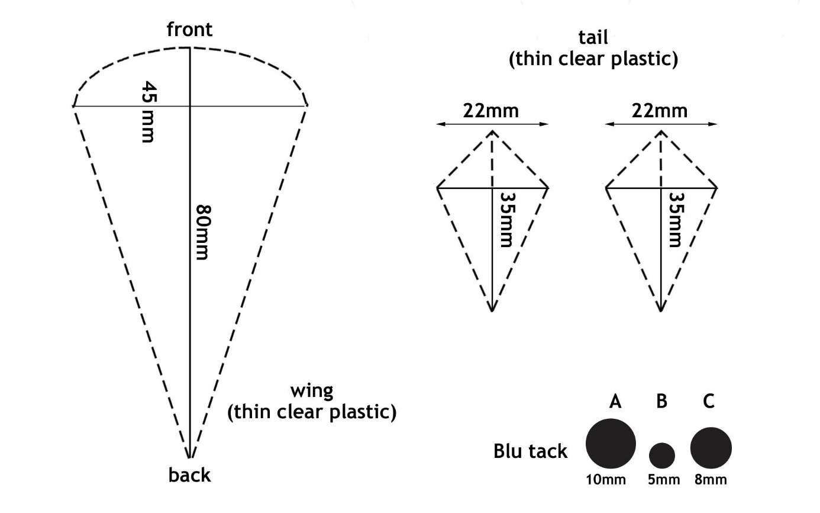

How to assemble the glider
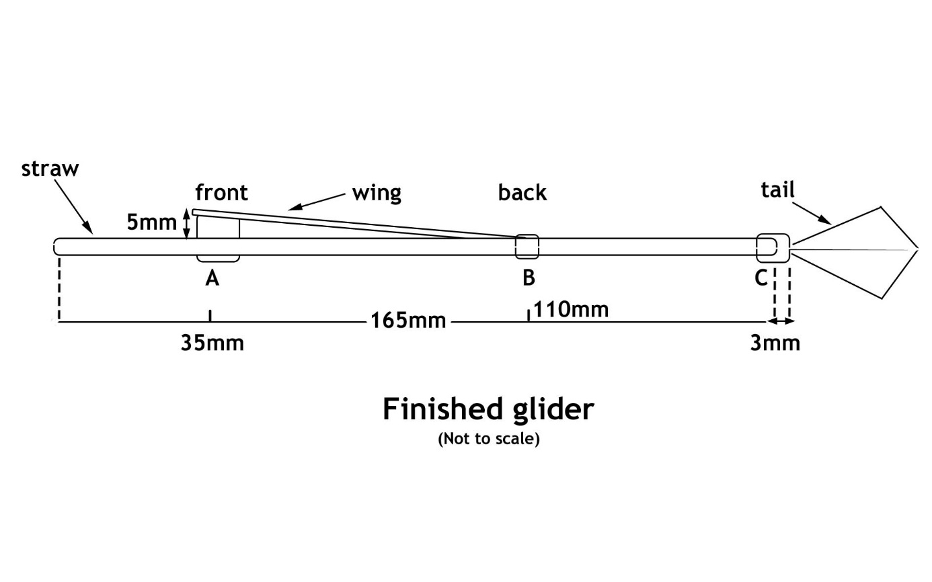

Trying to fly: making a model of Cayley's glider —
Finished glider
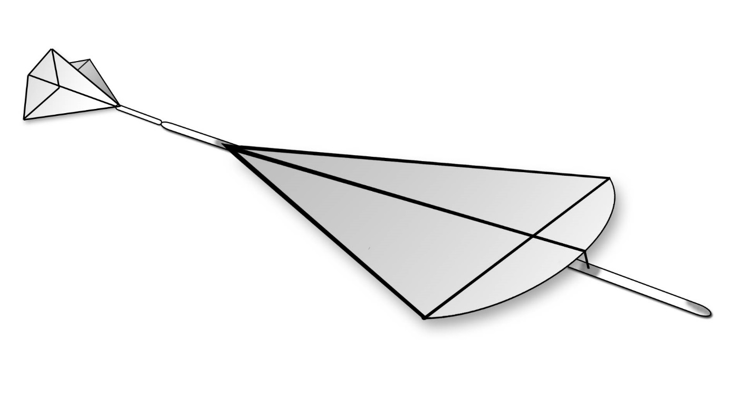

Main 2
Units and equations — Teaching notes

Task 2 is designed to get students recognising how they instinctively solve mathematical problems and that equations are a way to represent that process. Take the opportunity to ask students to describe/explain how they worked out the problems – each student will often have their own way of working out mathematical problems.

Differentiation
Depending on the ability of the students it may be appropriate to work through the problems as a class. Some students may be able to work through independently and find all of the possible solutions.
Students who need most support may need to be given each equation to work out.
e.g. distance = 12 metres time = 6 seconds
speed = distance ÷ time
speed = 12 ÷ 6
speed = …. m/s

Extension
Working in pairs, students could create their own examples similar to the ones above. They could create ones which they think might apply to the following examples:
- a snail, cheetah and a peregrine falcon
- a child on a tricycle, a Tour de France cyclist and a motorcycle courier delivering blood.
They could use them to write a set of problems which they swap with another pair.

Units and equations — Answers
Task 2

    - speed = 6 m/s, time = 2 s (or vice versa), distance = 12 m
    - speed = 6 m/s, time = 3 s (or vice versa), distance = 18 m
    - speed = 7 m/s, time = 5 s (or vice versa), distance = 35 m

    - 20 m ÷ 4 s = 5 m/s (or 4 ÷ 20 = 0.2 m/s)
    - 15 m ÷ 5 s = 3 m/s (or 5 ÷ 15 = 0.3 m/s)
    - 91 m ÷ 7 s = 13 m/s (or 7 ÷ 91 = 0.1 m/s)

    - 2, 6 2 x 6 = 12 m
    - 8, 5 8 x 5 = 40 m
    - 7, 9 7 x 9 = 63 m

    - 21 m ÷ 3 m/s = 7 s (or 3 m ÷ 21 m/s = 0.14 s)
    - 48 m ÷ 6 m/s = 8 s (or 6 m ÷ 48 m/s = 0.13 s)
    - 60 m ÷ 12 m/s = 5 s (or 12 m ÷ 60 m/s = 0.20 s)

- distance = speed x time

- time = distance ÷ speed

Units and equations
Many scientific investigations involve measurement to find out how much of a particular quantity an object has (e.g. length or mass). There are several different measurements which can be taken depending on what quantity you want to find out. Each quantity has its own base unit of measurement. Here are some you may be familiar with.
Task 1
- What other units may be used for some of these measurements? Fill in the last column of the table.
Quantity | Base unit | Abbreviation | Other units used
length | metre | m
time | second | s
mass | kilogram | kg
electric current | amp | A
temperature | Celsius and Kelvin | C and K
energy | joule | J
area | square metre | m²
volume | cubic metre | m³
force | newton | N
Scientists also need to calculate other quantities. They do this by combining two or more base units together into an equation.
- The table shows some compound units and the quantities that they represent. Use the information that you have been given to complete the table.
Quantity | equation using base units | compound unit
density | mass ÷ volume | kg/m³
 | distance ÷ time | m/s
power | energy ÷ time
pressure |  | N/m²
work done | force ÷ distance

- When you tested your glider how did you compare it with other gliders?
Did you measure how far it travelled?

- What else do you need to know to calculate the speed of your glider?

Task 2
Here are some measurements from the flights of a model glider. For each flight they wrote down, in no particular order, measurements for time, distance and speed. The group didn’t write down any units.
- For each of the three flights can you decide what each measurement is for - speed, distance or time? There is more than one correct answer.
    - 6, 2, 12
    - 18, 6, 3
    - 7, 35, 5
- Can you find the speed from just two measurements? Give your answers to 1 significant figure.
    - 4, 20
    - 15, 5
    - 91, 7
- Now imagine you have been asked to find the distance from two measurements. How will you do this?
    - 2, 6
    - 8, 5
    - 7, 9
- How about calculating time from two measurements? Give your answer to 2 decimal places.
    - 21, 3
    - 6, 48
    - 12, 60
- You know that speed = distance ÷ time. This is called an equation.
- Can you write an equation which shows how to calculate distance if you know the speed and time of your glider?

- What would be the equation to show time if you know the speed and distance of your glider?

Week 1 homework

- Please bring in an old pair of over-the-knee length socks or tights.

- A research task for a future lesson about termite mounds.

Watch the following clip of David Attenborough talking about termites from the BBC series Life in the undergrowth:
www.youtube.com/watch?v=xGaT0B__2DM

Answer these questions:
- What are termites?
- Where do termites live?
- Why are termites known as 'nature's architects'?

Week 1 homework

- Please bring in an old pair of over-the-knee length socks or tights.

- Research task for a future lesson about termite mounds.

Watch the following clip of David Attenborough talking about termites from the BBC series Life in the undergrowth:
www.youtube.com/watch?v=xGaT0B__2DM

Answer these questions:
- What are termites?
- Where do termites live?
- Why are termites known as 'nature's architects'?

