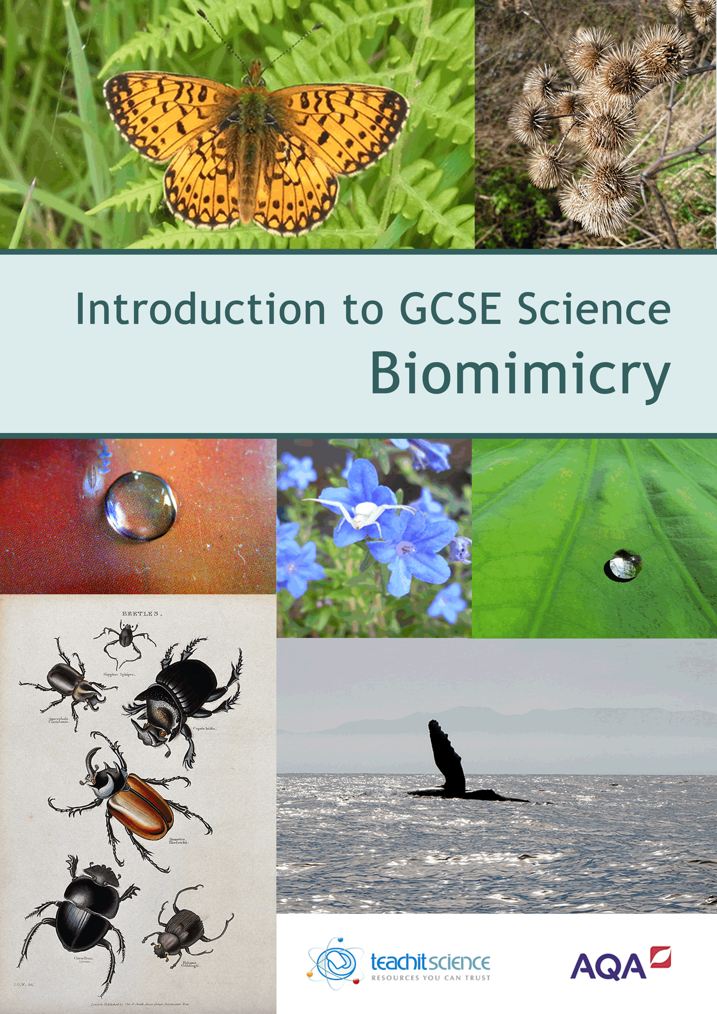
Introduction
This teaching pack is a collection of teaching ideas and student-facing resources (all of which were specifically commissioned for the pack), on the overarching theme of Biomimicry to be used as an introduction to GCSE Science for Y9 students. The theme of Biomimicry was chosen as it is an exciting area of research that extends across scientific disciplines using inspiration from nature to help scientists solve contemporary problems. The pack aims to bridge the gap between what students will have studied at KS3 (e.g. energy transfer, chemical reactions and photosynthesis) and areas studied at GCSE (e.g. nanotechnology, nerve impulses and forces).
It is planned as a six-week unit of work (18 lessons). Included are:
- starter, main and plenary activities
- practical investigations
- suggestions for differentiation and extension of activities
- suggested assessment opportunities
- resources to develop mathematical skills and understanding
- differentiated weekly homework activities
- links to areas of current research and scientists.
It is arranged lesson by lesson, with several suggested starters, main and plenary activities. It lends itself to a ‘pick and mix’ approach; choose from the suggested activities the most appropriate for your students. It could be dipped into on an ad hoc basis or it could form the basis of a longer unit of work. The resources are all available in adaptable formats, making it easy to differentiate the tasks by ability.
The practical investigations are all designed to use materials and equipment that are all easy to resource. They could be extended into more substantial investigations.
To help with navigation, there is a contents table which summarises the resources found in each lesson. Included are several interactive resources, to access these please go to www.teachitscience.co.uk/aqa-biomimicry
Our special thanks go to the author, Jane Robertson, who has created and written this pack.

Cover image credits: Butterfly, burdock and spider © Jane Robertson 2015 / Hydrophobic red material © Glenn Gould 2007 https://flic.kr/p/4nBnom / Hydrophobic green leaf © Michael Whitehead https://flic.kr/p/4y1YyZ / Beetle drawings © Wellcome Library, London / Whale © Boss Tweed 2008 https://flic.kr/p/5NhjwN
Copyright © 2015 AQA and its licensors. All rights reserved. AQA Education (AQA) is a registered charity (registered charity number 1073334) and a company limited by guarantee registered in England and Wales (company number 3644723). Registered address: AQA, Devas Street, Manchester M15 6EX

Resources summary
Lesson | Resource
W1L1  Introduction to biomimicry | Introduction to biomimicry — starter activities
 | Trying to fly: making a model of Cayley’s glider
 | Units and equations
 | Week 1 homework
W1L2  Nanotechnology | Large and small prefixes
 | Large and small prefixes (interactive whiteboard version)*
 | Powers of ten
 | What is nanoscience and technology?
W1L3  Developments in microscopy | Important developments in microscopy
 | Different types of modern microscope
W2L1  Things that glow in the dark | Using fluorescence — background information
 | Fluorescent chemicals
 | Week 2 homework
W2L2  What can we learn from termite mounds? | Odd one out
 | What can we learn from termite mounds?
 | Cross section of a termite mound
W2L3  What’s special about a lotus leaf? | What’s special about a lotus leaf?
 | Magnification activity

* To access please go to www.teachitscience.co.uk/aqa-biomimicry
Lesson | Resource
W3L1  Spiny–headed worms and skin grafts | Interviewing the professor
 | Week 3 homework
W3L2  Desalination | Water cycle
 | Water cycle (interactive whiteboard version)*
 | World’s population and water
W3L3  Freshwater in deserts | Freshwater in deserts
 | Questions and answers
W4L1  Neural networks | The brain — true or false?
 | Neural networks
 | A brief history of neural networks
 | Week 4 homework
W4L2  Mussel adhesive | How do mussels stick?
 | How do mussels stick? (interactive whiteboard version)*
 | Making a glue
 | Comparing mussel strength
W4L3  Tardigrades and vaccines | The problems with vaccines
 | Tardigrades under the microscope

* To access please go to www.teachitscience.co.uk/aqa-biomimicry
Lesson | Resource
W5L1  The Bombardier beetle | Scientist — who’s who?
 | Charles Darwin and the Bombardier beetle
 | Week 5 homework activity
W5L2  Wind turbine blades | Wind turbine blades
 | Investigation – comparing designs for a helicopter blade
W5L3  Silk moths and chitin | Silk moths and chitin
 | Comparing polymers
 | Shrilk
 | Maths and measuring volume
 | Match the Greek word with its meaning
W6L1  Artificial photosynthesis (1)  W6L2  Artificial photosynthesis (2) | Artificial photosynthesis —starter
 | Is chlorophyll the only pigment in green leaves?
 | Artificial photosynthesis – obstacles to overcome
 | What am I?
W6L3  A new look at wood | A new look at wood
 | Comparing concrete and wood
 | Cellulose and other materials

* To access please go to www.teachitscience.co.uk/aqa-biomimicry

