Week 6 Lesson 3
A new look at wood
Aim: To compare concrete and wood as construction materials and to look at a relatively new field of research, the molecular structure of plant cell walls.
Keywords: cellulose, durable, insulator, laminate, lignin, polymer, thermal energy,

Starter activity
- A new look at wood
A quick starter activity to introduce the concept of different woods having different properties, see the PowerPoint ‘A new look at wood’.

Main activities
- Where does the hardness of timber come from?
Ask students to make suggestions based on their knowledge of the structure of plant and animal cells.
Demonstrate the effect of a cell wall on the rigidity of a cell by using a balloon and a shoe box.
The cell wall gets its strength from the world's most abundant organic polymer (polymers were discussed in WK 5 lesson 3) – cellulose. The cellulose polymer consists of 8 000 – 10 000 monomers.
A second polymer, lignin, is also important.
- Comparing concrete and wood
Using the resource ‘Comparing concrete and wood’ students compare and contrast the properties of wood by placing statements into a Venn diagram. Discuss the advantages/disadvantages students have chosen. Highlight the differences in CO₂ emissions; wood is a much greener construction material.
- Cellulose and other materials
A selection of short tasks to compare the strength of different building materials, see the resource ‘Cellulose and other materials.

Background information on current research
Scientists are only just beginning to look at how the cellulose and lignin molecules, which make up cell walls, are arranged. This is an unexplored area of research with huge potential.
Paul Dupree, a biochemist at the University of Cambridge has received a grant of £1.75 million to work with architects and polymer chemists. They will use a nuclear magnetic resonance machine to find out more about the atomic structure of cell walls.
If the complex arrangement of cellulose molecules could be mimicked this may lead to the design and production of stronger laminated materials or to genetically engineered trees, strong enough to be used in the construction of bigger buildings.

Assessment opportunity
Check students’ graph drawing skills, understanding of ratios, knowledge of prefixes and interpreting data.

Plenary activity
- Biomimicry summary
Students list as many examples of biomimicry as they can in 30 seconds.
Students rank them in order of importance.
Which area of research/product development would they like to be involved in and why?
Starter 1
A new look at wood — PowerPoint

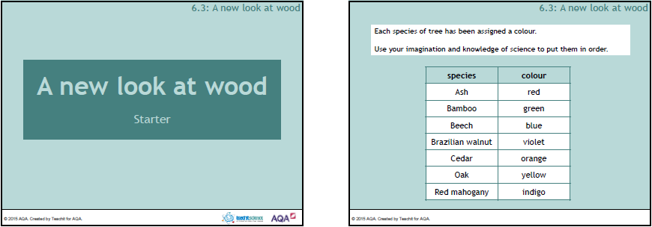

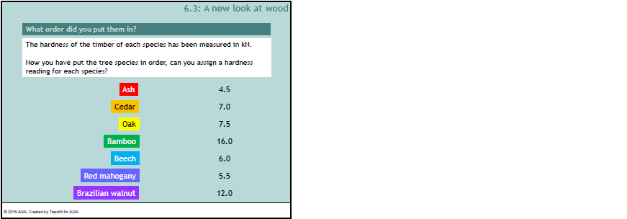

Main 2
Comparing concrete and wood — Answers

Material | Property
Concrete | Strong enough to support very tall buildings
 | Can be poured into moulds
 | Will solidify under water
 | Durable
 | Fire resistant
 | Poor thermal insulator
 | Can store and release a lot of thermal energy
 | Requires a lot of energy to manufacture and transport
 | Responsible for 5% of greenhouse gases*
 | When liquid may cause burns to skin and eyes
Wood | May swell when wet
 | Good thermal insulator
 | Higher strength to weight ratio than structural steel
 | Safe; non toxic
 | Plentiful
 | Lightweight
 | Oldest building material
 | Some species are very durable
 | Removes CO₂ from atmosphere
 | Waste and off cuts can be recycled
Both | Composite material
 | Low maintenance
* produced by human activity.
Comparing concrete and wood
Look at the statements in the table.
- Which ones apply to wood?
- Which apply to concrete?
- Which are shared by both?
Draw a suitable Venn diagram to sort the statements.
Discuss each statement with your partner before adding them to the Venn diagram.
Property
strong enough to support very tall buildings | good thermal insulator
safe; non toxic | removes CO₂ from atmosphere
will solidify under water | can be poured into moulds
waste and off cuts can be recycled | fire resistant
plentiful | lightweight
low maintenance | can last for hundreds of years
some species are very durable | can store and release a lot of thermal energy
requires a lot of energy to manufacture and transport | higher strength to weight ratio than structural steel
responsible for 5% of greenhouse gases* | durable
when liquid may cause burns to skin and eyes | composite material
may swell when wet | poor thermal insulator
* produced by human activity

Q. What do you think are the main advantages and disadvantages of concrete and wood as building materials?

Main 3
Cellulose and other materials — Answers
Task 1
- What will be the length of four fibres laid end to end?
100 µm
- How many fibres would there be in 750 µm?
30 fibres
- How many fibres would be in 1 mm?
1000 µm = 1 mm
1000 µm ÷ 25 µm = 40
Task 2
- What is Pa short for?
Pascal
- What does the unit Pa measure?
Pressure
- What does MPa mean?
Mega Pascal 10⁶ Pascal
Task 4
Material | Tensile strength (GPa) | Stiffness (GPa) | Ratio  tensile strength :stiffness | Working | Unitary ratio
Cellulose nanocrystals | 7.5 | 150 | 7.5 :150 | 150 ÷ 7.5 = 20 | 1 : 20
Glass fibre | 5 | 85 | 5 : 85 | 85 ÷ 5 = 17 | 1 : 17
Steel wire | 4 | 208 | 4 : 208 | 208 ÷ 4 = 52 | 1 : 52
Kevlar | 3.8 | 152 | 3.8 : 152 | 152 ÷ 3.8 = 40 | 1 : 40
Graphite whiskers | 21 | 420 | 21 : 420 | 420 ÷ 20 = 21 | 1 : 21
Carbon nanotubes | 11  73 | 275  876 | 11 : 275  73 : 876 | 275 ÷ 11 = 25  876 ÷ 73 = 12 | 1 : 25  1 : 12

- Which material shows the greatest proportional difference between its tensile strength and stiffness?
Steel wire has the greatest difference between tensile strength and stiffness.

- Describe how cellulose compares to other materials used as reinforcement.
Cellulose is very similar to graphite whiskers, glass fibre and carbon nanotubes.

- Do you have access to the internet? If so, can you find out why carbon nanotubes have a range of measurements for strength and stiffness?
You may remember from Week 1, lesson 2 nanotechnology that; the properties of carbon nanotubes including strength, depend on how the sheet of carbon atoms is rolled up.

- What does GPa mean?
Giga Pascal 10⁹ Pascal
Cellulose and other materials
Task 1 - cellulose
Cellulose fibres are on average 25 µm long.
- What will be the length of four fibres laid end to end?
- How many fibres would there be in 750 µm?
- How many fibres would be in 1 mm?

Task 2 – comparing strength of different materials
Material | Strength when compressed (MPa)
Bone | 170
Cast iron | 170
Cellulose fibres | 80
Concrete | 40
Douglas fir (wood) | 50
Marble | 15
Pine tree (wood) | 40
Polystyrene | 30
Structural steel | 400
Tooth enamel | 83
Table 1: Showing the compressive strength of a range of materials.

Draw a bar chart of the information in Table 1.
- What is Pa short for?
- What does the unit Pa measure?
- What does MPa mean?

Task 3 – making models of cellulose and cell walls
What do you notice about the strength of wood and concrete? What about when you compare cellulose and wood?

Wood is not is not as strong as cellulose because it contains vessels and water. Also, most of the cells are orientated in one direction – vertically.
In cell walls, cellulose fibres are tightly packed and arranged in layers. In each layer the fibres have a different orientation and are 'glued' together by a substance known as pectin. (This is what makes jam set).

Modelling cell walls and cellulose
Use this information to make simple models of the arrangement of cells in wood and the arrangement of cellulose fibres in cell walls.

Apparatus
- strips of stiff cardboard 1 cm wide, 20 – 25 cm long
- glue sticks

Task 4 – working out ratios

Material | Tensile strength (GPa) | Stiffness (GPa) | Ratio  tensile strength :stiffness | Working | Unitary ratio
Cellulose nanocrystals | 7.5 | 150 | 7.5 :150 | 150 ÷ 7.5 = 20 | 1:20
Glass fibre | 5 | 85
Steel wire | 4 | 208
Kevlar | 3.8 | 152
Graphite whiskers | 21 | 420
Carbon nanotubes | 11  73 | 275  876
Table 2: Showing the tensile strength and stiffness of materials used for reinforcement.

- Complete the table.
- Which material shows the greatest proportional difference between its tensile strength and stiffness?
- Describe how cellulose compares to other materials used as reinforcement.
- Do you have access to the internet? If so, can you find out why carbon nanotubes have a range of measurements for strength and stiffness?
- What does GPa mean?

