The World
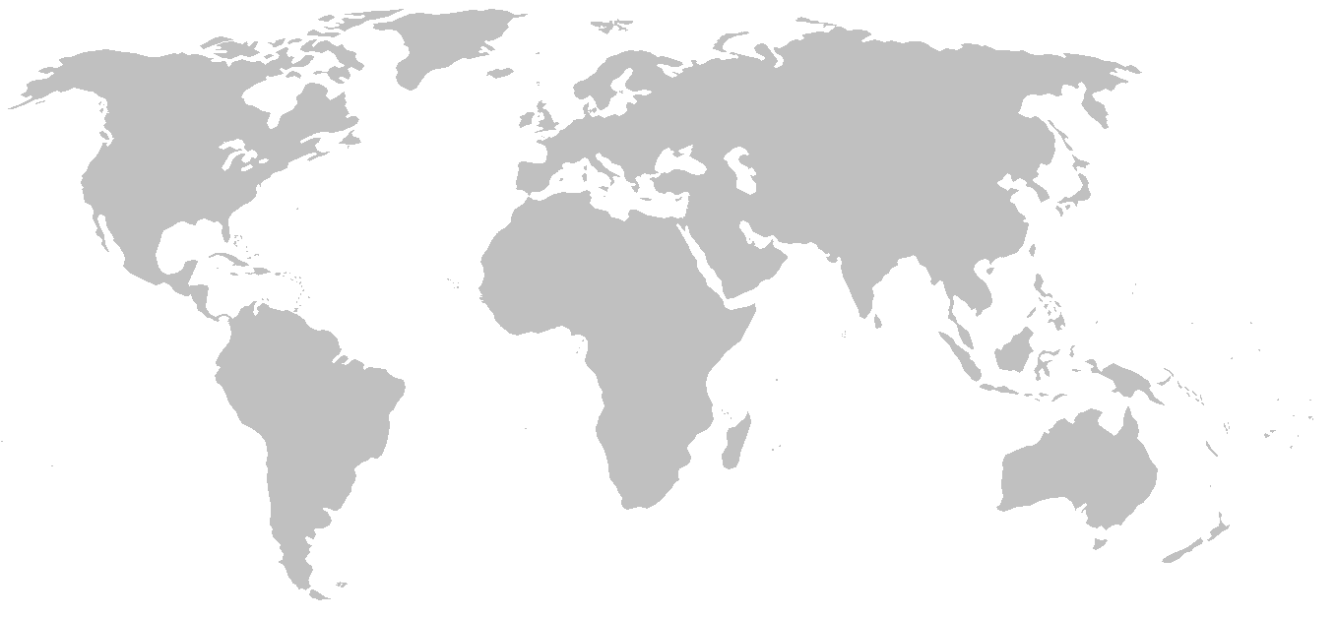

Map used courtesy of E Pluribus Anthony, released into the public domain via Wikimedia Commons.

