Student tasks
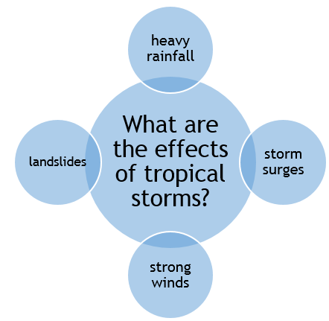
- Use the diagram, What are the effects of tropical storms? to construct five questions.
Each question needs to start with a different word.
The words are:
- What
- Where
- How
- Why
- When
An example of a question is:
How much rainfall fell on New Orleans during the passage of Hurricane Katrina in 2005?
or more specifically:
How high were the storm surges caused by Tropical Storm Haiyan in the Philippines in 2013?

- Your task is to then to find the answers to the questions.
Storm surge: as the area is under less atmospheric pressure, the sea level rises and water is driven onshore by the high winds

