Research: witness statements

It was my birthday, 8th November, but there was not much to celebrate as everything has been destroyed. Our livelihoods were from the coconut palms, but three massive waves destroyed the coastal communities and 95% of the trees in our region of Eastern Samar. | It was so windy! It’s was more than 160 km/h on average. Dad said the gusts were the highest he had ever known … about 280 km/h!
We are still in shock. The storm surge was over a metre high! It was like our island of Mangalabang was drowning. There was broken coral from the reefs everywhere. The coral reefs must have been destroyed. With no coral reefs, there are no fish, and with no fish, there is no livelihood for us here. | My home, in Barangy Punta, was destroyed. Most buildings were raised to the ground with just the floor remaining. It was difficult to avoid the flying debris as we tried to find shelter. Many people must have died from the flying debris. The corrugated iron roof of our home was blown off so easily.

I just can’t find out whether my friends and family are safe. There’s no electricity, no phone lines and no phone signal. I want to go to the next village, but the roads are blocked as well. | We will go to Roxas in the morning. It’s larger there so there should be food and help. I’ve heard they are struggling to cope there because of everyone going there and they have no water because of the broken pipes.
It’s horrendous. There’s debris everywhere and dead bodies are being washed up on the shore. We’ve got to identify them and bury them, but we don’t know who to contact, and we are scared that if we leave them where they are, they will spread disease.  The death toll is 3,000 at the moment, but that’s too low. They haven't counted in the areas that they can’t get to easily, like the smaller islands. It must be double that … over 6,000 must have died at least. | I want to see my family. They are on one of the thousand small islands here. I cannot reach them as all the boats have been destroyed. They couldn't get here, to the evacuation shelters on Cebu. It was just too dangerous. There were no mountains or storm shelters to hide in – nothing to protect them from the wind, water and flying debris.

Research: photographs

- A man stands surrounded by the devastation caused by Tropical Storm, Haiyan, in the city of Tacloban.

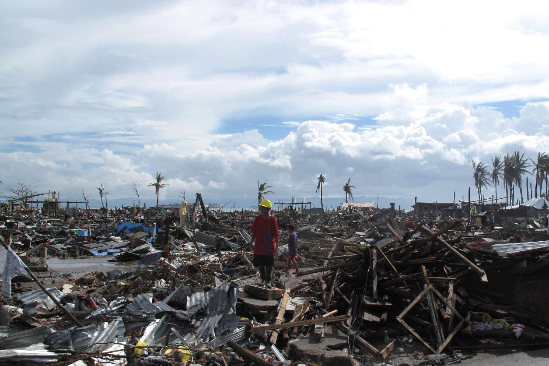
© DFID 2013 https://flic.kr/p/icG9De

- A sign requesting help on a roundabout on the main road into Tacloban.

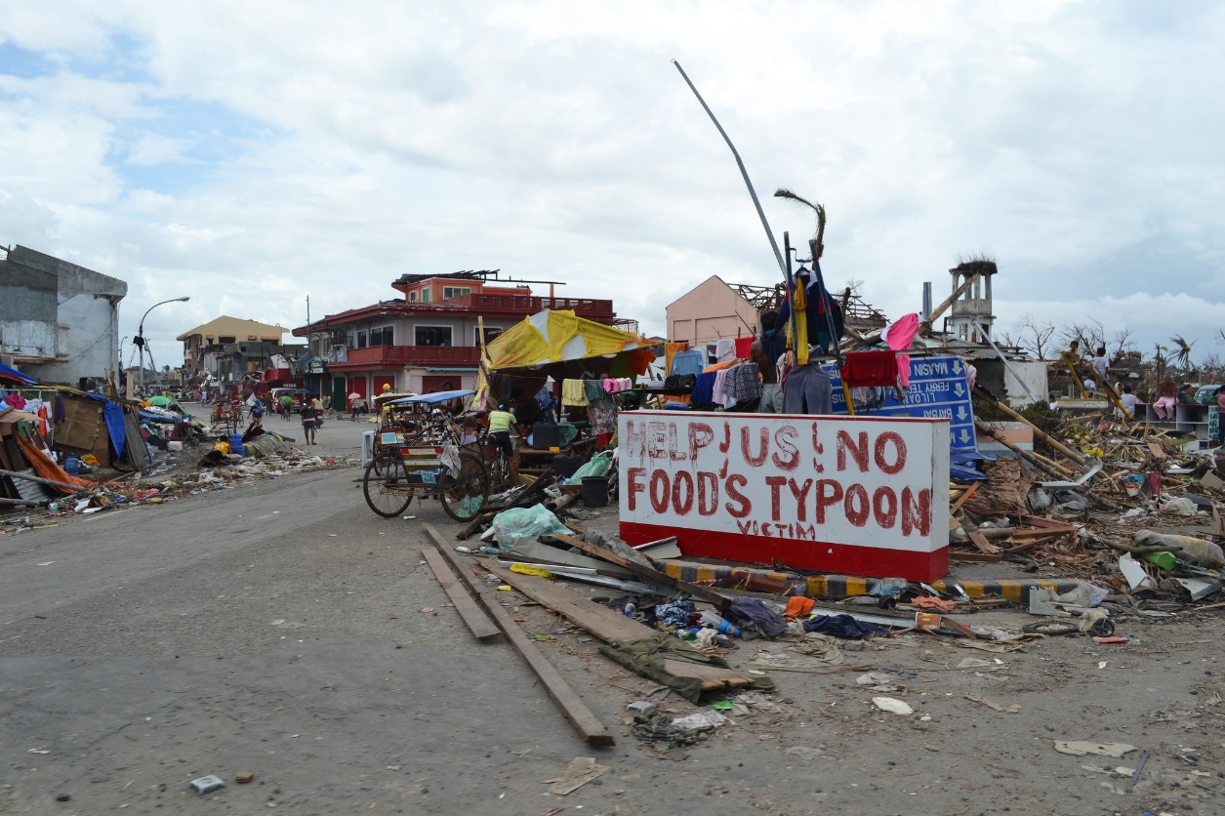
© Trocalre 2013 https://flic.kr/p/pEsxhm
Student task

Use the witness statements and the two photographs to help you design a leaflet for a charity. The leaflet will ask people for donations to help the inhabitants of the Philippines. You will need to be clear what response is needed urgently and what is needed over the long term.
Can you add anything else to the appeal leaflet?
To help plan the report, use the table below:
Response | Urgent (U) or long term (L) | Why is this needed?
Fresh water, food and medication
Treating the injured
Burying the dead
Accessing remote islands
Rebuilding the roads and homes
Mending boats and nets
Expanding storm shelters
Building temporary shelters

