Where?  When? | Primary effects  Secondary effects
Key facts
 | Prediction/Monitoring | Immediate responses  Long term responses

Student task
Use the information on this page to complete the template on the previous page.
Predicted path of the tropical storm | Actual path of the tropical storm | More than 6,000 people reported dead. | Nearly 1,600 evacuation centres set up. | The President of the Philippines requested planes and helicopters from the military. |  | More than 14 million people affected.
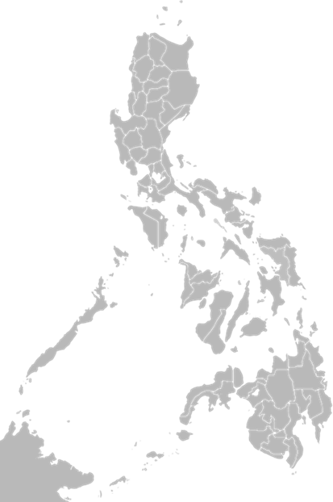 |  | Live electrical wires were immersed in water leading to some electrocutions. | 8th November 2013 |  |  | Mobile phone coverage was lost.
 |  |  | Over 1,000,000 homes damaged, many of which were totally destroyed. |  |  | 8 people died in Tacloban when a wall collapsed in a rice warehouse after people were raiding it for food.
 |  | 6 metre high wave from the storm surge came into Tacloban Bay; the funnel shape of the bay helped increase the height of the wave.
 |  | Haiyan was one of 8 tropical storms to affect the Philippines in 2013. | Tropical Storm Haiyan was called Tropical Storm Yolanda in the Philippines. |  | $20 billion cost to the Philippines (5% of its GNP).
 |  |  | Snakes entered damaged buildings to escape flood waters. | Stagnant water attracted mosquitos and more people contacted malaria.
Extension task
Why does it matter that the predicted path was different from the actual path?

