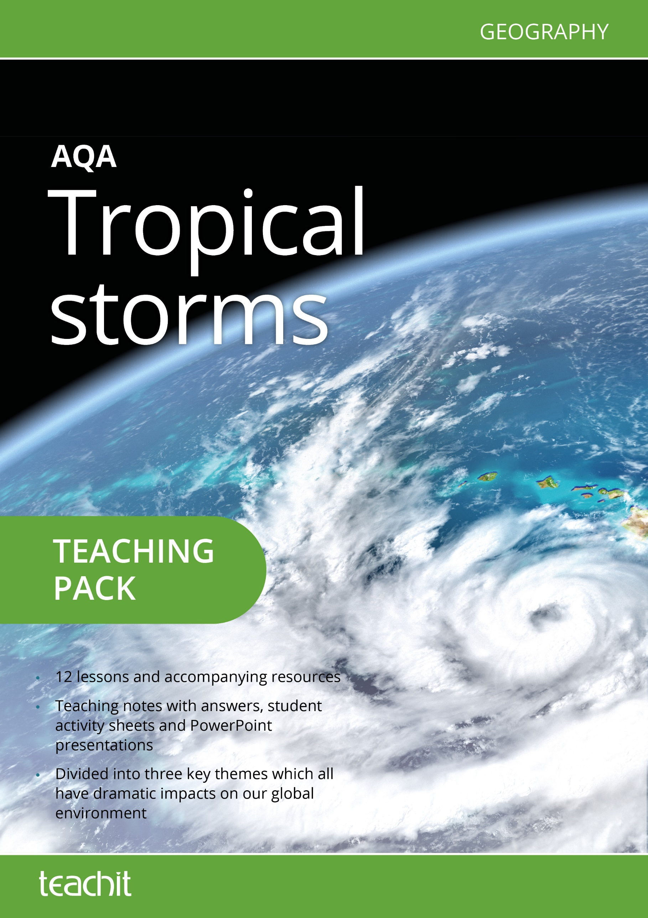

Contents page

Introduction 3
New GCSE Geography specification 4
OFQUAL assessment objectives for GCSE Geography 5
Suggested route through 6
Additional research 15
Resource listing 16
Resources 17
Acknowledgement of copyright-holders and publishers 68

Introduction
This teaching pack is a collection of teaching ideas and student resources (all of which were specifically commissioned for the pack), on the theme of Tropical storms for the new AQA GCSE in Geography. It builds on the two very successful previous AQA GCSE Geography syllabuses: Geography A (9030) and Geography (9035).
It is planned as a two-week unit of work and includes a selection of:
starter activities
activities to show students’ understanding
plenary activities
suggestions for differentiation.

The pack lends itself, particularly well to being used in different ways. It could be dipped into on an ad hoc basis or it could form the basis of a longer unit of work. The resources are all available in adaptable formats, making it easy to differentiate the tasks by ability.
We’ve included links to each separate resource within this pack so that you can access the resources directly on www.teachitgeography.co.uk. We’ve included the file number or name for each original resource — just pop this into Teachit Geography’s search box.
To help with navigation, there is a contents table which details which part of the pack each resource is used in and provides a page number.
Our thanks go to our contributor Rachel Atkins who has written the resources for this pack.
We hope you enjoy using this pack. If you have any questions, please get in touch: email support@teachitgeography.co.uk or call us on 01225 788850. Alternatively, you might like to give some feedback for other Teachit Geography members — you can do this by adding a ‘love heart’ and commenting on the relevant page of the resource on Teachit Geography, (please log in to access).

New GCSE Geography specification
Key idea | Specification content
Tropical storms (hurricanes, cyclones, typhoons) develop as a result of particular physical conditions. | Global distribution of tropical storms.  Conditions leading to the formation of a tropical storm.  The structure and characteristics of a tropical storm.  How climate change might affect the distribution, frequency and intensity of tropical storms.
Tropical storms have significant effects on people and environments. | A case study/example of a tropical storm to illustrate:  the effects (primary and secondary)  the responses (immediate and long term)  how monitoring, prediction, protection and planning can reduce the effects of a tropical storm.  Evidence to show that effects and responses vary depending upon the level of economic development of the country.

Objectives
To describe where tropical storms are located
To describe how and why tropical storms form
To outline the key structure of a tropical storm
To explain why tropical storms have the potential to be so dangerous
To describe and explain the effects of tropical storms
To understand the factors which influence the effects of a tropical storm
To use evidence to see whether the number of people affected relates strongly to the economic development of a country
To explain the effects of tropical storms on people and the environment – using a case study.

To investigate the future impact of tropical storms, with reference to climate change.

OFQUAL assessment objectives for GCSE Geography.
The pack uses the four OFQUAL assessment objectives for GCSE Geography.
Objective |  | Weighting
AO1 | Demonstrate knowledge of locations, places, processes, environments and different scales. | 15%
AO2 | Demonstrate geographical understanding of:  concepts and how they are used in relation to places, environments and processes  the interrelationships between places, environments and processes. | 25%
AO3 | Apply knowledge and understanding to interpret, analyse and evaluate geographical information and issues and to make judgements. | 35% (10% applied to fieldwork context/s)
AO4 | Select, adapt and use a variety of skills and techniques to investigate questions and issues and communicate findings. | 25% (5% used to respond to fieldwork data and context/s)

Suggested route through
Starter
Resource 24331: What am I?
This PowerPoint can be used as a starter activity to gauge prior knowledge and understanding of tropical storms.
An extension to the starter could be to use an image of a tropical storm, e.g. a visualisation of Hurricane Floyd approaching the coast of Florida and ask the students to describe what they can see.

Activity
Resource 24147: Where do tropical storms form?
This resource uses a PowerPoint presentation to introduce the concept that tropical storms only form in certain specific areas, e.g. in the broad zone of low pressure either side of the equator. It allows the development of communication skills and the reinforcement of KS3 locational knowledge.
The activity is a blindfold describing exercise. In pairs, one person describes the image they can see and another person has to redraw the image on a piece of paper. The person redrawing the image is not able to see the image as they are facing away from the board. The easiest way to manage this is if the class is in rows, then the first row turn and face the second row. The third row turn and face the fourth row.
Two blank world maps are provided to accompany this resource. One map shows only the landmasses while the other includes the borders of the countries. In terms of differentiation, the students could be asked to describe/plot locations using either of these blank maps. Alternatively, the students could be provided with an atlas or world map showing a selection of country names, the oceans and/or lines of latitude for this activity.
The image provided in the PowerPoint categorises the tropical storms by the Saffir-Simpson scale. A different version is available at: http://upload.wikimedia.org/wikipedia/commons/2/23/Global_tropical_cyclone_tracks-edit2.jpg and some students may find this an easier image to understand and describe.
The short (2.5-minutes) video from the BBC, http://youtu.be/4f45jA5UxB0, How a hurricane is born – The science of superstorms provides a useful addition to this resource. The video explains clearly the formation of a tropical storm/hurricane over the Atlantic Ocean.

Differentiated activity
Resource 24342: The location of tropical storms
If the Where do tropical storms form? activity, with the alternative approaches suggested above is considered too complicated, this resource is designed for lower ability students. It uses the image below:
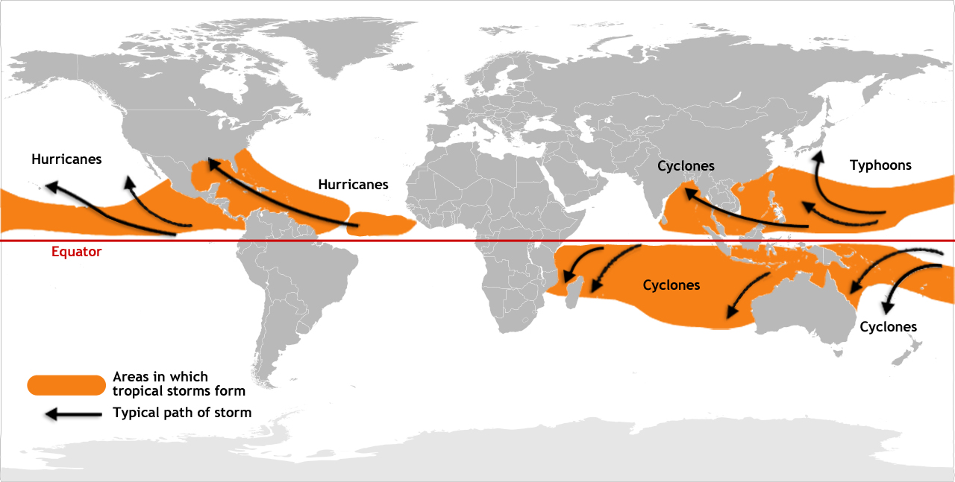

Extension activity
Resource 24339: What is the link?
This PowerPoint provides an extension activity to accompany the previous activity. Students would need to have a map of the tropical storm source areas to compare with the map in the PowerPoint. The resource is designed to emphasise that the ocean surface temperature needs to exceed approximately 26ºC for a tropical storm to develop and then intensify.

ICT task
Students can generate their own tropical storms using an interactive approach at www.nhc.noaa.gov/outreach/games/canelab.htm. This requires them to consider the contributory factors of sea temperature, wind speed, latitude etc.

Activity
Resource 24351: The formation of Hurricane Katrina
It is suggested that this activity is introduced with one of the following two wind maps:
http://earth.nullschool.net/#current/wind/isobaric/1000hPa/orthographic=-40.02,21.75,276
http://hint.fm/wind/

This exercise then reinforces the content of previous resources by asking students to correctly order the stages in the formation of a hurricane and relate these to a satellite image of Hurricane Katrina. A useful video showing the development of Hurricane Katrina is available at http://spaceplace.nasa.gov/hurricanes/en/#/review/hurricanes/hurricane-katrina.mp4
The Anatomy of a hurricane video (five minutes) at http://youtu.be/HJydFJORWf4 is also useful in understanding the formation of hurricanes.

Activity
Resource 24340: Wordsearch for tropical storms
This simple wordsearch could provide an alternative starter for the lesson as it includes 12 keywords for tropical storms.

Activity
Video: The effects of hurricanes
Students could be asked to watch the very short (< 1 minute) video at www.youtube.com/watch?v=H9VpwmtnOZc.
They can then be asked to script a commentary concentrating on the effects. Differentiation could be provided by asking for a separation of primary from secondary effects.

Activity
Resource 24336: The Saffir-Simpson scale
Using the provided Saffir-Simpson scale, students read the description of each of the five levels of damage from a hurricane before adding a cartoon or diagram for each description.
There is a useful animation at www.nhc.noaa.gov/aboutsshws.php, which could be of use with lower ability students.
An extension to this resource is for the students to list all of the effects of tropical storms using the Saffir-Simpson scale. The students can then be asked to list other possible effects. A key question could be … ‘Apart from wind, what else is causing damage?’

Activity
Resource 24150: Asking questions about the effects of tropical storms
It is suggested that the topic of the effects of tropical storms is introduced with a short section of video. The first twelve minutes of Journey inside the eye of a massive hurricane that shows a hurricane hitting New York is a useful approach. It is available at www.youtube.com/watch?v=h7lazmTqpCc. Category 3 on the Saffir-Simpson scale, introduced in the previous resource, may need to be explained.
The resource is a useful introduction to the effects of tropical storms as it asks the students to formulate questions as to the ‘When, Where, Why, What and How’ of tropical storms.
This is also a good task for a homework extension exercise with the students answering their questions through internet research. It consequently provides students with the opportunity to explore the key effects of tropical storms and these can then be shared with the class for the next lesson.
Alternatively, the resource can be revisited at a later time to answer the questions.
An additional resource, Tropical storms – a card sort (Resource - 24048) is available on the Teachit Geography website and gives an alternative approach for the effects of tropical storms.

Activity
Resource 24297: What factors influence the number of people affected by tropical storms?
This is a categorisation activity. Students could work in pairs and place the factors in the correct area on the handout. A more challenging activity would be for students to come up with their own ideas first, trying to name both human and physical factors. The boxes on the resource sheet can then be given, possibly as cards, to place in the correct area. This sheet also provides a useful summary sheet to consider the effects of the tropical storm in a selected case study.

Activity
Resource 24282: A choropleth exercise
The choropleth activity provides the opportunity to introduce/revise this important GCSE mapping technique. It uses data from the Philippines devastated by Typhoon Haiyan, one of the strongest tropical storms ever recorded. The additional questions allow students to practise with short answer GCSE-style question.

Activity
Resource 24328: Tropical Storm Haiyan – a summary
By completing this resource, students will develop a case study of the 2013 tropical storm. It is suggested that this is then used in later activities.

Activity
Resource 24293: Reporting Tropical Storm Haiyan
In this resource a selection of witness reports are provided reporting the effects of Tropical Storm Haiyan. The students are asked to categorise these into primary or secondary effects. A structured table is provided to assist the students with this.
The activity concludes by asking the students to create a newspaper style report using the witness statements, or, for a greater challenge, using a case study fact file which has been produced as a homework exercise prior to the lesson.
The wide format of the report (newspaper, video journal or podcast) allows for differentiation, and for a greater challenge, students can involve their own research. Blogs and eye witness accounts can contribute to the information gained about the effects of the storm and the responses.
Reports and accounts can be found at:
www.bbc.co.uk/news/world-24901032 (BBC)
https://youtu.be/7A95LiY4vt8 (YouTube – produced by Christian Aid)
www.ibtimes.co.uk/philippines-tacloban-leyte-island-tornado-storm-haiyan-520992 (International Business Times)

Plenary
Resource 24358: Why was the death toll from Tropical Storm Haiyan so high?
Students are presented with 24 statements that may or may not have had an impact on the magnitude of the death toll from Tropical Storm Haiyan in 2013.
At the simplest level, students could be required to cut out the statements and then discard any factors they consider irrelevant.
More able students could be asked to rank all contributory factors. The activity is specifically designed to create discussion.
The plenary could be extended for homework by asking students to research additional factors contributing to the high death toll from Tropical Storm Haiyan.

Activity
Resource 24327: Responding to tropical storms
This resource is a comprehension and photographic interpretation activity to examine the differences between responses in the short-term and the long-term.
The exercise allows for differentiation, as there is sufficient information to produce a charity leaflet from either of the two pages of witness statements or from using both pages and the two photographs.
Alternatively a different approach could be to use the witness statements / photographs and ask students to match observed effect and suitable response before asking them to identify responses in the short-term or the long-term.

Activity
Resource 24294: Vulnerability to tropical storms
This activity can be introduced with the question: Why might you fear living in one of the houses in the PowerPoint image when you hear that a tropical storm is predicted to arrive shortly?
They can then use the Word document to create a word mat of ideas about the vulnerability of the houses to the effects of tropical storms.

Numeracy activity
Resource 24278: A Spearman’s rank statistical activity of tropical storms
This activity has both a graphical and numerical focus and consequently allows for a degree of differentiation.
At a supportive level, the scattergraph could be used to introduce a basic comprehension of correlation. The provided scattergraph template may be used if required.
With more able pupils, the data in the resource is used to conduct a Spearman’s rank correlation. Full instructions and a step by step template are included to complete the correlation.
At the highest ability level, students are introduced to null hypotheses and significance and investigate the strength of the correlation coefficient.

ICT task
The data used in resource 24278 could be used in a spreadsheet, e.g. Excel, to construct the scattergraph.
Activity
Resource 24315: The future of tropical storms
The future of tropical storms worksheet is presented so that the students can empathise with a person affected by a tropical storm. Whilst a detailed knowledge of climate change is not needed to complete this activity, a recap of the subject may be helpful for some students
A writing frame has been provided for greater support if needed. In addition, again for greater support, students could match up the question in column 1 to the answer in column 2 and the reason in column 3 on the worksheet.
For greater challenge, the cards can be cut out and students asked to link each question with an answer and an explanation. By muddling the cards, students have to work out which column is which.
An extension challenge can be to examine how the area can prepare for the future. Three maps, cited below, would be useful for this:
Students could have access to additional information, such as the population density map of the Philippines: http://disaster.dswd.gov.ph/maps.php
Reports about the disaster response and planning for the future are found here: http://reliefweb.int/report/philippines/philippines-typhoon-haiyan-humanitarian-dashboard-22-october-2014
A map of the area which was destroyed from Haiyan is found here: http://google.org/crisismap/2013-yolanda

Plenary
Resource 24149: A tropical storms dominoes game
The domino activity can be used individually, in small groups or as a whole class. On each domino is a question and an answer to a different question. The activity can be carried out in a variety of ways:
Each student or groups of students simply match up the questions to the answer, and form the domino chain on the table in front of them.
Each student or groups of students can be provided with a few dominos and asked to write what they think the question could be, or what the answer would be, i.e. If that is the question, then what is the answer? If that is the answer, then what is the question?
Class dominos – each member of the class is given a domino, and the first student, who is holding the domino with start on reads out their question. The student who thinks they hold the answer puts up their hand and reads out what the domino says.
Domino race – two teams are formed and given a set of dominos each. They have to stand in a line linking the dominos in the correct order.

A useful extension to the dominoes game is to ask the students to use the information from the dominos to begin to answer the question: How do tropical storms form? This could then be concluded by asking the students to incorporate the details of a relevant case study into their answer.

Assessment
Resource 24292: Tropical storms — assessment
A GCSE-style sample question is provided to assess knowledge and understanding.

Tropical storms topic plenary
Students can be asked 5 4 3 2 1.
5 new terms learnt in this topic
4 effects of tropical storms
3 key things required to produce a tropical storm
2 labels to use on a tropical storm cross-section
1 way a tropical storm is measured

Additional research
If further direction is needed regarding students’ own research, the following websites may be of use:
www.earthweek.com/tropicscat.php – a weekly digest of tropical storms
http://preview.grid.unep.ch/index.php?preview=map&lang=eng – A GIS map, allowing the user to select information to map globally
www.emdat.be/disaster_profiles/index.html – An emdat database containing information on international disasters taken from the CRED database
Further data on tropical storms can be found here: www.preventionweb.net/english/hazards/statistics/?hid=58
If further comparisons need to be made, beyond the case study, or between other forms of natural hazard, then the National Weather Service in the USA produces clear and useful updated information, for example www.nws.noaa.gov/om/hazstats/sum13.pdf

Resource listing
Resource number | Title | Page number
24331 | What am I? | 17
24147 | Where do tropical storms form? | 19
24342 | The location of tropical storms | 22
24339 | What is the link? | 24
24351 | The formation of Hurricane Katrina | 25
24340 | Wordsearch for tropical storms | 27
24336 | The Saffir-Simpson scale | 28
24150 | Asking questions about the effects of tropical storms | 29
24297 | What factors influence the number of people affected by tropical storms? | 30
24282 | A choropleth exercise | 33
24328 | Tropical Storm Haiyan – a summary | 37
24293 | Reporting Tropical Storm Haiyan | 39
24358 | Why was the death toll from Tropical Storm Haiyan so high? | 43
24327 | Responding to tropical storms | 44
24294 | Vulnerability to tropical storms | 48
24278 | A Spearman’s rank statistical activity of tropical storms | 50
24315 | The future of tropical storms | 57
24149 | A tropical storms dominoes game | 61
24292 | Tropical storms — assessment | 62

We’ve included a screenshot of the PowerPoint slides here so you can see the resource. To access this resource please go to the Teachit Geography AQA Tropical storms page.

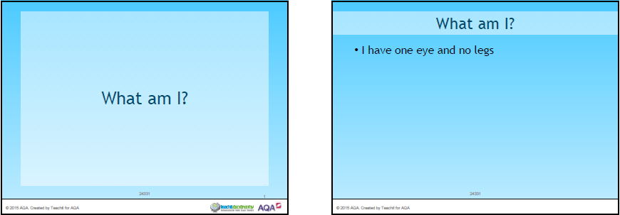
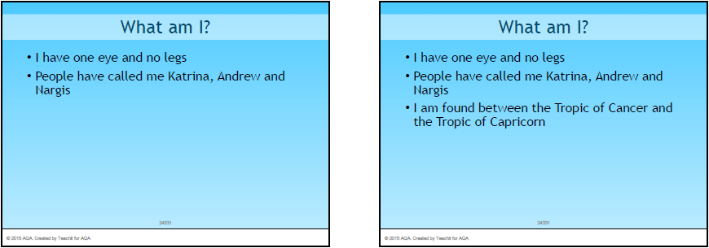
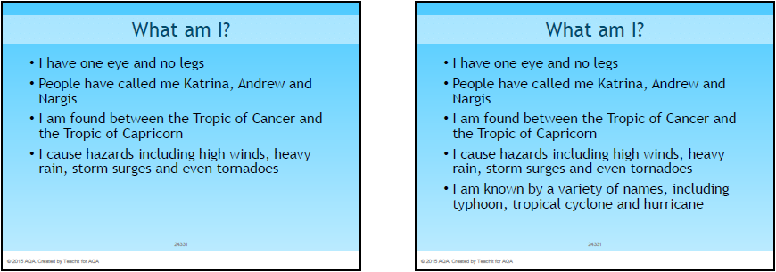

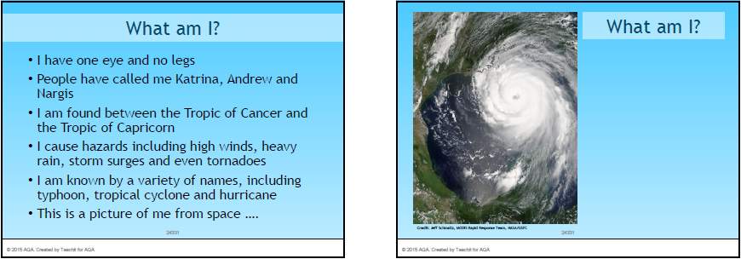
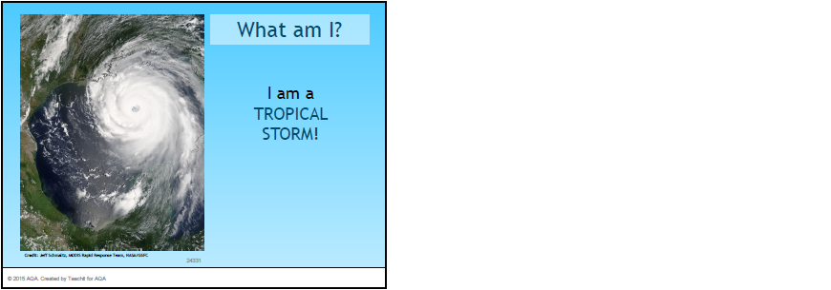

The World

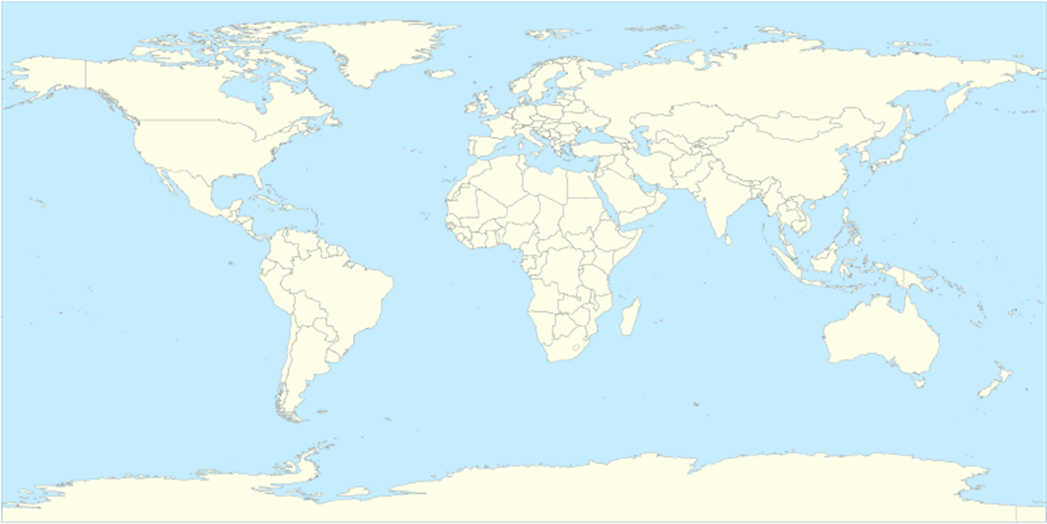

Map used courtesy Gringer, released into the public domain via Wikimedia Commons.

The World
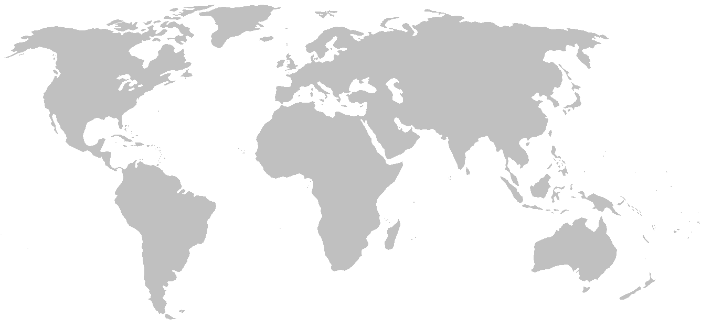

Map used courtesy of E Pluribus Anthony, released into the public domain via Wikimedia Commons.

We’ve included a screenshot of the PowerPoint slides here so you can see the resource. To access this resource please go to the Teachit Geography AQA Tropical storms page.

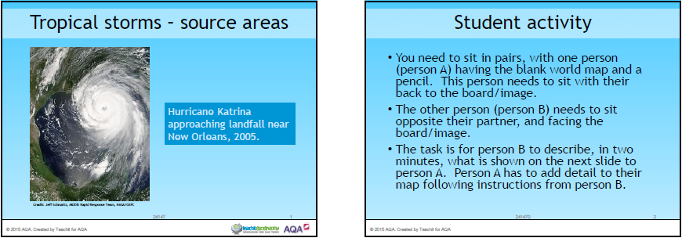

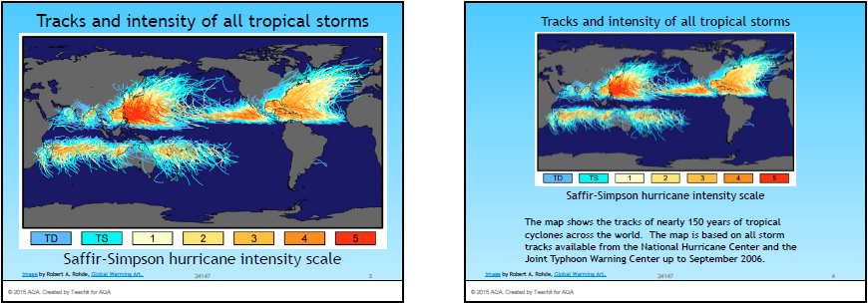

Hurricanes are the most violent storms on the planet and cause tremendous destruction. They are also called tropical storms, typhoons or cyclones, depending on their geographical location, e.g. tropical storms which form over the western Pacific Ocean are called typhoons.

Student tasks
- Use an atlas to label the world map below with:
- the Atlantic and Pacific Oceans
- the Tropics of Cancer and Capricorn
- five countries affected by tropical storms i.e. hurricanes, cyclones or typhoons.
- Using the map on the previous page, write a sentence to describe the location of the areas where tropical storms form.

- The image below shows a tropical storm approaching an area of land.

- Use an atlas to label two countries on the image.
- Label the eye of the hurricane.
- Draw an arrow to show the direction that the tropical storm is moving.

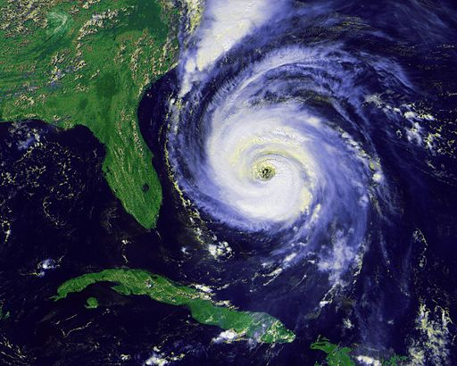
By NOAA / National Climatic Data Center [Public domain], via Wikimedia Commons

We’ve included a screenshot of the PowerPoint slides here so you can see the resource. To access this resource please go to the Teachit Geography AQA Tropical storms page.

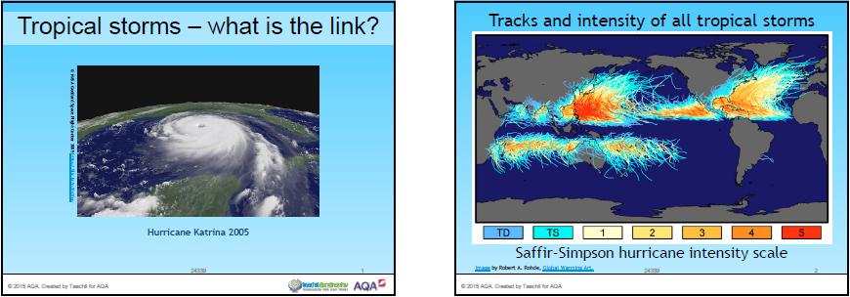

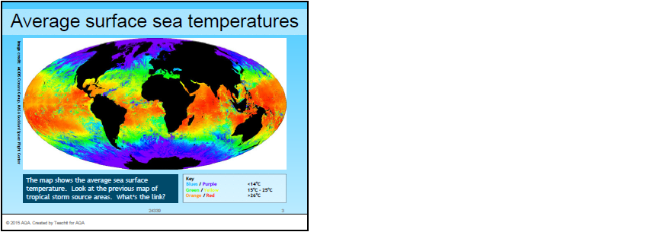

Hurricane Katrina approaching New Orleans on 29 August 2005
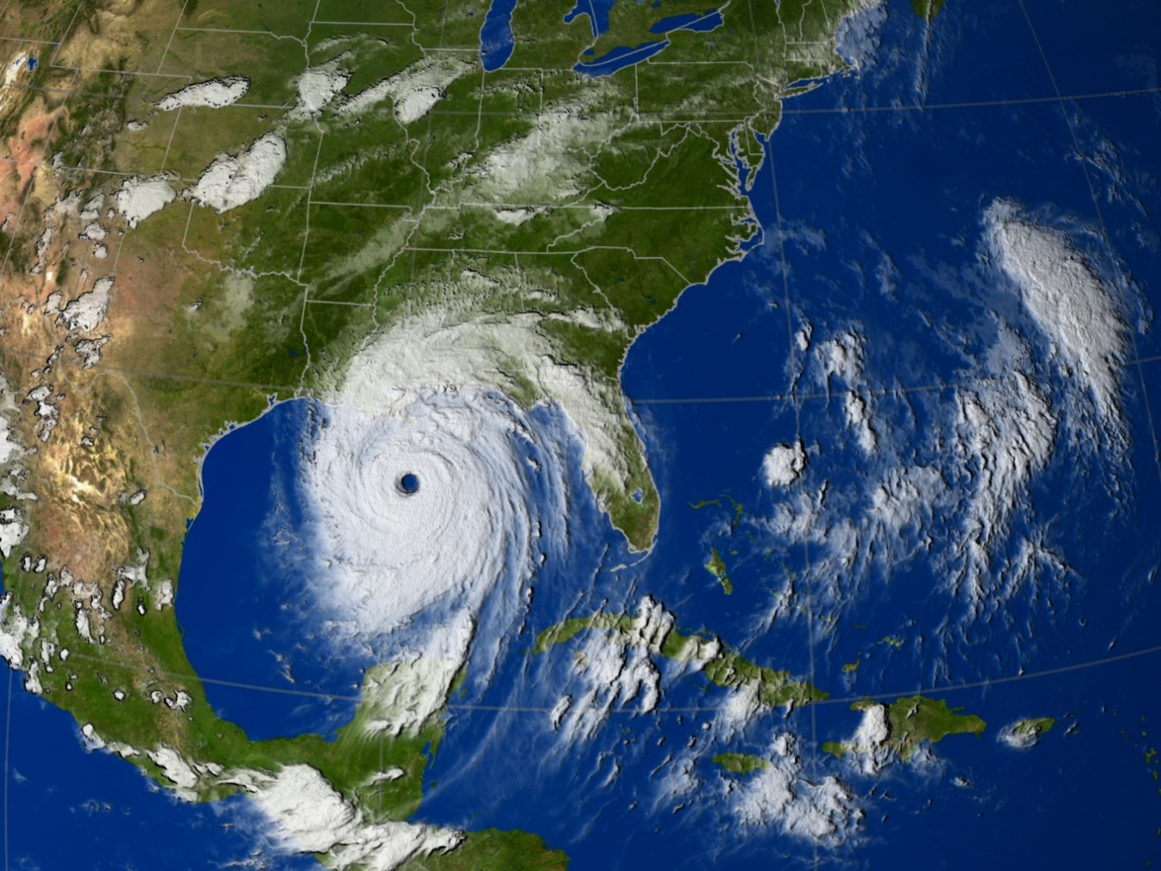
Image used courtesy of NASA/Goddard Space Flight Center Scientific Visualization Studio
Student tasks

- Watch the two NASA videos, Our World: What is a hurricane? at http://pmm.nasa.gov/education/videos/nasa-our-world-what-hurricane and Towers in the tempest, at http://pmm.nasa.gov/education/videos/towers-tempest.
- Using the information from the video clips, number the boxes below in the correct order, for the formation of Hurricane Katrina.
- Cut the boxes from this page, glue them around the image and arrow them to their correct position on the satellite image of Hurricane Katrina approaching New Orleans in August 2005.

Number:  Surrounding the eye are bands of heavy rain and very high winds. | Number:  Warm, humid air rises, cools and condenses to form clouds. More air spirals in to fill the gap left from the rising air. | Number:  Air descends at the centre of the hurricane. The eye is an area of calm conditions with a ring of clouds surrounding it.
Number:  All tropical storms take their distinctive, anticlockwise spiralling shape because of the Coriolis Force, generated by the rotation of the Earth. | Number:  The warm air continues to rise and sucks in more air. | Number:  Hurricane Katrina travelled westwards across the Gulf of Mexico; it gained more moisture and its speed increased.

Student task
Find the following ‘tropical storms’ keywords in the wordsearch square below:

cyclone | eye | hurricane | landfall
pressure | rainfall | Saffir-Simpson | storm
storm surge | temperature | tropical | typhoon

o | e | r | g | o | e | e | n | o | l | c | y | c | e | y
w | o | n | a | e | t | r | o | p | i | c | a | l | g | o
s | a | f | f | i | r | s | i | m | p | s | o | n | r | h
e | e | t | e | e | t | u | l | o | r | h | r | n | u | t
k | r | y | i | r | t | l | t | s | e | e | e | r | s | o
h | t | u | e | v | a | a | r | a | e | s | r | d | m | y
w | e | l | s | f | o | h | i | n | r | i | d | t | r | d
t | c | i | d | s | g | y | a | l | c | e | d | t | o | t
o | e | n | n | n | e | l | s | a | e | r | p | f | t | d
b | a | v | r | c | t | r | n | y | s | v | n | m | s | i
l | e | r | t | r | t | e | p | e | t | b | t | o | e | h
r | a | i | n | f | a | l | l | n | o | o | h | p | y | t
e | r | f | e | e | c | d | a | e | r | c | a | t | e | a
a | h | i | u | h | r | k | w | h | m | s | e | n | s | c
a | m | i | t | i | e | b | u | t | n | h | w | n | i | e
Extension task
Write a definition for five of the keywords from the wordsearch.

Hurricanes are the most extreme form of tropical storm. The Saffir-Simpson scale is a 1-5 rating based on a hurricane's sustained wind speed at that time. It can be used to give an indication of the potential damage and flooding.
Category | Wind speed | Description | Diagram
1 | 119-153 km/h | Low level of damage. Roof coverings could be partly removed. Mobile homes and carports could be destroyed. Glass could be broken and people and livestock could be injured or killed by flying debris. Large branches of trees could break. Power cables could be damaged, resulting in power cuts.
2 | 154-177 km/h | Moderate damage. All types of mobile homes and flimsy structures could be destroyed or shredded by flying debris. Roof structures on poorly constructed houses could be ripped off and unreinforced buildings could be damaged.
3 | 178-208 km/h | Extensive level of damage. People and livestock would risk death from flying debris. Older buildings, such as those made of metal could collapse. Windows could be blown out or smashed from flying debris. Trees could become uprooted. Gable ends and temporary structures, such as decking would be destroyed.
4 | 209-251 km/h | Extreme level of damage. Well-built homes can be damaged and poorly built homes can be completely destroyed. Windows from many buildings would be blown out. Signs and fences would be ripped out. Power cuts and water shortages would be significant.
5 | Greater than  252 k/h | Catastrophic level of damage. Complete devastation. People and livestock could be killed even if indoors. Total destruction of homes regardless of age or building type. Damage from flying debris catastrophic. Industrial buildings destroyed. Significant power cuts and water shortages.
Student tasks
- Draw a sketch of one aspect of the damage for each level of the Saffir-Simpson scale.
- Find a case study / example of each of the five levels of the Saffir-Simpson scale.
- What difficulties are there in using this scale for measuring a tropical storm?
- How would you measure a tropical storm? What other factors would you include?

Student tasks
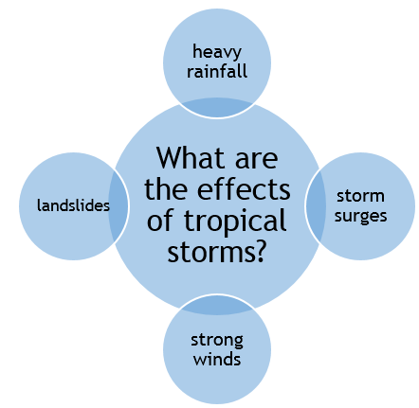
- Use the diagram, What are the effects of tropical storms? to construct five questions.
Each question needs to start with a different word.
The words are:
- What
- Where
- How
- Why
- When
An example of a question is:
How much rainfall fell on New Orleans during the passage of Hurricane Katrina in 2005?
or more specifically:
How high were the storm surges caused by Tropical Storm Haiyan in the Philippines in 2013?

- Your task is to then to find the answers to the questions.
Storm surge: as the area is under less atmospheric pressure, the sea level rises and water is driven onshore by the high winds

More people will be affected if... | Fewer people will be affected if...
Extension activity
Highlight the human factors in red and the physical factors in green.

Higher land | Good communications and warnings
Low wind speed | Storm path was not as predicted
Means to move inland e.g. transport | Sturdy building materials
Low population density | Low lying land
Roads are not blocked | Short and long term aid available
Light weight building materials | High population density
Funnel shaped bays | Lack of communications and warnings
Cliffs on coastline | Low storm surge
Cold air joins, reducing the energy | Lack of aid
Electricity supplies resume quickly | Storm path was as predicted
Coastal location | Strong economy
High storm surge | High wind speeds

We’ve included a screenshot of the PowerPoint slides here so you can see the resource. To access this resource please go to the Teachit Geography AQA Tropical storms page.

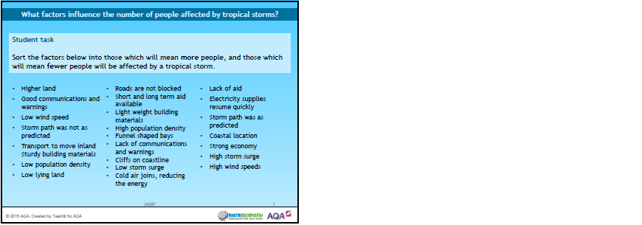

Tropical Storm Haiyan was one of the strongest tropical storms ever recorded, devastating portions of Southeast Asia in November 2013, particularly the Philippines. It was the deadliest tropical storm recorded in modern history in the Philippine, causing landslides, knocking out power lines and communication links, killing at least 6,340 people and injuring many others. The BBC reported that approximately 670,000 people were made homeless.  The Philippines consists of more than 7,000 islands but most of the population is concentrated on only 11 islands. The catastrophic damage caused by Tropical Storm Haiyan was widespread across the Philippines but was considerably worse in some areas. | 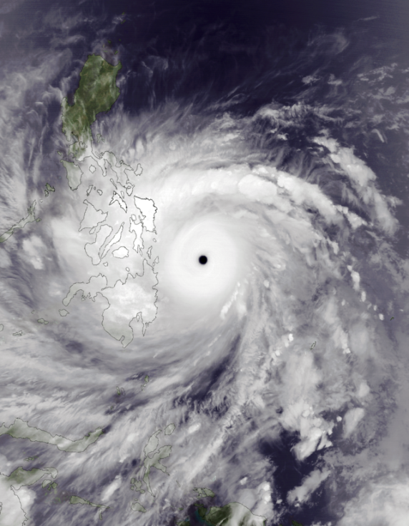  Satellite image used courtesy of NASA via Wikipedia Commons
 | Tropical Storm Haiyan approaching the Philippines on 7 November 2013
Choropleth maps are frequently used in geography. They use different colours or a graduated colour scale to show data in an area or region according to a predefined range of values. The table below can be used to create a choropleth map to show the number of people affected in different areas of the Philippines.
Tropical Storm Haiyan
Area | Number of people affected | Colour on map
Central Luzon | <1000
Caraga | <1000
Southern Tagalog | <1000
Bicol | 1,001- 10,000
Mimaropa - Mindoro | 1,001- 10,000
Western Mindanao | 1,001- 10,000
Northern Mindanao | 10,001 – 100,000
Western Visayas | 100,001 – 500,000
Central Visayas | >500,001
Eastern Visayas | >500,001
Mimaropa - Palawan | No data

Student tasks
- Decide on which colour will represent which range of values. The best order is to go from the lightest colour with the lowest values to the darkest colour with the highest values. The ‘No data’ category should be left blank/white.
- Colour the key for the map accordingly.
- Colour the areas on the map below according to the colours of your key.
A choropleth map to show the number of people affected in different areas of the Philippines

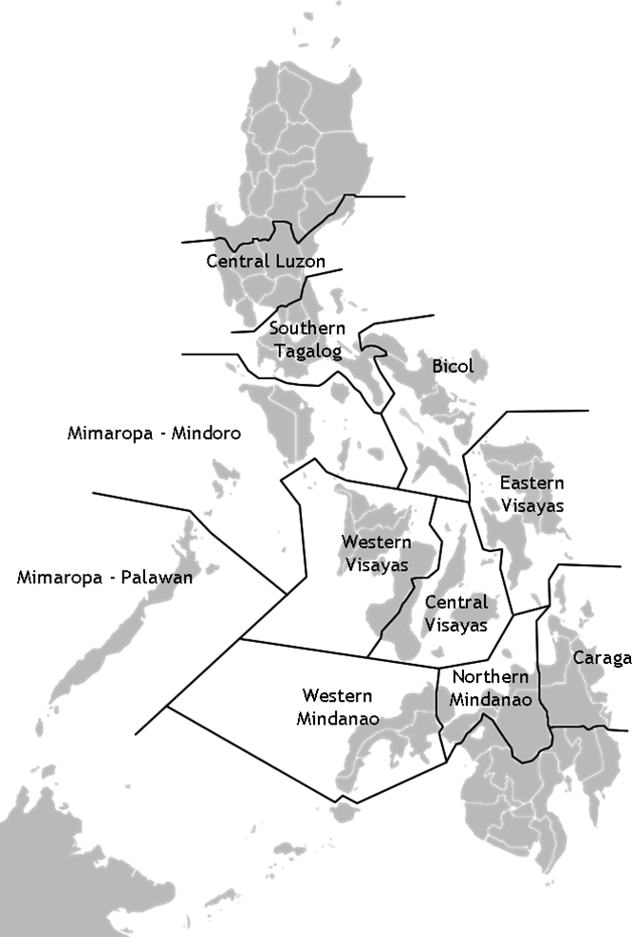
 | Key | Number of affected people
 |  | >500,001
 |  | 100,001 – 500,000
 |  | 10,001 – 100,000
 |  | 1,001- 10,000
 |  | <1000
 |  | No data
Map used courtesy of Photo07, via Wikimedia Commons.
- Use your choropleth map to describe the distribution of people affected by Tropical Storm Haiyan in the Philippines.

- Suggest reasons why different areas had different numbers of people affected.

- What advantages are there in showing this data on a choropleth map?

- What limitations are there when using this data and the choropleth map?

Extension tasks
- The data shows that the eastern and central Visayas areas had the highest number of people affected by the tropical storm. Use the internet to research these two areas. Why do you think these areas had the largest number of people affected by the tropical storm?

- Tropical Storm Haiyan travelled north westwards from the Philippines and made landfall in southern China. Use the map below to calculate how much notice the authorities in China had to prepare for the tropical storm.

Map showing the path of Tropical Storm Haiyan.
The dots indicate the position of the tropical storm at six-hour intervals.
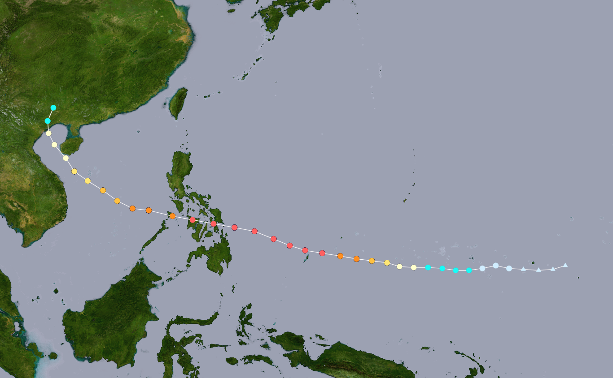
Image adapted from original. Used courtesy of NASA and Meow via Wikipedia Commons

- Explain why the tropical storm ‘died’ when it reached China.

Where?  When? | Primary effects  Secondary effects
Key facts
 | Prediction/Monitoring | Immediate responses  Long term responses

Student task
Use the information on this page to complete the template on the previous page.
Predicted path of the tropical storm | Actual path of the tropical storm | More than 6,000 people reported dead. | Nearly 1,600 evacuation centres set up. | The President of the Philippines requested planes and helicopters from the military. |  | More than 14 million people affected.
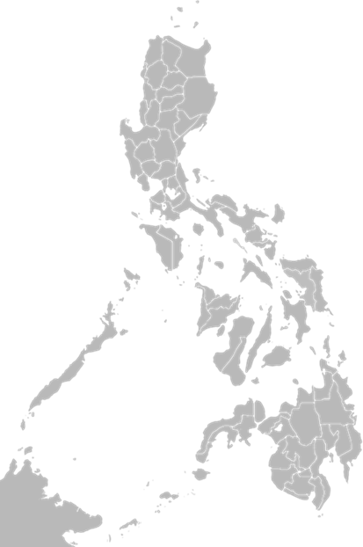 |  | Live electrical wires were immersed in water leading to some electrocutions. | 8th November 2013 |  |  | Mobile phone coverage was lost.
 |  |  | Over 1,000,000 homes damaged, many of which were totally destroyed. |  |  | 8 people died in Tacloban when a wall collapsed in a rice warehouse after people were raiding it for food.
 |  | 6 metre high wave from the storm surge came into Tacloban Bay; the funnel shape of the bay helped increase the height of the wave.
 |  | Haiyan was one of 8 tropical storms to affect the Philippines in 2013. | Tropical Storm Haiyan was called Tropical Storm Yolanda in the Philippines. |  | $20 billion cost to the Philippines (5% of its GNP).
 |  |  | Snakes entered damaged buildings to escape flood waters. | Stagnant water attracted mosquitos and more people contacted malaria.
Extension task
Why does it matter that the predicted path was different from the actual path?
Map from: www.graphatlas.com/philippines_map_blank.png
?
Why is it important to know where the higher populated areas are?
6 million people lost their source of income

Research: witness statements

It was my birthday, 8th November, but there was not much to celebrate as everything has been destroyed. Our livelihoods were from the coconut palms, but three massive waves destroyed the coastal communities and 95% of the trees in our region of Eastern Samar. | It was so windy! It’s was more than 160 km/h on average. Dad said the gusts were the highest he had ever known … about 280 km/h!
We are still in shock. The storm surge was over a metre high! It was like our island of Mangalabang was drowning. There was broken coral from the reefs everywhere. The coral reefs must have been destroyed. With no coral reefs, there are no fish, and with no fish, there is no livelihood for us here. | My home, in Barangy Punta, was destroyed. Most buildings were raised to the ground with just the floor remaining. It was difficult to avoid the flying debris as we tried to find shelter. Many people must have died from the flying debris. The corrugated iron roof of our home was blown off so easily.

I just can’t find out whether my friends and family are safe. There’s no electricity and no phone lines. I want to go to the next village, but the roads are blocked as well. | We will go to Roxas in the morning. It’s larger there so there should be more food and help. I’ve heard they are struggling to cope because of everyone going there and they have no water because of the broken pipes.
It’s horrendous. There’s debris everywhere and dead bodies are being washed up on the shore. We’ve got to identify them and bury them, but we don’t know who to contact, and we are scared that if we leave them where they are, they will spread disease.  The death toll is 3,000 at the moment, but that’s too low. They haven't counted the areas they can’t get to easily, like the smaller islands. It must be double that; over 6,000 must have died at least. | I want to see my family. They are on one of the thousand small islands here. I cannot reach them as all the boats have been destroyed. They couldn't get here, to the evacuation shelters on Cebu. It was just too dangerous and they were no mountains or storm shelters to hide in – nothing to protect them from the wind, water and flying debris.

Research: photographs

- A few palm trees remain standing amid the destruction caused by Typhoon Storm Haiyan in the city of Tacloban, Philippines

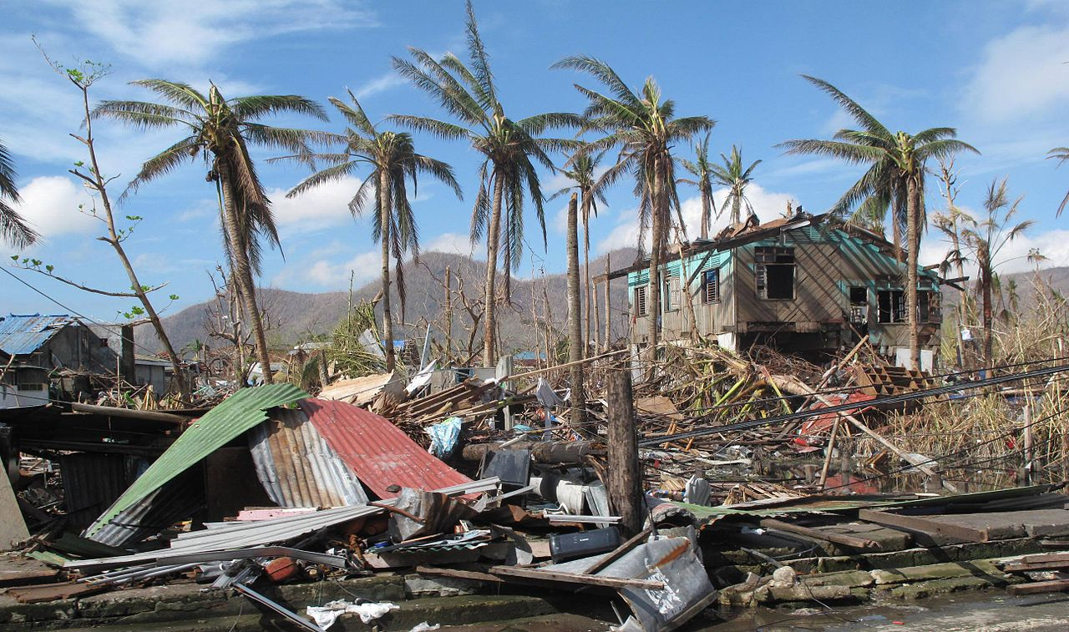
© DFID 2013 https://flic.kr/p/icFUcE

- The remains of a home destroyed by the storm in Tacloban City

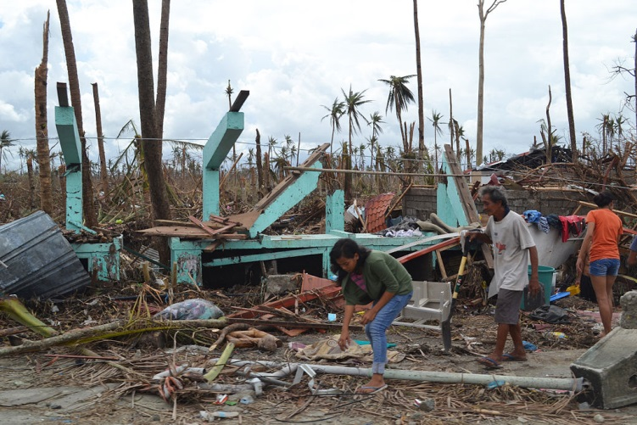
© Trocalre 2013 https://flic.kr/p/hzBGio

Student task
Imagine that you are a reporter; one of the first on the scene after a category 5 tropical storm hit the Philippines. You need to put a news report together from all the witness statements and photographs you took.
To help plan the report, use the table below:
Key facts about the storm and the Philippines
Primary effects (the immediate effect of the tropical storm)
Secondary effects (the indirect effects of the tropical storm)

One of the strongest tropical storms or cyclones ever recorded hit the Philippines in 2013. Large areas of the country were devastated. It was the deadliest typhoon recorded in the Philippines in modern history. The death toll was at least 6,300 people and bodies were still being found three months later.
The following factors may have been responsible for the high death toll:
Causes of the high death toll?
A lack of electricity | Low storm surge
A lack of nearby higher land | Low wind speed
Cliffs on coastline | Many coastal fishing villages
Difficult access to remote communities | No mobile phone signal
Funnel shaped bays | No transport to move inland
High population density | Poor communications
High storm surge | Roads blocked with debris
High wind speeds | Short term aid available
Light weight building materials | Storm path was not as predicted
Long term aid available | Strong economy
Low lying land | Sturdy building materials
Low population density | Warning of the tropical storm

Student activities
- Identify the factors that will have contributed to a high death toll.
- Which single factor do you think caused the most deaths?
- List two other factors that were also important in explaining the high death toll.

Research: witness statements

It was my birthday, 8th November, but there was not much to celebrate as everything has been destroyed. Our livelihoods were from the coconut palms, but three massive waves destroyed the coastal communities and 95% of the trees in our region of Eastern Samar. | It was so windy! It’s was more than 160 km/h on average. Dad said the gusts were the highest he had ever known … about 280 km/h!
We are still in shock. The storm surge was over a metre high! It was like our island of Mangalabang was drowning. There was broken coral from the reefs everywhere. The coral reefs must have been destroyed. With no coral reefs, there are no fish, and with no fish, there is no livelihood for us here. | My home, in Barangy Punta, was destroyed. Most buildings were raised to the ground with just the floor remaining. It was difficult to avoid the flying debris as we tried to find shelter. Many people must have died from the flying debris. The corrugated iron roof of our home was blown off so easily.

I just can’t find out whether my friends and family are safe. There’s no electricity, no phone lines and no phone signal. I want to go to the next village, but the roads are blocked as well. | We will go to Roxas in the morning. It’s larger there so there should be food and help. I’ve heard they are struggling to cope there because of everyone going there and they have no water because of the broken pipes.
It’s horrendous. There’s debris everywhere and dead bodies are being washed up on the shore. We’ve got to identify them and bury them, but we don’t know who to contact, and we are scared that if we leave them where they are, they will spread disease.  The death toll is 3,000 at the moment, but that’s too low. They haven't counted in the areas that they can’t get to easily, like the smaller islands. It must be double that … over 6,000 must have died at least. | I want to see my family. They are on one of the thousand small islands here. I cannot reach them as all the boats have been destroyed. They couldn't get here, to the evacuation shelters on Cebu. It was just too dangerous. There were no mountains or storm shelters to hide in – nothing to protect them from the wind, water and flying debris.

Research: photographs

- A man stands surrounded by the devastation caused by Tropical Storm, Haiyan, in the city of Tacloban.

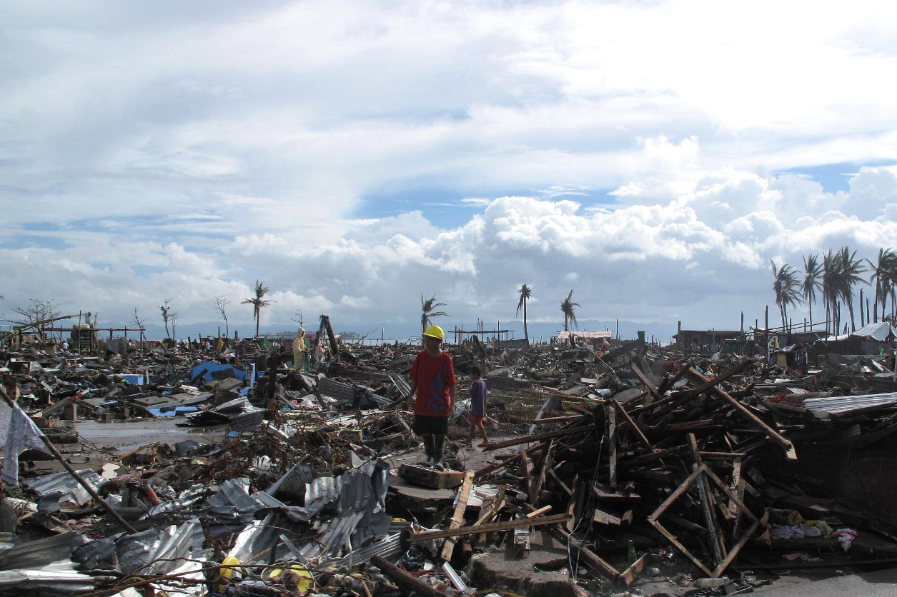
© DFID 2013 https://flic.kr/p/icG9De

- A sign requesting help on a roundabout on the main road into Tacloban.

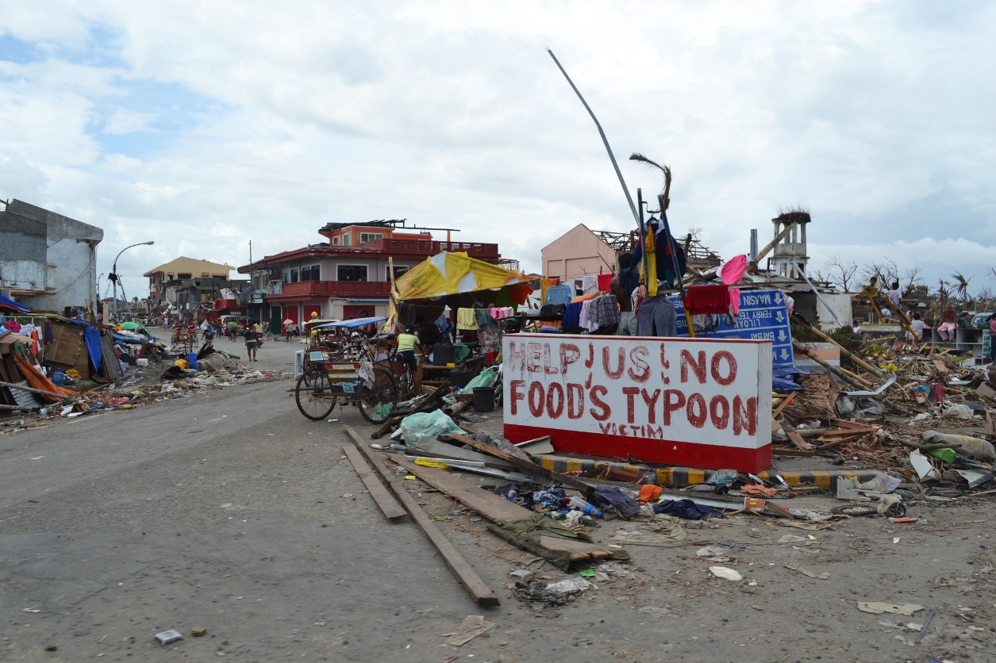
© Trocalre 2013 https://flic.kr/p/pEsxhm
Student task

Use the witness statements and the two photographs to help you design a leaflet for a charity. The leaflet will ask people for donations to help the inhabitants of the Philippines. You will need to be clear what response is needed urgently and what is needed over the long term.
Can you add anything else to the appeal leaflet?
To help plan the report, use the table below:
Response | Urgent (U) or long term (L) | Why is this needed?
Fresh water, food and medication
Treating the injured
Burying the dead
Accessing remote islands
Rebuilding the roads and homes
Mending boats and nets
Expanding storm shelters
Building temporary shelters

Student task
Annotate the image to show why these types of houses would be vulnerable to a tropical storm.

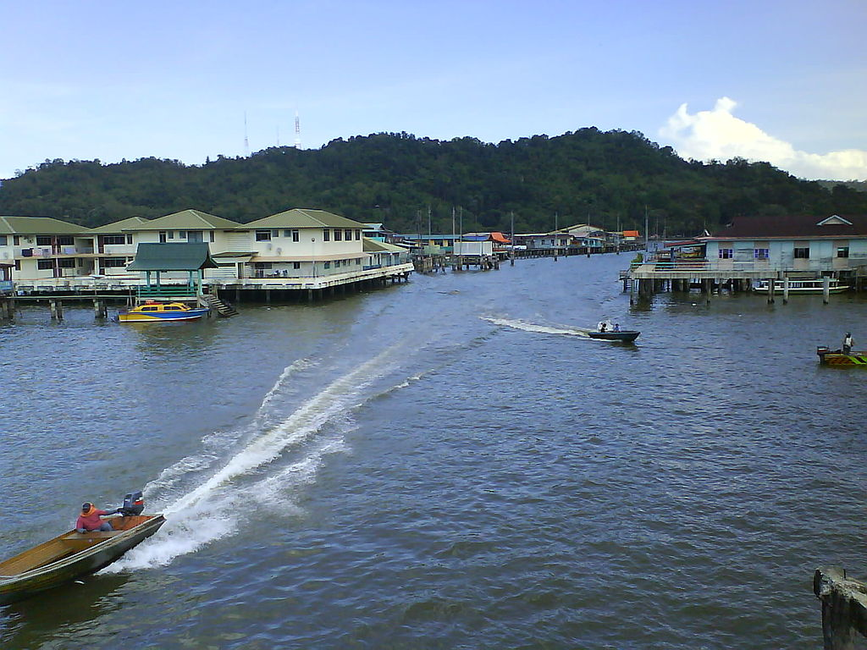

Image place in the public domain by Kurun under the Creative Commons Attribution-ShareAlike 3.0 License
We’ve included a screenshot of the PowerPoint slides here so you can see the resource. To access this resource please go to the Teachit Geography AQA Tropical storms page.

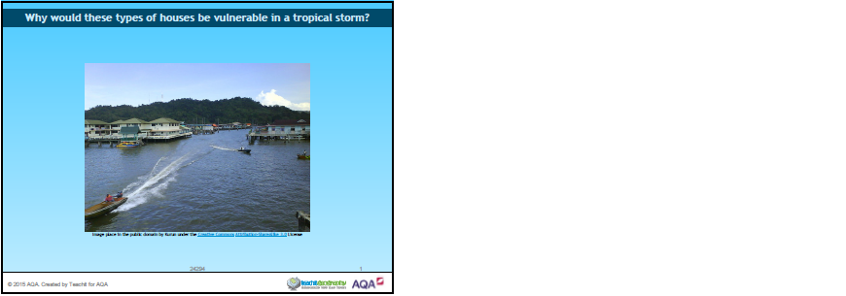

Some authorities suggest that MEDCs have more financial, educational and technological resources to help them deal with the effects of a tropical storm.

Do you think this statement is true? Discuss with your partner the relationship you would expect between how wealthy a country is and what the impact of the tropical storm is.
Is there a relationship between the wealth of a country and the impact of a tropical storm?

We can use data below to investigate these two variables to see if there is a relationship between them.

Tropical storms in 2014
Country | GNI per capita (US $) | Total people affected
China | 6,560 | 10,355,349
Comoros | 840 | 9,511
Guatemala | 3,340 | 100,000
India | 1,570 | 920,000
Japan | 46,330 | 36,721
Korea Rep | 25,920 | 0
Madagascar | 440 | 1,736
Mexico | 9,940 | 69,135
Papua New Guinea | 2,010 | 12,346
Philippines | 3,270 | 9,980,019
Taiwan (Republic of China) | 6,560 | 0
Tonga | 4,490 | 4,014
United States | 53,470 | 834
Vanuatu | 3,130 | 20,006
Vietnam | 1,740 | 48,075

Modified data used courtesy of the World Bank and The International Disaster database.
What relationship could there be?
One method of investigating the relationship between the wealth of a country and the impact of a tropical storm is to draw a scatter graph. This will allow us to see any possible relationship between two variables in a simple way.
Use the graph paper template to draw a scatter graph of the Gross National Income and the number of people affected in the country.
Scatter graph template
Number of people affected (in millions)
10
5
20
40
50
30
60
0
10
Gross National Income per capita (US$ thousands)
Title:

Visualising the relationship
Describe what the scatter graph shows you.

The relationship can also be described in statistical terms. Below are three ways the data might look once plotted on the scattergraph:
Positive relationship  (As one variable goes up, the other variable goes up) | Negative relationship  (As one variable goes up, the other variable goes down) | No relationship

Use the sketches of the three relationship types above to describe what the scattergraph shows us in statistical terms.

Explain why the scattergraph shows this relationship. Give reasons for the relationship you can see.

THE SPEARMAN’S RANK TEST
We now need to see whether this relationship is statistically significant. To do this, we can conduct a statistical test called the Spearman’s rank test.
This test will provide a numerical value between -1 and +1, which gives an indication of the strength of a possible relationship between the Gross National Income and the number of people affected in the country. A value close to zero suggests the lack of a statistical relationship i.e. a random pattern.
The numerical value also confirms the direction of the relationship. A negative value indicates the possibility of a negative relationship between the two variables and the closer the answer is to -1, the stronger the possibility of a negative relationship and vice versa with a positive result suggesting a positive relationship.
The Spearman rank formula is: $r_{s}=1-\frac{6\sum{d^{2}}}{n^{3}-n}$
$$r_{s}$$ | is the Spearman’s rank test result (this result will always be between -1 and +1).
$$d$$ | is the difference between the rank of the gross national income per capita and the rank of the total number of people affected.
$$n$$ | is the number of pairs of data (In this case is 15).
Method

- Assume there is no relationship between the variables.
- State the null hypothesis – that there is no relationship between the two variables
There is no .
- Complete the ranks in the table. Madagascar has been completed for you. Order each column of data separately. A tied rank takes the average value of the ranks that they would have been. Calculate the differences between the ranks.
Answer A
Answer B
Answer C
Answer D
- Square the individual differences.
- Calculate the sum of the d² column ($\sum{d^{2}})$
- Multiply $\sum{d^{2}}$ by 6 (Answer A)
- Calculate n³ = n x n x n (Answer B) 15 x 15 x 15 in this example
- Subtract n from Answer B to give answer C
- Divide $6\sum{d^{2}}$ by (n³ – n) to give answer D
Calculate 1 – the value of answer D to give you $r_{s}=1-\frac{6\sum{d^{2}}}{n^{3}-n}$

Country | GNI  per capita (in US $) | Rank | Total affected | Rank | d | d²
China | 6,560 |  | 10,355,349
Comoros | 840 | 2 | 9,511
Guatemala | 3,340 |  | 100,000
India | 1,570 | 3 | 920,000
Japan | 46,330 |  | 36,721
Korea Rep | 25,920 |  | 0 | 1.5
Madagascar | 440 | 1 | 1,736 | 4 | -3 | 9
Mexico | 9,940 |  | 69,135
Papua New Guinea | 2,010 |  | 12,346
Philippines | 3,270 |  | 9,980,019
Taiwan (Republic of China) | 6,560 |  | 0 | 1.5
Tonga | 4,490 |  | 4,014 | 5
United States | 53,470 |  | 834 | 3
Vanuatu | 3,130 |  | 20,006
Vietnam | 1,740 | 4 | 48,075

$$\sum{d^{2}}$$ |  | n³ - n
$$6\sum{d^{2}}$$ |  | $$\frac{6\sum{d^{2}}}{n^{3}-n}$$
n³ |  | $$r_{s}=1-\frac{6\sum{d^{2}}}{n^{3}-n}$$

The Spearman rank formula is: $r_{s}=1-\frac{6\sum{d^{2}}}{n^{3}-n}$ $=$
Calculation answer
What is your $r_{s}$value? The result should be between -1 (a perfectly negative correlation) and +1 (a perfectly positive correlation) The nearer to 0, the weaker the correlation. If your number exceeds the range -1 to +1 then there is a mistake in the calculation.

Significance
We need to know how statistically significant this answer is. Is it close enough to either +1 or -1 to be called a correlation?
With 15 pairs of data the critical value, which it needs to exceed, is 0.44. Place your $r_{s}$ result on the line below:
-1 |  | 0 |  |  | +1
Significant |  | Not significant |  |  | Significant
 | -0.44 |  |  | +0.44

Look at the area where your $r_{s}$ result falls. Is your result significant or not significant? Return to your hypothesis and if the result is not significant, you need to accept the null hypothesis you wrote. If it is significant, you need to conclude an alternative hypothesis, that there is a significant relationship between the two variables.

Extension tasks
This exercise has only considered the two variables of wealth of country (as measured by GNI per capita) and level of impact (as measured by the number of people who were affected by the event).
If you were to extend this study, which other variables could you use to investigate a relationship?
How else could you measure the level of impact?
Teaching notes
The calculations for the Spearman rank activity are provided below:
Country | GNI per capita  (in US $) | Rank | Total affected | Rank | d | d²
China | 6,560 | 10.5 | 10,355,349 | 15 | -4.5 | 20.25
Comoros | 840 | 2 | 9,511 | 6 | -4 | 16
Guatemala | 3,340 | 8 | 100,000 | 12 | -4 | 16
India | 1,570 | 3 | 920,000 | 13 | -10 | 100
Japan | 46,330 | 14 | 36,721 | 9 | 5 | 25
Korea Rep | 25,920 | 13 | 0 | 1.5 | 11.5 | 132.25
Madagascar | 440 | 1 | 1,736 | 4 | -3 | 9
Mexico | 9,940 | 12 | 69,135 | 11 | 1 | 1
Papua New Guinea | 2,010 | 5 | 12,346 | 7 | -2 | 4
Philippines | 3,270 | 7 | 9,980,019 | 14 | -7 | 49
Taiwan (Republic of China) | 6,560 | 10.5 | 0 | 1.5 | 9 | 81
Tonga | 4,490 | 9 | 4,014 | 5 | 4 | 16
United States | 53,470 | 15 | 834 | 3 | 12 | 144
Vanuatu | 3,130 | 6 | 20,006 | 8 | -2 | 4
Vietnam | 1,740 | 4 | 48,075 | 10 | -6 | 36

$$\sum{d^{2}}$$ | 653.5 | n³ - n | 3360
$$6\sum{d^{2}}$$ | 3921 | $$\frac{6\sum{d^{2}}}{n^{3}-n}$$ | 1.16
n³ | 3375 | $$r_{s}=1-\frac{6\sum{d^{2}}}{n^{3}-n}$$ | -0.16

Typhoon Haiyan was one of the strongest tropical storms or cyclones ever recorded, devastating portions of Southeast Asia, particularly the Philippines, in November 2013. Yanna lives in Tacloban, in the Philippines. She has many questions about her future following the recent tropical storms.

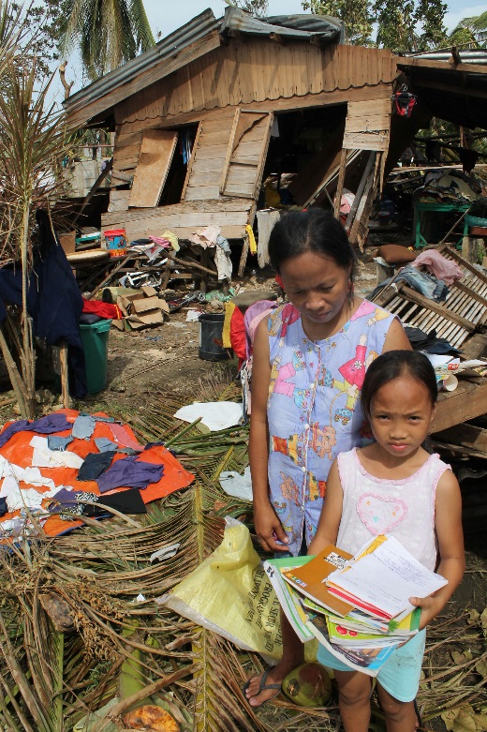  © European Commission DG ECHO 2013 https://flic.kr/p/hwiM6d | - Will the tropical storms come more frequently?  - Will the tropical storms have a greater effect in the future?  - Is it just my country, the Philippines, which will see changes happening?

Student tasks
- Match up the statements to find the answers to her questions and the explanations.

1. Will the tropical storms come more frequently? | Changes will occur globally, though different places will see different effects. | - Warmer seas mean there is more energy to increase the intensity of tropical storms.  - Rising sea levels means that the risk of coastal flooding from storm surges will be greater.  - More people living in coastal communities in the future means that more people will be affected.
2. Will the tropical storms have a greater effect in the future? | It is difficult to say whether the evidence for increased frequency of tropical storms is strong enough. | - The locations of tropical storms may increase as warmer seas mean that the source areas may extend further north and south of the equator. Low-lying coastal communities within the tropics are the most vulnerable especially where the population density is high, and the income level is low.
3. Is it just my country, the Philippines, which will see changes happening? | The effects from tropical storms may increase in the future – they could become more intense and powerful, and effect more people. | - The lack of historical records for the South Pacific makes prediction about frequency harder. Evidence suggests that tropical storms may become more intense due to climate change, though they may not become more frequent.

- Answer either part a, part b or part c.

- Use the information from the table to write a mini information leaflet for Yanna to give to her friends.
The title is – Possible effects of climate change on tropical storms.

The leaflet should include:
  - basic effects of climate change on coastal areas, e.g. the increase in sea surface temperature and the increase in sea level
  - the possible effects of climate change using the sub headings: frequency, distribution and intensity of future tropic storms.

- Using the word bank below, complete the writing frame to show the possible effects of climate change on tropical storms:
Word bank
low | west | south
temperature | frequent | increase
level | size | decrease
less frequent | warmer | darker

Possible effects of climate change on tropical storms

Climate change does affect everyone. Climate change can cause an increase in sea ____________________ and an increase in the ______________________________ of the sea.

Frequency: The evidence says that tropical storms may become more intense but not necessarily more __________________________.

Distribution: Warmer seas mean that the source areas for tropical storms become further ________________ and South of the equator. Higher sea levels mean that more _____________ lying coastal communities will be affected.

Intensity: _______________ seas mean more energy to _______________ the intensity of tropical storms.
- Complete the following sentences. Circle the correct answer in each set of brackets.

Possible effects of climate change on tropical storms

- Climate change [does / does not] affect everyone.
- Climate change can cause [a decrease / an increase] in sea levels and an increase in the [colour/level] of the sea.
- The evidence says that tropical storms may become more intense but not necessarily more [frequent/infrequent].
- Warmer seas mean that the source areas for tropical storms become further [north/west] and south of the equator.
- Higher sea levels mean that [highland / more low-lying] coastal communities will be affected.

- Tick the correct box to show whether each of the following statements is true or false.

 | True | False
Typhoon Haiyan was one of the strongest tropical cyclones ever recorded
Climate change will mean more intense and more frequent tropical storms in the future.
Future tropical storms will only affect the Philippines.

Extension task
In March 2015, Tropical Cyclone Pam devastated the small country of Vanuatu and the government requested US$ 29.9 million in aid from the international community. Vanuatu’s President Baldwin Lonsdale blamed the disaster partly on climate change. Write a letter from the president to the United Nations explaining why he believes that climate change is partly responsible for the devastation.
Teaching notes – suggested answer
1. Will the tropical storms come more frequently? | It is difficult to say whether the evidence for increased frequency of tropical storms is strong enough. | The lack of historical records for the South Pacific makes prediction about frequency harder. Evidence suggests that tropical storms may become more intense due to climate change, though they may not become more frequent.
2. Will the tropical storms have a greater effect in the future? | The effects from tropical storms may increase in the future – they could become more intense and powerful, and effect more people. | - Warmer seas mean there is more energy to increase the intensity of tropical storms.  - Rising sea levels means that the risk of coastal flooding from storm surges will be greater.  - More people living in coastal communities in the future means that more people will be affected.
3. Is it just my country, the Philippines, which will see changes happening? | Changes will occur globally, though different places will see different effects. | The locations of tropical storms may increase as warmer seas mean that the source areas may extend further north and south of the equator. Low-lying coastal communities within the tropics are the most vulnerable especially where the population density is high, and the income level is low.

 | True | False
Typhoon Haiyan was one of the strongest tropical cyclones ever recorded | True
Climate change will mean more intense and more frequent tropical storms in the future. |  | False
Future tropical storms will only affect the Philippines. |  | False

Start | A system of intense low pressure. | At least 26ºC, and must be warmed to at least 50 metres. | Between 5º and 20º north and south of the Equator.
What is a tropical storm? | What minimum seawater temperature is required? | Which latitudes are tropical storms found in? | Why are tropical storms not found on the Equator?
The spinning effect on the earth (Coriolis effect) is not strong enough. | West to northwest. | Tropical depressions – areas of low pressure where warm air rises. | 118 km/h.
Which direction do tropical storms mainly move in? | What is the first stage of a tropical storm? | What wind speed is required for the classification of a tropical storm? | How are tropical storms measured?
The Saffir-Simpson scale places them into one of five categories of disaster. | In the summer and autumn when sea temperatures are at their highest. | The air cools, condenses and releases latent heat. This powers the tropical storm. | The cooler, denser air sinks and conditions are calmer.
When are tropical storms most likely to occur? | What happens as air rises over the sea? | What happens in the eye of a tropical storm? | Finish

- Study Figure 1 which shows average physical exposure to tropical storms.
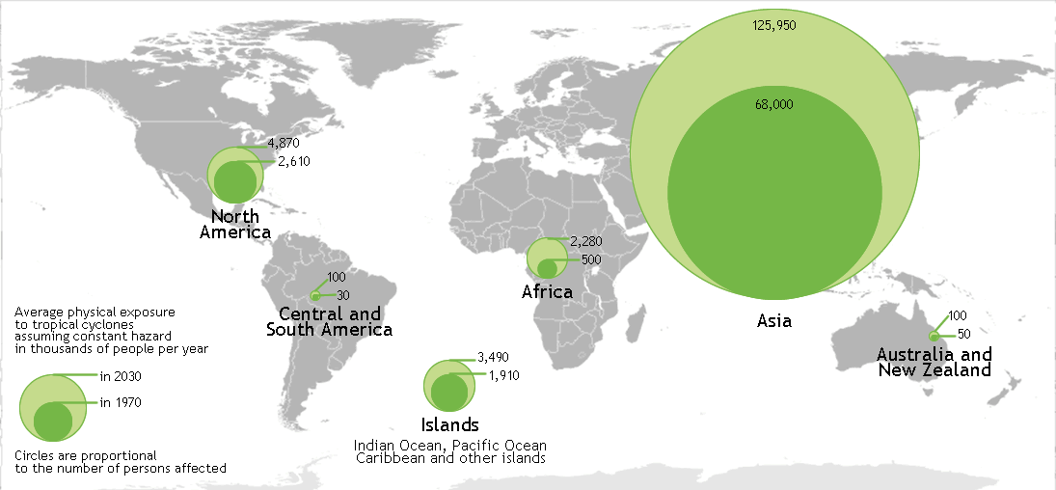
Figure 1
Complete the following paragraph. Use figure 1.
The highest number of people exposed to tropical storms is within the continent of ________________. The Islands areas, including islands in the Indian Ocean, Pacific Ocean etc. in 1970, had ________________ thousand people per year exposed to tropical storms.
[2 marks]

- Give one way that climate change may affect tropical storms in the future.

[1 mark]

- Study figure 2a and 2b, which show some immediate responses to a tropical storm.
Figure 2a Figure 2b
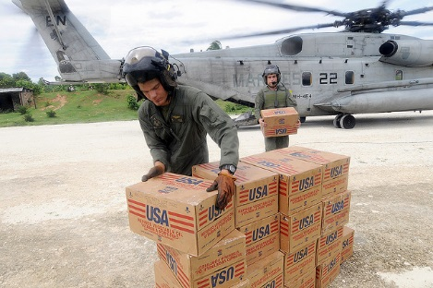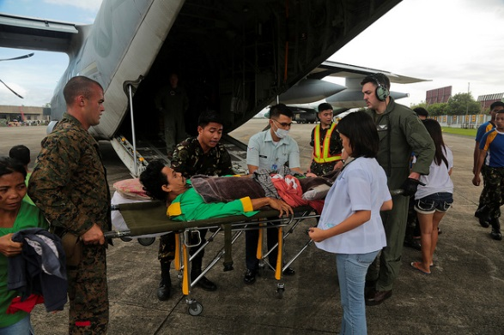
Using figures 2a and 2b only, describe two characteristics of the immediate short-term response to the tropical storm.
Characteristic one:

Characteristic two:

2 x 2 marks [4 marks]
- Describe the primary and secondary effects of a tropical storm.

[9 marks] + 3SPaG

END OF QUESTIONS

Image credits:
Page 1: Figure 1: Map created from image in the public domain http://commons.wikimedia.org/wiki/File:BlankMap-World6-Equirectangular.svg. The file is made available under the Creative Commons CC0 1.0 Universal Public Domain Dedication.
Page 2: Figure 2a: © Marion Doss 2007 https://flic.kr/p/5Enrfz
Figure 2b: © DVIDSHUB 2013 https://flic.kr/p/hvLbqA

Acknowledgement of copyright-holders and publishers
Permission to reproduce all copyright material has been applied for.
In some cases, efforts to contact copyright-holders have been unsuccessful and Teachit Geography will be happy to rectify any omissions of acknowledgements in future if notified.
Other images used in this teaching pack are listed as being in the public domain. Users are advised to make their own copyright assessment and to understand their rights to fair use as required.

