Teaching notes

This activity was planned for AQA’s Britain: health and the people component.
The activities could be used in class or as an independent homework (all web links are provided within the document, in case of the latter). The extension questions have been included to allow a degree of differentiation, although the overall approach in this resource is aimed at the slightly more able student.

Starter answers

- I
- F
- H
- G
- C
- A
- D
- B
- E

A note about web links

The web links below (also included in the main task sheet) allow students to access two short, relevant videos. They could be played to the whole class, or accessed individually by students. They were correct and working at the time of publication but should be checked prior to teaching.

- vimeo.com/16976640

- youtube.com/watch?v=WjlHW_-4uEY

Student information and task pack
Task 1: Diseases and immunisation
By the time they start school, most young people in the UK have been vaccinated against the diseases in the left hand column of the table. Can you draw lines to link the disease with the symptoms? Vaccination is also known as immunisation.
Diseases vaccinated against | Symptoms of the disease
- tetanus  In 2005 a tetanus epidemic was discovered amongst survivors of the Boxing Day Tsunami in Indonesia. | - can be a serious condition – cold-like symptoms, high temperature, sensitivity to light, fever
- whooping cough  There was an epidemic in California in 2010 - 10 babies died. | - also known as German measles, a viral infection that used to be common in children
- polio  2,400 deaths in New York were caused by polio in 1916. | - very serious infection of the meninges (protective membranes) that surround the brain and spinal cord
- influenza type b  This strain is less likely to cause epidemics but can spread from human to human in large numbers. | - contagious viral infection that used to be common in children - most recognisable by painful swellings at the side of the face
- meningitis  303,000 people died worldwide from this disease in 2013. | - cause of severe diarrhoea among infants and young children
- measles  In February 2015 there was a measles epidemic in California. | - potentially fatal, contagious bacterial infection that mainly affects the nose and throat
- mumps  This disease no longer causes epidemics – because of immunisation. | - flu virus that can cause respiratory problems, fever and stomach symptoms
- rubella  There were regular epidemics of rubella in the USA during the 1960s. It is controlled now, due to immunisation. | - affected children worldwide, causing paralysis and death
- rotavirus  This disease can still produce epidemics, especially in less developed countries. | - usually occurs when a flesh wound becomes contaminated

Task 2: How immunisation works
Follow the link below to watch a short animation about how immunising people with vaccines can help prevent widespread epidemics of the diseases:
- vimeo.com/16976640

Jot down answers to the following questions:
- How can vaccines be made?
- What are antibodies?
- How else can immunity be achieved?

Task 3: Jenner’s discovery
Look carefully at the picture. The man in the centre, with the long black coat and the grey hair, is Edward Jenner. Read the brief outline of Jenner’s life and career below and then try the questions which follow:
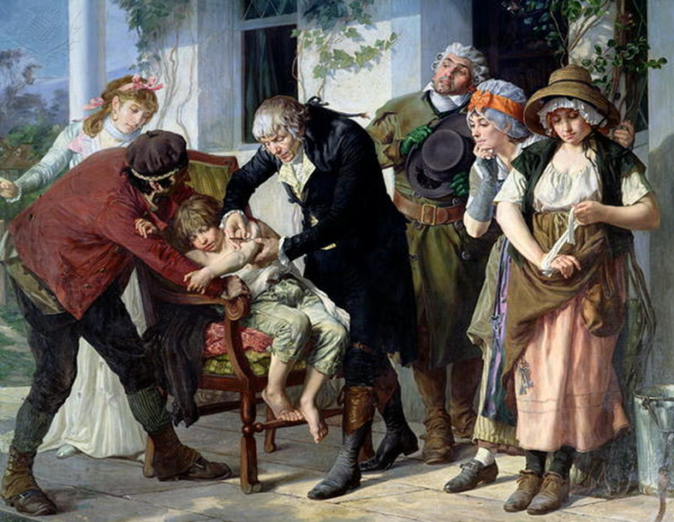
Edward Jenner / CREDIT: Gaston Melingue / Bridgeman Art Library / Universal Images Group / COPYRIGHT: © Bridgeman Art Library / For Education Use Only. This and millions of other educational images are available through Britannica Image Quest. For a free trial, please visit www.britannica.co.uk/trial

Edward Jenner (1749 - 1823)
Edward Jenner was born on 17 May 1749 in Berkeley, Gloucestershire. He was the eighth son of the Reverend Stephen Jenner. He went to school near Cirencester where he was inoculated for smallpox. At age fourteen he was apprenticed to a local surgeon for 7 years. He then worked in London as an apprentice surgeon. In 1773 he returned to Berkeley where he worked as the local, family doctor.
In 1796 Jenner carried out an experiment on James Phipps who was eight years old. Jenner scraped pus from a cowpox pustule on the hand of a milkmaid called Sarah Nelmes. He then inserted it into a cut on James’ arm. He was testing the commonly held idea that milkmaids who suffered the mild disease of cowpox never contracted smallpox, one of the deadliest diseases of the time. Jenner went on to prove that Phipps was indeed immune to smallpox. He wrote up his experiment for the Royal Society in 1797 but was told he needed more proof. So, Jenner experimented on 23 other children, including his own 11-month-old son! Eventually it was accepted that the process worked and Jenner named it vaccination, after the Latin for cow – vacca.
Jenner was criticised widely. Many believed it was disgusting and ungodly to inoculate someone with the pus of a diseased person. A cartoon published in 1802 showed vaccinated people sprouting cow's heads. But the protection vaccination provided eventually won out. In 1840 the British government banned inoculation and provided vaccination with cowpox free of change. Jenner became famous – he gave up practicing ordinary medicine and set up the Jennerian Society which aimed to eradicate smallpox. He died from a stroke on 26 January 1823. Smallpox was declared an eradicated disease by the World Health Organisation in 1979.

Questions
- Who is the young boy slumped in the chair?
- Describe what Jenner is doing to the boy.
- How was what Jenner is trying in the picture different from previous inoculation practices?
- Look carefully at the woman at the far right of the picture, the one with the brown hat, wrapping a bandage around her wrist. Who is she? What role do you think this woman might have played in the events shown in the painting?
- By carrying out this procedure, what was Jenner hoping to prove?
- Jenner had invented vaccination. Why did he choose this particular word?

Extension
How useful do you think the painting might be to a historian researching the history of disease and medicine? What does it tell you / suggest to you? What can’t it tell you?
Task 4: Reaction to Jenner’s work
Look closely at the cartoon below. It was drawn by a famous artist called James Gillray who shows Jenner wearing the red coat.

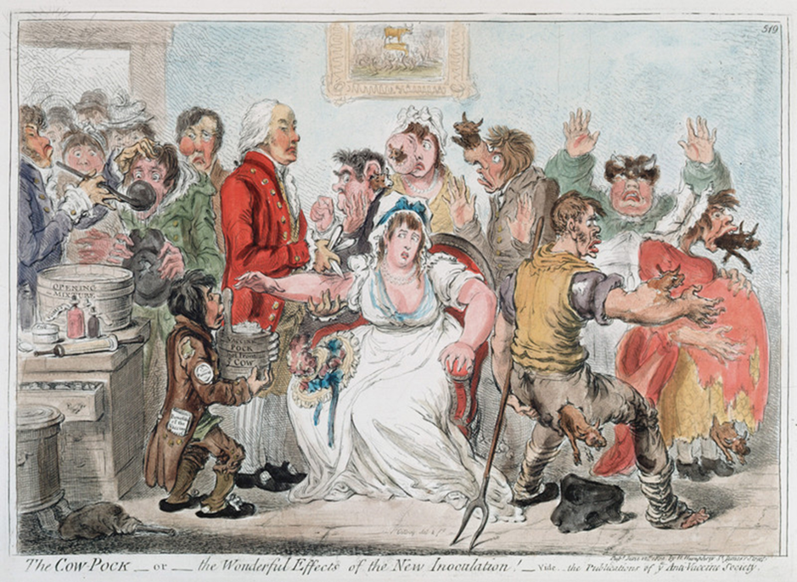
Gillray cartoon on vaccination against Smallpox using Cowpox serum, 1802. In 1796 the English physician Edward Jenner (1749-1823) proved efficacy of practice, but opposition continued for a while. Hand-coloured engraving / CREDIT: Universal History Archive/Universal Images Group / COPYRIGHT: © Universal Images Group / For Education Use Only. This and millions of other educational images are available through Britannica Image Quest. For a free trial, please visit www.britannica.co.uk/trial

Questions
- Describe what you can see happening in the cartoon.
- Do you think Gillray was in favour of the cowpox vaccine or do you think he is being critical? Explain your answer by referring to the cartoon.
- List 4 ways in which the Gillray cartoon would be useful to you as a historian researching the life of Edward Jenner.
Follow the link below to watch a short video about opposition to Jenner. Write a list of reasons why people disliked Jenner’s discovery.
- youtube.com/watch?v=WjlHW_-4uEY
Task 5: Making some judgements about Edward Jenner
Use all the materials and information you now have about Edward Jenner and his work to provide some brief responses to the following statements. You should explain the judgements you are making by referring to evidence from your reading.
Statement | Judgement/evidence
Jenner’s work on vaccinations and cowpox had a positive impact on the lives of people in the early 19th century.
Not everyone agreed with Jenner’s ideas.
Jenner’s work was a significant change from how people had tried to prevent disease before.
Jenner’s work affected the lives of people long after he had died.

Extension
Can you think of any modern examples that illustrate concerns about the use of vaccinations?
Use the frame below to design a poster that would encourage people in the early 19th century to be vaccinated against smallpox.

