Source pack

Source A
Bread riots in Richmond, Virginia, April 1862

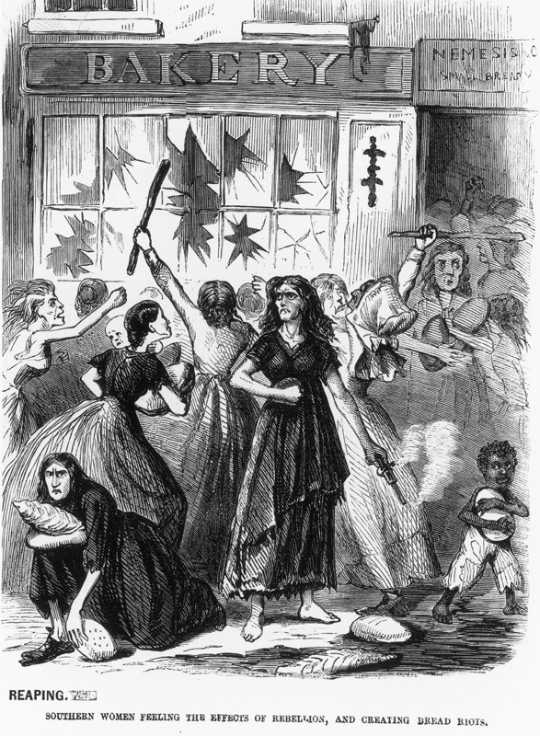

American Civil War / Credit: Fotosearch / Archive Photos / Getty Images / Universal Images Group / Copyright © Getty Images / For Education Use Only. This and millions of other educational images are available through Britannica Image Quest. For a free trial, please visit www.britannica.co.uk/trial

Source B
Shelling disrupts a ball, 1861

‘In Petersburg, Virginia, people, although in daily danger, entertained as if no war was going on. I attended a ball at the house of Mr Johnson and while it was going on, two twelve-inch shells fell and exploded in the front yard, throwing dirt over the guests who were in the garden, but only stopping the dance for perhaps five minutes. People paid scarcely any attention to the shelling, though several people were killed by it.’

From The Haskell Memoirs by John Cheeves Haskell

Source C
Photograph taken in 1865 showing Charleston, South Carolina

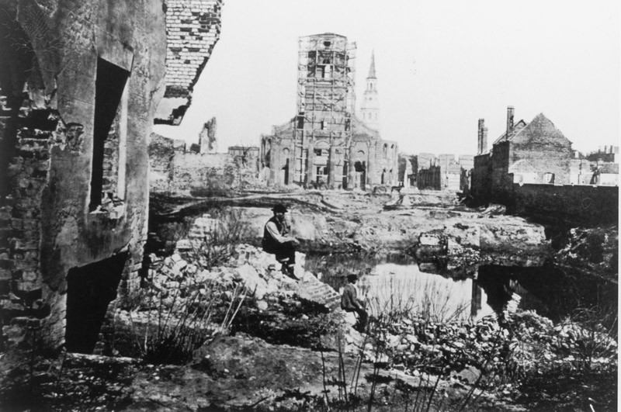

American Civil War / Credit: Fotosearch / Archive Photos / Getty Images / Universal Images Group / Copyright © Getty Images / For Education Use Only. This and millions of other educational images are available through Britannica Image Quest. For a free trial, please visit www.britannica.co.uk/trial

Source D
The recollections of a twelve year old girl from Baton Rouge, Louisiana

‘In those few months of war my childhood slipped away from me. Necessity, duty to others, family pride and patriotism had taken entire possession of my little emaciated* body.’

* ‘Emaciated’ means abnormally thin or weak, especially because of illness or a lack of food.

From Remembering Louisiana, 1850-1871 by Celine Fremaux Garcia
Source E
An image of women filling cartridges in a munitions factory during the American Civil War

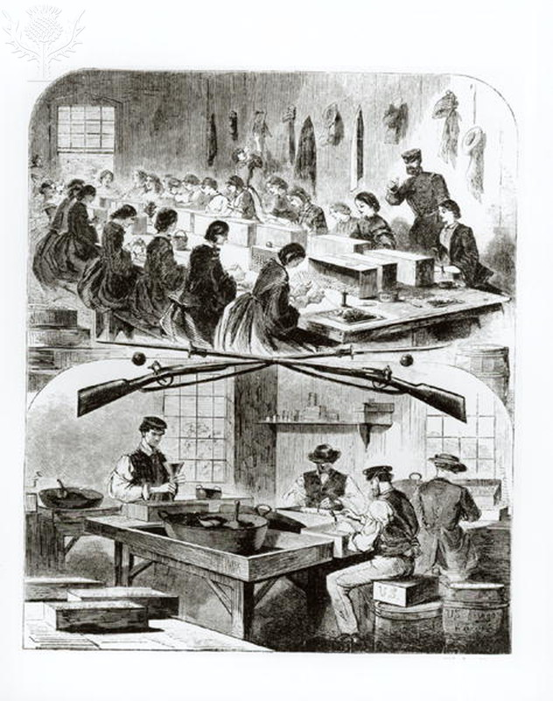
Filling cartridges at the arsenal at Watertown, Massachusetts, 1860s / Credit: Winslow Homer / Bridgeman Art Library / Universal Images Group / Copyright © Bridgeman Art Library / For Education Use Only. This and millions of other educational images are available through Britannica Image Quest. For a free trial, please visit www.britannica.co.uk/trial

Source F
Georgeanna Woolsey, a volunteer nurse, describes her time at a makeshift hospital in Washington D.C. in 1862

‘ We spread mattresses on the marble slabs and put the sickest men there. As the number increased, camp beds were set up between the glass cases in the outer room. We worked for weeks among these men, cooking for them, feeding them, washing them, sliding them along on their tables, while we climbed up on something and made up their beds with brooms, putting powders down their throats, all up and down what seemed half a mile of uneven floor; coaxing back to life some of the most unpromising − watching the youngest and best die.’

From Source Letters of a Family During the War 1861-65 by Georgeanna Woolsey
Source G
Extract from the Richmond Dispatch newspaper, July 1863

‘The state of affairs brought about by the speculation and extortion practiced upon the public cannot be better illustrated than by comparing the prices before the war and at present:

1860 1863
Bacon (10lbs) $1.25 Bacon (10lbs) $10.00
Sugar (5lbs) $ .40 Sugar (5lbs) $5.75
Coffee (4lbs) $ .50 Coffee (4lbs) $20.00
Soap (5lbs) $ .50 Soap (5lbs $5.50’

Source H
Money being offered to volunteers in 1863

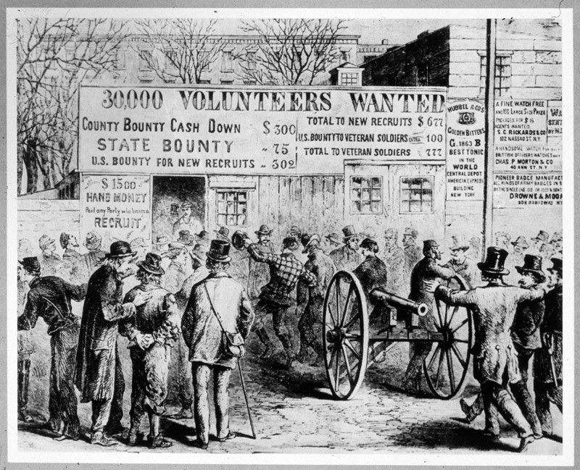

Volunteers Wanted / Credit: MPI / Archive Photos / Getty Images / Universal Images Group / Copyright © Getty Images / For Education Use Only. This and millions of other educational images are available through Britannica Image Quest. For a free trial, please visit www.britannica.co.uk/trial

Source I
The actions of a Southern guerrilla band, fighting behind Union lines

‘ We came upon the corpse of a man hung by his neck over a creek. We learnt from the dead man`s wife that the guerrillas had tried to force him into the Rebel service but his refusal had cost him his life. They hung him like a dog.’

From Under the Flag of the Nation, ed. O. Bond

Source J
Feeding the Union army in Pennsylvania, 1863

‘During our supper some women came rushing in saying – “Oh, good heavens, now they’re killing our fat hogs. Our cows have already gone.” To which General Longstreet replied –“Yes, madam, it’s very sad and this sort of thing has been going on in Virginia for more than two years”’

From the memoirs of a Union officer

Source K
Anti draft riots in New York in 1863 after Congress passed a new conscription law.

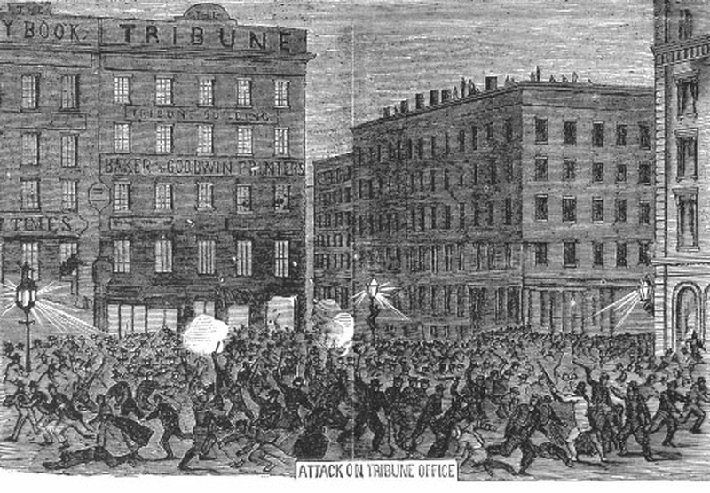
NEW YORK: DRAFT RIOTS, 1863. - A mob of rioters attacking the offices of the 'New York Tribune' during the New York City Draft Riots of 13-16 July 1863. Contemporary American wood engraving. / Credit: The Granger Collection / Universal Images Group / Copyright © The Granger Collection / For Education Use Only. This and millions of other educational images are available through Britannica Image Quest. For a free trial, please visit www.britannica.co.uk/trial

Source L
A Union officer describes what happened when the front line moved.

‘A few yards away was a little log cabin and we saw a woman running from the door with a child in her arms and two or three other children hanging from her dress. In front of them was the rebel line with our line behind them. Halting for just a moment, she started through a little cornfield parallel to us, while musket balls were cutting the corn stalks on every side. But she had a charmed life and soon disappeared in woods to the right.’

Source M
A family leaving their home in the South as the fighting approaches

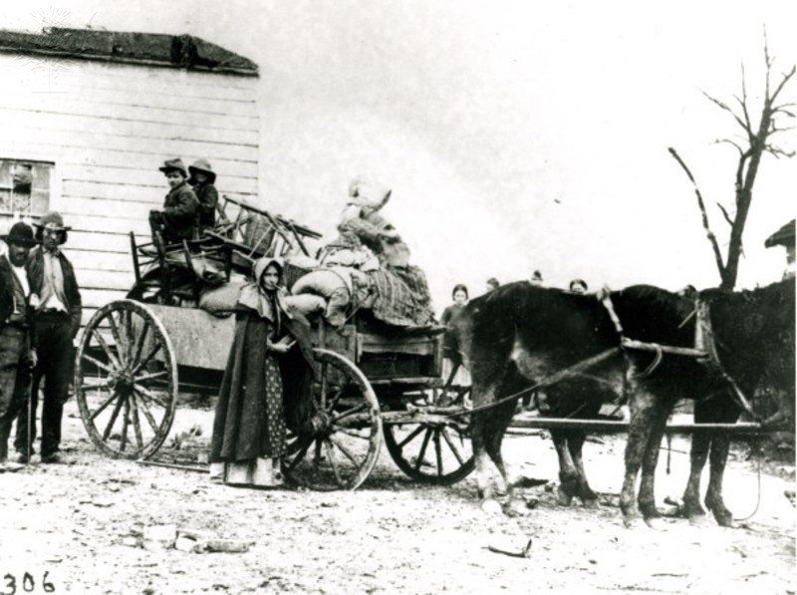

USA, Civil War, refugee family, photo. / Credit: akg Images / Universal Images Group / Copyright © AKG Images / For Education Use Only. This and millions of other educational images are available through Britannica Image Quest. For a free trial, please visit www.britannica.co.uk/trial

Source N
Life in Richmond, Virginia in 1864

‘Some of the people look like vagabonds in ragged clothes; they appear gaunt and pale with hunger. But the speculators and thieving quartermasters look sleek and comfortable. In these times of hardship and destitution I see many men enjoying comfortable positions and looking for investments for their surplus funds.’
Source O
Report from a New York newspaper in March 1865.

‘There never was a time in the history of New York when business prosperity was more general, when the demand for goods was greater than in the last two or three years. Companies have doubled or trebled their dividends to stockholders.’

Source P
1862 woodcut entitled ‘The Influence of Women’

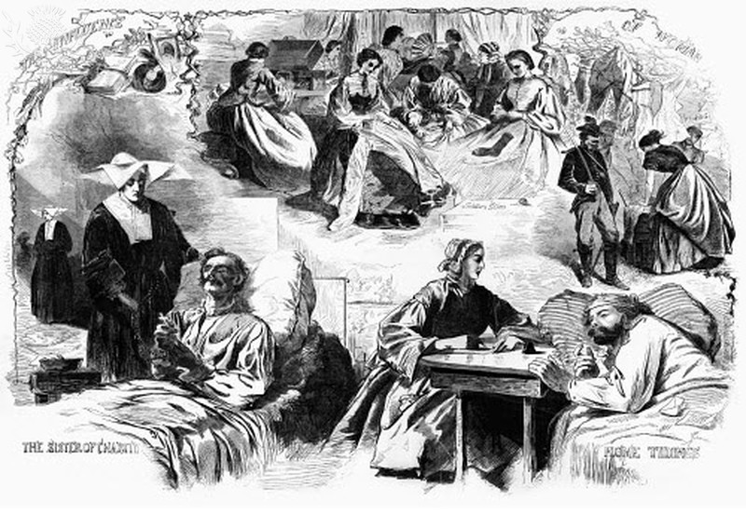

CIVIL WAR: WOMEN, 1862. - 'The Influence of Woman.' Composite of scenes of women sewing and doing laundry for soldiers, a nun visiting a wounded soldier and a woman writing a letter, during the American Civil War. Wood engraving, 1862 / Credit: The Granger Collection / Universal Images Group / Copyright © The Granger Collection / For Education Use Only. This and millions of other educational images are available through Britannica Image Quest. For a free trial, please visit www.britannica.co.uk/trial

Teacher notes

This collection of sources on the home front during the American Civil War can be used for a number of class/group activities:

- Students could work individually or in pairs on an individual source and then present their ideas to the class (perhaps with the source projected on a screen).

- Divide the class into small groups. Each member is given two or three sources to analyse and then reports back to the group on what it tells them about various aspects of life on the home front. They could use one of the analysis sheets on pp.9-10 to record the group’s findings. (N.B. Version 1 of the analysis sheet identifies the main sources to use for each aspect; version 2 allows students to identify the relevant sources for themselves.

- Give the class a statement which they have to verify/qualify in their groups, using the sources (alternatively, each group could be given a different statement).

Eg `Everyone suffered on the home front`
`The lives of women changed the most on the home front`
`All aspects of life were affected on the home front`
`Everyone worked together on the home front to bring about victory`
`The Civil War brought everybody together with a common purpose on the home front`
`The home front was never that dangerous`

- If each group had to pick just six sources (or a number chosen by the teacher) which best summed up the home front, which ones would they be, and why? You could specify that their choice must include a certain mix of picture/text sources.

- Print copies of the pictorial sources with a surrounding blank border so that students can annotate them by picking out the main/relevant features (e.g. what people are doing/their expressions/state of the buildings etc).

Homework task:
The below are relevant websites on the home front during the American Civil War:

library.mtsu.edu/tps/Home_Front_During_the_Civil_War.pdf
www.ushistory.org/us/34d.asp
www.civilwar.org/...civil-war/Children-on-the-Civil-War-Home-Front.html

Students could use these to research the home front and bring back one new piece of information not gained from the provided sources. This could be reported back to their group/class and added to their analysis sheets.
Source analysis sheet: version 1

Topic | Relevant sources | Information gathered
Women on the home front | A, E, F, P
Shortages and inflation | A, D, G, J, N
Children | D, L, M
Dangers | B, I, L,
Law and order | A, E, I, K
Living in a war zone | B, C, H, L, M
Rich and poor | A, B, C, H, M, N, O

Source analysis sheet: version 2

Topic | Relevant sources | Information gathered
Women on the home front
Shortages and inflation
Children
Dangers
Law and order
Living in a war zone
Rich and poor

