Cartoon sources

The following are four cartoons depicting Abraham Lincoln. They offer varied interpretations of him as an individual.
Source A: shows the 1864 Presidential campaign with Abraham Lincoln on the left and his rival, General George McClennan, in his military uniform to the right.

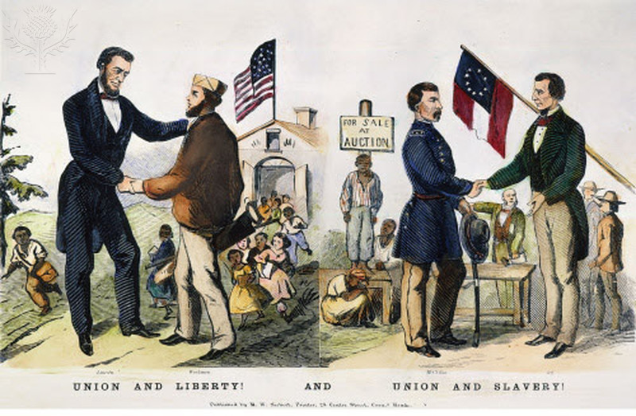
PRESIDENTIAL CAMPAIGN, 1864./nAmerican cartoon from the presidential campaign of 1864 showing the rival candidates, President Abraham Lincoln (Union and Liberty!) and General George B. McClellan (Union and Slavery!)./ Credit: The Granger Collection / Universal Images Group / Universal Images Group / Copyright © The Granger Collection / For Education Use Only. This and millions of other educational images are available through Britannica Image Quest. For a free trial, please visit www.britannica.co.uk/trial

Source B: shows Abraham Lincoln (‘Uncle Abe’) as a cat.
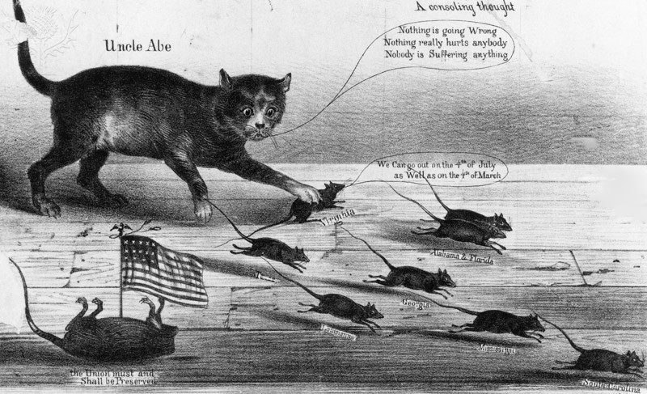
American Civil War / Credit: Fotosearch / Archive Photos / Getty Images / Universal Images Group / Copyright © Getty Images / For Education Use Only. This and millions of other educational images are available through Britannica Image Quest. For a free trial, please visit www.britannica.co.uk/trial

Source C: shows Lincoln as a rail splitter – a reference to his upbringing in a log cabin when he would have split logs to make fences. Two of Lincoln`s supporters are watching him.
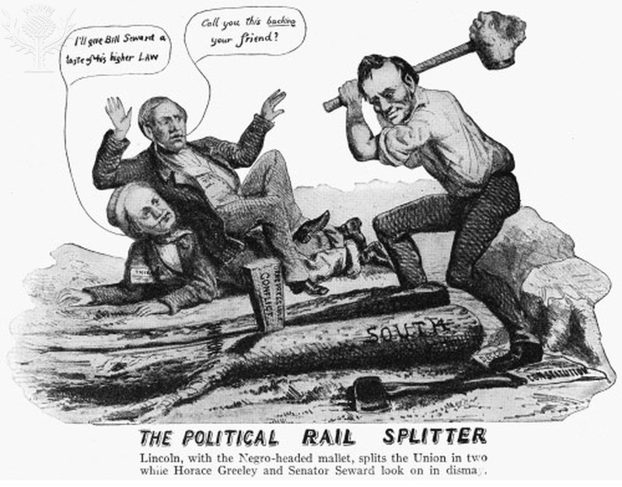
PRESIDENTIAL CAMPAIGN 1860. - An 1860 cartoon showing Abraham Lincoln splitting the Union in two with a slave-headed mallet while Horace Greeley and Senator William Henry Seward look on in dismay./ Credit: The Granger Collection / Universal Images Group / Copyright © The Granger Collection / For Education Use Only. This and millions of other educational images are available through Britannica Image Quest. For a free trial, please visit www.britannica.co.uk/trial

Source D: shows reactions to Lincoln`s inauguration as President in 1861.
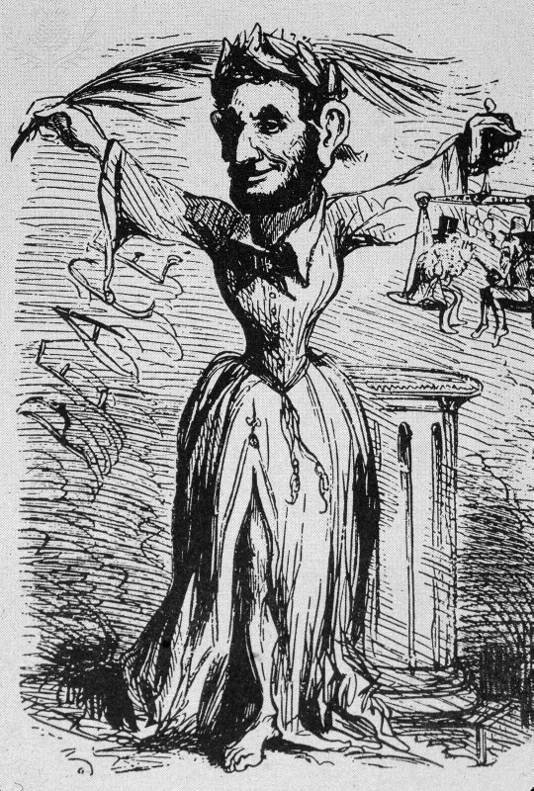
Editorial Cartoon Of Lincoln Inauguration, 1861/ Credit: Kean Collection / Getty Images / Universal Images Group / Copyright © Getty Images / For Education Use Only. This and millions of other educational images are available through Britannica Image Quest. For a free trial, please visit www.britannica.co.uk/trial

N.B. This version of the cartoon has been significantly cropped. The original (which we can’t print due to copyright restrictiond) shows a contrasting reaction to the inauguration speech from that shown here. The full version can be seen here: abrahamlincolnsclassroom.org/cartoon-corner/president-lincoln/the-presidents-inaugural/

Text sources and interpretations
The following are five interpretations of the issues behind the American Civil War.
Interpretation A: From Twenty-Eight Years a Slave, by Thomas Johnson, published in 1909. Johnson was born a slave in 1836 in Virginia where he was bought and sold several times. After the Civil War he was freed and moved north, where he became a church minister and eventually a missionary in Africa.
‘In 1860, there was great excitement over the election of Mr Abraham Lincoln as President of the United States. The slaves prayed to God for his success. We knew that he was in sympathy with the abolition of slavery. The election was the signal for a great conflict in which the question was: Shall there be slavery or no slavery in the United States? The South said: Yes, there shall be slavery.’
Interpretation B: From The Rise and Fall of the Confederate Government, by Jefferson Davis, published in 1881. Davis was the son of a plantation owner who, in 1845, entered Congress for the state of Mississippi. When Mississippi and six other states left the Union and set up their own Confederate government in 1861, Davis was elected as its President.
‘The Confederates fought for the fundamental right to withdraw from a Union which they had, as independent states, voluntarily entered. On reading what has recently been written, people might conclude that the war was caused by efforts on the one side to extend and keep slavery, and on the other to resist it and establish human liberty. The Southern States and Southern people have been represented as "defenders" of slavery, and the North as the champions of universal freedom. This is false.’

Source C: From a speech by George Julian in the American Senate on 14th January, 1862. Julian was a politician, lawyer, and writer who represented the state of Indiana in Congress.

‘This rebellion is a bloody and terrible demonstration of the fact that slavery and freedom cannot live together in peace. I know that it was not the purpose of this administration, at first, to abolish slavery, but only to save the Union, and keep the old order of things. The policy of emancipation has come from the circumstances of the rebellion. I believe the popular demand now is, or soon will be, for the total abolition of slavery as the righteous purpose of this war, and is the only means of achieving a lasting peace.’
Source D: From The Vicksburg Mississippi Daily Whig newspaper, January 1860
‘The people of the South have allowed Yankees* to monopolise trade with its huge profits. We have let the North do all the importing and most of the exporting business for the whole Union. Thus the North has grown more powerful to an astonishing degree, at the expense of the South. It is no wonder that their villages have grown into magnificent towns and cities.’
* Yankees - people from the Northern states of America

Source E: From a letter written by President Abraham Lincoln to Horace Greeley, 22nd August 1862. Greeley was the editor of The New York Tribune newspaper.
‘There are those who would not save the Union unless they could at the same time destroy slavery. I do not agree with them. My overriding object in this struggle is to save the Union, and it is not either to save or destroy slavery. If I could save the Union without freeing any slave, I would do it; and if I could save it by freeing all the slaves, I would do it; and if I could do it by freeing some and leaving other slaves alone, I would also do that.’

Tasks:
- Read sources and interpretations A-E. Underline the key points in each source.

- What does each source/interpretation suggest about what caused the American Civil War?

- How useful is each source/interpretation in helping you to answer the question ‘What caused the American Civil War?’ Think about:

- Who wrote the source/interpretation?
- When was it written?
- What was the purpose of the source/interpretation?
- Who was the audience for the source/ interpretation?

- Why do you think that North and South fought each other in the American Civil War?

Teaching notes

Task suggestions for the cartoon sources (pp.3-6)
- Students (individually or in pairs) should analyse each cartoon to decide if it is for or against Lincoln, or if it is neutral. (N.B. including the latter option could lead to a discussion over whether any cartoon on a political person/topic can be neutral.)
- Students should then explain how the cartoonist puts across their point of view about Lincoln.

Notes on the sources
Source A: Students might, amongst other aspects of the cartoon, comment on:
- The wording at the bottom of the cartoon.
- The different experiences of the African Americans in the background.
- Lincoln being thanked by a working man; McClennan by a slave owner.

Source B: Students might, amongst other aspects of the cartoon, comment on:
- The whole image of the cat (Lincoln) chasing/killing the mice (the Southern states).
- The sarcastic use of the kindly phrase ‘Uncle Abe’ and the unthreatening words he is uttering.
- The mouse in the bottom left hand corner representing the Union that has already been killed/beheaded by the cat.

Source C: Students might, amongst other aspects of the cartoon, comment on:
- Lincoln splitting the Union into two.
- The wedge with ‘conflict’ written on it.
- Lincoln trampling on the Constitution of the United States.
- The slave’s head on the mallet which is driving the ‘conflict’ wedge.
- The dismayed expression of the two onlookers.

Source D: Students might, amongst other aspects of the cartoon, comment on:
- The different expressions on the faces of Lincoln.
- The symbols of ‘Peace’ on the left (the North’s reaction to the speech) − the palm branches and garlands of peace, and scales of justice.
- The symbols of ‘War’ on the right (the South’s reaction) − different Roman dress, appearing as a helmeted warrior standing on a vanquished enemy, in this case, a slave owner.

Task suggestions for the text sources and interpretations (pp.7-8)

The initial tasks are outlined at the bottom of p.8, for you to share with your students.

Hot-seating activity:
A potential follow-up task would be to conduct some dramatic exploration!

- Allocate pairs of students to be Abraham Lincoln and Jefferson Davis.
- Students should argue with each other about why they are going to war.
- This could be further extended by selecting two confident students to continue their debate in front of the whole class.
- The rest of the class could then challenge them both by asking questions.

