From source to the sea - fact sheet

A river is divided up into three sections. These are called the courses. There is the upper, middle and a lower course.



Diagram used courtesy of AQA

A river starts in the upper course. This is usually in an upland or mountain area. This is because mountains receive the highest amounts of rainfall. The point at which a river starts is called the source.

As a river travels downstream, it erodes the landscape. Erosion means it wears away the land and its river channel. The river channel is where a river flows. Other streams and rivers will join it and it will become much wider and deeper. Eventually, a river will reach a sea, ocean or lake. The point at which it enters is called the mouth of the river.

# Waterfalls

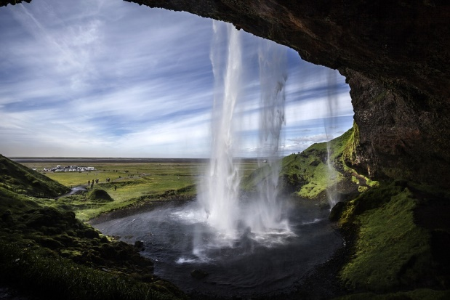Along the river, you can find several geographical features including waterfalls. These are found on the upper course. They form when there are layers of hard and soft rock. The soft rock erodes to create a small waterfall. Over time the waterfall becomes bigger and bigger. The tallest waterfall in the world is Angel Falls in Venezuela. It has reached 987 metres high.

# Meanders

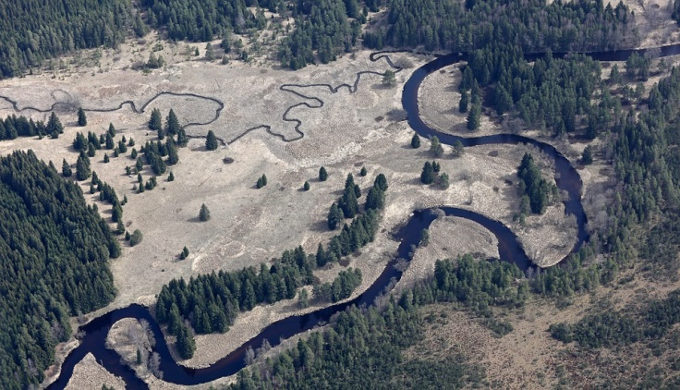A meander is simply a large bend in the river. A meander occurs when water is forced to the outside of bend. Due to the strong force of the water, it wears away or erodes the outside bank increasing the size of the bend. The water flows fastest on the outside edge of the meander causing erosion. The water speed is slowest on the inside of the meander.

# Student tasks – twenty questions

Answer the questions:

1. Which is the largest river in the UK?
2. Name five other rivers in the UK.
3. Name a city or large town located on a river.
4. What is the longest river in the world?
5. What are the three different courses of a river?
6. In what type of area does a river start?
7. Why do rivers start there?
8. What is the start of a river called?
9. What is erosion?
10. Where do you usually find waterfalls?
11. Explain how waterfalls form.
12. What is a gorge?
13. What is the world’s tallest waterfall? How tall is it?
14. Name another waterfall.
15. How does erosion affect the shape of a river?
16. What is a meander?
17. Where is the water flow fastest in a meander?
18. How does a meander form?
19. What is a floodplain?
20. The image below shows a river entering the sea. What is this landform called?

