Student tasks
- The table below shows the 12 largest cities in the world. Use an atlas to complete the country column.

Rank | City | Population | Population  density per km² | Country
1 | Shanghai | 24,256,800 | 3,826 | China
2 | Karachi | 23,500,000 | 6,663 | Pakistan
3 | Beijing | 21,516,000 | 1,311
4 | Delhi | 16,787,941 | 11,320
5 | Lagos | 16,060,303 | 18,206
6 | Tianjin | 15,200,000 | 1,293
7 | Istanbul | 14,160,467 | 2,593
8 | Tokyo | 13,297,629 | 6,075
9 | Guangzhou | 13,080,500 | 1,759
10 | Mumbai | 12,478,447 | 20,680
11 | Moscow | 12,197,596 | 4,859
12 | São Paulo | 11,895,893 | 7,821

- Give two reasons why the population data could be inaccurate. The table is adapted from en.wikipedia.org/wiki/List_of_cities_proper_by_population.

- Use this blank world map and an atlas to plot the locations of these cities.
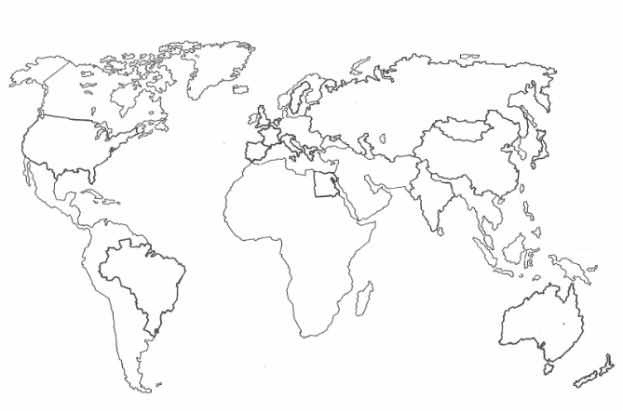
This map has been borrowed from Tombola (Nelson, 1992) by kind permission of the authors, John Palim, Paul Power and Phyllis Vannuffel.

- Do the 12 largest cities of the world appear to be concentrated in a particular continent of the world?

- What similarity can you see about their location?

- How might the rank order of this list change in the future?

Suggested answers
- Countries

Rank | City | Population | Population  density per km² | Country
1 | Shanghai | 24,256,800 | 3,826 | China
2 | Karachi | 23,500,000 | 6,663 | Pakistan
3 | Beijing | 21,516,000 | 1,311 | China
4 | Delhi | 16,787,941 | 11,320 | India
5 | Lagos | 16,060,303 | 18,206 | Nigeria
6 | Tianjin | 15,200,000 | 1,293 | China
7 | Istanbul | 14,160,467 | 2,593 | Turkey
8 | Tokyo | 13,297,629 | 6,075 | Japan
9 | Guangzhou | 13,080,500 | 1,759 | China
10 | Mumbai | 12,478,447 | 20,680 | India
11 | Moscow | 12,197,596 | 4,859 | Russia
12 | São Paulo | 11,895,893 | 7,821 | Brazil

- Suggested answers:
- The population numbers will be in a constant state of natural change.
- The majority of these 12 cities are in LDCs or NICs and will be experiencing a considerable amount of migratory change.
- It is impossible to obtain population data accurate to one person, in real time.
- The Wikipedia data source could be inaccurate / out of date. Data is from en.wikipedia.org/wiki/List_of_cities_proper_by_population.
- The Wikipedia data may have not been typed correctly.

- Nine of the 12 cities are found in Asia. Istanbul is located in both Europe and Asia. Although Russia is also in both the continents of Asia and Europe, Moscow is west of the Urals so is located in Europe.

Rank | City | Country | Continent
1 | Shanghai | China | Asia
2 | Karachi | Pakistan | Asia
3 | Beijing | China | Asia
4 | Delhi | India | Asia
5 | Lagos | Nigeria | Africa
6 | Tianjin | China | Asia
7 | Istanbul | Turkey | Europe/Asia
8 | Tokyo | Japan | Asia
9 | Guangzhou | China | Asia
10 | Mumbai | India | Asia
11 | Moscow | Russia | Europe
12 | São Paulo | Brazil | South America

- The majority of the 12 cities are located on the coast.
- The rank order is difficult to predict. Tokyo is the only city in a HIC and its urban growth has slowed in the last 40 years. Urban growth rates remain high in LICs and NEEs.
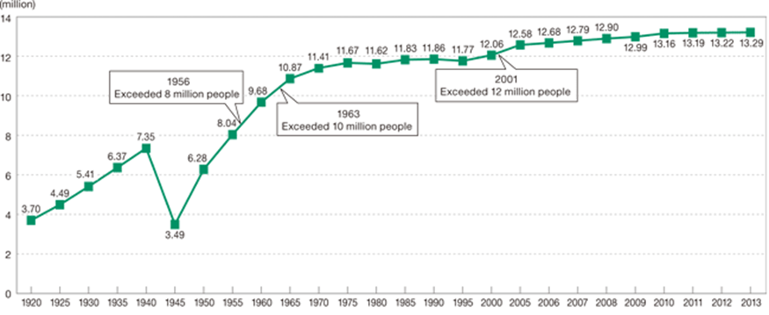
Tokyo historical population since 1920

Graph used courtesy of Matsuyama Mayumi, 2016 under a Creative Commons Attribution-Share Alike 4.0 International license. commons.wikimedia.org/wiki/File:Tokyo_historical_population.gif

