Student task

Gloucester was always a small port, but shipping had to navigate the treacherous tides of the River Severn. In 1827, the Gloucester and Sharpness canal was opened and that significantly increased trade through, and development in, the docks.

As ships have become ever larger since Victorian times, the port of Gloucester has declined in importance. Nowadays, visiting narrow boats, the occasional yacht and other pleasure boats have replaced the working ships and barges and the old Victorian warehouses on the quaysides have been transformed.

What was once a busy working port is now a major tourist attraction, home to Gloucester Quays Designer Outlet, Gloucester Quays Antiques Centre, museums, waterfront bars, restaurants and coffee shops.

Student task

Match the caption to the correct image:

Caption
- Leisure use at Gloucester docks today
- Warehouse converted for flats and offices
- Church for Norwegian sailors at Gloucester docks
- Warehouse and flour mill at Gloucester docks
- Warehouses at Gloucester dock in 1973
- Old warehouse – change of use to an Antiques centre
- A café/bar in a renovated warehouse at Gloucester docks
- Working barges in Gloucester docks, 1999

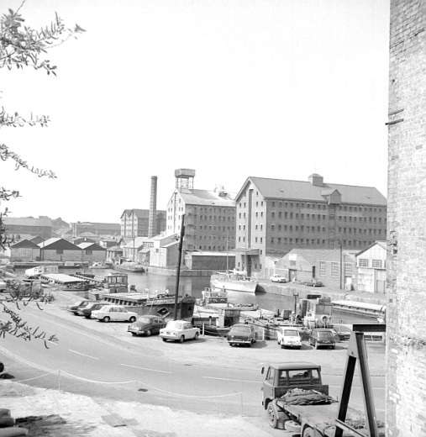
a.

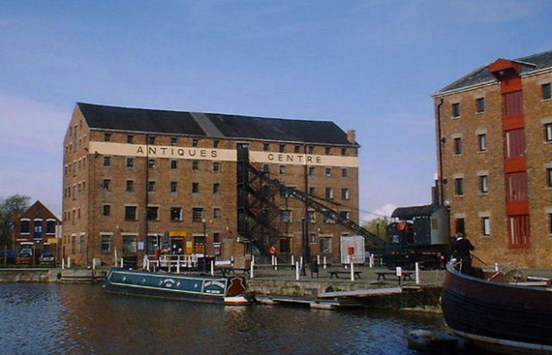
b.

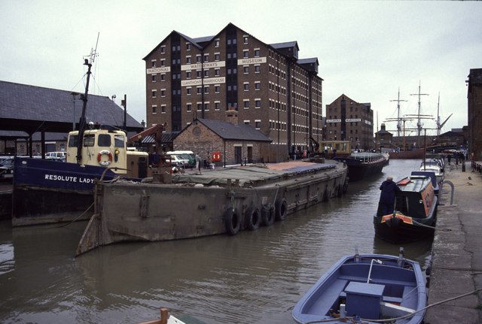
c.

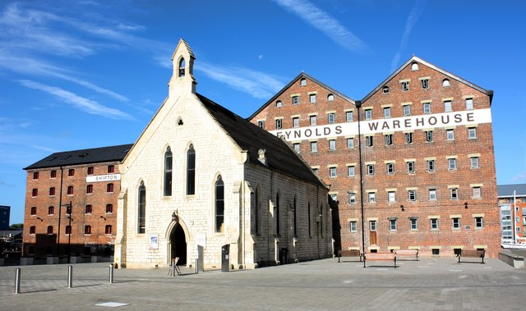
d.

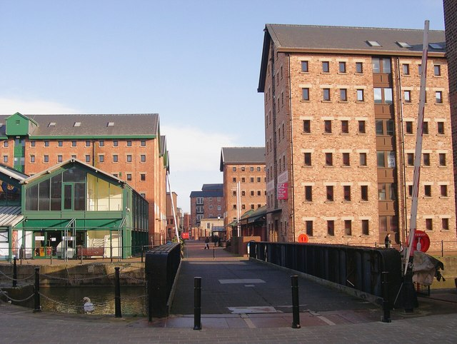
e.

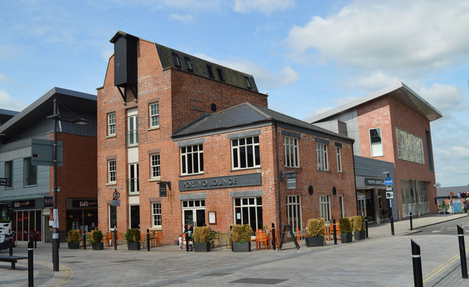
f.

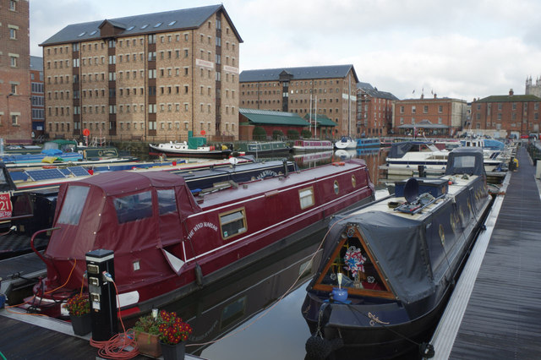
g.

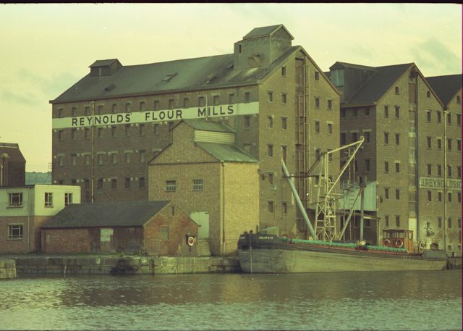
h.

Teaching notes

Image | Caption | Credit | Source
A | Warehouses at Gloucester docks in 1973 | © Copyright Alan Longbottom 1973 geograph.org.uk/reuse.php?id=396263 and licensed for reuse under this Creative Commons Licence | geograph.org.uk/photo/396263
B | Old warehouse – change of use to an Antiques centre 1999 | © Copyright Paul Best 1999 geograph.org.uk/reuse.php?id=276404 and licensed for reuse under thisCreative Commons Licence | geograph.org.uk/photo/276404
C | Working barges in Gloucester docks, 1990 | © Copyright Chris Allen 1990 geograph.org.uk/reuse.php?id=621257and licensed for reuse under thisCreative Commons Licence | geograph.org.uk/photo/621257
D | Church for Norwegian sailors at Gloucester docks | © Copyright Colin Manton 2009 geograph.org.uk/reuse.php?id=2430182and licensed for reuse under this Creative Commons Licence | geograph.org.uk/photo/2430182
E | Warehouse converted for flats and offices at Gloucester docks | © Copyright Philip Pankhurst 2008 geograph.org.uk/reuse.php?id=676710 and licensed for reuse under this Creative Commons Licence | geograph.org.uk/photo/676710
F | A café/bar in a renovated warehouse at Gloucester docks | © Copyright Philip Pankhurst 2014 geograph.org.uk/reuse.php?id=4031575 and licensed for reuse under this Creative Commons Licence | geograph.org.uk/photo/4031575
G | Leisure use at Gloucester docks today | © Copyright Stephen McKay 2014 geograph.org.uk/reuse.php?id=4260723 and licensed for reuse under this Creative Commons Licence | geograph.org.uk/photo/4260723
H | Warehouse and flour mill at Gloucester docks | © Copyright Peter Randall-Cook 1974 geograph.org.uk/reuse.php?id=2142674 and licensed for reuse under this Creative Commons Licence | geograph.org.uk/photo/2142674
All images used under a Creative Commons Licence.

