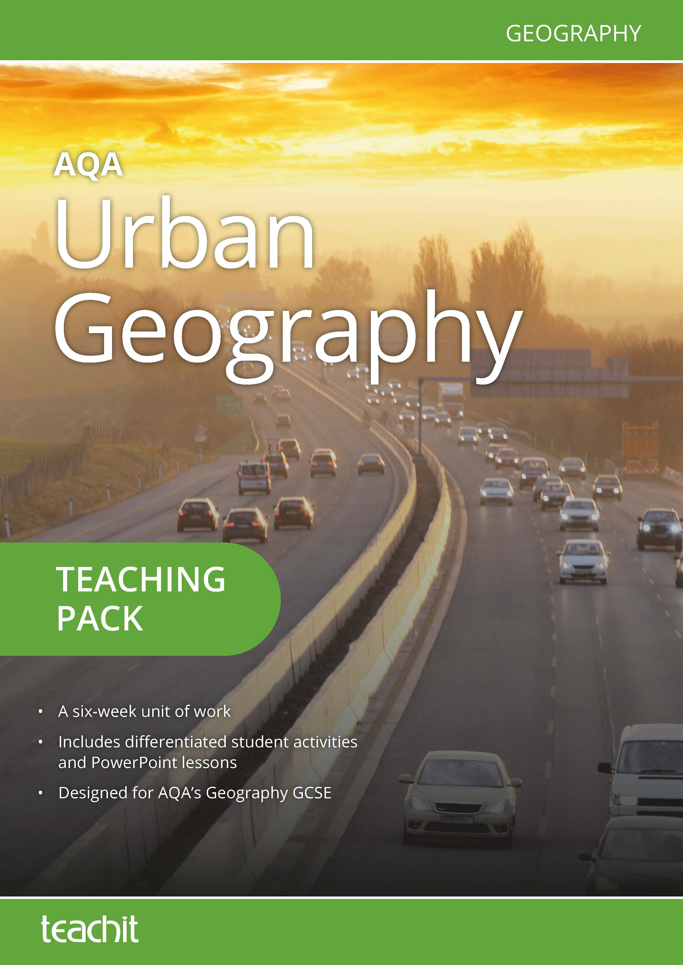

Contents page

Introduction 3
New GCSE Geography specification 4
OFQUAL assessment objectives for GCSE Geography 6
Suggested route through 7
Resource listing 23
Resources 26
Acknowledgement of copyright-holders and publishers 138

Introduction

This teaching pack is a collection of teaching ideas and student resources (all of which were specifically commissioned for the pack), on the topic of Urban Geography for the new AQA GCSE in Geography. It builds on the two very successful previous AQA GCSE Geography syllabuses: Geography A (9030) and Geography (9035).
It is planned as a six-week unit of work and includes a selection of:
- starter activities
- activities to develop and show students’ knowledge and understanding
- plenary activities
- suggestions for differentiation and extension activities.
The pack lends itself particularly well to being used in different ways. It could be dipped into on an ad hoc basis or it could form the basis for teaching the whole urban issues and challenges section of the specification. The resources are all available in adaptable formats, making it easy to differentiate the tasks by ability.
Included within the pack are teaching notes and a suggested route through. This identifies a possible sequence of enquiry and suggests ways of using the resources provided.
We’ve included a resource listings page which provides the links to each separate resource within this pack so that you can access the resources directly on www.teachitgeography.co.uk. Also included is the file number and name for each original resource — just type this into Teachit Geography’s search box.
To help with navigation, the resource listing also provides a page number to identify the resource easily within the teaching pack itself.
Our thanks go to our contributors Emma Espley and Chris Smart who have written the resources for this pack.
We hope you enjoy using this pack. If you have any questions, please get in touch: email support@teachitgeography.co.uk or call us on 01225 788850. Alternatively, you might like to give some feedback for other Teachit Geography members — you can do this by adding a ‘love heart’ and commenting on the relevant page of the resource on Teachit Geography.

New GCSE Geography specification

3.2.1 Section A: Urban issues and challenges
Challenges in the human environment
This unit is concerned with human processes, systems and outcomes and how these change both
spatially and temporally. They are studied in a variety of places and at a range of scales and must
include places in various states of development, such as higher income countries (HICs), lower income countries (LICs) and newly emerging economies (NEEs).
The aims of this unit are to develop an understanding of the factors that produce a diverse variety of human environments; the dynamic nature of these environments that change over time and place; the need for sustainable management; and the areas of current and future challenge and opportunity for these environments.

In this section, students are required to study all the themes.

Key idea | Specification content
A growing percentage of the world’s population lives in urban areas. | The global pattern of urban change.  Urban trends in different parts of the world including HICs and LICs.  Factors affecting the rate of urbanisation – migration (push–pull  theory), natural increase.  The emergence of megacities.
Urban growth creates opportunities and challenges for cities in LICs and NEEs. | A case study of a major city in an LIC or NEE to illustrate:  • the location and importance of the city, regionally, nationally and internationally  • causes of growth: natural increase and migration  • how urban growth has created opportunities:  • social: access to services – health and education; access to resources – water supply, energy  • economic: how urban industrial areas can be a stimulus for economic development  • how urban growth has created challenges:  • managing urban growth – slums, squatter settlements  • providing clean water, sanitation systems and energy  • providing access to services – health and education  • reducing unemployment and crime  • managing environmental issues – waste disposal, air and water pollution, traffic congestion.  An example of how urban planning is improving the quality of life for the urban poor.

Key idea | Specification content
Urban change in cities in the UK leads to a variety of social, economic and  environmental opportunities and challenges. | Overview of the distribution of population and the major cities in the UK.  A case study of a major city in the UK to illustrate:  • the location and importance of the city in the UK and the wider world  • impacts of national and international migration on the growth and character of the city  • how urban change has created opportunities:  • social and economic: cultural mix, recreation and entertainment, employment, integrated transport systems  • environmental: urban greening  • how urban change has created challenges:  • social and economic: urban deprivation, inequalities in housing, education, health and employment  • environmental: dereliction, building on brownfield and greenfield sites, waste disposal  • the impact of urban sprawl on the rural–urban fringe, and the growth of commuter settlements.  An example of an urban regeneration project to show:  • reasons why the area needed regeneration  • the main features of the project.
Urban sustainability requires management of resources and transport. | Features of sustainable urban living:  • water and energy conservation  • waste recycling  • creating green space.  How urban transport strategies are used to reduce traffic congestion.

Ofqual assessment objectives for GCSE Geography

Assessment objectives (AOs) are set by Ofqual and are the same across all GCSE Geography specifications and all exam boards.

The exams will measure how students have achieved the following assessment objectives.

- AO1: Demonstrate knowledge of locations, places, processes, environments and different scales (15 %).

- AO2: Demonstrate geographical understanding of: concepts and how they are used in relation to places, environments and processes; the interrelationships between places, environments and processes (25 %).

- AO3: Apply knowledge and understanding to interpret, analyse and evaluate geographical information and issues to make judgements (35 %, including 10 % applied to fieldwork context(s)).

- AO4: Select, adapt and use a variety of skills and techniques to investigate questions and issues and communicate findings (25 %, including 5 % used to respond to fieldwork data and contexts).

Assessment objective weightings for GCSE Geography (Paper 2)
Assessment objectives (AOs) | Component weightings (approx %) | Overall weighting  (approx %)
AO1 | 7.5 | 15
AO2 | 11 | 25
AO3 | 8.5 | 35
AO4 | 8 | 25

Teaching notes and suggested route through

Week 1: Why do people wish to live in urban areas?

Starter activities:

Resource 1: 'Urban geography — 5Ws and how?'

- Get students to work in pairs. Ask them to note the fact, look carefully at the image and then consider the six questions surrounding it. Feedback into a whole class discussion.

Resource 2: 'Urban growth per hour'

- Work through the slides showing the growth of Shenzhen in China since 1950. There is an opportunity to locate Shenzhen, Jakarta and Tokyo in an atlas or online. Pose the questions on slide 7 to students, e.g. How does Jakarta compare with the other cities listed? Which cities are experiencing the greatest urban growth? What is happening in Tokyo? Does urban growth appear to be concentrated in a particular part of the world? Is it restricted to the Far East?

Main activities:

Resource 3: 'Global urbanisation'

- Introduce the students to the five global urbanisation facts (1800–2050) provided on the worksheet and in the PowerPoint. Ask the question as to the accuracy of the last statement. Links can be made from the map to the development status of a country but obvious exceptions, e.g. Saudi Arabia should be highlighted.

Resource 4: 'Urban growth' and 'The growth of world cities'

- A possible starting question could be to ask the location and size of the world’s largest city. There is an opportunity for discussion as to what constitutes a city and how the boundaries of a city are defined. Share background to 'Urban growth' with students, emphasising key statistics and geographical vocabulary in the process. Get students to make use of a software application, such as Excel, to complete the activities thereafter. There is an opportunity for work with an atlas or with the internet to show the location of Shenzhen in China.

Resource 5: 'The world’s 12 largest cities'

- Students work though the activities on the worksheet. A blank world map will be required for activity 3. These activities should raise students’ awareness of reliability of the data. These data are correct but not very reliable as it is from different courses and therefore hard to make comparisons.

- Show the first 3:45 minutes of the following clip twice:

- youtube.com/watch?v=fo6d-pahxPM

- Ask students to watch the clip the first time. On the second showing, get students to try to write a definition for the term ‘megacity’ (‘an urban area with a population of 10 million or more’) and list some of their key characteristics. Feedback into a whole class discussion.

- Refer to the following website, which provides comparable data:

- allianz.com/en/about_us/open-knowledge/topics/demography/articles/150316-top-20-megacities-by-population.html/

- What are the top twenty megacities?

- Are you surprised by any that entered the top twenty?

The top ten are as follows: Tokyo-Yamahama, Jakarta, Delhi, Manila, Seoul, Shanghai, Karachi, Beijing, New York, Guangzhou-Foshan.

- Get students to consider the location of the top twenty megacities (by population) on a map of the world.

Students could be asked to produce their own map of major world cities.

- Ask students what they notice about their distribution. Questions could include, On which continent are most found? Are they found in LICs, HICs or NEEs?

- Feedback into a whole class discussion.

Resource 6: 'Causes of urbanisation'

- Get students to complete the three activities. Review as a class.

Resource 7: 'Push and pull factors'

- Get students to work in pairs. Ask them to read and sort the various cards into two piles, one for push factors and the other for pull factors. Review as a class. Are there some factors that exert a stronger push/pull than others do?

Resource 8: 'Push factors – a diamond nine exercise'

- This activity can be used as an extension to 'Resource 7' as it concentrates on just push factors.

Resource 9: 'Informal employment in a LIC city – a SATO exercise'

- This activity considers a possible informal employment activity in a developing city – the result of push and pull factors.

Plenary activities:

Resource number 10: 'Plenary dice'

- Challenge the class with the plenary dice activity.
Week 2: What opportunities and challenges does urban growth have for cities in LICs and NEEs?

Starter activities:

Activity 11: Where am I?

- Watch the video clip - youtube.com/watch?v=fo6d-pahxPM (from 3:45 to 7.20 minutes).

- Ask students if the five megacities mentioned in the clip (namely Shanghai, Dhaka, Tokyo, London and Mexico City) exhibit the same opportunities and challenges. What similarities and differences can they identify? (e.g. prospects look brighter for megacities in HICs or NEEs than for those in LICs).

Resource 12: 'Where am I?'

- Project the image. Ask students where they think the image was taken. Give out clues, one at a time, until someone identifies the city correctly (Mumbai). Explain to students that they will shortly be ‘zooming in’ on Mumbai to discover more about this fascinating megacity.

- Ask students to access Google Earth and travel from the UK to Mumbai. In which direction and how far do they need to travel? Get students to explore Mumbai from above. Extract their initial thoughts about/first impressions of Mumbai via a whole class discussion.

Main activities:

Resource 13: 'Mumbai - Location, location, location'

- Get students to complete the five activities on the sheet. Once they have done this, they should form a small group and share their findings with others. Encourage students to note any new information that they discover in the process.

- Watch the following clip: youtube.com/watch?v=PBMDGcYWPvU

- Ask students to imagine they are a slum dweller in Dharavi. Get them to list any opportunities that they might have and the challenges that they might face. Feedback into a whole class discussion. Do they think that the challenges outweigh the opportunities, or vice versa? How does this film/Dharavi compare with the earlier image that they saw and their initial thoughts/first impressions of Mumbai?

Resource 14: 'Opportunities and challenges in Mumbai'

- Get students to work in pairs. Ask them to read and sort the various cards into two piles, one for opportunities and the other for challenges. Review as a class. There are two differentiated resources.

- Ask students how they might classify these further, e.g. social, economic and environmental opportunities/challenges; by cost; by location; by urgency; by the time or scale involved.

Resource 15: Mumbai’s challenges – a diamond nine activity

- Get students to work in pairs and complete the diamond nine activity. Stress that they should be able to justify their ranking when questioned later.

- Review as a class.

Plenary activities:

Resource 16: 'Life in the slum'

- Get students to look carefully at the image in the middle of the sheet and imagine that they are the young person in the photograph. What might they see, hear, taste, touch, smell and feel (emotions)? Ask them to note their thoughts in the relevant boxes surrounding the image. The image is of Jakarta and students should draw obvious parallels with slums in Mumbai.

- Feedback into a whole class discussion.

Resource 17: 'Mumbai - A time for reflection'

- Get students to work with a partner and consider the three questions on the slide:

- What does the future hold for Mumbai?

- Will the gap between the rich and poor become bigger or smaller?

- How can Mumbai best address the challenges it now faces?

Feedback into a whole class discussion.

Week 3: How is urban planning improving the quality of life for the urban poor?

Starter activities:

Resource 18: 'Life in the slum – a SATO question'

- The image is of a slum in Jakarta and is an alternative plenary to 'Resource 16' requiring empathy. Students can complete the activity instead of 'Resource 16' with more able students considering similarities and differences with respect to Dharavi.

Resource 19: 'Top ten wishes'

- Ask students to once again imagine that they are the young person in the photograph. A fairy godmother, aka a charity/organisation/government, has come along to grant them ten wishes. What would be their top ten wishes and why? Get students to complete the stars on the accompanying sheet.

- Afterwards, encourage them to form a small group and share their thoughts with others. Were their wishes similar or different? How much would it cost to make all their wishes come true? Do they think it would be easy or difficult to meet their wishes?

Resource 20: 'Dharavi Sudoku'

- A fun way to end the lesson examining some of the problems of life in the Dharavi slum.

Main activities:

Resource 21: 'What can you see? A Dharavi factory SATO exercise'

- Ask students to complete the SATO exercise to consider a small factory in Dharavi.

Resource 22: 'Dharavi - True or false?'

- Show the following clip to students:

- youtube.com/watch?v=PBMDGcYWPvU

- Encourage them to watch it the first time around, then complete the true/false activity. Record as many facts as they can during a second viewing in the false column. Afterwards, get students to test themselves.

- Show the following clip to students:

- youtube.com/watch?v=RmpMNe9y1qg

- Get students to work in small groups. They should imagine that they are a private developer, who is keen to put forward a bid to develop a section of the Dharavi slum. In their small group, they must come up with a redevelopment plan. This could be produced as an annotated sketch or as a multimedia presentation that is given to the rest of the class, depending on the time and resources available. An element of peer assessment could be incorporated here too.

- Ask small groups to move around the room and view each group’s annotated sketch. Identify WWW (what went well/strengths) and EBI (even better if/weaknesses/improvements). A similar approach could be taken towards any multimedia presentations; get students to award a number from 1 to 9 (1 being the best) and then identify WWW (what went well/strengths) and EBI (even better if/weaknesses/improvements).

- Afterwards, chair a vote to determine which group’s bid should win. Encourage students to justify why they believe this to be the case too.

Resource 23: 'Redevelopment in Dharavi'

- Look at the image, how could this site be developed? Answer questions 1 and 2. Listen to the radio programme and go through the latest news slides on the powerpoint, then complete questions 5 and 6. Challenge students to make use of the Internet to see if they can uncover any further developments that have taken place since May 2016. Afterwards, get them to form small groups and share their findings with others. Convene for a whole class discussion, asking students if they found out any further information and if everyone is actually in favour of the redevelopment of Dharavi.

- An ideal short assessment might be:

- filestore.aqa.org.uk/subjects/AQA-90302H-QP-JUN15.PDF

- filestore.aqa.org.uk/subjects/AQA-90302H-W-MS-JUN15.PDF

- filestore.aqa.org.uk/subjects/AQA-40302H-QP-JUN13.PDF

- filestore.aqa.org.uk/subjects/AQA-40302H-W-MS-JUN13.PDF

- Question 2c (i, ii and iii).

Plenary activities:

Resource 24: 'Mumbai – past, present and future'

- Give students a copy of the above resource and ask them to complete the activity to the best of their ability.
- Pair them with another individual (a less able student with a more able student, perhaps?) to exchange information that they have written down. You could review as a class later on if you wish and time allows.

- Get students to listen to the following audio clip:

- abc.net.au/radionational/programs/counterpoint/slums-of-despair-or-hope-/3137144

- Steer a whole class discussion around the question: ‘Are slums places of despair or places of hope?’

Week 4: What is the impact of urban change for cities within the UK?

Starter activities:

Resource 25: 'Population density within the UK'

- Pose questions to students that encourage them to extract figures, identify patterns, pick out similarities and differences, etc. Concentrate on population density in particular.

- Students will need a copy of the map if the extension activity is to be completed.

Resource 26: 'Where are the UK’s largest cities?'

- Students may need a brief introduction to satellite imagery prior to attempting this exercise. An atlas will be required for the last question. An extension is to locate the school’s location and comment on its light pollution.

Main activities:

Activity 27: Timeline

- Show the following animation to students:

- youtube.com/watch?v=NB5Oz9b84jM

- Suggest that students now construct a timeline (from AD 0 to 2013). Ask them to annotate it with details extracted from the animation to demonstrate how the city has developed over time. Later, review as a class.

Resource 28: 'A case study of London'

- Students now have the opportunity to undertake an independent enquiry. They should make use of the Internet (suggested web-links have been listed as a starting point) and a search engine, such as Google, as well as any relevant newspaper or magazine articles or books, to find out information to answer the questions. Reinforce to individuals the need to consider copyright and the reliability of any source/s used. An element of self and peer assessment, as well as teacher assessment, could be incorporated here too.

- A possible, additional short assessment is included but another possibility might be question 2c (i, ii and iii) from filestore.aqa.org.uk/subjects/AQA-90302H-QP-JUN14.PDF

Plenary activities:

Resource 29: 'A London plenary triangle'

- Project the slide onto the screen and challenge students to answer the three questions.

Resource 30: 'London and UK cities urban quiz questions'

- Utilise the above resource as a means of revising topical vocabulary and key ideas.

Resource 31: 'The future of UK cities'

- Display Slide 1 and ask students what they think the three diagrams are suggesting. Outline the three possible scenarios on Slides 2-4.

- Next, use the various questions on Slide 5 as a focus for a whole class discussion.
Extension: You may wish to challenge more able pupils with the following task or set it as a homework activity - ‘Postcard from the future’. A template and example to distribute to students can be found here:

- gov.uk/government/uploads/system/uploads/attachment_data/file/515895/gs-16-9-future-uk-cities-scenarios.pdf

Week 5: What has happened recently within the city of …?

Starter activities:

Resource 32: 'KWHL grid'

- Explain to pupils that you are going to conduct an enquiry together. This will be centred on Gloucester. Ask if anyone has been to Gloucester. Hand out the KWHL grid. Ask pupils to fill in the first box. Review as a class.

- Launch the focus of your enquiry by referring to the second box. Ask students to complete the third box. Review as a class. Tell pupils that you will re-visit this sheet and the last box as a plenary activity.

- Access Google Earth and, via a large screen/IWB, travel from your current location to Gloucester. In which direction and how far do you need to travel? Explore the city of Gloucester from above, getting students to identify key physical and human features in the process.

Resource 33: 'Gloucester docks – match the captions'

- This activity is best undertaken with the students working in either pairs or small groups. If the students are working in pairs, you could take the opportunity to place a less able student/s with a more able student/s). These are photographs, and their captions, which have been taken of Gloucester Docks, from the 1950s to the present day.

- Review as a class. How many did they guess correctly?

- Next, challenge pairs/small groups to sequence the photographs from the 1950s to the present day to exemplify some of the changes that have taken place over time. The captions may help them do this.

- Later, review as a class.

- Source of photographs and captions: geograph.org.uk/

Resource 34: 'Gloucester docks - before and after redevelopment'

- Pupils will need to work in pairs, and then small groups, to complete the task on the sheet. This involves the annotation of two images and the creation of lists of words/phrases to describe the scene in each photograph.

- Ask the class what annotations they added to each image and draw up a bank of ten words/phrases on the board, relating to each photograph.

Main activities:

- Explain to students that you will now show them two clips that have been filmed in Gloucester Docks, the first during the 1930s and the second in 2015. What similarities and differences can they spot?

- youtube.com/watch?v=ahKCj2cskk4

- youtube.com/watch?v=cwilHjgQbIQ

Feedback into a whole class discussion.
- Show the following clip twice to students:

- youtube.com/watch?v=_csda7CGrRI

Students should simply watch the clip the first time around. During the second showing, encourage them to note down as many facts as they can about the Gloucester Quays development. Review as a class.

Resource 35: 'Gloucester Docks – an urban sequencing activity' &
Resource 36: 'The regeneration of Gloucester Docks - fact or opinion'

- Explain to students that they will now complete two different activities to help them respond to the two parts of the enquiry (see second box on 'Resource 32 - the KWHL grid'). The first is a sequencing task, which should help them list the ‘reasons why the area needed regeneration’.

- The second is a card sort activity, separating facts from opinion. This should help students identify ‘the main features of the project’.

Resource 37: 'Urban and industrial change at the Lock Warehouse'

- This resource could also be used as a starter if task 3 was not included. It will provide an example of regeneration within Gloucester Docks.

Resource 38: 'Map interpretation at Gloucester Docks'

- By examining an old OS map, students should be able to see the docks close to its industrial peak. Students should work in pairs or small groups for this activity.

Resource 39: 'Gloucester Docks and Gloucester Quays - a case study summary'

- Allow students access to ICT. Share the suggested web-links with students, highlighting aspects to focus upon (further guidance could be provided for less able pupils). Give pupils time to complete the case study summary card independently, using both their prior knowledge and understanding and the recommended web-links.

- Review as a class thereafter. Ask pupils for their thoughts about the regeneration of the Gloucester Docks as well as Gloucester Quays.

- Challenge pupils to find an example of urban regeneration within another locality. Get them to take an image, add a suitable caption (and have it checked) before uploading it to Geograph’s website (geograph.org.uk/submit.php). You may wish to monitor the upload process via a generic/class account set up by yourself.

Plenary activities:

Activity 40: Case study update

- Allow students time to explore @GloucesterDocks and @GloucesterQuays Twitter feeds for the latest updates, etc.

- Provide students with access to the Internet. Ask them to make use of a search engine, such as Google, and to type in the words ‘Bakers Quay’. They should customise their search to include UK sites only and only those links relating to the past year. Stress that news items are the most valuable way of gaining up-to-date information about the proposed regeneration initiative.

- Ask them to record any information that they find. Emphasise that this will show the examiner that they are keeping abreast of developments and referring to up-to-date material. Feedback into a whole class discussion.

Activity 41: 'Resource 32: KWHL grid'

- Re-visit the final box within the KWHL grid and ask pupils to add their updated information.

- Review as a class thereafter.

Week 6: Why is the management of resources and transport so important?

Starter activities:

Resource 42: 'Letter sort and word generator game'

- Before the lesson, cut up the various letters for this resource and place them in an envelope. Repeat so that there are enough sets for students to work in small groups/teams.

- Challenge small groups to rearrange the letters to spell a ‘buzz word’ of our times (SUSTAINABILITY). Once the answer has been revealed, set a timer for 5 minutes. In the time available, students should attempt to list as many words as they can (of three letters or more) using the letters in the word SUSTAINABILITY. Stress that bonus marks will be awarded for any word that has great geographical/topical significance.

- Afterwards, invite small groups to share their list with others. They should cross off a word if another group has it.

- Determine the winning team.

- Ask students what the word ‘SUSTAINABILITY’ means and write a definition in their note book/folder.

Resource 43: 'Sustainable or unsustainable features?'

- Students will need to work in pairs for this activity (you could allocate a less able student to work alongside a more able student here). They should complete the activity which is a card sort of sustainable and unsustainable features.

- Afterwards, ask students to share instances of sustainable features in ‘real life’. Reinforce that these may be useful examples to refer to in an examination answer.

Resource 44: 'Ask away … in Cairo'

- Ask students to form small groups (you could allocate less able students to work alongside more able students here). Provide each group with an enlarged copy of both the photograph and question sheet (ideally A3 size).

- Allow students sufficient time to contemplate the various questions within their small groups before inviting them to contribute to a whole class discussion.

Main activities:

Activity 45: 'Sustainable cities'

- A blank world map per student will be required.

- Show the following clip to students:

- youtube.com/watch?v=fcDDUSUbq9A

- Get students to mark the world’s top ten sustainable cities on the outline world map provided. Encourage them to include an annotation next to each one to explain why it is considered to be so sustainable. Information may be gained by accessing the following web-link, reading the article and viewing the images and their accompanying captions:

- fastcoexist.com/3016816/the-10-cities-that-are-leading-the-way-in-urban-sustainability

Activity 46: 'A new sustainable city'

- Tell students that another sustainable city is currently being developed, aptly named ‘The Sustainable City’. Explain that you will conduct a hot seating activity – you will now place yourself in the ‘hot seat’ and they can each ask you a question about ‘The Sustainable City’. Students should record any details that they discover in the process, as this will be needed for a subsequent task. You can glean information in advance by accessing the following web-links:

- dailymail.co.uk/travel/travel_news/article-3087751/Dubai-goes-green-Plans-unveiled-ambitious-Sustainable-City-desert-100-solar-powered-hotel-organic-farms-grass-amphitheatre.html

- Next, show the following clip to students and encourage them to note down any further facts/statistics relating to the new development:

- youtube.com/watch?v=lh3RwrDJ6yg

- Ask students to work in pairs. They must imagine that they are researchers for the BBC Radio 2’s Jeremy Vine programme, a topical/discussion slot which runs from 12 noon until 2.00 pm each weekday. Later this week the focus will be on ‘sustainability’ and Faris Saeed, the CEO of Diamond Developers that is overseeing ‘The Sustainable City’ in Dubai, will be in the studio. What questions should Jeremy Vine pose to Faris Saeed in order to uncover further details about this new development? Emphasise that a good interviewer also considers the answers that the interviewee might give. How will Faris Saeed respond to Jeremy Vine’s questions? Get students to script the interview between the two men, drawing on the background knowledge and understanding that they have already gained, as well as referring to the web-links below:

- dailymail.co.uk/travel/travel_news/article-3087751/Dubai-goes-green-Plans-unveiled-ambitious-Sustainable-City-desert-100-solar-powered-hotel-organic-farms-grass-amphitheatre.html

- youtube.com/watch?v=lh3RwrDJ6yg

- This would also provide an ideal verbal assessment opportunity. Students could perform their scripted interview to the rest of the class. Peers could assess them on a scale of 1 to 9 (1 being the best) and jot down one strength/WWW (what went well) and one area for improvement/EBI (even better if). An average score could be calculated and each pair encouraged to note down three given strengths/WWW (what went well) and three suggested areas for improvement/EBI (even better if).

- A possible short written assessment might be:

- filestore.aqa.org.uk/subjects/AQA-90302H-QP-JUN15.PDF

- filestore.aqa.org.uk/subjects/AQA-90302H-W-MS-JUN15.PDF

- Question 2a (i, ii and iii).

- Question 2d.

Resource 47: 'Transport sustainability in Curitiba, Brazil'

- Get students to complete the various tasks on this resource. This involves watching a clip of approximately 15 minutes duration, before answering questions about transport sustainability within Curitiba, Brazil and annotating an image (a street scene in Curitiba) to highlight key aspects of the plan.

- Review as a class thereafter.

- A possible short assessment might be:

- filestore.aqa.org.uk/resources/geography/AQA-80352-SQP.PDF

- filestore.aqa.org.uk/resources/geography/AQA-80352-SMS.PDF

- Questions 1.7 and 1.8.

Plenary activities:

Resource 48: 'Examination question model'

- Project slide 1 & 2. These display syllabus information and part of a GCSE examination question. Ask students to think about how they might answer it. Use this as a basis for a whole class discussion.

- Reveal possible answers on the following slides. The question, Question 2b (ii) was taken from the examination paper below:

- filestore.aqa.org.uk/subjects/AQA-40302H-QP-JUN13.PDF

- filestore.aqa.org.uk/subjects/AQA-40302H-W-MS-JUN13.PDF

Resource 49: 'Sustainable matching activity'

- Get students to attempt this matching activity (key terms with their definitions) to help reinforce topical vocabulary. The answers are provided in the PowerPoint.

Resource 50: 'Urban sustainability definitions'

- This activity could be used as an extension to 'Resource 49', or as a revision exercise at a later date to gauge understanding and knowledge retention.

Activity 51: Researching local sustainability

- How sustainable is your nearest city? Allow students access to the Internet and/or provide an array of local newspapers/magazines. Ask them to investigate what is being done in your nearest city in order to make it more sustainable. How effective are these strategies? Is there anything else that could be implemented?

- Feedback as a whole class discussion. One approach is to use an IWB as a large spider diagram and to photograph the final result for students.

Resource listing

Resource number | Title | Page number
27109 | AQA Urban Geography teaching pack - notes for teachers | 5
26375 | Urban Geography – 5 W’s and how? | 26
26376 | Urban growth per hour | 28
26510 | Global urbanisation | 31
26376 | Urban growth | 34
26512 | The growth of world cites | 36
26377 | The world’s 12 largest cities | 40
26513 | Causes of urbanisation | 45
26514 | Push and pull factors | 48
26515 | Push factors – a diamond nine exercise | 51
26829 | Informal employment in a LIC city - a SATO exercise | 53
26653 | Plenary dice | 54
26654 | Where am I? | 55
26655 | Mumbai – location, location, location | 57
26698 | Opportunities and challenges in Mumbai | 61
26699 | Mumbai’s challenges – a diamond nine activity. | 68
26818 | Life in the slum | 69
26700 | Mumbai – a time for reflection | 70

26819 | Life in the slum - SATO questions | 70
26820 | Top ten wishes | 72
26828 | Dharavi sudoku | 73
26830 | What can you see? A Dharavi factory SATO exercise | 76
26826 | Dharavi - true or false? | 77
26927 | Redevelopment in Dharavi | 80
26915 | Mumbai, past, present and future | 83
26916 | Population density in the UK | 85
26917 | Where are the UK's largest cities | 88
26990 | A case study of London | 89
26924 | A London plenary triangle | 96
26991 | London and UK cities urban quiz questions | 97
26995 | The future of UK cities | 99
26996 | KWHL grid | 100
27002 | Gloucester Docks - match the captions | 101
26997 | Gloucester Docks - before and after redevelopment | 103
27084 | Gloucester docks – an urban regeneration sequencing activity | 108
27093 | The regeneration of Gloucester Docks – fact or opinion | 113
26998 | Urban and industrial change at the Lock Warehouse | 117
26999 | Map interpretation at Gloucester Docks | 118

27094 | Gloucester Docks and Gloucester Quays – a case study summary | 119
27095 | Letter sort and word generator game | 120
27096 | Sustainable or unsustainable features? | 124
27098 | Ask away in Cairo | 126
27099 | Transport sustainability in Curitiba, Brazil | 127
27100 | Examination question model | 131
27101 | Sustainable matching activity | 133
27102 | Urban sustainability definitions | 137

FACT: A growing percentage of the world’s population lives in urban areas.
What do we mean by an ‘urban area’? |  | How much (in percentage terms) are we thinking about?
Where do you think this photograph was taken? | 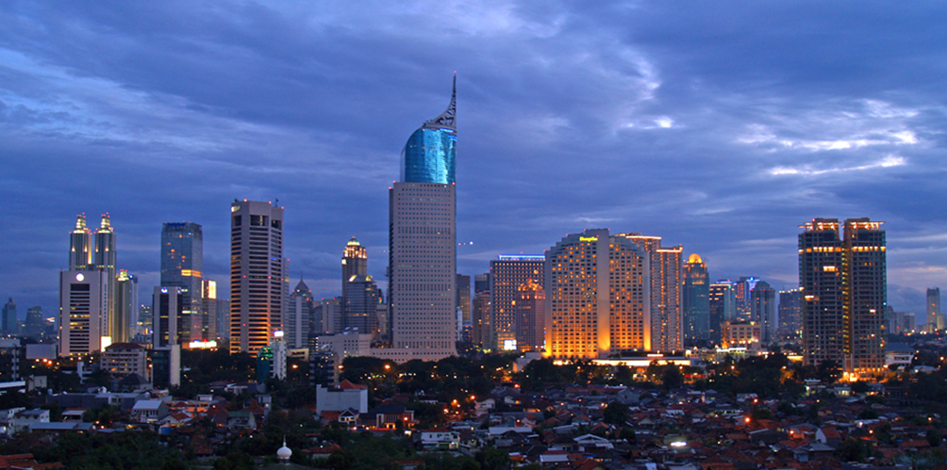  Source: © The Diary of a Hotel Addict 2008 https://flic.kr/p/4vAyAe |  | Why is the percentage of the world’s urban population growing?
Who might be attracted to cities such as this? |  | Which urban areas are growing the fastest?

Teaching notes and suggested answers

- What do we mean by an urban area?
An urban area implies towns and cities. You could ask your students what defines an urban area.

- How much (in percentage terms) are we thinking about?
Approximately one third of the world’s population (34%) lived in towns and cities in 1960. This had risen to approximately half (54%) by 2014 and by 2050, it is expected that around 66% of the world’s population will be living in urban areas.
It is important to distinguish between the percentage of the world’s urban population and the world’s urban population in absolute numbers. Currently, the percentage of the world’s urban population is greatest in the countries of the developed world, e.g. the UK at 85% in 2015 but in absolute numbers; the urban population growth is concentrated in the less developed regions of the world. However, by 2017, it is estimated that even in less developed countries numerically, a majority of people will be living in urban areas.

- Where do you think this photograph was taken?
Jakarta, Indonesia in 2008.

- Why is the percentage of the world’s urban population growing?
This is due to a combination of the natural increase in population and push and pull factors. The latter encourage rural to urban migration. Students could be asked to list push and pull factors.

- Who might be attracted to cities such as this?
Young people, especially young males and later their families. Students could be asked to consider this answer in relation to the previous answer.

- Which urban areas are growing the fastest?
Presently, the world’s fastest growing cities are to be found largely in Asia and Africa e.g. Suzhou, China; Guangzhou, China; Surat, India; Luanda, Angola; Kinshasa, Dem. Rep. of Congo; Lagos, Nigeria; Beijing, China; Hangzhou, China; Quanzhou, China and Bangalore, India
- Use the data from the table below to answer the questions below:

City | Increase (in people per hour)
Berlin | 1
Delhi | 79
Dhaka | 74
Hong Kong | 4
Istanbul | 19
Jakarta | 27
Johannesburg | 2
Kinshasa | 63
Kolkata | 32
Lagos | 85
London | 9
Manila | 29
Mexico City | 22
Mumbai | 51
New York | 10
Rio de Janeiro | 10
Sao Paulo | 18
Shanghai | 53
Shenzhen | 15
Tokyo | -1

- Which cities are experiencing the greatest urban growth?

- How does Jakarta compare with the other cities listed?

- What is happening in Tokyo?

- Does urban growth appear to be concentrated in a particular part of the world?

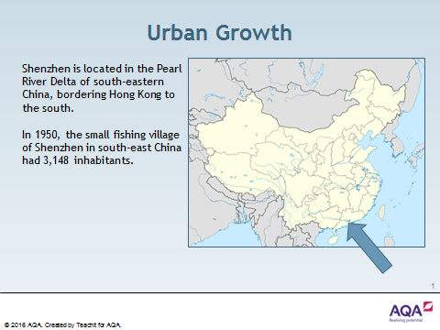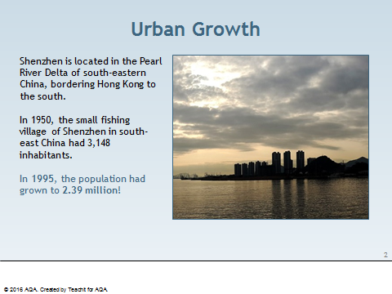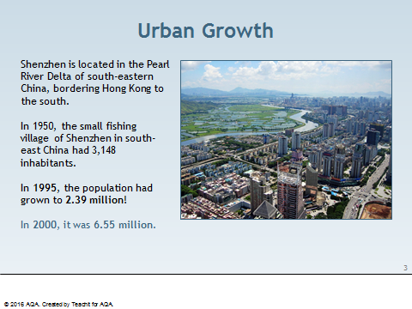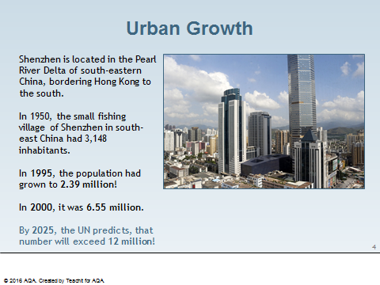
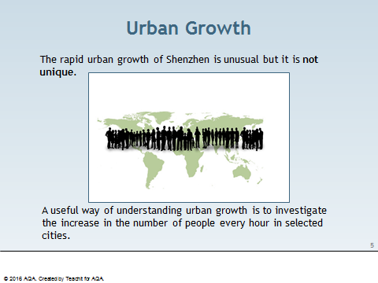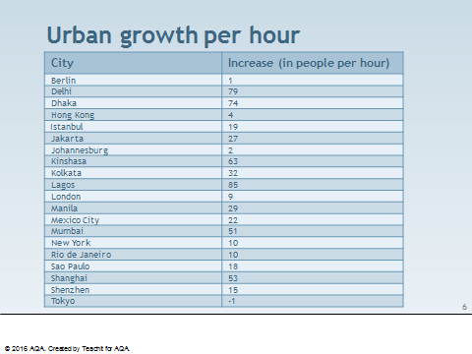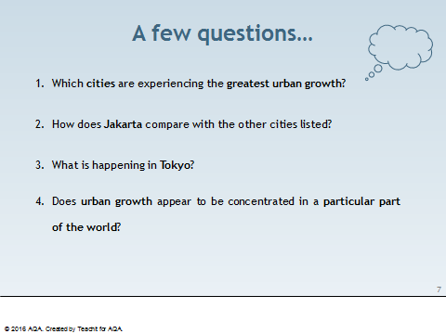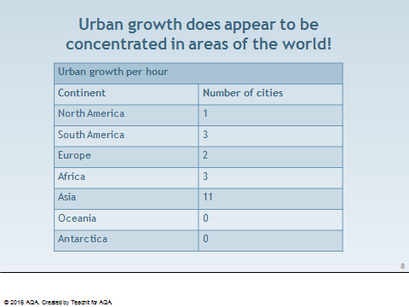
Urbanisation is the proportion or percentage of people living in towns and cities.

- In 1800, only about 3% of the world’s population lived in urban areas.
- In 1950, about 30% of the world’s population lived in urban areas.
- In 2008, the UN estimated half of the world’s population lived in urban areas.
- In 2014, 54% of the world’s population lived in urban areas.
- In 2050, it is anticipated that 66% of the world’s population will be living in urban areas.

Student tasks

- Draw a line graph to show the increase in the proportion or percentage of people living in towns and cities between 1800 and 2050. Use a horizontal scale of 1 cm to 25 years.

- Study the global urbanisation map below. This shows the percentage of urbanisation per country in 2012.

Map used courtesy of Rotterdamus1234, 2012 under the Creative Commons Attribution-Share Alike 3.0 Unported license.
commons.wikimedia.org/wiki/File:Urbanisation-degree.png

- Use an atlas to name five countries where the country has between 75% and 100% of the population living in towns and cities.

- Use an atlas to name five countries where the country has 25% or less of the population living in towns and cities.

- Circle the correct word in brackets to complete the sentence:
HICs have a [higher/lower] percentage of their population living in towns and cities than LICs.

- Complete the table to show if the statements are true or false:
 | True | False
The highest proportions of urbanisation are found in the HICs of North America, Western Europe and Oceania.
The lowest proportions are found in the LICs of Africa and Southeast Asia.
Several countries within South America have more than 75% of their population living in urban areas.

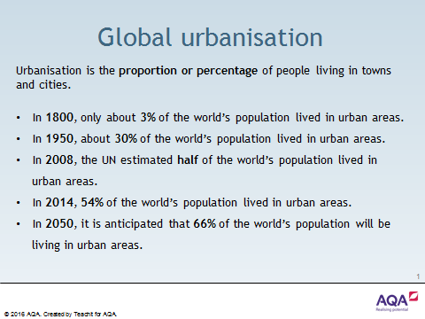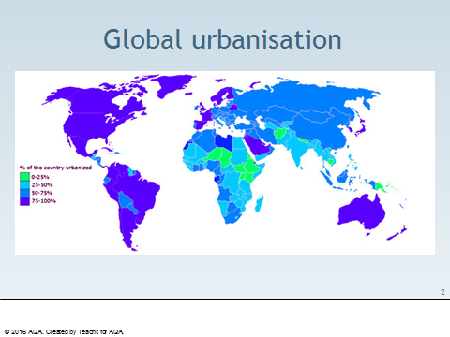
Student tasks
- Draw a bar graph to show the growth of Shenzhen:

Year | Population
1950 | 3,148
1995 | 2.39 million
2000 | 6.55 million
2025 | 12 million

- What problem did you find drawing this graph?

- Use the data from the table below to answer the questions below:

City | Increase (in people per hour)
Berlin | 1
Delhi | 79
Dhaka | 74
Hong Kong | 4
Istanbul | 19
Jakarta | 27
Johannesburg | 2
Kinshasa | 63
Kolkata | 32
Lagos | 85
London | 9
Manila | 29
Mexico City | 22
Mumbai | 51
New York | 10
Rio de Janeiro | 10
Sao Paulo | 18
Shanghai | 53
Shenzhen | 15
Tokyo | -1

- Which cities are experiencing the greatest urban growth?

- How does Jakarta compare with the other cities listed?

- What is happening in Tokyo?

- Does urban growth appear to be concentrated in a particular part of the world?

Information sheet

Urbanisation is the proportion or percentage of people living in towns and cities.
- In 1800, only about 3% of the world’s population lived in urban areas.
- In 1950, about 30% of the world’s population lived in urban areas.
- In 2008, the UN estimated half of the world’s population lived in urban areas.

Urbanisation has resulted in more and more, larger and larger cities around the world. There has been a growth of very large cities with a population of more than 1 million.
- In 1850, there were only 2 millionaire cities, namely London and Paris.
- In 1950, there were 83 millionaire cities.
- In 2015, there were approximately 500 millionaire cities.

There has been a change in the location and distribution of millionaire cities:
- Before 1950, many millionaire cities were found in HICs and temperate latitudes north of the Equator.

The world now also has megacities. These are cities with a population in excess of 10 million.
- In 1950, there were only three megacities in the world: London, New York and Tokyo.

In 2014, there were 28 megacities worldwide: 16 in Asia, 4 in South America, 3 each in Africa and Europe and 2 in North America.
- By 2030, the world is projected to have 41 megacities.

Student tasks
- Use a software application, such as Excel, to produce a bar graph to show how the number of millionaire cities has changed over time.
- Research the names and locations of the world’s 15 largest cities of today.

Name of City | Location of City

- Write a sentence to describe the changing location of the world’s megacities.

- Complete the table below.
 | True | False
There has been a change in the location and distribution of large cities since 1850.
In 1970, half of the world’s ten largest cities were found in the HICs of North America and Europe.
By 2000, 15 of the 19 world’s largest cities were found in the LICs of Africa, Asia and South America.
Since the 1970s, the growth rate of most cities in HICs has slowed down, or even declined.
Currently, the fastest growing cities are in Southern Asia.

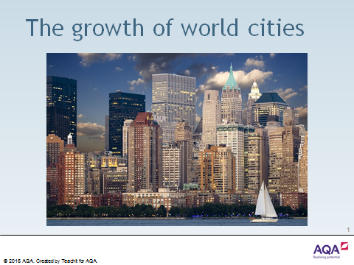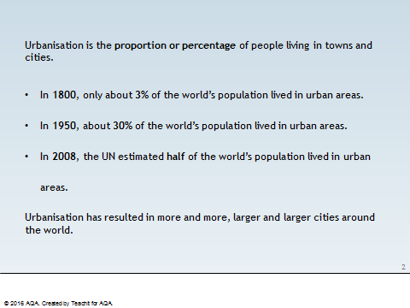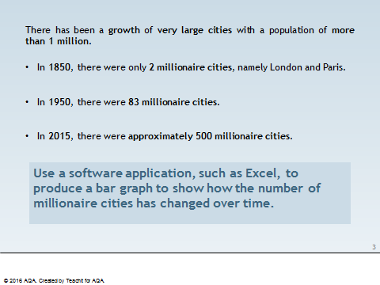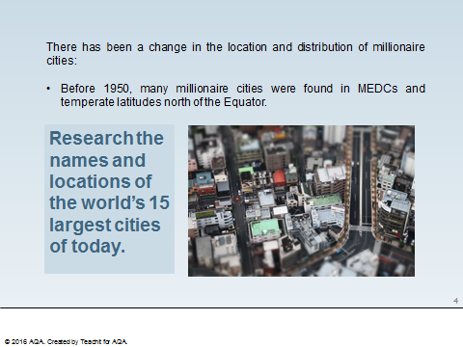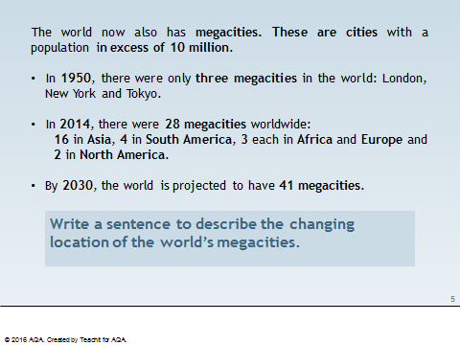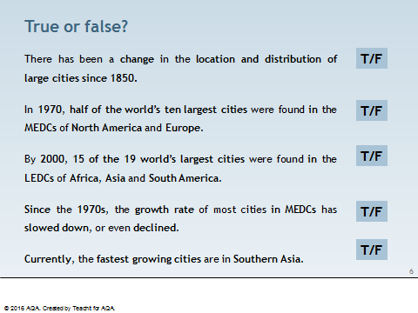
Student tasks
- The table below shows the 12 largest cities in the world. Use an atlas to complete the country column.

Rank | City | Population | Population  density per km² | Country
1 | Shanghai | 24,256,800 | 3,826 | China
2 | Karachi | 23,500,000 | 6,663 | Pakistan
3 | Beijing | 21,516,000 | 1,311
4 | Delhi | 16,787,941 | 11,320
5 | Lagos | 16,060,303 | 18,206
6 | Tianjin | 15,200,000 | 1,293
7 | Istanbul | 14,160,467 | 2,593
8 | Tokyo | 13,297,629 | 6,075
9 | Guangzhou | 13,080,500 | 1,759
10 | Mumbai | 12,478,447 | 20,680
11 | Moscow | 12,197,596 | 4,859
12 | São Paulo | 11,895,893 | 7,821

- Give two reasons why the population data could be inaccurate. The table is adapted from en.wikipedia.org/wiki/List_of_cities_proper_by_population.

- Use this blank world map and an atlas to plot the locations of these cities.
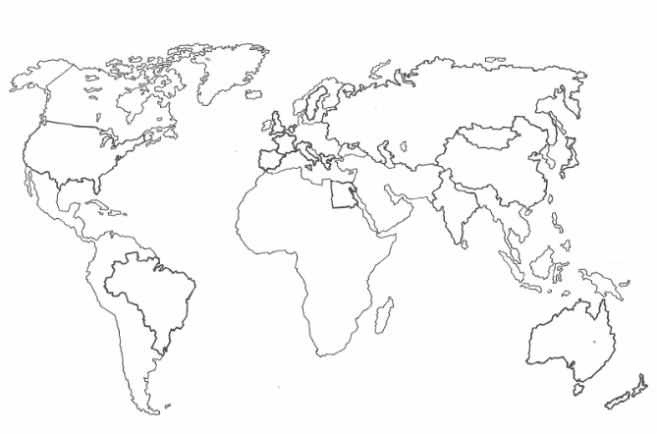
This map has been borrowed from Tombola (Nelson, 1992) by kind permission of the authors, John Palim, Paul Power and Phyllis Vannuffel.

- Do the 12 largest cities of the world appear to be concentrated in a particular continent of the world?

- What similarity can you see about their location?

- How might the rank order of this list change in the future?

Suggested answers
- Countries

Rank | City | Population | Population  density per km² | Country
1 | Shanghai | 24,256,800 | 3,826 | China
2 | Karachi | 23,500,000 | 6,663 | Pakistan
3 | Beijing | 21,516,000 | 1,311 | China
4 | Delhi | 16,787,941 | 11,320 | India
5 | Lagos | 16,060,303 | 18,206 | Nigeria
6 | Tianjin | 15,200,000 | 1,293 | China
7 | Istanbul | 14,160,467 | 2,593 | Turkey
8 | Tokyo | 13,297,629 | 6,075 | Japan
9 | Guangzhou | 13,080,500 | 1,759 | China
10 | Mumbai | 12,478,447 | 20,680 | India
11 | Moscow | 12,197,596 | 4,859 | Russia
12 | São Paulo | 11,895,893 | 7,821 | Brazil

- Suggested answers:
- The population numbers will be in a constant state of natural change.
- The majority of these 12 cities are in LICs or NEEs and will be experiencing a considerable amount of migratory change.
- It is impossible to obtain population data accurate to one person, in real time.
- The Wikipedia data source could be inaccurate / out of date. Data is from en.wikipedia.org/wiki/List_of_cities_proper_by_population.
- The Wikipedia data may have not been typed correctly.

- Nine of the 12 cities are found in Asia. Istanbul is located in both Europe and Asia. Although Russia is also in both the continents of Asia and Europe, Moscow is west of the Urals so is located in Europe.

Rank | City | Country | Continent
1 | Shanghai | China | Asia
2 | Karachi | Pakistan | Asia
3 | Beijing | China | Asia
4 | Delhi | India | Asia
5 | Lagos | Nigeria | Africa
6 | Tianjin | China | Asia
7 | Istanbul | Turkey | Europe/Asia
8 | Tokyo | Japan | Asia
9 | Guangzhou | China | Asia
10 | Mumbai | India | Asia
11 | Moscow | Russia | Europe
12 | São Paulo | Brazil | South America

- The majority of the 12 cities are located on the coast.
- The rank order is difficult to predict. Tokyo is the only city in a HIC and its urban growth has slowed in the last 40 years. Urban growth rates remain high in LICs and NEEs.
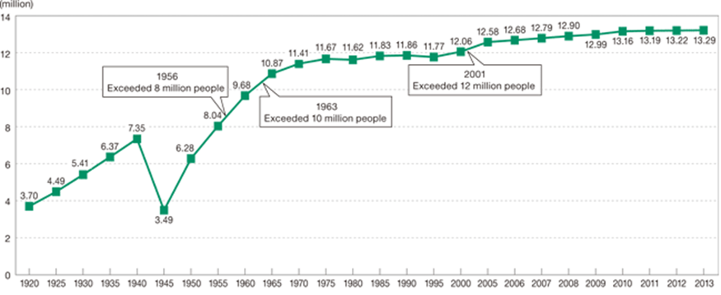
Tokyo historical population since 1920

Graph used courtesy of Matsuyama Mayumi, 2016 under a Creative Commons Attribution-Share Alike 4.0 International license. commons.wikimedia.org/wiki/File:Tokyo_historical_population.gif

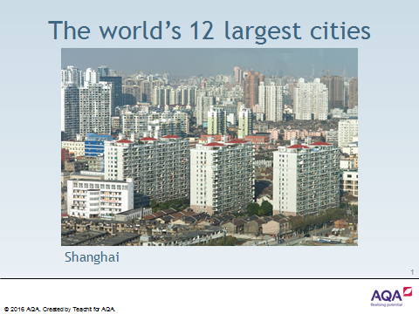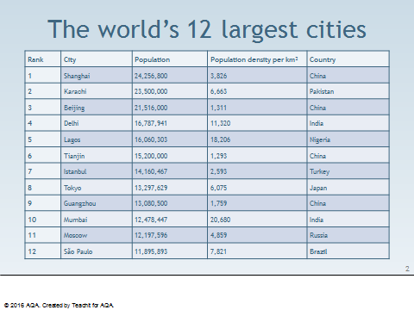

Brandt Report

The Brandt Report was written by the Independent Commission, first chaired by Willy Brandt (the former German Chancellor) in 1980, to review international development issues.

The report identified the Brandt Line, a north south divide between the extremely wealthy HICs and the poorer LICs.

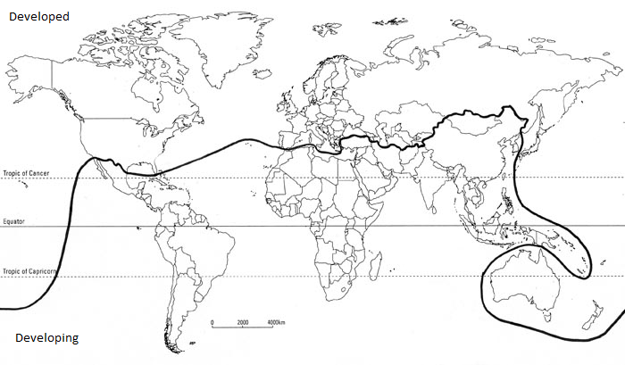
Map used courtesy of ovan.gec, 2015 under the Creative Commons Attribution-Share Alike 4.0 International license.commons.wikimedia.org/wiki/File:The_Brandt_Line.png

Student tasks
The rush to the towns has created the same kind of misery as existed in the 19th century cities of Europe and America. But industrialisation in those days was labour-intensive, so the cities grew as the jobs expanded.
The migration in today’s developing world is often due to the lack of opportunity in the countryside – it is ‘rural push’ as much as ‘urban pull’. The consequences of high birth rates and rapid migration are all too visible in many cities of the Third World (now referred to as LICs), with abysmal living conditions and very high unemployment or underemployment.
The strains on families, whose members are often separated, are very heavy. In Sao Paulo in Brazil, the population was growing at around 6-7 per cent annually in the late sixties and early seventies, in such appalling conditions that infant mortality was actually increasing.
The fact that people still migrate to these cities only underlines the desperate situation which they have left behind.
- Read the extract from the Brandt Report below.

- What does the Brandt Report identify as the two main causes of urbanisation?

- What does the Brandt Report identify as one cause of urban growth?

- Complete the card sort to match the correct term to the appropriate definitions.

Term | Definition
natural increase | The expansion of towns and cities so that they cover more land, as well as gaining large populations.
birth rate | The movement of people from the countryside to towns and cities where they wish to live permanently.
death rate | Reasons why people are encouraged to leave rural areas.
urbanisation | The average number of deaths of children under one year of age per 1000 live births.
unemployment | Employed at work, yet does not make use of or acknowledge one's full ability, training or such like.
underemployment | The number of deaths per 1000 people per year.
push factors | Reasons why people are attracted to urban areas.
rural-urban migration | The growth in population resulting in an excess of births over deaths.
pull factors | The increase in the proportion of people living in towns and cities.
infant mortality | The number of live births per 1000 people per year.
urban growth | The state of not having a job.

Teaching notes
- The Brandt Report identifies the main cause of urbanisation as push and pull factors encouraging rural-urban migration. However, the high birth rate in the urban areas will also contribute to a higher urbanisation percentage.
- The Brandt Report identifies a cause of urban growth as natural increase with birth rates of 6–7 per cent annually in the late sixties and early seventies.
- Card sort:
Term | Definition
natural increase | The growth in population resulting in an excess of births over deaths.
birth rate | The number of live births per 1000 people per year.
death rate | The number of deaths per 1000 people per year.
urbanisation | The increase in the proportion of people living in towns and cities.
unemployment | The state of not having a job.
underemployment | Employed at work, yet does not make use of or acknowledge one's full ability, training or such like.
push factors | Reasons why people are encouraged to leave rural areas.
rural-urban migration | The movement of people from the countryside to towns and cities where they wish to live permanently.
pull factors | Reasons why people are attracted to urban areas.
infant mortality | The average number of deaths of children under one year of age per 1000 live births.
urban growth | The expansion of towns and cities so that they cover more land, as well as gaining large populations.

Student tasks

- Working with a partner, cut up the cards below.
- Read each card carefully.
- Decide whether the card defines a push or pull factor.
- Separate the cards into two piles on the table in front of you.

Push | Pull
Lack of employment opportunities. | Limited food production due to overgrazing or the misuse of land, resulting in soil erosion or exhaustion.
Better paid jobs. (Factory workers receive about three times the wages of farm workers). | Pressure on the land, e.g. division of land among sons – each has too little to live on.
Starvation, resulting from either too little output for the people in the area or crop failure. Frequently, it may also be caused by a change in agriculture – from producing crops for the family/local community to a system that produces cash/plantation crops for consumption in HICs. | A better chance of services, e.g. schools, medical treatment, entertainment.
More comfortable houses and a higher quality of life. | Many families do not own land.
Extreme physical conditions, e.g. aridity, mountainous terrain, cold, heat and dense vegetation. | Lack of services.
The ‘bright lights’ of the city. | Overpopulation, resulting from high birth rates.
Religious and political activities can be carried out more safely. | Mechanisation has led to a reduction in jobs available on the land, as well as a decrease in yields in many areas.
Farming is hard work with long hours and little pay. In LICs, a shortage of money implies a lack of machinery, pesticides and fertiliser. | More reliable sources of food.
Local communities forced to move. | Lack of investment as money available to the government will be spent in urban areas.

Teaching notes

Push | Pull
Lack of services. | Better paid jobs. (Factory workers receive about three times the wages of farm workers).
Pressure on the land, e.g. division of land among sons – each has too little to live on. | More comfortable houses and a higher quality of life.
Limited food production due to overgrazing or the misuse of land, resulting in soil erosion or exhaustion. | A better chance of services, e.g. schools, medical treatment, entertainment.
Lack of employment opportunities. | The ‘bright lights’ of the city.
Many families do not own land. | Religious and political activities can be carried out more safely.
Starvation, resulting from either too little output for the people in the area or crop failure. Frequently, it may also be caused by a change in agriculture – from producing crops for the family/local community to a system that produces cash/plantation crops for consumption in HICs. | More reliable sources of food.
Overpopulation, resulting from high birth rates.
Extreme physical conditions, e.g. aridity, mountainous terrain, cold, heat and dense vegetation.
Mechanisation has led to a reduction in jobs available on the land, as well as a decrease in yields in many areas.
Lack of investment as money available to the government will be spent in urban areas.
Farming is hard work with long hours and little pay. In LICs, a shortage of money implies a lack of machinery, pesticides and fertiliser.
Local communities forced to move.

Student tasks

- Using the previous resource about push and pull factors, complete this diamond activity.

Most important push factors:

Least important push factors:

S.A.T.O.

This image shows informal employment in a LIC city. The man may have migrated from the countryside in search of a better life.

In geography useful information can usually be obtained from studying photographs like this. One helpful method is to answer SATO questions.

Senses

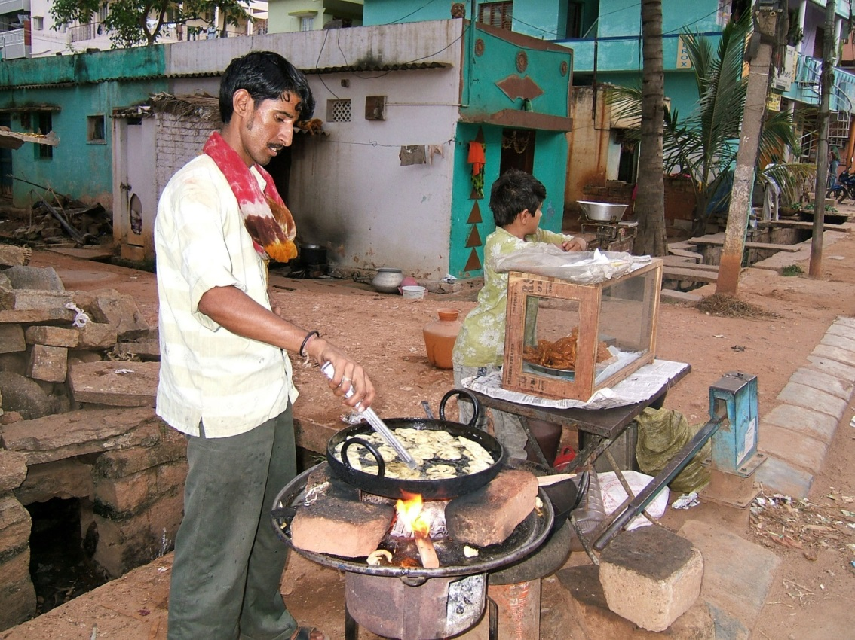
- What can you see?
- What could you hear if you were there?
- What could you smell if you were there?

Action

- What do you think is happening in the photograph?
- Why was it happening?
- What could be going on to the left and right of the scene in the photograph?

Time

- What do you think happened immediately before this photograph was taken?
- What do you think might happen next?
- How do you think the scene in the photograph has changed since the photograph was taken in 2007?
©Shankar.s.2007 https://flic.kr/p/cCTHKY
Overall

- What does this photograph tell us, e.g. about people and place/location?
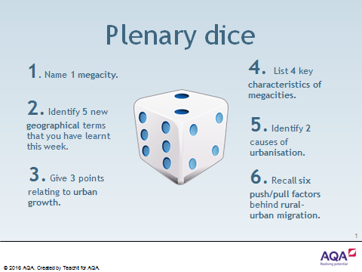

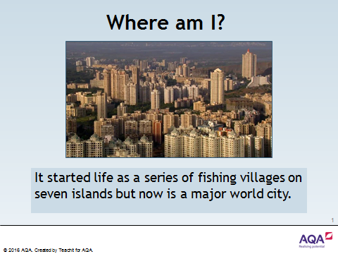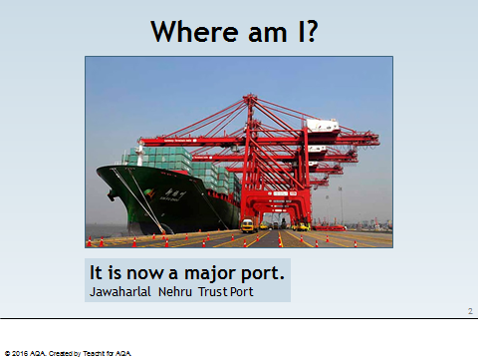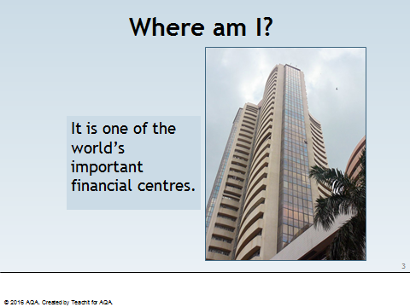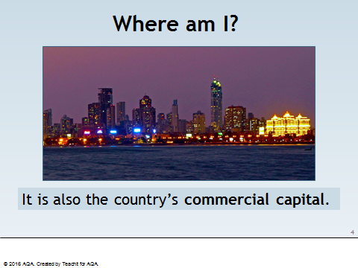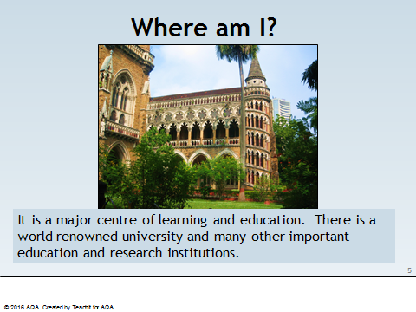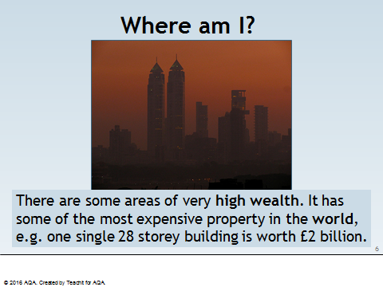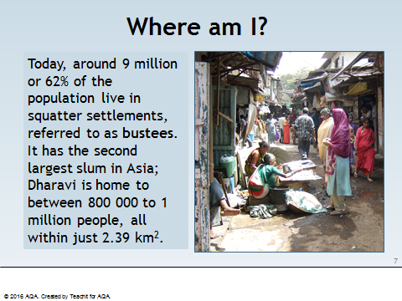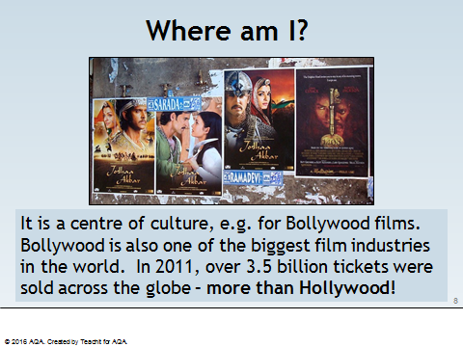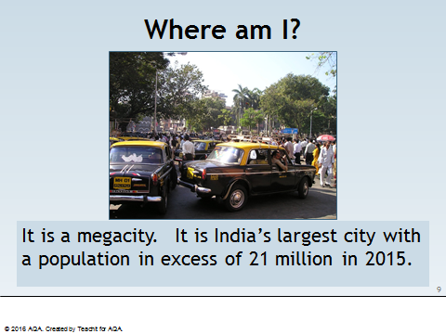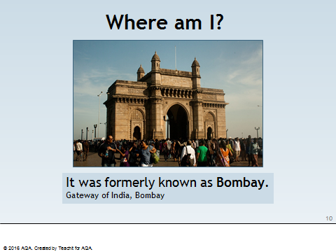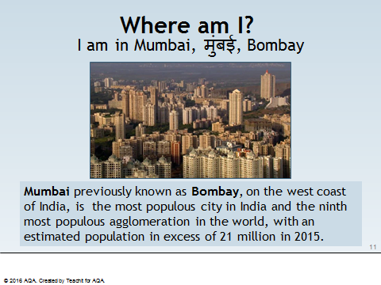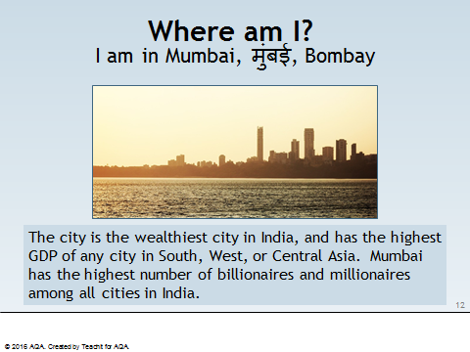

This activity will help you to:

- locate Mumbai.
- appreciate its importance regionally, nationally and internationally.
- understand why it has grown so rapidly.

Student tasks

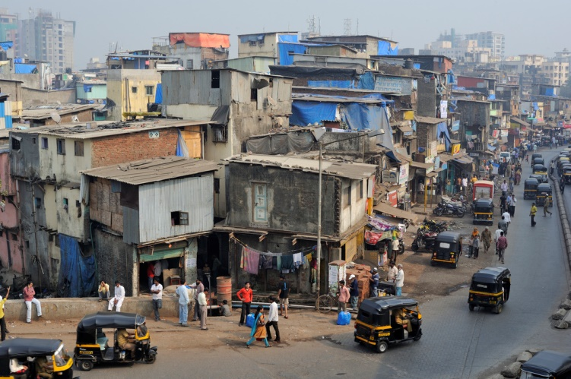
- On the India in the world map outline, shade and label the country of India.

- On The states of India outline map of India, mark on the following:
- the city of Mumbai
- the capital city, New Delhi
- the Arabian Sea
- the Bay of Bengal
- the Indian Ocean
- the state of Maharashtra.

- On the more detailed map of Mumbai city, identify the following:
- the Sanjay Gandhi National Park
- the centre of Mumbai
- Navi Mumbai
- the slum area of Dharavi.
The edge of Dharvai in Mumbai
Image used courtesy of M M Padmanaba01, 2010 under a 2.0 Generic (CC by SA 2.0 license. flickr.com/photos/43423301@N07/5842973175/

India in the world

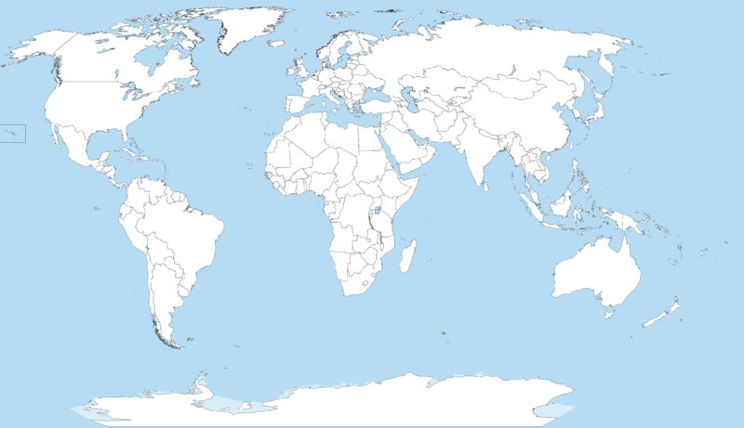
Image in public domain under Creative Commons Attribution-Share Alike 3.0 Unported license.2014, courtesy of Wikipedia https://commons.wikimedia.org/wiki/File:A_large_blank_world_map_with_oceans_marked_in_blue.PNG

The states of India

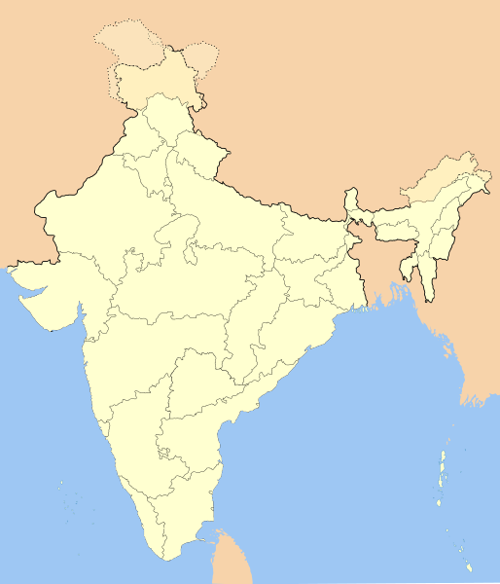

Image in public domain under Creative Commons Attribution-Share Alike 3.0 Unported license.2016, courtesy of Wikipedia
en.wikipedia.org/wiki/File:India-locator-map-blank.svg

Map of Mumbai

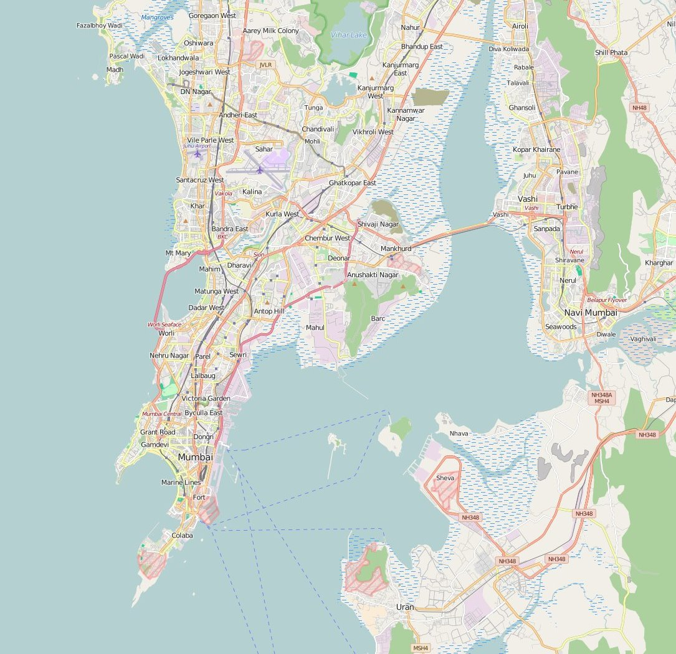
Map used courtesy of OpenStreetMap under the Creative Commons Attribution-ShareAlike 2.0 licence. openstreetmap.org/#map=12/18.9917/72.8479

- Use the Internet to research Mumbai’s importance as a regional, national and international centre and its growth over time and space.

- Insert details into the relevant boxes below. A few points have been added to get you started.

Growth
Largely due to natural increase and rural-urban migration.
Population has nearly doubled since 1991, from 12.5 million to over 21 million people today (estimated figure for the city and its metropolitan area in 2015).
Started life as a series of fishing villages, became a port, with growth concentrated on the peninsular, and is now a megacity.
The Malad-Dahisar region in the west and Cembur-Govandi region in the east have grown the fastest.
The north is becoming more populated, whilst the south is now less populated.

Importance Nationally
India’s financial and commercial centre.
India’s principal port.

Importance Regionally
The capital city of the Indian state of Maharashtra.

Student tasks

Work with a partner.

- Cut up the following cards.
- Read each card carefully.
- Decide whether it is an opportunity for the megacity of Mumbai or a challenge that it faces.
- Create two piles on the table in front of you.
- Answer the question – Is Mumbai a city of opportunities or challenges?

Opportunities for the Mumbai megacity | Challenges for the Mumbai megacity
A major centre of learning and education. Mumbai has a world renowned university and many other important education and research institutions. | The city runs more than 1,000 primary and secondary schools, with free education up to certain ages.
Most people have an electricity and water supply. | It is the financial capital of India, the home of the Mumbai Stock Exchange.
Literacy rates are high (89.7%). Even in the slums, the literacy rate is estimated to be more than 69%. | It is the centre of the Hindi movie industry – Bollywood with many media concerns, e.g. television and satellite networks, publishing houses, which employ huge numbers of people.
An estimated 9 million (62% of the population) people live in squatter settlements (bustees) today. It has the second largest slum in Asia (Dharavi, in central Mumbai, is home to nearly 1 million people in just 2.39 km²). It was initially an area of temporary shelter, but is now a permanent feature. | Drop-out rates are high. Many youngsters, particularly in slum areas, are unable to pursue their education as they must find a job to bring in some money to support their family. There are inadequate resources and declining standards in public institutions.
Water pipes often run close to sewer lines. Leakages lead to contamination of water and the spread of water-borne diseases. In Dharavi, children play amongst sewerage waste. Doctors deal with 4,000 cases a day of typhoid and diphtheria. | Urbanisation is the main cause of unemployment. Economic growth has not been fast enough to create sufficient jobs for the available workforce.
Crime rates are high. Nearly one third of the population have been victims of crime. Corruption is rife and 22.9% of citizens have been exposed to bribery. | Rubbish is frequently left in the streets. This attracts vermin, e.g. rats and flies. Poisonous liquids may leak and contaminate ground water supplies.
It is an important economic hub of India, contributing 10% of all factory employment and 40% of foreign trade. | Many of India’s TNCs (trans-national corporations) are based here, e.g. State Bank of India, Reliance and Tata.
Mumbai has severe water shortages. Water is rationed. Standpipes often come on for two hours at 5.30 am and are shared between many people. | Air pollution is high as old cars emit dirty and harmful fumes and there is little regulation of emissions from factories. Sewerage waste is not always treated properly and drains into the sea.
It has a large, unskilled and informal self-employed workforce. These are often unregulated workers, e.g. street hawkers, street sellers, taxi drivers and mechanics. | It has areas of wealth, with some of the most expensive property in the world. One 28 storey structure is worth £2 billion.
Overcrowding means diseases spread very easily, e.g. dysentery, malaria, plague, jaundice, diarrhoea and typhoid. | Underemployment is common (people paid less than they should be for the task that they do), with poor working standards.
It has most of India’s specialised technical industries, e.g. aerospace, optical engineering, medical research, computers and electronic equipment, shipbuilding and salvaging and renewable energy. | Many people often live far from their place of work and are dependent on public transport. Buses and trains are always crammed. Roads are overcrowded with vehicles. The movement of traffic is very slow. Peak traffic times can last several hours.
Other formal work may be in government- or state-related positions. | It has the best city transport system in India.
Many properties have a water and electricity supply, but this has often been set up haphazardly and poses health and safety risks. | Levels of PM10 (particulate matter which can cause asthma, bronchitis and cancer) are dangerously high (132 mg/m³; WHO’s recommendation is 20 mg/m³).
At least 650 million litres of water are lost each day due to old, leaking pipes. Slum dwellers may spend up to 20% of their income on water. | There is a lack of basic sanitation in Mumbai with only 1 toilet per 1,000 people on average in the unplanned squatter settlements.

Student tasks

Work with a partner.

- Cut up the following cards.
- Read each card carefully.
- Decide whether it is an opportunity for the megacity of Mumbai or a challenge that it faces.
- Create two piles on the table in front of you.
- Answer the question – Is Mumbai a city of opportunities or challenges?

Opportunities for the Mumbai megacity | Challenges for the Mumbai megacity
Mumbai is major centre of learning and education. | Mumbai has more than 1,000 primary and secondary schools.
Literacy rates are high. | It is the financial capital of India.
Most people have an electricity and water supply. | It is the centre of the Hindi movie industry – Bollywood.
An estimated 9 million (62% of the population) people live in squatter settlements known as bustees. | Many youngsters, particularly in the squatter settlements are unable to complete their education as they must find a job.
Water pipes often run close to sewer lines. Leakages lead to contamination of water and the spread of diseases. | Nearly one third of the population have been victims of crime.
Economic growth has not been fast enough to create sufficient jobs for the available workforce. | At least 650 million litres of water are lost each day in Mumbai due to old, leaking pipes.
It is an important economic hub of India, contributing 40% of foreign trade. | Many of India’s trans-national corporations are based in Mumbai.
Rubbish is frequently left in the streets. Poisonous liquids may leak and contaminate ground water supplies. | Air pollution is high as old cars emit dirty and harmful fumes.
It has a large, unskilled and informal self-employed workforce. | It has areas of wealth, with some of the most expensive property in the world.
It has most of India’s specialised technical industries. | Many people often live far from their place of work and use public transport.
Formal employment may be in government or state-related positions. | It has the best city transport system in India.
There is a lack of basic sanitation (on average, 1 toilet per 1000 people) in the unplanned squatter settlements. | Many properties have a water and electricity supply, but this has often been set up illegally and poses health and safety risks.
Sewerage waste is not always treated properly and drains into the sea. | Workers are often unregulated, e.g. street sellers, taxi drivers and mechanics.
Slum dwellers may spend up to 20% of their income on water. | There is little control of emissions from factories in Mumbai.
Buses and trains are always overcrowded. | Corruption is a common problem in Mumbai.

Work with a partner.

Complete the ‘diamond nine’ activity below, prioritising the challenges that the megacity of Mumbai must address (from most important to least important). Make sure that you are later able to justify why you have placed items where you have.

Most important challenge to address:

Least important challenge to address:

A slum in Jakarta Indonesia

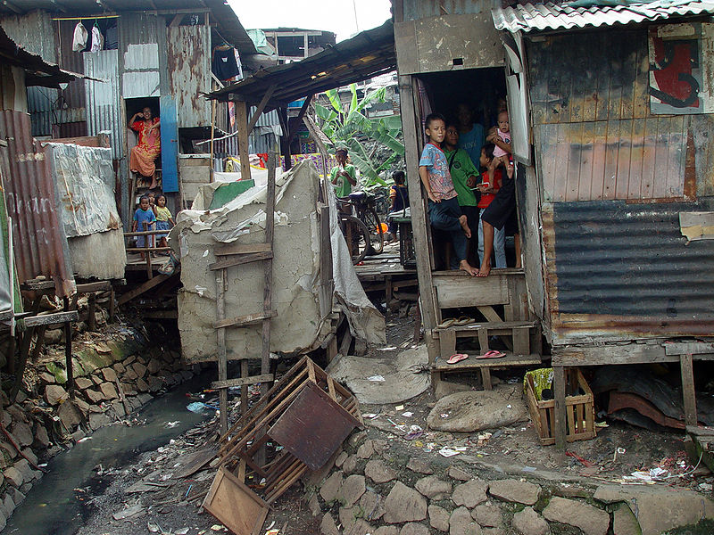
See
Touch
Hear
Feel (emotions)
Smell
Taste

Image used courtesy of ©JonathanMcIntosh2004/commons.wikimedia.org/wiki/File:Jakarta_slumlife31.JPG

Extension task

The image was taken in 2004. How do you think this slum/shanty town will have changed since then?

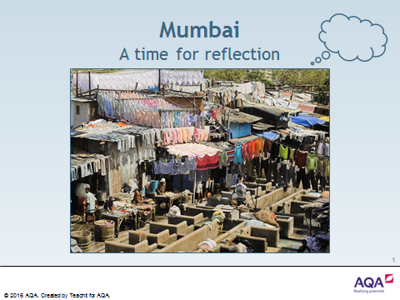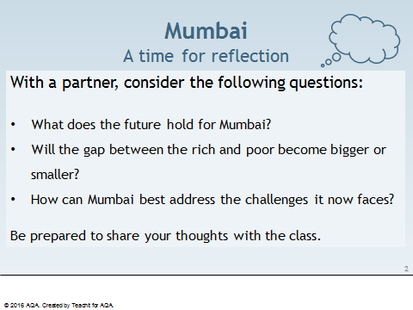

S.A.T.O.

In geography useful information can usually be obtained from studying photographs like this. One method is to answer SATO questions.

Senses
- What can you see?
- What could you hear if you were there?
- What could you smell if you were there?

Action

- What do you think is happening in the photograph?
- Why was it happening?
- What could be going on to the left and right of the scene in the photograph?

Time

- What do you think happened immediately before this photograph was taken?
- What do you think might happen next?
- How do you think the scene in the photograph has changed since the photograph was taken in 2004?
Image used courtesy of ©JonathanMcIntosh2004/commons.wikimedia.org/wiki/File:Jakarta_slumlife31.JPG
Overall

- What does this photograph tell us, e.g. about people and place/location?
A slum in Jakarta Indonesia

Image used courtesy of ©JonathanMcIntosh2004/commons.wikimedia.org/wiki/File:Jakarta_slumlife31.JPG

My top ten wishes are:

Student tasks

Use the word bank to complete the two geodoku grids below:

Disease | Few jobs | No electricity
No sanitation | Overcrowding | Poor water supply

Disease |  |  | Few jobs | No electricity
 |  | Overcrowding |  | Disease | Poor sanitation
Overcrowding | No electricity |  |  | Poor sanitation
 | Disease |  | No electricity |  | Poor water supply
Poor water supply | Overcrowding |  | Poor sanitation | Few jobs
 |  | No electricity |  |  | Disease

 | Poor sanitation |  | Overcrowding | Poor water supply
No electricity |  | Poor water supply | Poor sanitation |  | Disease
 | Few jobs | No electricity |  |  | Overcrowding
Overcrowding |  |  | Few jobs
Few jobs |  | Overcrowding |  | Poor sanitation
Poor water supply | Disease | Poor sanitation |  | Overcrowding

Teaching Notes

The rules of Sudoku are easy and probably well known to the students, although the six by six grids used in this resource are possibly less familiar. These two geodoku (a geography based Sudoku) grids use six key words/phrases linked to urban issues in LICs. The students need to place one of the six key words/phrases into each empty cell in the grid. Each row, column, and three by two boxes must contain only one of each of the six key words/phrases.

These two geodoku grids are set at an easy level. Students could be set a time limit if they find this puzzle too easy or you could ask them to design one themselves using the six key words/phrases.

Sudoku grid answers

Disease | Poor water supply | Poor sanitation | Few jobs | No electricity | Overcrowding
No electricity | Few jobs | Overcrowding | Poor water supply | Disease | Poor sanitation
Overcrowding | No electricity | Poor water supply | Disease | Poor sanitation | Few jobs
Poor sanitation | Disease | Few jobs | No electricity | Overcrowding | Poor water supply
Poor water supply | Overcrowding | Disease | Poor sanitation | Few jobs | No electricity
Few jobs | Poor sanitation | No electricity | Overcrowding | Poor water supply | Disease

Disease | Poor sanitation | Few jobs | Overcrowding | Poor water supply | No electricity
No electricity | Overcrowding | Poor water supply | Poor sanitation | Few jobs | Disease
Poor sanitation | Few jobs | No electricity | Poor water supply | Disease | Overcrowding
Overcrowding | Poor water supply | Disease | Few jobs | No electricity | Poor sanitation
Few jobs | No electricity | Overcrowding | Disease | Poor sanitation | Poor water supply
Poor water supply | Disease | Poor sanitation | No electricity | Overcrowding | Few jobs

S.A.T.O.

In urban geography useful information can always be obtained from studying photographs. One method is to answer SATO questions.

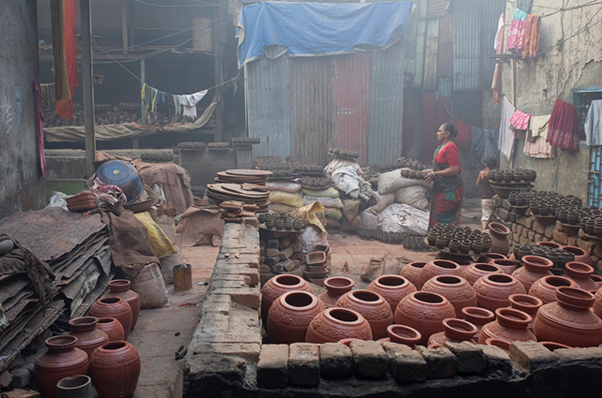
Senses

- What can you see?
- What could you hear if you were there?
- What could you smell if you were there?

Action

- What do you think is happening in the photograph?
- What could be happening to the left and right of the scene in the photograph?

Time

- What do you think happened immediately before this photograph was taken?
- What do you think might happen next?
- How do you think the scene in the photograph has changed since the photograph was taken?
©MM2010https://flic.kr/p/9aDcRU
Overall

- What does this photograph tell us, e.g. about people and place/location?

Student tasks

- Read the statements in the table below.
- Decide whether each is true or false and write your answer in the second column.
- If the statement is false, then explain why and add a correct version in the final column.

Statement | True or false? | Why is it false?  Corrected statement
55% of Mumbai’s population live on 40% of the land.
The Dharavi slum is home to 1.2 million people.
Rents are high.
90% of residents have access to safe drinking water.
Toxic levels are three times more than the safe limit.
Products made in Dharavi are sourced and sold to all around the world.
All businesses in Dharavi make a huge loss.
The slum is home to a handful of small businesses and single-room factories.
30% of Mumbai’s waste is recycled; 23% in the UK.
The average wage in Dharavi is $1.25 or £0.80 a day.
Disease is limited.

Answers

Statement | True or false? | Why is it false?  Corrected statement
55% of Mumbai’s population live on 40% of the land. | False | 55% of Mumbai’s population live on 6% of the land.
The Dharavi slum is home to 1.2 million people. | True
Rents are high. | False | Rent is as low as 185 Rupees a month ($4 or £2.20).
90% of residents have access to safe drinking water. | False | 24% of residents have access to safe drinking water.
Toxic levels are three times more than the safe limit. | True
Products made in Dharavi are sourced and sold to all around the world | True
All businesses in Dharavi make a huge loss. | False | Annual business turnover in Dharavi is or $650 or £350 million every year. This is the equivalent of $2.5 million or £16 million per hectare of land.
The slum is home to a handful of small businesses and single-room factories. | False | The slum is home to 5,000 businesses and 15,000 single-room factories.
30% of Mumbai’s waste is recycled; 23% in the UK. | False | 80% of Mumbai’s waste is recycled, 23% in the UK.
The average wage in Dharavi is $1.25 or £0.80 a day. | True
Disease is limited. | False | 4,000 cases of disease are reported daily.

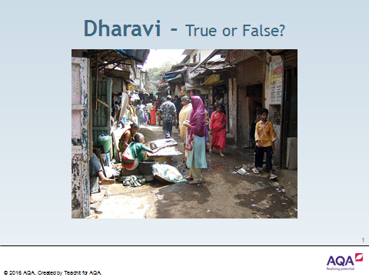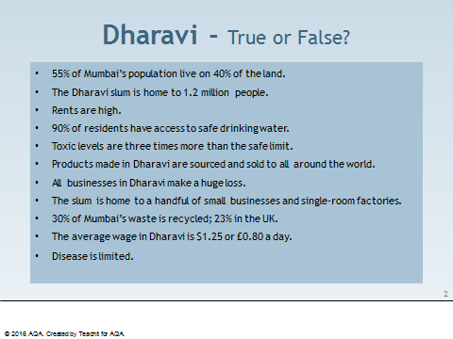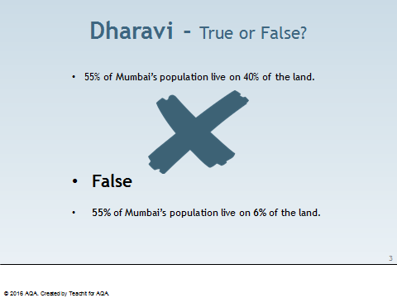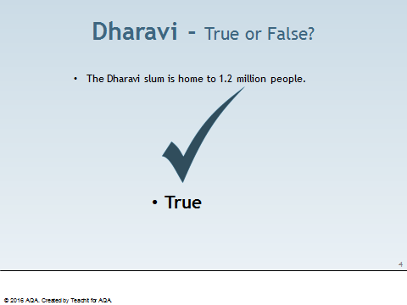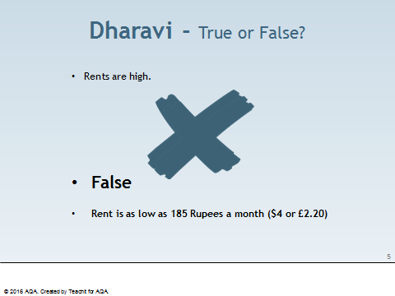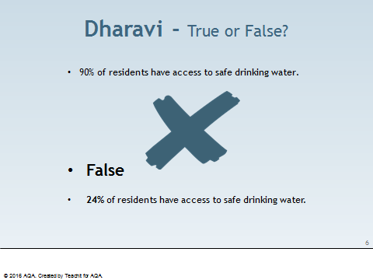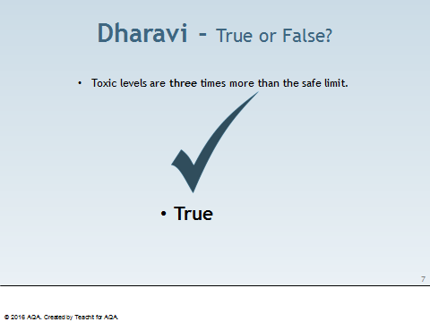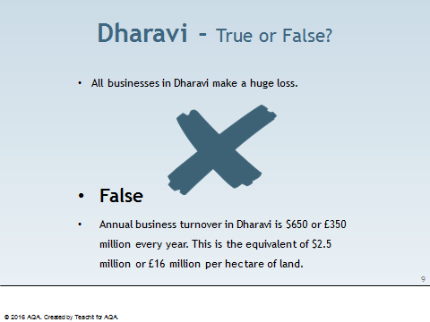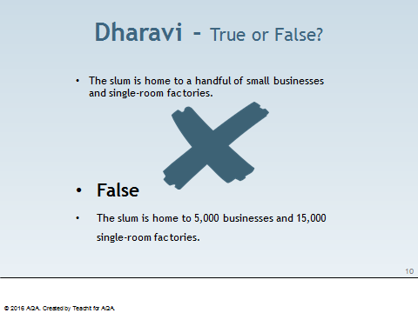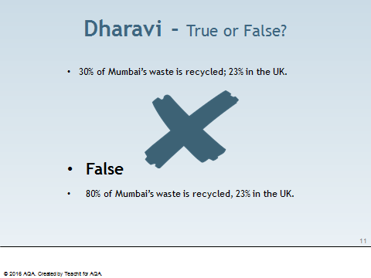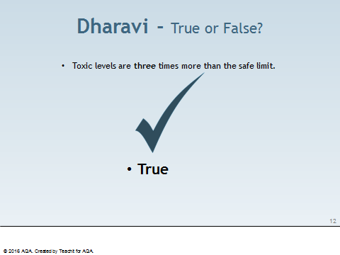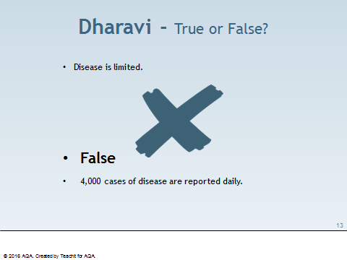

Introduction

Dharavi in Mumbai is one of the largest slums in the world. It was made famous by the film, Slumdog Millionaire. The slum has a population of between 700,000 and 1 million people and currently covers an area of approximately 200 hectares or 2km².

Dharavi dates back to 1882, when factories and residents were moved out of the city centre to what was then a mangrove swamp. Since then it has grown considerably due to migration from the surrounding poor rural areas into Mumbai.

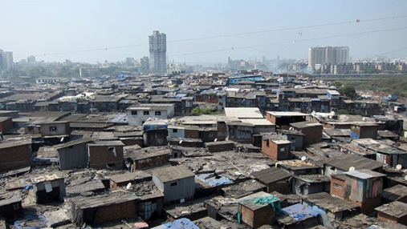
The very high population density and poor sanitation in Dharavi has resulted in the easy spread of many diseases.

Since 1997, there have been several plans to redevelop Dharavi. The slum is next to three railway lines and several major roads making it easily accessible to nearby Mumbai city centre and the rest of India.

Private developers are keen to develop the area. In 2010, it was estimated the redevelopment would cost at least US$2.2 billion.

©TheForumofYoungGlobalLeaders2011flic.kr/p/aW97tx

Student tasks

- What is the population density of Dharavi?

- What diseases might spread easily in Dharavi?

- Listen to the BBC radio programme, Crossing Continents, India - The Real Slumdog Story at:

bbc.co.uk/programmes/b00cyl87

This explains a controversial plan to provide the answer Dharavi’s problems.

- Read the two paragraphs below:

The latest urban redevelopment plan proposed for the Dharavi area is to raze it to the ground and to construct 2,800,000 square metres of housing, schools, parks and roads to serve the families residing in the area. Approximately 4 million square metres of residential and commercial space for sale would also be provided.

There is still a significant local opposition to the plans. Existing residents still feel 33 square metres of accommodation per tenant is not adequate and disagree that only families who lived in the area before 2000 would be resettled. Concerns have also been raised that some small businesses in the 'informal' sector may not be relocated under the redevelopment plan.

- Imagine you are asked to provide a list of five bullet points to attempt to convince a Dharavi resident to accept the redevelopment plan.

- Imagine you are living in Dharavi, write a letter to the local government explaining why you
disagree with the planned scheme.

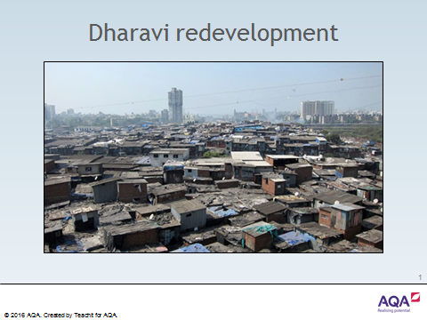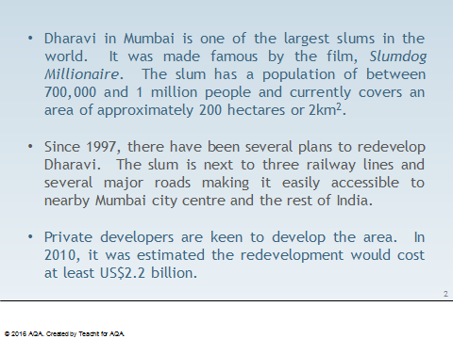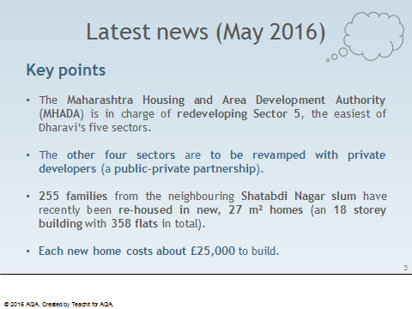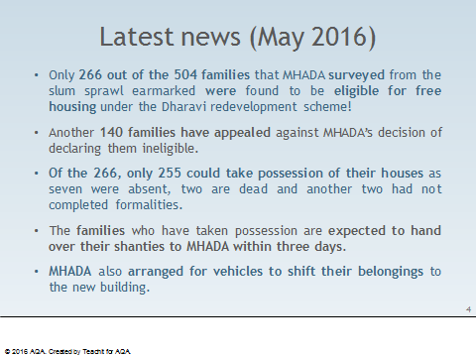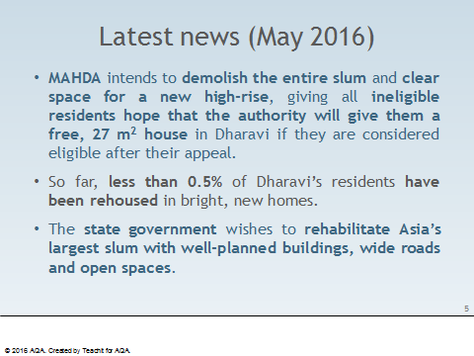

Student task

Test yourself!
Now that you have spent some time looking at urban growth in Mumbai, how much can you recall about it?
You should try to include at least five facts/points in each of the following boxes.

Mumbai in the past,  e.g. What was Mumbai like 20 years ago? | Mumbai in the present,  e.g. What is happening in Mumbai right now? | Mumbai in the future  e.g. What will Mumbai be like in 20 years’ time?

Now, share your notes with a partner. Are you able to add any further facts/points following your discussion?
Introduction

Population density is the number of people living in a particular area, e.g. the population density of the UK is approximately 259 people per km². Some areas will be much higher than others, e.g. cities such as London, Portsmouth and Liverpool. The population density in a city is always very high, e.g. in 2011, Greater London had a population density of approximately 5,200 people per km².

Student tasks

Use the table on the next page.

- Which region of the UK had the highest population density in 2011?

- Which region of the UK had the lowest population density in 2011?

- What was the average density for all of the UK in 2011?

- Which region of the UK was nearest the average population density in 2011?

- The average density in Scotland was approximately 67 people per km². Name an area or place in Scotland that has a higher population density.

- Construct a bar graph of the population densities of the UK in 2011. Use a vertical scale of 1 cm to 1,000 people per km².

Region | Population (2011) | Population density (2011)
England | 53,012,456 | 406.55/km²
- South East  - Greater London  - North West  - East  - West Midlands  - South West  - Yorkshire and Humber  - East Midlands  - North East | 8,634,750  8,173,941  7,052,177  5,846,965  5,601,847  5,288,935  5,283,733  4,533,222  2,596,886 | 452.20/km²  5199.71/km²  497.86/km²  305.80/km²  430.00/km²  221.95/km²  342.65/km²  290.09/km²  302.24/km²
Scotland | 5,295,000 | 67.22/km²
Wales | 3,063,456 | 147.43/km²
Northern Ireland | 1,810,863 | 130.81/km²
United Kingdom | 63,181,775 | 259.16/km²

Data adapted from Office of National Statistics, under Open Government Licence v3.0
ons.gov.uk/peoplepopulationandcommunity/populationandmigration

Extension task

Use the table of population densities of the UK in 2011 to construct a bar graph of regional population densities on the map on the next page.

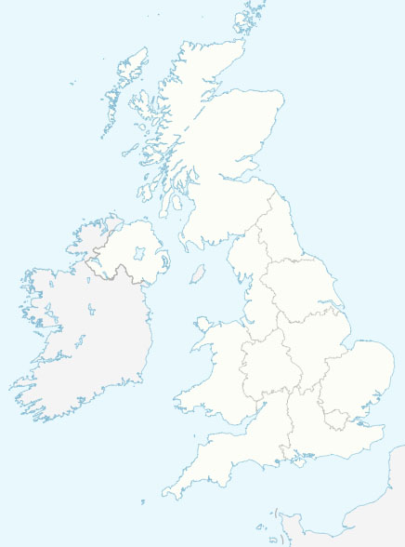
Map used courtesy of NordNordWest, 2008
Creative Commons Attribution-Share Alike 3.0 Unported license.
Introduction

The satellite image below shows most of Great Britain as it appeared on the night of 27 March, 2012. The areas of white show the major centres of population.
Student tasks

- Which country of the United Kingdom, England, Wales, Scotland and Northern Ireland has the largest number of bright lights at night?
- Which country of the British Isles has the lowest number of bright lights at night?
- What are the lights in the northeast corner of the satellite image?
- Use an atlas to name the ten largest cities on the satellite image below:

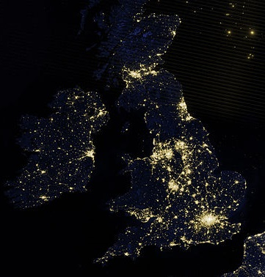
Map used courtesy of the NASA Earth Observatory the Creative Commons Attribution 2.0 Generic license. commons.wikimedia.org/wiki/File:Northwestern_Europe_at_night_by_VIIRS.jpg

Introduction

The Romans established the first settlement of Londinium on the banks of the River Thames. Today, London is the largest city in England and the United Kingdom and has a worldwide influence. Within the city there is a diverse range of peoples and cultures, with more than 300 languages spoken.
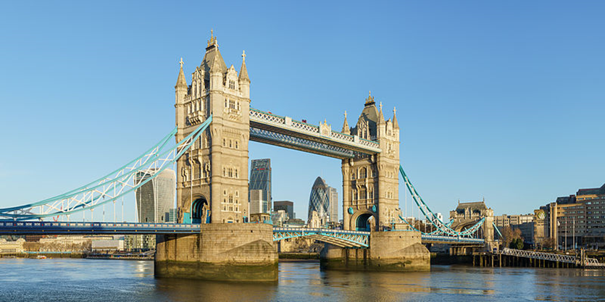
© User:Colin / Wikimedia Commons / CC BY-SA 4.0

Your task is to produce a detailed case study of London as an urban settlement.

Student tasks

- Find a map to show the location of the city in relation to other countries throughout the world.

- Find a map to show the location of the city within the UK.

- Include one or more images that is/are representative of London.

- Explain the importance of the city globally. Do not forget to give sources for your information.

- Explain the importance of the city nationally. Have you given sources?

- Urban change in London has created many social opportunities. How has migration affected London? What cultural, recreational and entertainment opportunities are there in London?

- Urban change in London has created many economic opportunities. List some of the economic opportunities in London.

- What is the importance of the integrated transport systems in London?

- London has created many environmental opportunities, e.g. urban greening. Explain the importance of green spaces within London.

- Urban change in London has also created social and economic challenges. Describe the challenges of urban deprivation, inequalities in housing, education, health and employment.

- Urban change in London has also created environmental challenges. What is urban dereliction? What are brownfield and greenfield sites? What are the challenges of waste disposal in London?

- What are the impacts of national and international migration on the growth and character of the city?

- What is the impact of urban sprawl on the rural–urban fringe of London?

- What are commuter settlements?

Name:
Date:

Self-assessment

I think that I have achieved marks.

Reasons:

Peer assessment

I think that achieved marks.

Reasons:

Suggested area(s) for improvement

Teacher assessment

I think that has achieved marks.

Reasons:

Suggested mark scheme

Marks | Description
1 - 3 | - Has included a suitable map to show the location of the city in relation to other countries throughout the world, but a caption is missing.  - Has ‘zoomed in’ and included a map to show the location of the city within the UK, but no caption is visible.  - Has included an image that is fairly representative of the city.  - Has shown some awareness of copyright restrictions, but the source/s of the inserted material, e.g. maps and image, has/have not been recorded.  - Has begun to explain why the city is important nationally.  - Has begun to explain why the city is important globally.  - Has briefly outlined the impact of urban sprawl on the rural-urban fringe and the growth of commuter settlements, but no named examples have been given.  - Has listed a couple of social, economic and environmental opportunities relating to urban change.  - Has listed a couple of social, economic and environmental challenges relating to urban change.  - Has identified a few of the impacts of both national and international migration on the growth and character of the city, but no statistical evidence has been mentioned.  - Has shown limited use of initiative, with findings presented in a somewhat disorganised manner.  - Has conducted a degree of independent research and utilised a few different sources in order to gain the required information.

4 - 6 | - Has included a suitable map to show the location of the city in relation to other countries throughout the world, but little or no caption has been added.  - Has ‘zoomed in’ and included a map to show the location of the city within the UK, but the accompanying caption is either brief or omitted entirely.  - Has included an image that is representative of the city.  - Has considered copyright implications to some degree and attempted to identify the source/s of much of the inserted material, e.g. maps and image.  - Has given some reasons as to why the city is important nationally.  - Has given some reasons as to why the city is important globally.  - Has identified the impacts of both national and international migration on the growth and character of the city, although statistical evidence is limited.  - Has listed some social, economic and environmental opportunities relating to urban change.  - Has listed some social, economic and environmental challenges relating to urban change.  - Has discussed the impact of urban sprawl on the rural-urban fringe and the growth of commuter settlements, with just one or two example/s named.  - Has shown some use of initiative and presented findings in an appropriate manner.  - Has conducted independent research and utilised several sources in order to gain the required information.

7 - 10 | - Has included a suitable map to show the location of the city in relation to other countries throughout the world, along with an appropriate caption.  - Has ‘zoomed in’ and included a map to show the location of the city within the UK, which is accompanied by a brief caption.  - Has included at least one image that is truly representative of the city.  - Has clearly identified the source(s) of all inserted material, e.g. maps and images.  - Has explained in detail why the city is important nationally.  - Has explained in detail why the city is important globally.  - Has identified the impacts of both national and international migration on the growth and character of the city, incorporating relevant statistics.  - Has listed many social, economic and environmental opportunities relating to urban change.  - Has listed many social, economic and environmental challenges relating to urban change.  - Has discussed the impact of urban sprawl on the rural-urban fringe and the growth of commuter settlements, giving several examples.  - Has shown use of initiative and presented findings in an imaginative and effective manner.  - Has conducted independent research and utilised a number of sources in order to gain the required information.

Useful webpages

- google.co.uk/maps
- bing.com/mapspreview
- search.creativecommons.org/
- data.london.gov.uk/census/
- data.london.gov.uk/demography/
- files.datapress.com/london/dataset/population-change-1939-2015/historical%20population%201939-2015.pdf
- youtube.com/watch?v=oAFQ1W1JZ0w
- theguardian.com/cities/2014/may/15/the-evolution-of-london-the-citys-near-2000-year-history-mapped
- bbc.co.uk/news/uk-england-london-31056626

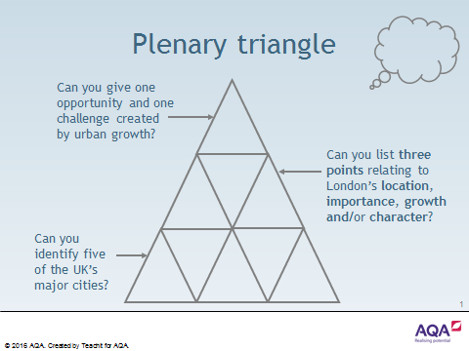

London and UK cities urban quiz questions

 | Question | Answer
1. | What G is one of the UK’s major cities?
2. | What C M is often used to show variations in population density?
3. | What L has a population density that is 10 times more than anywhere else in the UK?
4. | What M is the movement of people from one place to another?
5. | What S describes the spread of cities into the countryside?
6. | What U is the opposite of rural and is used to describe towns and cities?
7. | Which R was responsible for establishing the settlement of Londinium in AD 47?
8. | What U G is an environmental opportunity created by urban change?
9. | What U D is a social and economic challenge created by urban change?
10. | What I are found in all urban areas and often relate to significant differences in education, health, employment and housing?
11. | What C S are found beyond the urban-rural fringe?
12. | What B S are derelict areas, often found in the inner city, that have previously been in use?
13. | What D is the study of population statistics?
14. | What R T is a physical feature that divides the city of London into two parts, north and south?
15. | What G S is a piece of land that has not been built on before, but is now being considered for development?

Student task

- Can you provide definitions for the following key words and terms?

Sustainability key words and terms
Biofuel | Green electricity
Biomass | Greenfield site
Brownfield site | Greenhouse gases
Carbon credit | Non-renewable resources
Carbon footprint | Photovoltaic cell
Congestion charge | Pollution
Cost benefit analysis | Recycling
Deforestation | Regeneration
Economic development | Renewable resources
Food miles | Smog
Fossil fuels | Stewardship
Geothermal energy | Sustainable
Global warming | Think global, act local

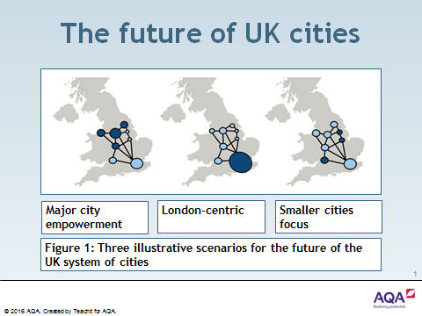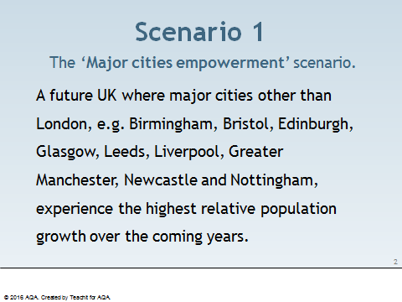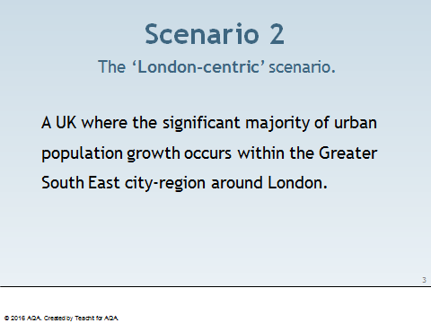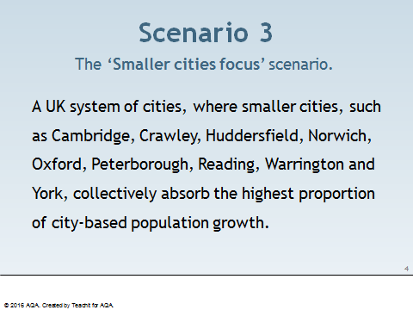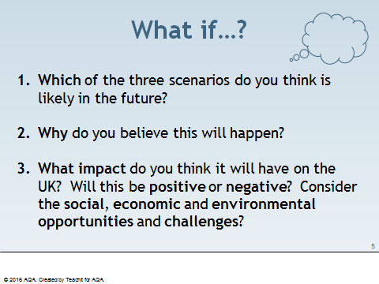

Name of urban centre

What do I already know?
What do I want to know?
- An example of an urban regeneration project to show:

- reasons why the area needed regeneration;

- the main features of the project.
How can I find out?

What have I learnt?

Student task

Gloucester was always a small port, but shipping had to navigate the treacherous tides of the River Severn. In 1827, the Gloucester and Sharpness canal was opened and that significantly increased trade through, and development in, the docks.

As ships have become ever larger since Victorian times, the port of Gloucester has declined in importance. Nowadays, visiting narrow boats, the occasional yacht and other pleasure boats have replaced the working ships and barges and the old Victorian warehouses on the quaysides have been transformed.

What was once a busy working port is now a major tourist attraction, home to Gloucester Quays Designer Outlet, Gloucester Quays Antiques Centre, museums, waterfront bars, restaurants and coffee shops.

Student task

Match the caption to the correct image:

Caption
- Leisure use at Gloucester docks today
- Warehouse converted for flats and offices
- Church for Norwegian sailors at Gloucester docks
- Warehouse and flour mill at Gloucester docks
- Warehouses at Gloucester dock in 1973
- Old warehouse – change of use to an Antiques centre
- A café/bar in a renovated warehouse at Gloucester docks
- Working barges in Gloucester docks, 1999

a.
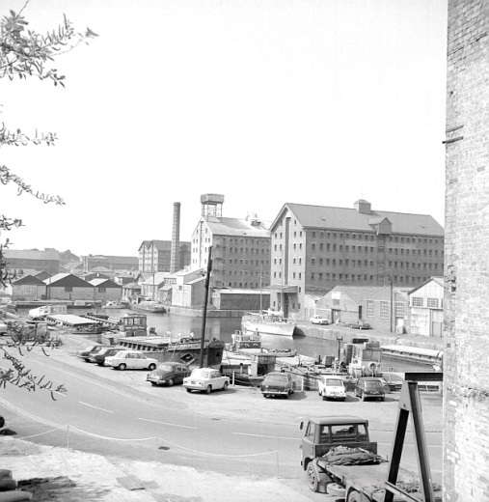

b.
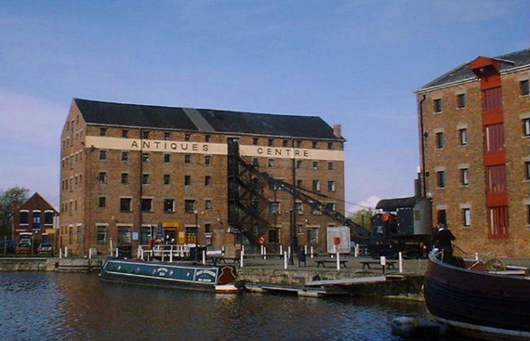

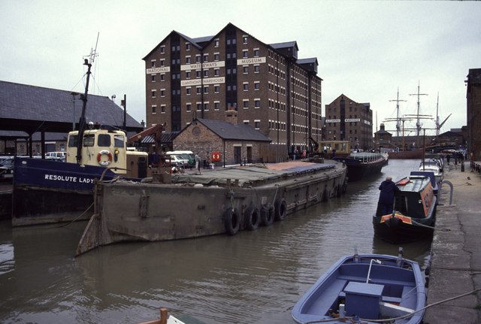
c.

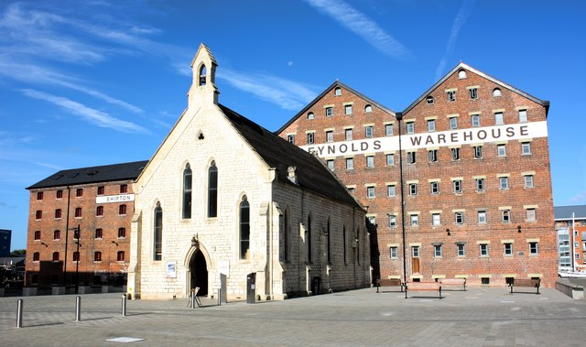
d.

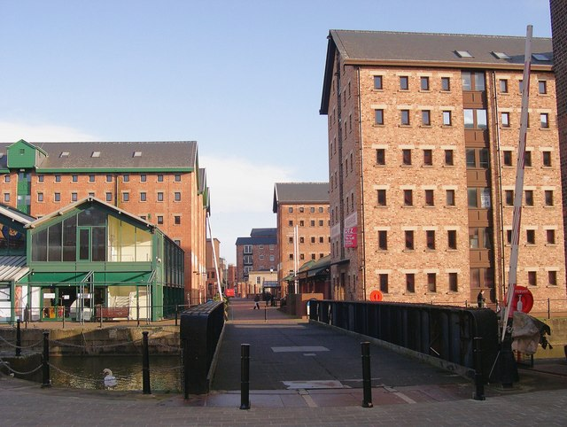
e.

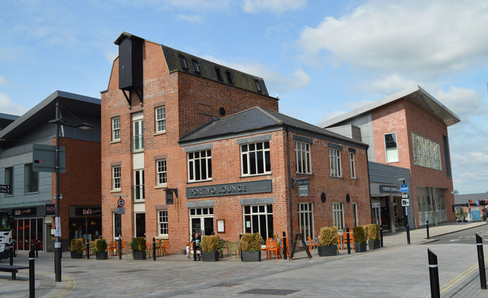
f.

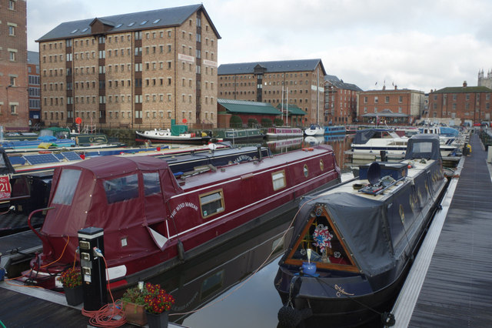
g.

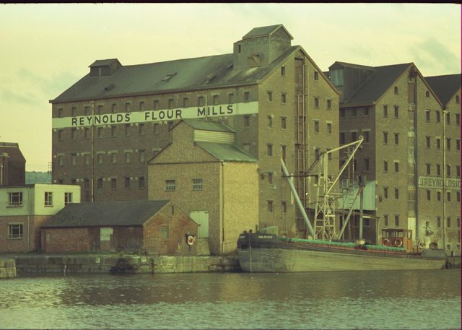
h.

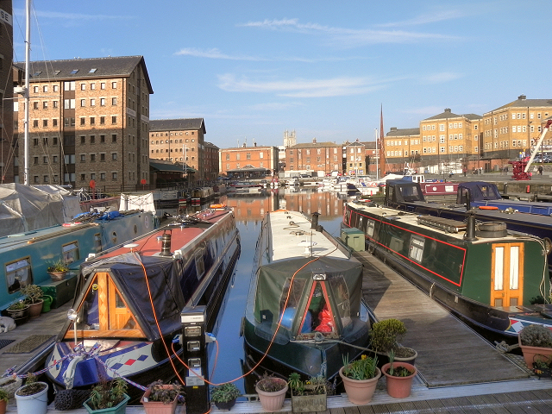

©Chris Allen geograph.org.uk/photo/1764218 and licensed for reuse under this Creative Commons Licence © Copyright David Dixon geograph.org.uk/reuse.php?id=2836475 and licensed for reuse under this Creative Commons Licence
Student tasks

- Working with a partner for this activity, look carefully at the two photographs. Both photographs were taken at Gloucester Docks, but they were taken 31 years apart.

- What physical and human features can you identify? Use the two annotation sheets to label each image accordingly.

- Make a list of ten words/phrases to describe the scene in each photograph.
- Join with another pair and share your annotated images and lists of words/phrases.

- Were their annotations and lists similar to yours?

- Did they have any features or words that you could now add to your images or lists?

Annotation sheet

©Chris Allen geograph.org.uk/photo/1764218 and licensed for reuse under this Creative Commons Licence

Annotation sheet

© Copyright David Dixon geograph.org.uk/reuse.php?id=2836475 and licensed for reuse under this Creative Commons Licence

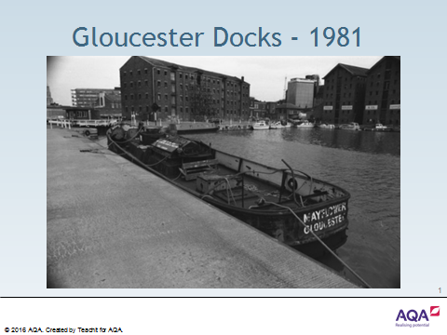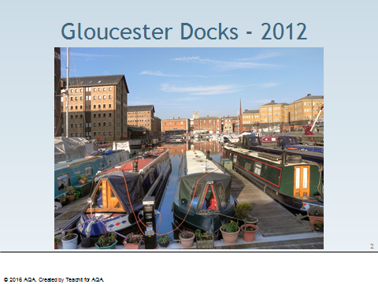

Teaching notes

Image | Caption | Credit | Source
A | Warehouses at Gloucester docks in 1973 | © Copyright Alan Longbottom 1973 geograph.org.uk/reuse.php?id=396263 and licensed for reuse under this Creative Commons Licence | geograph.org.uk/photo/396263
B | Old warehouse – change of use to an Antiques centre 1999 | © Copyright Paul Best 1999 geograph.org.uk/reuse.php?id=276404 and licensed for reuse under thisCreative Commons Licence | geograph.org.uk/photo/276404
C | Working barges in Gloucester docks, 1990 | © Copyright Chris Allen 1990 geograph.org.uk/reuse.php?id=621257and licensed for reuse under thisCreative Commons Licence | geograph.org.uk/photo/621257
D | Church for Norwegian sailors at Gloucester docks | © Copyright Colin Manton 2009 geograph.org.uk/reuse.php?id=2430182and licensed for reuse under this Creative Commons Licence | geograph.org.uk/photo/2430182
E | Warehouse converted for flats and offices at Gloucester docks | © Copyright Philip Pankhurst 2008 geograph.org.uk/reuse.php?id=676710 and licensed for reuse under this Creative Commons Licence | geograph.org.uk/photo/676710
F | A café/bar in a renovated warehouse at Gloucester docks | © Copyright Philip Pankhurst 2014 geograph.org.uk/reuse.php?id=4031575 and licensed for reuse under this Creative Commons Licence | geograph.org.uk/photo/4031575
G | Leisure use at Gloucester docks today | © Copyright Stephen McKay 2014 geograph.org.uk/reuse.php?id=4260723 and licensed for reuse under this Creative Commons Licence | geograph.org.uk/photo/4260723
H | Warehouse and flour mill at Gloucester docks | © Copyright Peter Randall-Cook 1974 geograph.org.uk/reuse.php?id=2142674 and licensed for reuse under this Creative Commons Licence | geograph.org.uk/photo/2142674
All images used under a Creative Commons Licence.

Student task

Place the following events in chronological order, i.e. from the earliest to the latest.
This will help you understand the reasons why the dockland area has undergone change and why it has undergone recent regeneration.

Difficulties were encountered during the 1860s as ships had increased in size and were now too large to travel fully laden up the canal. To cope with this, a new entrance and dock were opened in 1874 at Sharpness. There was a continued growth in imports as smaller vessels were able to travel up the canal and cargoes from larger ships could be transhipped at Sharpness and then brought up the canal in barges.
Additional warehouses were built around the Main Basin to cope with the greater than expected trade and an engine house was constructed to increase the canal’s water supply by pumping it from the River Severn. Bakers Quay was built alongside the canal to increase the quay space and this was mainly laid out for timber storage yards. These were vital as the timber loading ports inconveniently iced-up during the winter. Several of the yards had high fences and were locked under customs supervision so foreign timber was able to be stored without import duties having to be paid. Some of the ships that brought timber from North America were owned by locals and, frequently, carried emigrants on the return journey.
The 1920s saw new traffic due to the increased demand for petroleum products to supply the growing number of road vehicles. This trade became more and more important and a fleet of tanker barges were used to bring petroleum from Avonmouth.
Once the canal had been opened, local merchants were soon taking advantage of the new facilities. Importing through Gloucester avoided Bristol, where port charges were high. It also meant that cargo could be transferred directly to narrow canal boats, which could then supply the expanding, industrial towns of the Midlands.

The position of Gloucester so far inland was extremely beneficial and traffic was soon much greater than anticipated. Imports included corn from Ireland and continental Europe, timber from the Baltic and North America, as well as wines and spirits from Portugal and France. The main export was salt, which was transported down the canal from Worcestershire.
After 1947, the decline in commercial traffic was partly replaced by an increase in pleasure craft, with the docks becoming a popular place for moorings. The old warehouses and other industrial buildings have seen many changes. They have proved to be an ideal location for filming historical dramas, e.g. many scenes for the popular TV series, The Onedin Line, were filmed in front of Biddle Warehouse and scenes for the latest Alice in Wonderland sequel, ‘Through the Looking Glass’, were shot by Llanthony Bridge. New uses have been found for the warehouses in recent times and the docks are now proving to be an attractive leisure and residential area.

There were also attempts to connect the railway to the docks during the 1840s. The Midland railway constructed a standard gauge line from their station, sited at the south end of Bakers Quay, with a branch serving the east side of the main docks area. The Great Western Railway operated a broad gauge branch from South Wales to serve a new quay on the west side of the canal. The lines competed with the river and canal route to carry goods into the Midlands.
By the early 20th century, the docks were being used by both steamers and sailing vessels, with regular services to continental ports. The continued increase in the size of merchant ships, particularly steamers, meant that more goods were arriving in Gloucester by barges from Sharpness or other ports within the Bristol Channel. Warehouses in Gloucester were needed less and less as the majority of the corn was sent straight on to the Midlands.
In the 1840s, it was recognised that further developments were needed as the docks became very crowded at peak times and vessels had to wait their turn for a berth. There was a national movement towards reduced import duties too, especially after the repeal of the Corn Laws in 1846, and the Canal Company expected there to be a massive increase in foreign imports. Victoria Dock, constructed to the east of the Main Basin with a narrow cut linking the two, opened in 1849. Additional corn warehouses and new timber yards were built.
In 1947, the Canal Company was nationalised and the new management encouraged more sea-going ships to travel up to Gloucester. The docks remained busy with barge traffic until well into the 1960s. However, the construction of underground pipelines and a depot at Quedgeley caused a rapid decline in petroleum traffic. Barge traffic faced fierce competition from road transport as well. By 1980, the only remaining commercial vessels coming to the quays south of Llanthony Bridge were the coasters.
Imports grew dramatically during the 1850s and 1860s, largely due to the improved facilities. Corn was imported from northern Europe and around the Black Sea and new warehouses and three flour mills were built. New timber yards and saw mills were constructed alongside the canal south of Gloucester as more and more timber was being imported from the Baltic, North America and the Arctic coast of Russia. Other imports included wines and spirits, oranges and lemons and bones and guano for fertiliser. Salt was the only main, regular export since most vessels went elsewhere to source their return cargo.
The Main Basin at Gloucester was built as the terminus of the ship canal, with an entrance from the Severn estuary at Sharpness. As work was nearing completion, concern was expressed about the size of the basin in relation to the amount of expected trade. Hence, an additional Barge Arm was constructed to ensure that the Main Basin was left free for sea-going ships. The Canal Company also erected a warehouse at the north end of the basin. The formal opening of the canal took place on 26th April 1827. A large crowd gathered to observe the first two vessels enter the basin, accompanied by a firing of guns and the ringing of church bells.

Teaching notes

A very quick chronology can be achieved by using the dates. This suggestion will assist weaker students. These are in bold below:

The Main Basin at Gloucester was built as the terminus of the ship canal, with an entrance from the estuary of the River Severn at Sharpness. As work was nearing completion, concern was expressed about the size of the basin and the expected trade. Consequently, an additional area of docks was dug to leave the main basin free for ocean-going ships. The formal opening of the canal took place on 26th April 1827. A large crowd gathered to observe the first two vessels enter the docks, accompanied by a firing of guns and the ringing of church bells.
Once the canal had been opened, local merchants were soon taking advantage of the new facilities. Importing through Gloucester avoided Bristol, where port charges were high. It also meant that cargo could be transferred directly to narrow canal boats, which could then supply the expanding, industrial towns of the Midlands.

The position of Gloucester so far inland was extremely beneficial and traffic was soon much greater than anticipated. Imports included corn from Ireland and continental Europe, timber from the Baltic and North America, as well as wines and spirits from Portugal and France. The main export was salt, which was transported down the canal from Worcestershire.
Additional warehouses were built around the Main Basin to cope with the greater than expected trade and an engine house was constructed to increase the canal’s water supply by pumping it from the River Severn. Bakers Quay was built alongside the canal to increase the quay space and this was mainly laid out for timber storage yards. These were vital as the timber loading ports inconveniently iced-up during the winter. Several of the yards had high fences and were locked under customs supervision so foreign timber was able to be stored without import duties having to be paid. Some of the ships that brought timber from North America were owned by locals and, frequently, carried emigrants on the return journey.
In the 1840s, it was recognised that further developments were needed as the docks became very crowded at peak times and vessels had to wait their turn for a berth. There was a national movement towards reduced import duties too, especially after the repeal of the Corn Laws in 1846, and the Canal Company expected there to be a massive increase in foreign imports. Victoria Dock, constructed to the east of the Main Basin with a narrow cut linking the two, opened in 1849. Additional corn warehouses and new timber yards were built.

There were also attempts to connect the railway to the docks during the 1840s. The Midland railway constructed a standard gauge line from their station, sited at the south end of Bakers Quay, with a branch serving the east side of the main docks area. The Great Western Railway operated a broad gauge branch from South Wales to serve a new quay on the west side of the canal. The lines competed with the river and canal route to carry goods into the Midlands.
Imports grew dramatically during the 1850s and 1860s, largely due to the improved facilities. Corn was imported from northern Europe and around the Black Sea and new warehouses and three flour mills were built. New timber yards and saw mills were constructed alongside the canal south of Gloucester as more and more timber was being imported from the Baltic, North America and the Arctic coast of Russia. Other imports included wines and spirits, oranges and lemons and bones and guano for fertiliser. Salt was the only main, regular export since most vessels went elsewhere to source their return cargo.
Difficulties were encountered during the 1860s as ships had increased in size and were now too large to travel fully laden up the canal. To cope with this, a new entrance and dock were opened in 1874 at Sharpness. There was a continued growth in imports as smaller vessels were able to travel up the canal and cargoes from larger ships could be transhipped at Sharpness and then brought up the canal in barges.
By the early 20th century, the docks were being used by both steamers and sailing vessels, with regular services to continental ports. The continued increase in the size of merchant ships, particularly steamers, meant that more goods were arriving in Gloucester by barges from Sharpness or other ports within the Bristol Channel. Warehouses in Gloucester were needed less and less as the majority of the corn was sent straight on to the Midlands.
The 1920s saw new traffic due to the increased demand for petroleum products to supply the growing number of road vehicles. This trade became more and more important and a fleet of tanker barges were used to bring petroleum from Avonmouth.
In 1947, the Canal Company was nationalised and the new management encouraged more sea-going ships to travel up to Gloucester. The docks remained busy with barge traffic until well into the 1960s. However, the construction of underground pipelines and a depot at Quedgeley caused a rapid decline in petroleum traffic. Barge traffic faced fierce competition from road transport as well. By 1980, the only remaining commercial vessels coming to the quays south of Llanthony Bridge were the coasters.

After 1947, the decline in commercial traffic was partly replaced by an increase in pleasure craft, with the docks becoming a popular place for moorings. The old warehouses and other industrial buildings have seen many changes. They have proved to be an ideal location for filming historical dramas, e.g. many scenes for the popular TV series, The Onedin Line, were filmed in front of Biddle Warehouse and scenes for the latest Alice in Wonderland sequel, ‘Through the Looking Glass’, were shot by Llanthony Bridge. New uses have been found for the warehouses in recent times and the docks are now proving to be an attractive leisure and residential area.

Student task

- With a partner, read through the comments below together.

- Decide whether each is a fact or opinion.

- Separate the comments into two piles, one for facts and one for opinions.

- Thinking about your pile of opinions – do you think the majority of people are in favour of or against the regeneration of Gloucester Docks?

Regeneration to date has been largely heritage-led, with the restoration of, and new uses for, many historic buildings, including warehouses in the Gloucester Docks and buildings at the Gloucester Quays.
The Gloucester Docks are a unique heritage site, and along with the Cathedral, are one of the city’s most visited tourist destinations.
A combination of new build and the repair/refurbishment of many of the historic warehouses, typically for apartments with active commercial uses on the ground floor, have breathed new life into the docks.
It’s well worth visiting the dock area; a lovely place for an interesting walk. Plenty of seats. The maritime museum and also the large antique centre are great. Some good pubs and the restaurants are always open. Sometimes when the weather is good there are outdoor entertainers that add to the atmosphere. There is plenty of parking at reasonable prices.
Full of canal barges, tall ships and pleasure craft, the docks have been excellently developed. Plenty of shops, cafes and restaurants. Well worth a visit.
The Gloucester Docks regeneration project was effectively started by the Council’s pioneering move to save four of the historic warehouses in the 1980s.
There is a wide variety of bars and restaurants to enjoy and the quays really come to life in the evening. Great for a night out with the girls, a family meal, or even a nice date night.
The regeneration of the docks, coupled with the creation of a small outlet mall, works well. Plus, lots of bars and eateries to suit all tastes. We visited during the Victorian Christmas market, so it was very busy. I would imagine it is lovely on a warm summer day. Shame the museum is currently under refurbishment. Next time! Smaller than the likes of Meadow Hall, Trafford Centre and Cheshire Oaks, but loads more character. Will happily return in summer.
The Gloucester Quays scheme also covers around 25 hectares of brownfield land, where Gloucestershire College, Sainsbury’s, Travelodge, a cinema and several restaurants are now located.
The Gloucester Quays scheme has involved a significant investment by the Peel Group and made a major contribution to the regeneration of Gloucester.

We visited the docks as we used to live in the area and it has been totally revised since then. It generally was a pleasant place to be, although parking was a bit difficult to find and expensive at more than £1 per hour. This is not conducive to casual visiting. Actually found though that there were limited things to do and the National Waterways Museum was closed for refurbishment. There was just shopping and wandering around the dock area to do, although there were many restaurants to visit. I think more could be made of the area with boats open for visits on them, rather than having to look at them from afar. Also could do with more explanations of the area, rather than the few signs dotted around the place. Could see it all in about an hour at present! There did not appear much for young children to do, unless parents were well-informed and could explain what the site was about. A display centre would be useful. It was clean and tidy though.
In a joint venture with Merchant Place Developments, Rokeby Developments has recently acquired Bakers Quay and plans to deliver an exciting, good quality mixed-use regeneration scheme. This will bring the last two, vacant Victorian Warehouses in the Gloucester Quays back into use.
We enjoyed seeing the old ships in the dry docks. It was interesting, but it is not a place I would go back to, unless I was taking a boat ride somewhere.
The Victorian Docks have been sympathetically regenerated with shops, pubs and numerous places to eat. The docks themselves would fascinate anyone with an interest in the sea having numerous, old sailing vessels and barges; the beautiful, old warehouses have been remodelled and are now home to many and varied enterprises. We were there for the Victorian Christmas Market and it was an excellent day out. The only drawback seems to be that this new area has drained the life out of the older parts of Gloucester.
The Gloucester Docks regeneration project has also seen considerable investment in the public realm.
The Gloucester Quays scheme includes the Outlet Centre operated by Peel Holdings.
It is a strange thing of beauty. It reminds me of so many ideas mashed into one, but somehow does not pull it off. Princes Quays, Liverpool and McArther Glenn outlets all rolled into one. The shops are the usual run of the mill that you will find anywhere in the country. But it is clean and has a good sized, multi-storey car park with disabled access.
Lots of history surrounds the docks, and it is a gorgeous place to stroll and take in the views. There is a great bar at the docks (Doctor Foster's) and it is next to Gloucester Quays ... there are plenty of things to see and do.
Peel Outlets will invest £100 million in the Gloucester Quays over the next three years.
Great day out, lots to see and do. Great shopping and lots of places to eat. Lovely to see the tall ships in for repairs.

Teaching notes

Comment | Fact or opinion
Regeneration to date has been largely heritage-led, with the restoration of, and new uses for, many historic buildings, including warehouses in the Gloucester Docks and buildings at the Gloucester Quays. | Fact
The Gloucester Docks are a unique heritage site, and along with the Cathedral, are one of the city’s most visited tourist destinations. | Fact
A combination of new build and the repair/refurbishment of many of the historic warehouses, typically for apartments with active commercial uses on the ground floor, have breathed new life into the docks. | Fact
It’s well worth visiting the dock area; a lovely place for an interesting walk. Plenty of seats. The maritime museum and also the large antique centre are great. Some good pubs and the restaurants are always open. Sometimes when the weather is good there are outdoor entertainers that add to the atmosphere. There is plenty of parking at reasonable prices. | Opinion
Full of canal barges, tall ships and pleasure craft, the docks have been excellently developed. Plenty of shops, cafes and restaurants. Well worth a visit. | Opinion
The Gloucester Docks regeneration project was effectively started by the Council’s pioneering move to save four of the historic warehouses in the 1980s. | Fact
There is a wide variety of bars and restaurants to enjoy and the quays really come to life in the evening. Great for a night out with the girls, a family meal, or even a nice date night. | Opinion
The regeneration of the docks, coupled with the creation of a small outlet mall, works well. Plus, lots of bars and eateries to suit all tastes. We visited during the Victorian Christmas market, so it was very busy. I would imagine it is lovely on a warm summer day. Shame the museum is currently under refurbishment. Next time! Smaller than the likes of Meadow Hall, Trafford Centre and Cheshire Oaks, but loads more character. Will happily return in summer. | Opinion
The Gloucester Quays scheme also covers around 25 hectares of brownfield land, where Gloucestershire College, Sainsbury’s, Travelodge, a cinema and several restaurants are now located. | Fact
The Gloucester Quays scheme has involved a significant investment by the Peel Group and made a major contribution to the regeneration of Gloucester. | Fact

We visited the docks as we used to live in the area and it has been totally revised since then. It generally was a pleasant place to be, although parking was a bit difficult to find and expensive at more than £1 per hour. This is not conducive to casual visiting. Actually found though that there were limited things to do and the National Waterways Museum was closed for refurbishment. There was just shopping and wandering around the dock area to do, although there were many restaurants to visit. I think more could be made of the area with boats open for visits on them, rather than having to look at them from afar. Also could do with more explanations of the area, rather than the few signs dotted around the place. Could see it all in about an hour at present! There did not appear much for young children to do, unless parents were well-informed and could explain what the site was about. A display centre would be useful. It was clean and tidy though. | Opinion
In a joint venture with Merchant Place Developments, Rokeby Developments has recently acquired Bakers Quay and plans to deliver an exciting, good quality mixed-use regeneration scheme. This will bring the last two, vacant Victorian Warehouses in the Gloucester Quays back into use. | Fact
We enjoyed seeing the old ships in the dry docks. It was interesting, but it is not a place I would go back to, unless I was taking a boat ride somewhere. | Opinion
The Victorian Docks have been sympathetically regenerated with shops, pubs and numerous places to eat. The docks themselves would fascinate anyone with an interest in the sea having numerous, old sailing vessels and barges; the beautiful, old warehouses have been remodelled and are now home to many and varied enterprises. We were there for the Victorian Christmas Market and it was an excellent day out. The only drawback seems to be that this new area has drained the life out of the older parts of Gloucester. | Opinion
The Gloucester Docks regeneration project has also seen considerable investment in the public realm. | Fact
The Gloucester Quays scheme includes the Outlet Centre operated by Peel Holdings. | Fact
It is a strange thing of beauty. It reminds me of so many ideas mashed into one, but somehow does not pull it off. Princes Quays, Liverpool and McArther Glenn outlets all rolled into one. The shops are the usual run of the mill that you will find anywhere in the country. But it is clean and has a good sized, multi-storey car park with disabled access. | Opinion
Lots of history surrounds the docks, and it is a gorgeous place to stroll and take in the views. There is a great bar at the docks (Doctor Foster's) and it is next to Gloucester Quays ... there are plenty of things to see and do. | Opinion
Peel Outlets will invest £100 million in the Gloucester Quays over the next three years. | Fact
Great day out, lots to see and do. Great shopping and lots of places to eat. Lovely to see the tall ships in for repairs. | Opinion

Introduction

The Lock Warehouse at the entrance to Gloucester Docks has witnessed many changes since it was built in 1834 for Messrs J & C Sturge, the leading corn merchants of that time. Following its industrial use as a warehouse, it later became the home of the Gloucester Antiques Centre but has now been converted to flats with commercial and retail use of the ground floor.

Student tasks

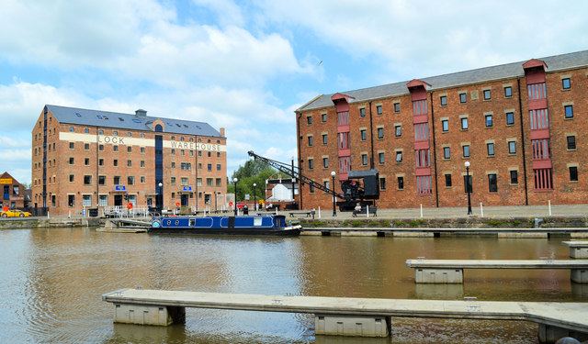
- Label five items of geographical interest on the image.

- Write five sentences to describe how the scene would have been very different in the past when ships were loading and unloading their cargo. At the start of the twentieth century, the cargoes included grain, timber, copper, sugar, iron bars, moulding sand and flour.

©Philip Pankhurst, 2014 under CC License

- Can you imagine living in a converted warehouse? Investigate properties for sale in Lock Warehouse in Gloucester Docks using zoopla.co.uk or a similar site.

Introduction

A considerable amount of information can be gathered from a study of an old OS map. The map gives us an historical view of the land and allows us to see the changes that have occurred when compared to a modern map.

Student tasks

- What map evidence is there that this area was settled in ancient times?

- What map evidence is there that this was once probably an agricultural area?

- Use the map to identify ten sources of employment in 1901.

- How might this location have changed since 1901? How much trade do you think still happens at Gloucester Docks?
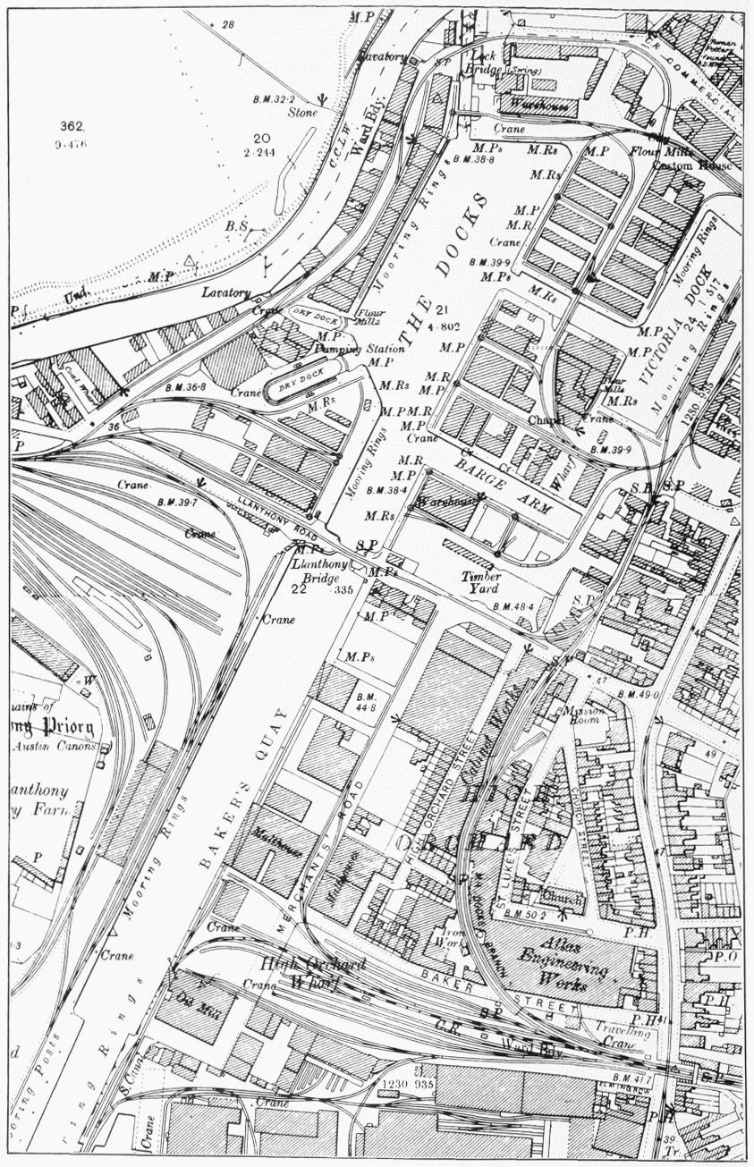

Student tasks

Using the weblinks below and your knowledge of the Gloucester Docks and Gloucester Quays, complete a summary poster / case study of the regeneration project.

Include the following:

- Images
Gloucester Docks / Gloucester Quays in the past
Gloucester Docks / Gloucester Quays as it is today

- A short history of the docks
growth from the 1840s
decline in the 20th century - reasons why the area needed regeneration

- The main features of the Gloucester Docks project
Including the role of heritage, e.g. the warehouses

- An overview of regeneration project to date
The journey so far

- The regeneration project - future plans:
Economic and development strategies 2016–2021

- Public opinion
e.g. Tripadvisor, Twitter (@GloucesterDocks and @GloucesterQuays ) etc.

- Your opinion - success or failure?

Useful websites

- southwestbusiness.co.uk/regions/gloucestershire/council-reveals-five-year-regeneration-and-economic-development-strategy-plan-for-gloucester-14032016071727/

- smarterwebcompany.co.uk/swbusiness-co-uk/_img/Glos_pdf/Regeneration_Economic_Development_Strategy_2016_2021.pdf

- gloucestercitizen.co.uk/Start-date-55m-Gloucester-Docks-Bakers-Quay/story-29198492-detail/story.html

- gloucesterdocks.me.uk/gloucester/regeneration.htm

- gloucesterquays.co.uk/

- twitter.com/GloucesterDocks

- twitter.com/GloucesterQuays

- tripadvisor.co.uk/Attraction_Review-g187047-d2476434-Reviews-Gloucester_Quays-Gloucester_Cotswolds_England.html

- tripadvisor.co.uk/Attraction_Review-g187047-d2515607-Reviews-Gloucester_Docks-Gloucester_Cotswolds_England.html

N |  |  | Y
B |  |  | T
I | U
S | I
A |  | I
L |  | A

T | S

Introduction

Sustainable living aims to include a number of features, such as the use of renewable resources, energy efficiency, use of public transport and accessible resources and services. Many people and organisations are attempting to make cities more sustainable.

A sustainable city should offer a good quality of life to current residents and not reduce the opportunities for future residents to enjoy. A sustainable city will also grow at a sustainable rate and use resources in a sustainable way.

Student tasks

- Working with a partner, cut out the cards below. Each card contains information related to urban living.

- Sort the cards into two piles, one linked to sustainable features and the other demonstrating unsustainable features.

Not all new homes are energy efficient. | Public transport is safe and reliable.
Public transport is viewed as a viable alternative to cars. | Public transport is not always safe and reliable.
Recycling is minimal; hence the large amounts of waste to deal with. | Not all housing is affordable.
Areas of open space are safe, accessible and enjoyable. | Wherever possible, renewable resources are used instead of non-renewable resources
Resources and services in the city are accessible to all. | Communities do not tackle pressing issues, such as those related to crime and security.
Resources and services in the city are inaccessible to some people. | Communities work together to deal with issues, such as crime and security.
Access to cultural and social amenities is limited to a few people. | Walking and cycling is safe.
Cars are considered to be the best means of getting around. | Walking and cycling can sometimes be dangerous

- What ‘real-life’ examples can you find of items in the sustainable features pile?

Teaching notes

Item | Sustainable or unsustainable?
Not all new homes are energy efficient. | Unsustainable
Public transport is viewed as a viable alternative to cars. | Sustainable
Recycling is minimal; hence the large amounts of waste to deal with. | Unsustainable
Areas of open space are safe, accessible and enjoyable. | Sustainable
Resources and services in the city are accessible to all. | Sustainable
Resources and services in the city are inaccessible to some people. | Unsustainable
Access to cultural and social amenities is limited to a few people. | Unsustainable
Cars are considered to be the best means of getting around. | Unsustainable
Public transport is safe and reliable. | Sustainable
Public transport is not always safe and reliable. | Unsustainable
Not all housing is affordable. | Unsustainable
Wherever possible, renewable resources are used instead of non-renewable resources | Sustainable
Communities do not tackle pressing issues, such as those related to crime and security. | Unsustainable
Communities work together to deal with issues, such as crime and security. | Sustainable
Walking and cycling is safe. | Sustainable
Walking and cycling can sometimes be dangerous | Unsustainable

Introduction

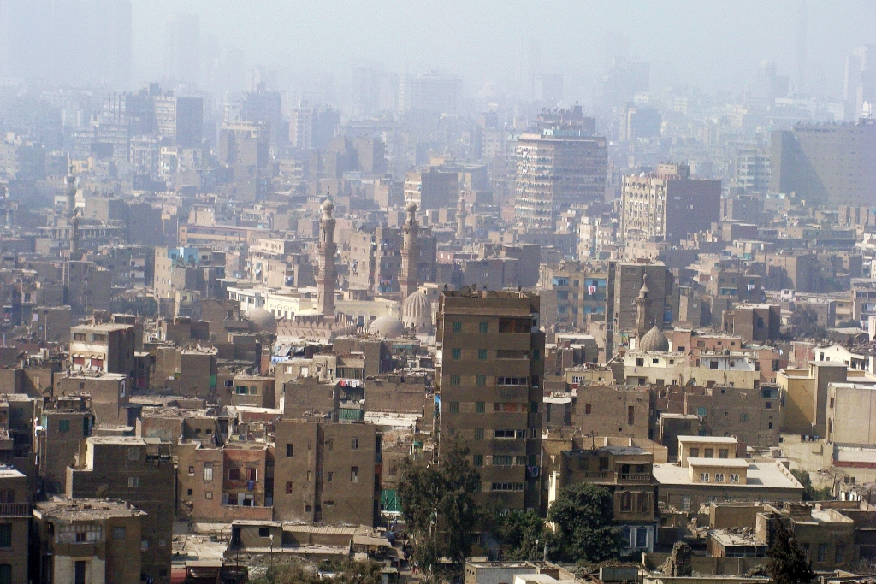
In 2007, Cairo’s air was ranked as the worst in the world for pollution by particulates by the World Bank. Particulates are tiny fragments of soot or dust that are most damaging to human lungs.
Cairo in Smog, Silar, commons.wikimedia.org/wiki/File:0021_Cairo_in_smog,_2010.JPG, 2010, CC BY-SA 3.0

Student tasks

- Write five words to describe Cairo in the image above.

- What title would you give this image?

- What do you think? Answer the following questions:

- Is there affordable housing for everyone?
- Is there enough investment in the city centre?
- Are the homes in Cairo energy efficient?
- Do people walk, cycle or use public transport rather than cars in Cairo?
- Is there a strong sense of community?
- Do they use renewable energy in Cairo?
- How could Cairo be more sustainable?

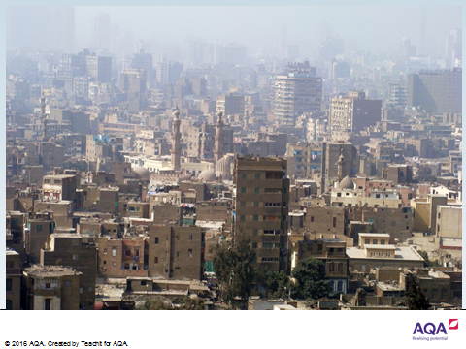

Introduction

Curitiba is the capital and largest city in the state of Paraná in southeast Brazil. The city witnessed a very large increase in its population from the middle of the 20th century and was often gridlocked with traffic. Residents felt that the city was under attack.

In 1971, Jaime Learner was elected mayor of the city and said that a combination of “Mobility, sustainability, and identity” was the answer. He wanted Curitiba to be great place to live and approached the problem with a radical plan involving public transport. Today, Curitiba is considered one of the world's most successful examples of urban planning.

Location and facts – Curitiba, Brazil
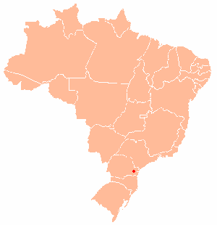
Curitiba
BRAZIL

- Curitiba is the capital Paraná state in southeast Brazil, approximately 1,000km from Rio de Janeiro.

- The 2010 census recorded the population of Curitiba at approximately 2.5 million people.

- Curitiba is the eighth most populous city in Brazil.

- Between 1950 and 1990, the population increased rapidly, from 300,000 to 2.1 million.

Curitiba, NordNordWest, 2013 wikipedia.org/wiki/Curitiba CC BY-SA 3.0

Student tasks

- Watch the following video clip, youtube.com/watch?v=hRD3l3rlMpo which describes sustainability schemes in Curitiba, Brazil. Sustainability has many different aspects, but here, you should focus on sustainability linked to transport. Note down any relevant points that may help you to answer the questions below later on.

- Answer the questions:

- How has the road system been made more efficient? Draw a sketch of the new transport plan.

- How many people benefit from the new system of transportation?

- How is public transport in Curitiba funded?

- How have both the buses and boarding tubes been modified? How is this a sustainable strategy?

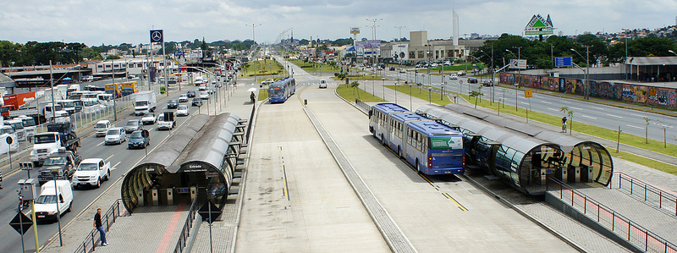
- Add labels to the image of a street scene in Curitiba, to highlight key aspects of its transport sustainability plan.

©mariordo59, 2011, flic.kr/p/dSEKqN

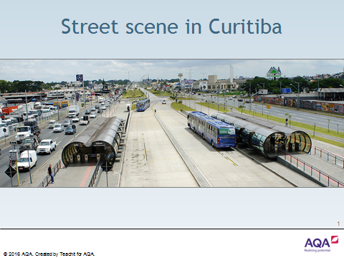
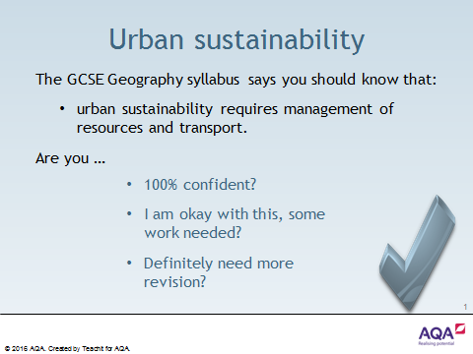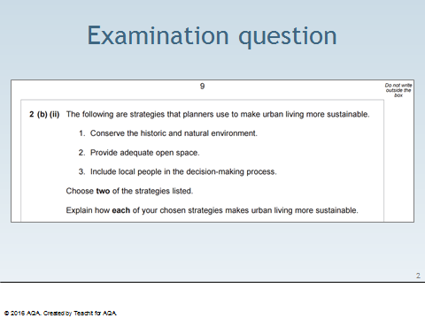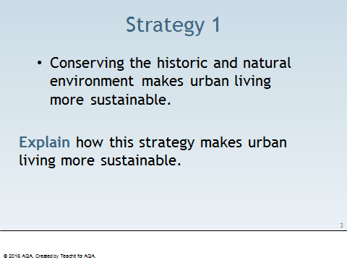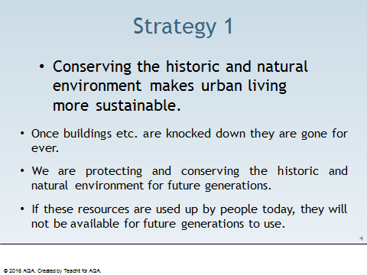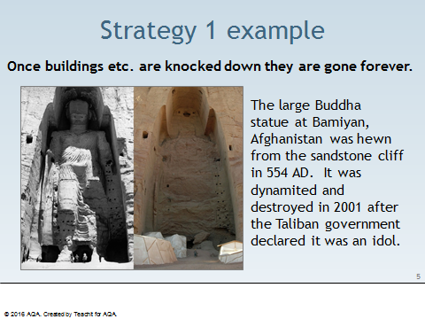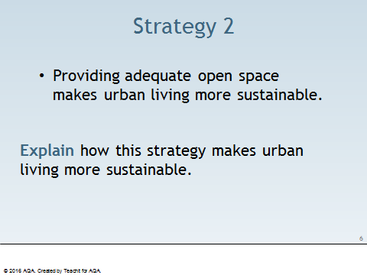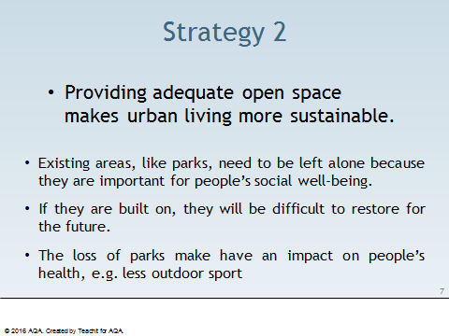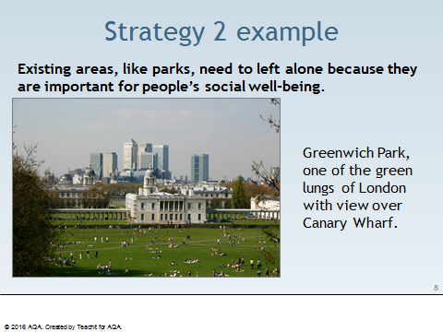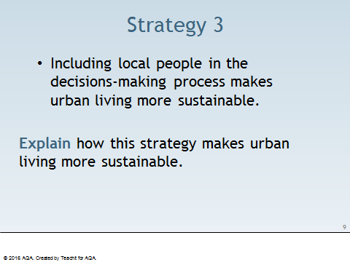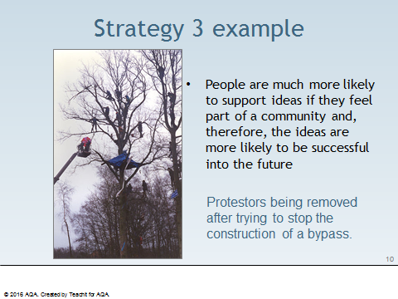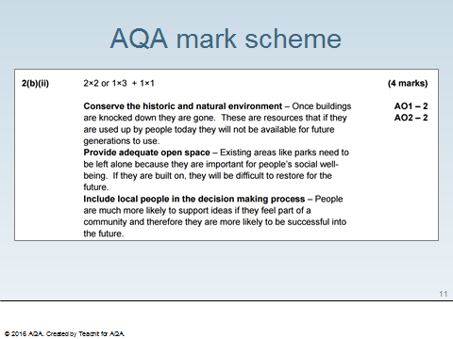

Student task

- Test yourself! Can you match the following key words and terms with their appropriate definitions?

Key term | Definition
Sustainable | Growth in areas that have experienced decline in the past.
Non-renewable resources | The process of using a material more than once, e.g. a glass bottle can be melted down and re-formed into a jam jar.
Renewable resources | Contamination of the environment, usually by chemicals.
Brownfield site | Fuels, such as coal, oil and natural gas, burned to produce energy. They are formed from the remains of animals and plants from millions of years ago.
Congestion charge | Minimising damage to the environment and avoiding using natural resources, e.g. by using renewable resources.
Carbon footprint | Resources that are generated from sources that are not finite or exhaustible, e.g. wave power, wind power and solar power.
Recycling | A mixture of smoke produced by factory or domestic emissions and fog.
Global warming | The progress made by creating wealth through businesses, industry and trade.
Fossil fuels | The amount of energy generated from the activities of people.
Greenhouse gases | The rise in the average temperature of the Earth’s surface.
Green electricity | Resources that cannot be replaced once they have been used up, e.g. coal, oil and natural gas.
Regeneration | An area of derelict urban land that has previously been built upon.
Greenfield site | Naturally occurring gases, e.g. carbon dioxide, methane and nitrous oxide. These are thought to have increased due to the burning of fossil fuels.
Economic development | Electricity generated by a renewable method with a relatively low impact on the environment, e.g. wave, wind and solar power.
Pollution | A payment that has to be made if a vehicle drives in a designated area during certain times of the week.
Smog | A piece of land that has not been built upon before, but is now being considered for development.

Teaching notes

Key term | Definition
Sustainable | Minimising damage to the environment and avoiding using natural resources, e.g. by using renewable resources.
Non-renewable resources | Resources that cannot be replaced once they have been used up, e.g. coal, oil and natural gas.
Renewable resources | Resources that are generated from sources that are not finite or exhaustible, e.g. wave power, wind power and solar power.
Brownfield site | An area of derelict urban land that has previously been built upon.
Congestion charge | A payment that has to be made if a vehicle drives in a designated area during certain times of the week.
Carbon footprint | The amount of energy generated from the activities of people.
Recycling | The process of using a material more than once, e.g. a glass bottle can be melted down and re-formed into a jam jar.
Global warming | The rise in the average temperature of the Earth’s surface.
Fossil fuels | Fuels, such as coal, oil and natural burned to produce energy. They are formed from the remains of animals and plants from millions of years ago.
Greenhouse gases | Naturally occurring gases, e.g. carbon dioxide, methane and nitrous oxide. These are thought to have increased due to the burning of fossil fuels.
Green electricity | Electricity generated by a renewable method with a relatively low impact on the environment, e.g. wave, wind and solar power.
Regeneration | Growth in areas that have experienced decline in the past.
Greenfield site | A piece of land that has not been built upon before, but is now being considered for development.
Economic development | The progress made by creating wealth through businesses, industry and trade.
Pollution | Contamination of the environment, usually by chemicals.
Smog | A mixture of smoke produced by factory or domestic emissions and fog.

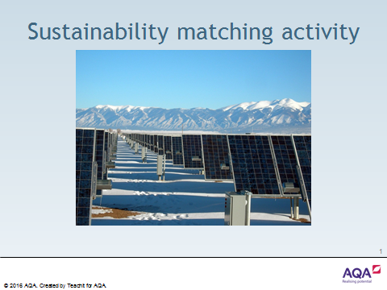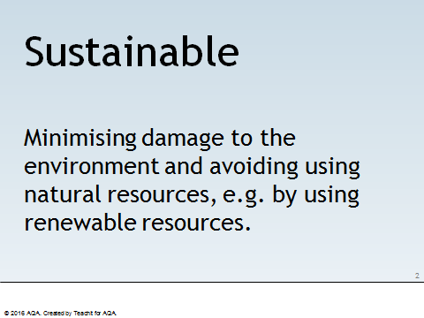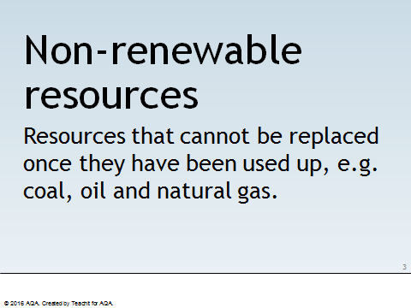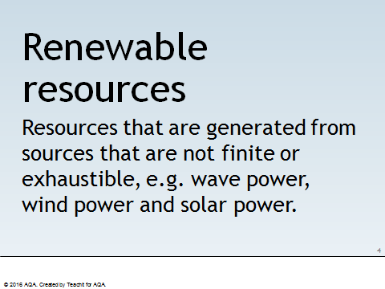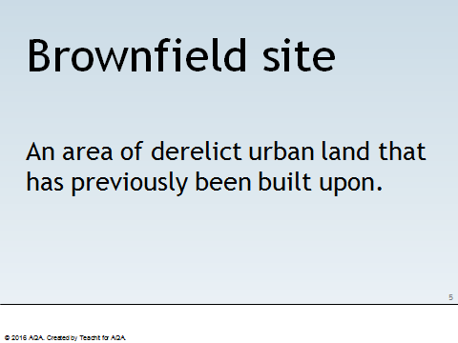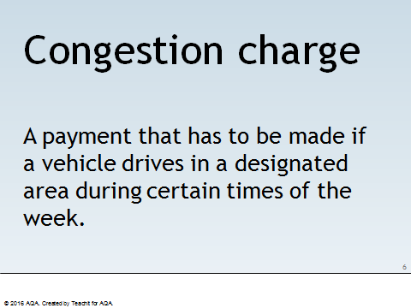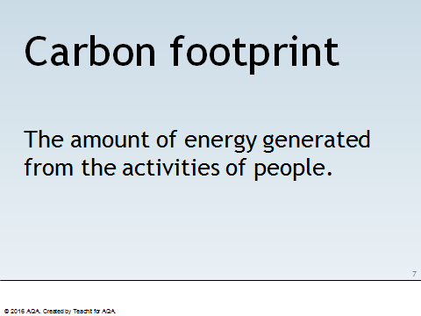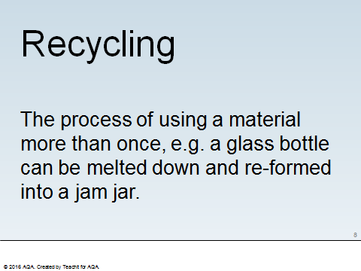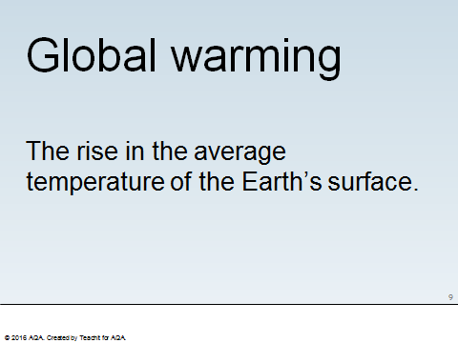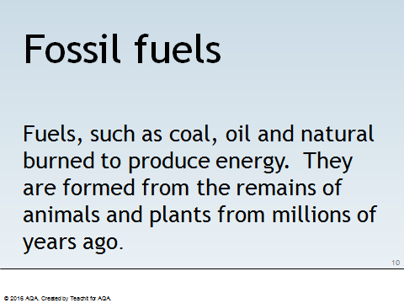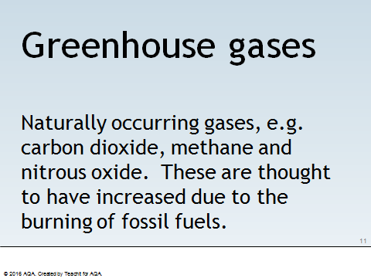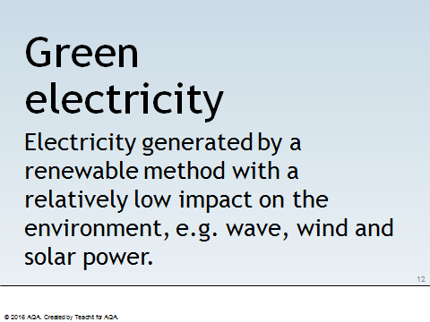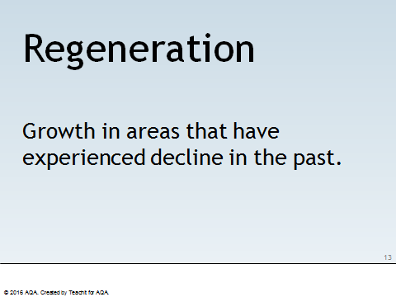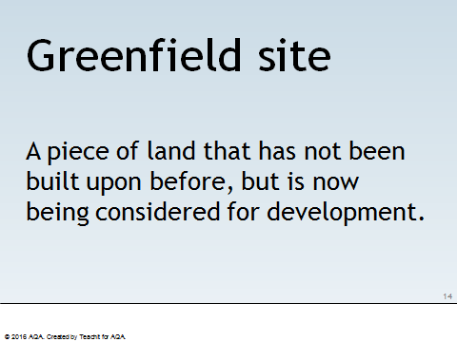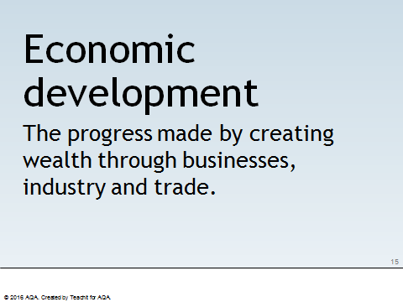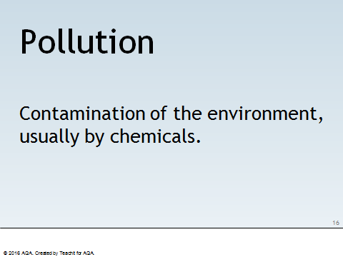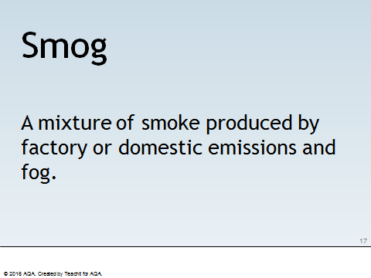

Student task

- Can you provide definitions for the following key words and terms?

Sustainability key words and terms
Biofuel | Green electricity
Biomass | Greenfield site
Brownfield site | Greenhouse gases
Carbon credit | Non-renewable resources
Carbon footprint | Photovoltaic cell
Congestion charge | Pollution
Cost benefit analysis | Recycling
Deforestation | Regeneration
Economic development | Renewable resources
Food miles | Smog
Fossil fuels | Stewardship
Geothermal energy | Sustainable
Global warming | Think global, act local

Acknowledgement of copyright-holders and publishers

Resource 47: ‘Transport sustainability in Curitiba, Brazil’ contributed by Gareth Hughes.

All other resources contributed by Emma Espley and Chris Smart.

Permission to reproduce all copyright material has been applied for.
In some cases, efforts to contact copyright-holders have been unsuccessful and Teachit Geography will be happy to rectify any omissions of acknowledgements in future if notified.
Other images used in this teaching pack are listed as being in the public domain. Users are advised to make their own copyright assessment and to understand their rights to fair use as required.

