Diagram | Description of main features | Explanation of processes
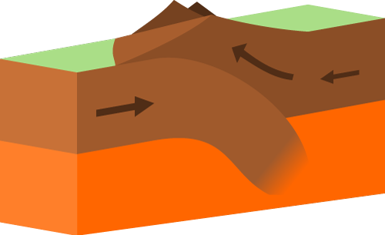 | - Continental and continental plates.  - Earthquakes  - NO volcanoes  - Fold mountains  - E.g. Eurasian and Indo-Australian Plates (creating The Himalayas) | Two plates can move past each other either in different directions, or in the same direction but at different speeds. Crust isn’t created or destroyed, so there are no volcanoes.
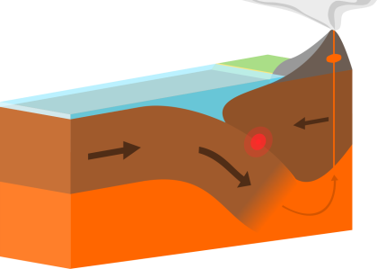 | - Two tectonic plates  - Earthquakes  - No volcanoes  - E.g. North American and Pacific Plates | The denser oceanic plate is forced down (subducted) into the mantle and destroyed. The melting plate is less dense than the surrounding mantle so rises to the surface to form volcanoes. A deep ocean trench is formed at the point of subduction.
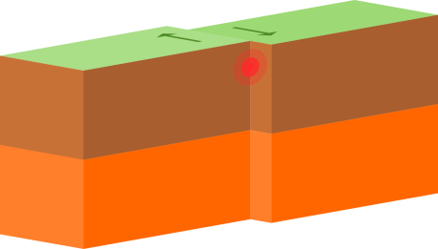 | - Oceanic and continental plates  - Volcanoes AND earthquakes  - Ocean trenches  - Fold mountains  - E.g. Nazca and South American Plates (creating The Andes) | The two plates meet head on, but are both the same density. This means no crust can be destroyed through subduction, so there are no volcanoes, and instead the plates are pushed upwards.
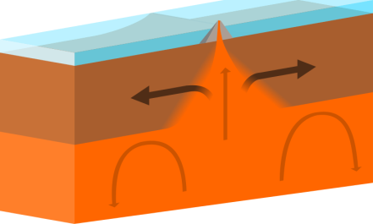 | - Two oceanic plates (usually)  - Volcanoes  - Very small earthquakes  - Ocean ridges  - E.g. Eurasian and North American Plates (creating the Mid-Atlantic Ridge) | As the two plates move apart, due to convection currents in the mantle, new magma rises from the mantle to fill the gap between them. It cools to create new crust and volcanoes.

 | Diagram | Description of main features | Explanation of processes
Destructive
boundary
Constructive
boundary
Collision
boundary
Conservative
boundary

Plate boundary | Labelled diagram
Destructive boundary.
An plate and a plate collide. The heavier is forced under the crust and slowly destroyed. This creates and .

E.g.
Collision boundary.
Two plates collide. The crust cannot be destroyed and instead the plates are pushed up. This forms
.

E.g.
Constructive boundary.
Two plates are moving each other. As they move apart, molten rock (magma) rises into the gap and cools to form new
Between the two plates
are formed.

E.g. .
Conservative boundary.
Two plates are moving each other, at different speeds or in different directions. If the plates get stuck you can get
.

E.g.

Teacher notes:

Students to use the card sort activity to complete the blank table showing the four plate boundaries. They should organise the cards into the three columns of the table:

- Diagram
- Description of main features
- Explanation of processes.

Once they have completed the card sort, they should use this information to complete their student table worksheet. This could be done in one of three ways to differentiate for ability level of class/individual.

- They could stick the cards onto the table once they have checked positions.
- They could use the fill in the gaps sheet and draw a labelled diagram for each plate boundary.
- They could use a blank table and add their own notes summarising information from the card sort.

©domdomegg - Own work, CC BY 4.0, commons.wikimedia.org/w/index.php?curid=45874902
©domdomegg - Own work, CC BY 4.0, commons.wikimedia.org/w/index.php?curid=45732560
©domdomegg - Own work, CC BY 4.0, commons.wikimedia.org/w/index.php?curid=50782243
©domdomegg - Own work, CC BY 4.0, commons.wikimedia.org/w/index.php?curid=50782243

