Read the following article carefully.

The Oracle
The newspaper that seeks the truth! |  | XVIII July LXIV AD
Burning Hatred
Christians Blamed for Setting Rome Alight... But did they?
The mighty city of Rome is in chaos tonight as an out of control fire sweeps across the city. Citizens have been forced to flee their burning homes, as buildings collapse and businesses are ruined. Fanned by strong winds, the raging inferno quickly devoured whole sections of this wonderful city as flames like living devils leapt from building to building. People are fighting a losing battle, with some officials claiming this could be the end of Rome as we know it!  ‘We were just bathing when we heard the terrible sound of a nearby building collapsing accompanied by horrendous screams!’ one citizen tells us. ‘There was suddenly choking smoke. My poor wife burnt her arm and my brother is still missing. Someone said it was the Christians. Those Christians have a lot to answer for!’  But Octavia Lucida, an XI-year-old, claims she was an eyewitness to the beginning of this terrifying event. She has a different theory and it does not include blaming the Christians. ‘They are a peaceful people. Their religion is based on peace, and it is becoming more and more popular,’ she explained to us. She was one of the lucky ones to have escaped the fire. | 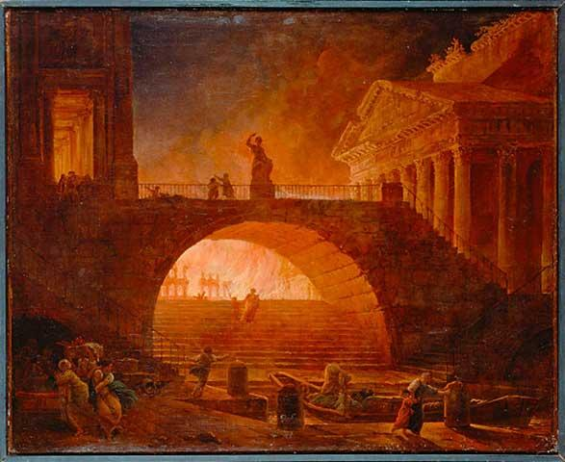
She went on to tell us how she saw a suspicious-looking fellow behind the Circus Maximus – the main chariot racing station. She was with her younger brother Tacitus near the shop. A fellow wearing a red cloak, with a wicked, single glittering eye and an eye-patch, had started a fire in the doorway. He was then seen to run away with a grin on his face. ‘The Christians have set my shop alight!’ she heard him cry.

But minutes later, the shop owner himself came around the corner, only to see his livelihood go up in smoke. He is a Christian – so none of this makes any sense...

This is beginning to look more like a hate crime to us at The Oracle. Will these poor Christians ever
be accepted in our usually tolerant city?

Name: Date:
With a response partner, answer the following questions.

- Underline any words you are unsure of. Try to work out what they mean by reading the whole of the sentence. Does reading around the word help you with the meaning?
- Think about what you liked about the article. Was it dramatic, exciting or mysterious? Did you like one part in particular? Highlight your favourite part/s and explain why you liked that part.
- How does the article make you feel? Do you feel sorry for anyone? Do you dislike anyone?
- Do you want to know more? Does this article leave you with any questions? Who do you think caused the fire of Rome? Write your questions and theories down.

Answer the following questions. Hunt down the answers if you think they are in the text. Some of the answers may be inferred (suggested in the text), so you must think about these very carefully.

- Why did the reporter choose the two words in the headline?

They chose the word ‘burning’ because

They chose the word ‘hatred’ because

- Copy the words from the subheading that tell you the reporter is not sure if it was the Christians who caused the fire.

- Look in the first paragraph to find two different words which are used instead of the word ‘fire’:

word 1: word 2:

- How did the citizen who was bathing know that something was wrong?
Give two ways that he knew:

- Give two pieces of evidence which persuaded the reporter that the fire at the shop was not started by the Christians. Explain why you chose the evidence:

Answers

You may choose to discuss the response questions as a whole class before they tackle the comprehension.
Allow reasonable variants where the pupil can explain the difference between their answer and the ones below. Total mark out of 10.

- Why did the reporter choose the two words in the title?
[2 marks]

They chose the word ‘burning’ because the story is about a fire / there is a fire / it is a pun for strong or currently important e.g. strong feelings of hatred towards Christians were happening at this time in Rome

They chose the word ‘hatred’ because people are showing hatred to Christians / blaming Christians and being mean to them

- Copy the words from the subheading that tell you the reporter is not sure it was the Christians who caused the fire: But did they? / did they?
[1 mark]

- Look in the first paragraph to find two different words which are used instead of the word ‘fire’:

[2 marks]
word 1: flames word 2: inferno

- How did the citizen who was bathing know that something was wrong? Give two ways that they knew. Choose any of the following two reasons:
[2 marks]

they heard a building collapse / loud noise as a building fell down and screams / horrendous screams / choking smoke

- Name two pieces of evidence which persuaded the reporter that the fire at the shop was not started by the Christians. Any two of the following reasons with one or more explanations:
[3 marks]

- The shopkeeper was a Christian, so he wouldn’t try to get other Christians in trouble.

- The man who started the fire said he was the shop owner, but he wasn’t.

- The man ran away from the fire he started with a smile on his face.

- The man who started the fire was grinning, not upset at the fire / he was glad about the fire he had started.

- The witness saw him start the fire on purpose then run away and blame the Christians.

