Beyond ‘Once upon a time …’

Cut out and pass around the following story openers to provide children with inspiration for storytelling. Ask them to continue the story and then have a go at writing story openers to challenge a friend. Included below are some image prompts for children that might prefer a visual stimulus.

On a warm beach where the sand meets the sea …
One wild and stormy night …
In a valley below the hills …
Deep inside a cave …
In a room at the top of the tallest castle tower in the land …
Underneath a seat on the top deck of a bus …
Far above the Earth …
From inside a tree …
Behind a thick, velvet curtain …
At the top of a winding staircase …
At the entrance to a tunnel …

In the middle of the wood …
When the battle was over …
On the first day of Spring …
As the sun went down …
At the bottom of the garden …
In the middle of the jungle …
At a quarter past midnight …
Every Thursday, at sunrise, …
Inside the belly of a whale …
As the last light went out …
Five thousand light years away …
On a distant, rocky island …
In a tiny cabin inside a submarine …

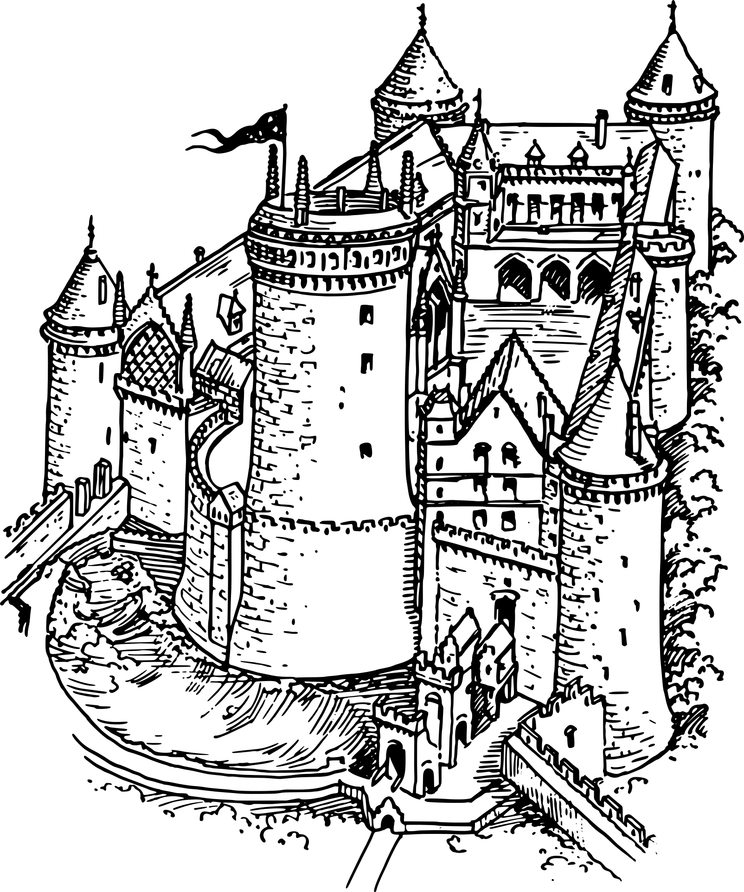 |  | 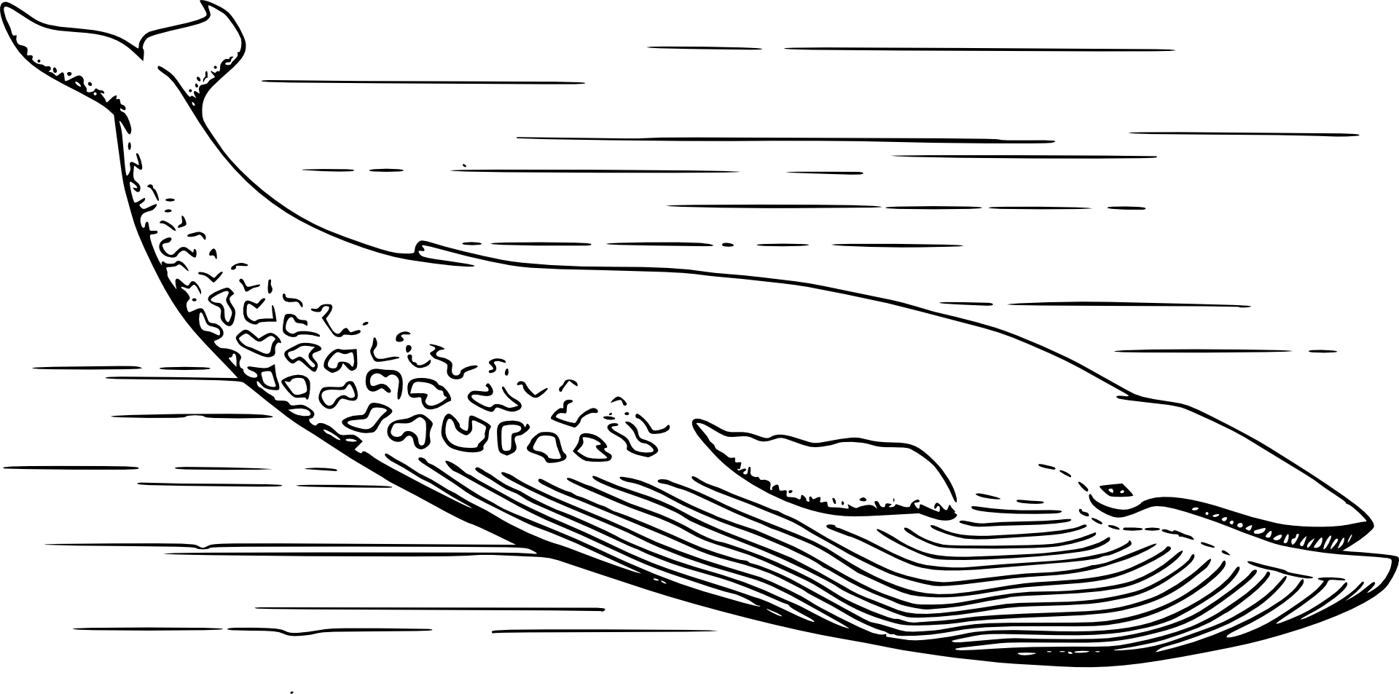
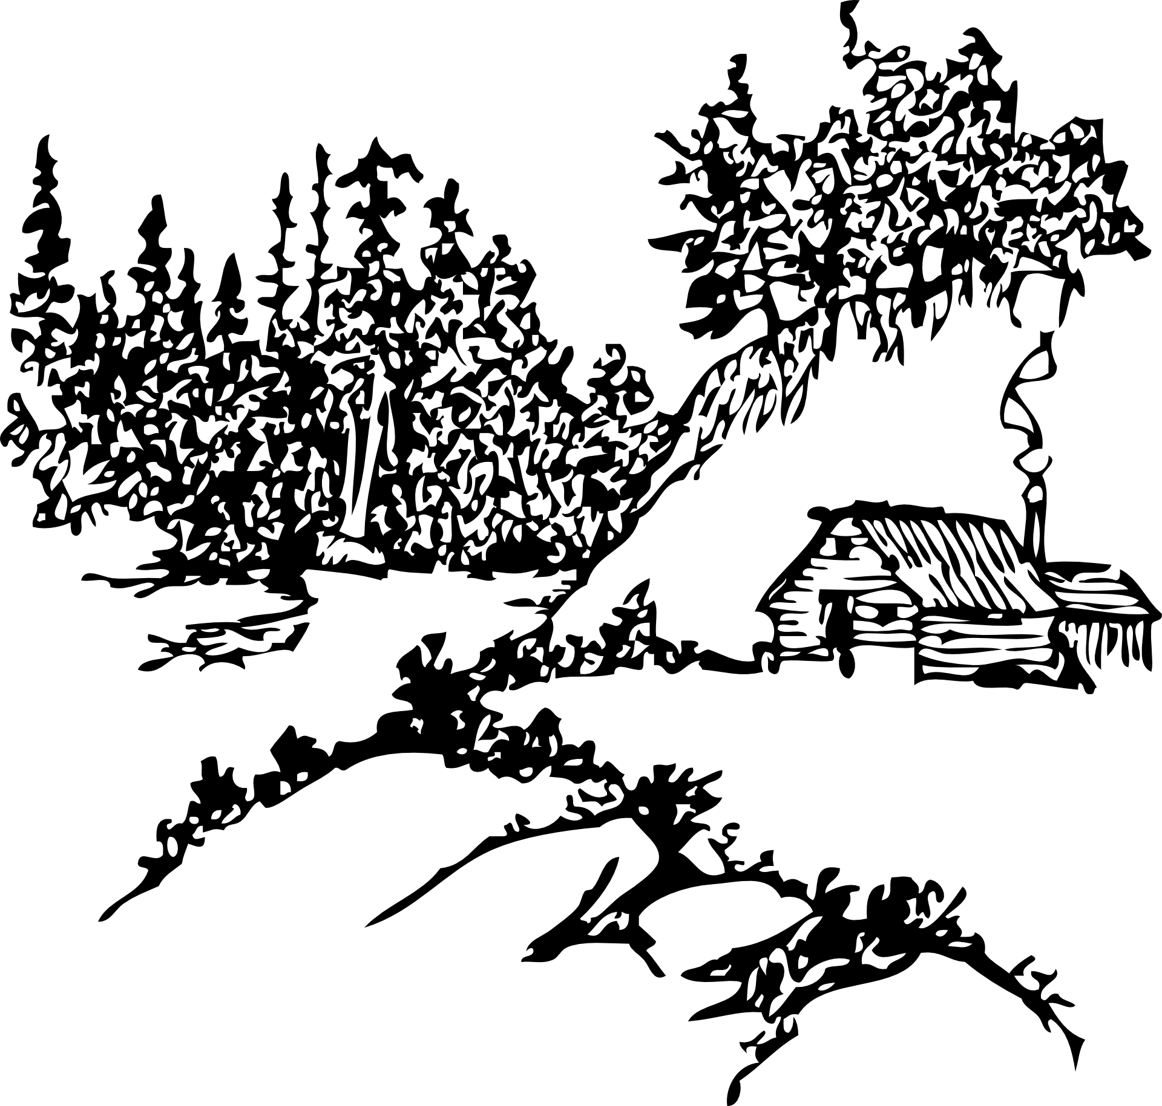 | 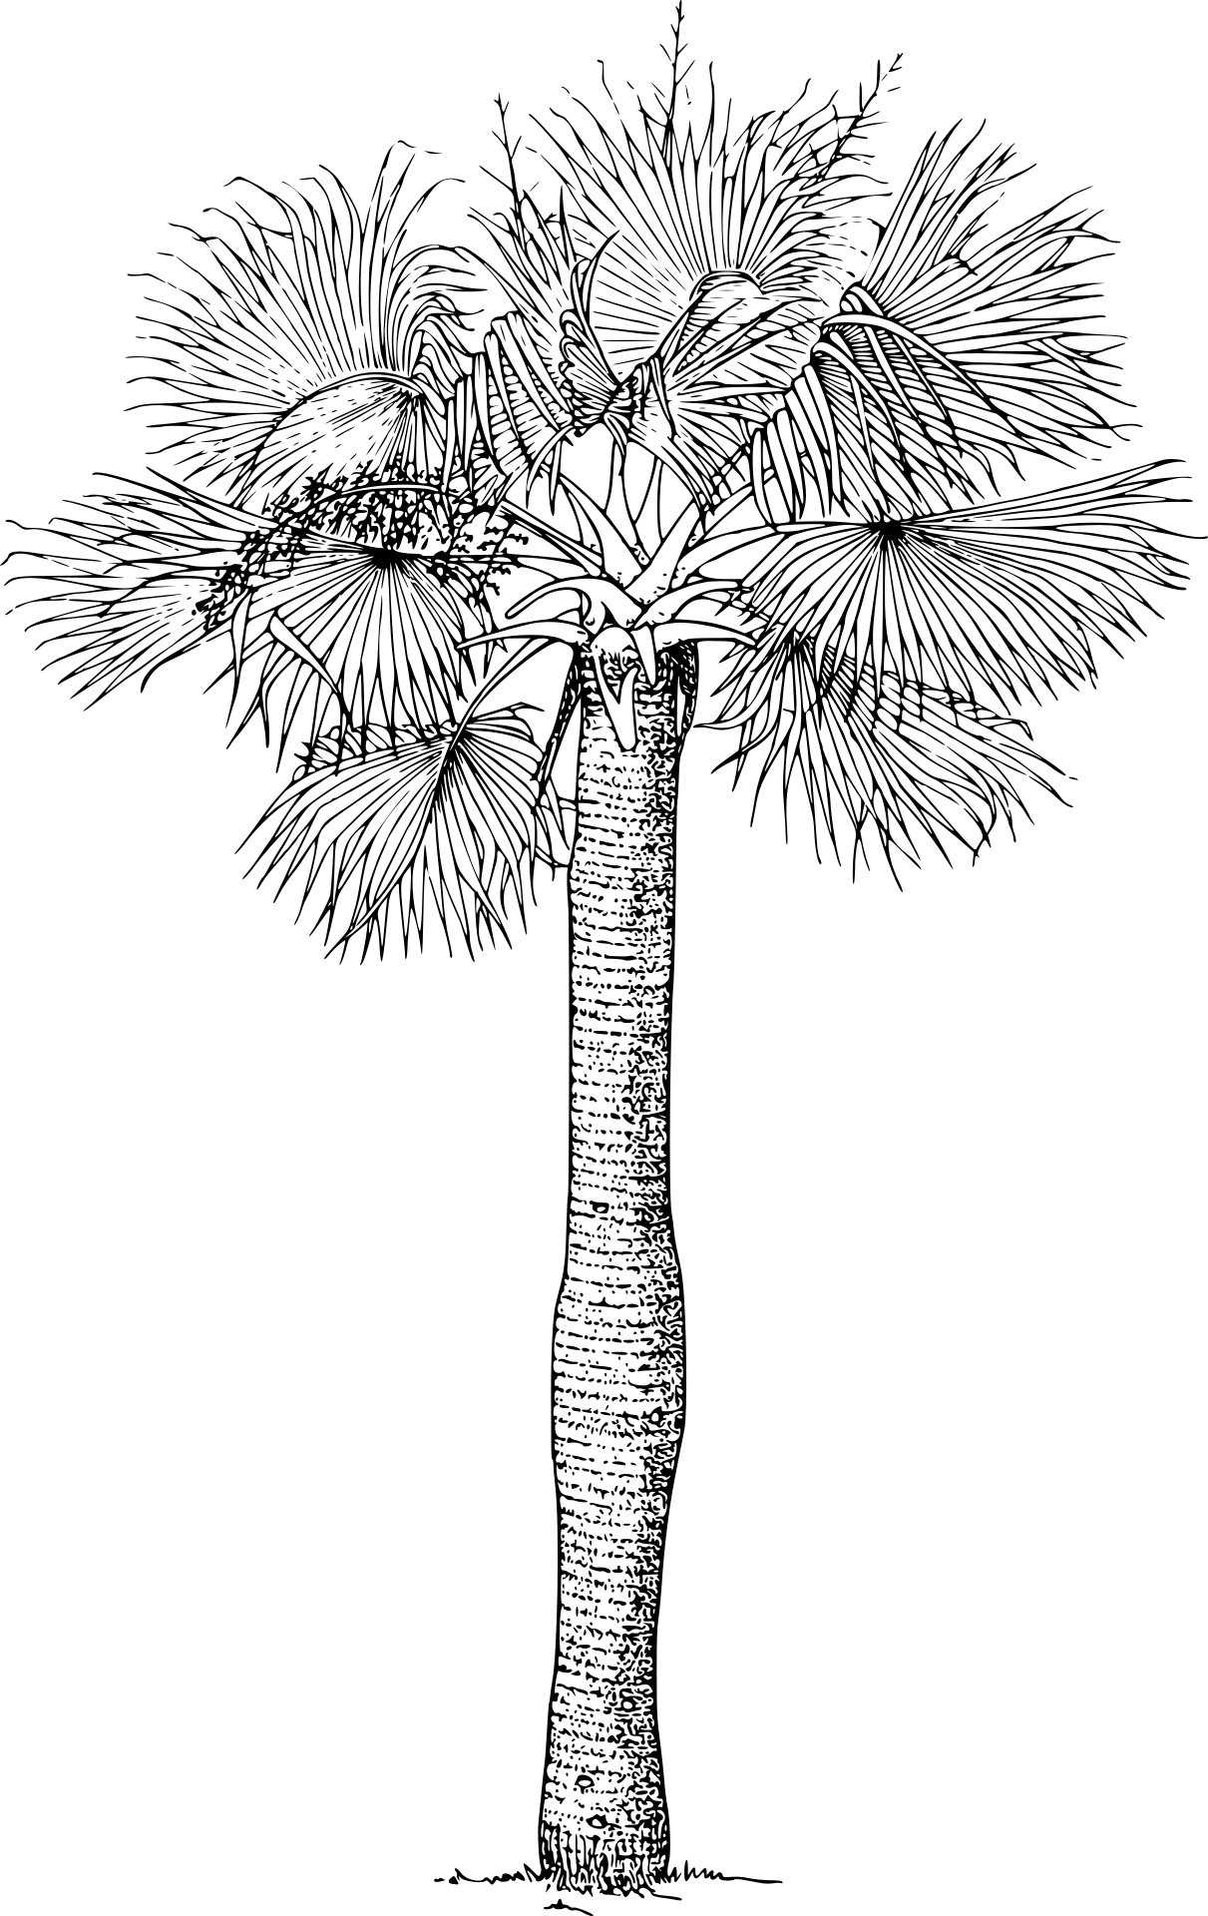

A character’s journey (EYFS) Provide children with materials to make a model of a character. This could be an animal, a person, a monster or whatever inspires them. If the children find this difficult they could use teddies or other toys instead. Now ask the children to think about a journey their character goes on and ask them to tell their partner where their character goes, who they meet and what adventures they have.
Adapt a story (KS1) To help children ‘innovate’ on a familiar story during ‘Talk for Writing’ activities, ask children to retell the ending of a story to a partner. Next their partner should challenge them to make a change, e.g. to the setting, the characters or by adding an unexpected event. How might the story change? For example, how would the story end if the Gingerbread Man came to the edge of a canyon rather than to a river? Children can then swap roles, with the storyteller adding changes suggested by their partner.
Mini sagas (KS2) A mini saga is a story that has exactly 50 words, not including the title. Challenge children to write a mini saga – e.g. retelling a traditional tale; a well-known story with a changed ending; or their own story on a given theme. As National Storytelling Week is all about the oral tradition of storytelling, encourage the children to learn their story so they can retell it to a friend or even to the whole class. Reassure them that they don’t need to learn it by heart as stories often change, expand or shrink with each telling.
Stripped down stories (KS2) Ask children to tell themselves a story they like out loud using single nouns, verbs, adjectives and the key dialogue, maybe as they walk around the classroom, playground or hall. Next, to ensure they have the basic structure right, ask them to retell the story to a friend a couple of times. This allows them to make mistakes and experiment by adding embellishments to make the story their own before telling it to a larger audience.
Story openers (all ages) All children will know at least a few story openers; Once upon a time … ; A long, long time ago … ; One sunny day … . Give your children a challenge by asking them to come up with some more thought-provoking openers. Use the resources above for ideas. You could prompt them with a few examples e.g. At the bottom of the garden … ; As the sun went down … ; In the middle of the jungle … ; On the first day of Spring … ; When the battle was over … . Compile and display a list for the class to use as a prompt for future inspiration.

