Student data collection sheet: subjective measuring of the weather (primary data)

- Record the weather for a week at home in the table below.
- You will need to use the instruction sheet to help you record your measurements.
- Use Google maps or a compass to work out where North is in your back Garden. Location should be your town or village but also use Google maps to calculate latitude and longitude.

My homes latitude: and longitude:

Day/date and time | Wind speed (Beaufort scale) | Wind speed  (miles per hour) | Wind direction  (use compass rose) | Cloud cover (oktas) | Precipitation  (scale) | Temperature  (scale)
Example in class
Student data collection sheet: objective measuring of the weather (secondary data)

- Go to the BBC website - www.bbc.co.uk/weather/.
- Search for your town/village in the find a forecast box. You may need to change your search to a nearby town or village if your village is too small to be found.
- Record the information each day in the table below.

Day and date | Wind speed  (miles per hour) | Wind direction | Cloud | Precipitation  (Yes or no,  Type – light or heavy) | Temperature  (^{O}C)
Example in class
Student tasks to compare the primary and secondary data

- Precipitation
Draw a bar graph of your subjective data over the seven days. (3 marks)

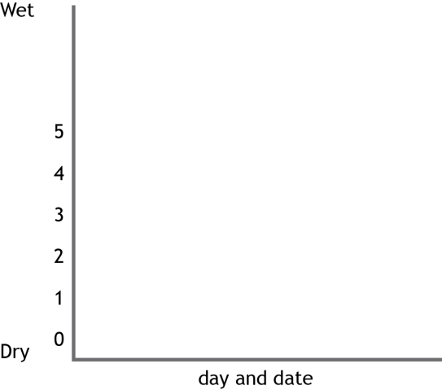

- Temperature
Draw a line graph of your objective data (BBC) over the seven days. Have two lines one for maximum temperature one for minimum temperature. (5 marks)

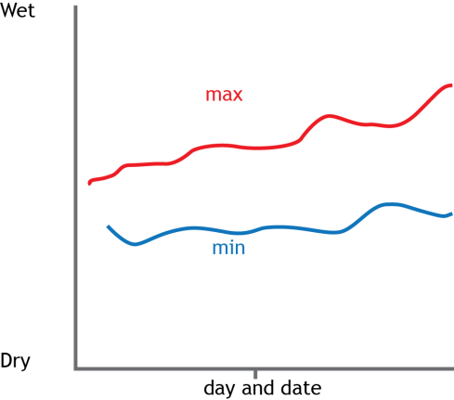

- From the objective (BBC) maximum temperature data calculate the range, median and mean values over the seven days. You must show your full working. (5 marks)

- For wind speed, create a bar graph that shows the subjective and objective data together in miles per hour. (5 marks)
Your subjective data shows a miles per hour based on the Beaufort scale, use the middle value of the miles per hour range, e.g. 13-18mph middle value is 15.5 mph.

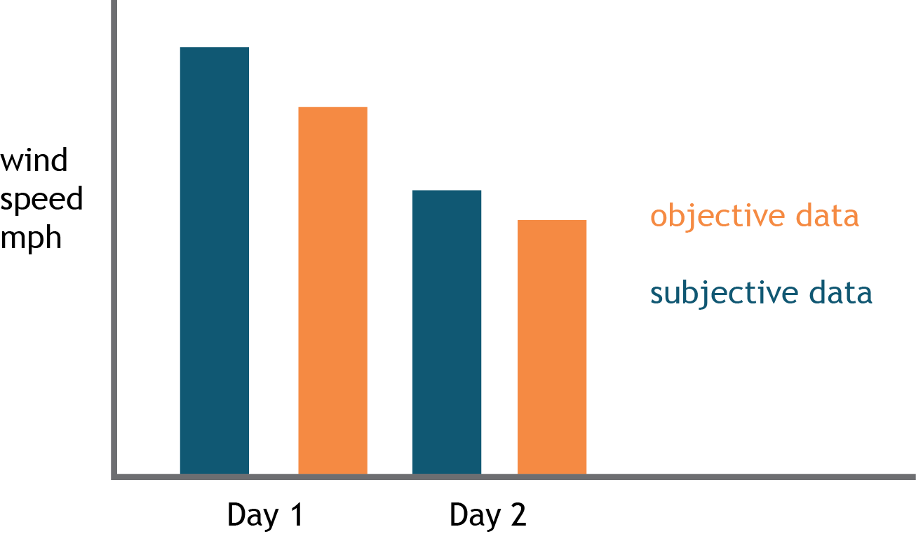

- Compare and contrast the subjective and objective data from your graph drawn in question 4. What is different and similar between them? Provide some data from the graphs to support your answer. (4 marks)

- Use the two wind roses below to shade on your wind direction for both subjective and objective data. Cut these out and stick them into your books with appropriate titles. State the prevailing wind direction (if there is one). (3 marks)

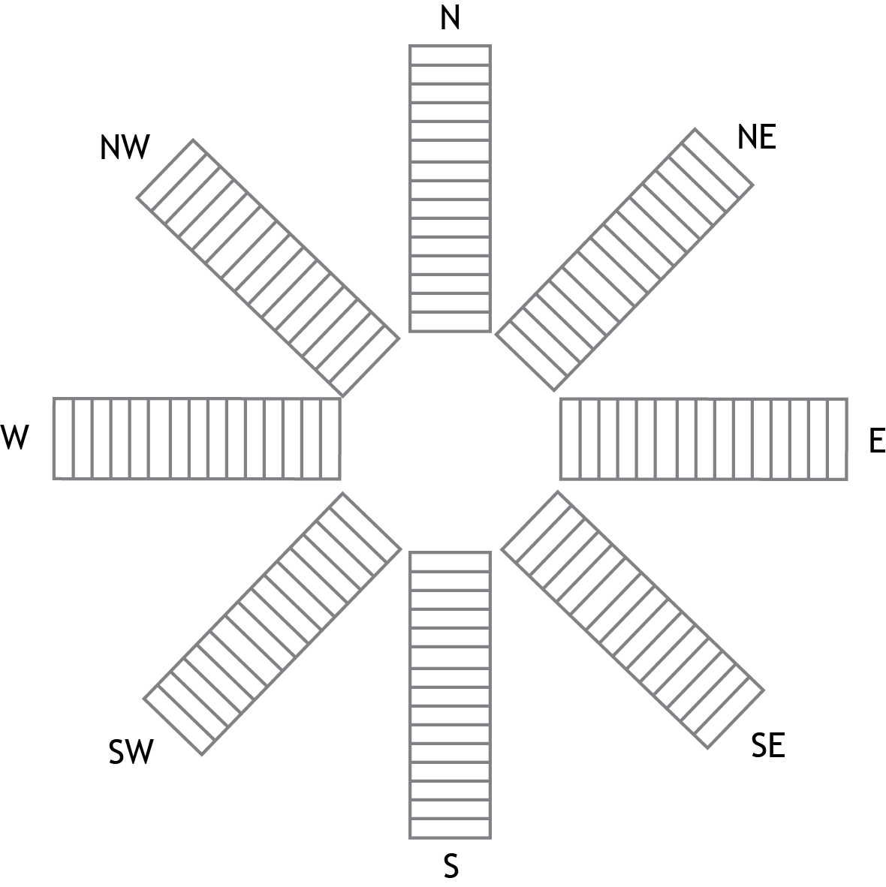

Information sheet: how to collect the data

Precipitation and temperature

Precipitation scale |  | Temperature scale
None | 0 | Freezing (see breath)
Light drizzle | 1 | Cold (need a coat)
Prolonged drizzle | 2 | Mild (wearing a jumper)
Some heavy downpours | 3 | Warm (comfortable in a t-shirt)
Constant rain | 4 | Hot (t-shirt, shorts and sandals)
Heavy rain/thunderstorms | 5 | Very hot (uncomfortable)

Wind speed: Beaufort scale

Beaufort number | Miles per hour | Description
0 | 0 | Smoke rises vertically
1 | 1-3 | Some drifts slowly
2 | 4-7 | Leaves just move
3 | 8-12 | Leaves move constantly
4 | 13-18 | Small branches move
5 | 19-24 | Small trees sway
6 | 25-31 | Large branches move
7 | 32-38 | Large trees sway
8 | 39-46 | Small branches break
9 | 47-54 | Large branches break
10 | 55 - 63 | Small trees fall

Wind direction

A more graphical way of displaying wind direction during a week is in the form of a wind rose.

A wind rose template is shown here.

Each day when you make your weather observations shade in one rectangle on the wind rose to indicate the wind direction you recorded.

At the end of the week you should have a complete wind rose. Simply by looking at the wind rose you will be able to see what has been the most common wind direction during the month, this is known as the prevailing wind direction.

Cloud cover

0 oktas | Clear skies
1 okta | Almost clear skies, just the odd cloud
2 oktas | Mostly clear skies, only a quarter of the sky covered by cloud
3 oktas | Partly cloudy, just over half the sky is cloudless
4 oktas | Partly cloudy, half of the sky covered by cloud
5 oktas | More than half the sky covered by cloud
6 oktas | Mostly cloudy, only a quarter of the sky showing
7 oktas | Almost overcast, just a small amount of sky showing
8 oktas | Overcast, no sky showing

