- Understanding key words
a)

catalyst | temperature | surface area | concentration
frequency | activation energy | collision theory | tangent

Colour in red any factors that can alter the rate of a reaction.
Colour in green the word/s that sums up that particles need to hit each other to react.
Colour in blue a way of calculating the rate of a reaction.
b) Write a sentence that uses three of the words from the boxes to explain why a reaction speeds up when one factor is changed.

- Making links
Draw arrows from each of the left-hand boxes to at least one right-hand box.

Increased temperature |  | The particles have more energy.
Using a catalyst |  | The collisions are more frequent.
Increased pressure |  | There is a pathway with lower activation energy.
Higher surface area |  | The particles are closer together.
 |  | There are more particles round the outside available to react.

- Explain
- Catalysts are specific to a reaction. What does that mean?

- Only one factor (increased temperature) actually means a reaction is more likely to happen when two particles collide. Why?

- Increasing pressure and concentration can be thought of as similar ideas. Use particles to explain why.

- Correct
A student is designing an experiment to see the effect of increasing temperature on reacting sodium thiosulfate and hydrochloric acid. He is going to use three different temperatures and time how long it takes the solution to get so cloudy a cross looks to disappear. What could he do to improve this experiment and make his results as good as possible?

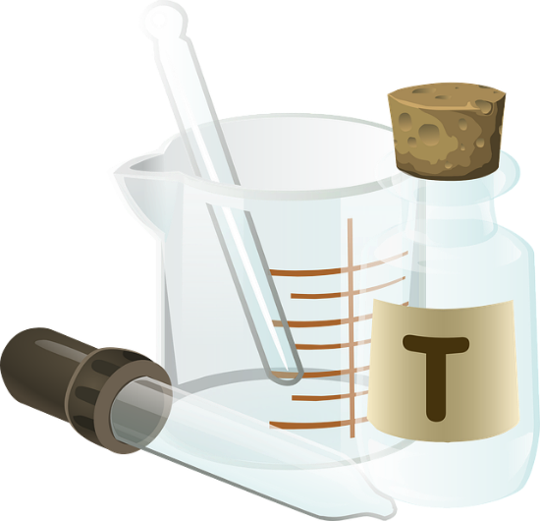

Suggested answers

1. Understanding key words
- Top line, collision theory, tangent.
2. Making links

Increased temperature |  | The particles have more energy.
Using a catalyst |  | The collisions are more frequent.
Increased pressure |  | There is a pathway with lower activation energy.
Higher surface area |  | The particles are closer together.
 |  | There are more particles round the outside available to react.

3. Explain
- You need a certain catalyst for certain reactions (they do not all work on every reaction).
- Because the particles hit each other harder so are more likely to react.
- They both involve the particles being closer together (because they are pushed closer or there are more reactant particles in total).
4. Correct
There are numerous possible answers but could include:
- Use 5 temperatures to get a clearer pattern on the graph.
- Use a colorimeter to measure cloudiness instead of by eye.
- Use a water bath to get both reactants to a stable temperature.
- Make sure other variables are controlled like concentration (possibly by using a clean conical flask each time or drying it between experiments).
- Repeat the experiment to spot anomalies.
- Take out any anomalous results when calculating a mean.
- Choose an appropriate range of temperatures (enough difference between them to show a pattern).

