Teaching notes

This resource, designed as a group activity, allows students to use primary source material in order to understand the challenges faced by African Americans in the South during and after Reconstruction.
- Divide the students into groups of four. Explain that their task is to produce a textbook passage entitled `Life after the Civil War for African Americans in the Southern states.’ This will be based on four primary sources.
- Give each group four of the sources. Each group will receive a slightly different set of sources. These might need to be chosen carefully and matched to the students. The five text sources are longer and more complex, so a mix of the text/picture sources should be chosen as appropriate to the individual students. Sources E and G paint a more optimistic picture of emancipation which was not always borne out by events (or matched in the other sources) so it would be best only to use one of these in any group.
- Each student is responsible for reading/analysing one source and considering the questions at the end of their source.
- Once all group members have read/analysed their source, they should explain their source to the group. In reporting back to the group they should include any other relevant points they have noticed.
- Once every group member has explained their source, the group should work together to write a textbook passage entitled `Life in the South after the Civil War.` Their passage should include reference to:
- What Americans from both northern and southern States, and both white and African American, thought should happen to the latter after the Civil War.
- What the experience of African Americans was in the southern states after the Civil War.
- Any other relevant points they discover in analysing the sources.
- Each group should read their completed textbook passage out to the rest of the class. Students can add any additional points from other groups in the form of notes at this stage. (N.B. an alternative would be for students to create a mind map/spider diagram alongside their textbook passage. This could then be quickly added to if necessary as other textbook passages are being read out.)
- The teacher draws the work together through a class discussion and/or summary mind map/spider diagram.

Source A: The views of a former slave from Tennessee in 1865. Following the 13th Amendment ending slavery, Samuel Childress, a former slave in Nashville wrote a letter to the editor of the Weekly Anglo-African newspaper. His letter was published on 29th November.

‘A Bleak Future for Freedmen
Mr. Editor:

You want to know our opinions respecting the policy of the President Andrew Johnson concerning the coloured race. To us the prospect seems gloomy. We have no permanent homes, and we see no prospect of getting any. Most of us are used to farm labour, and our skills lie in that direction. Land is dear, and few of us are able to buy it. It is said that we can hire ourselves out to our former masters, but it is well known that the temper of our former masters had not greatly improved toward us. Is it the intention of the Government to drive us to our worst enemies to ask for work?

Our race has tilled this land for ages so whatever wealth has been accumulated in the South has been gained mainly by our labour. The profits of our labour have gone to increase the pride and wickedness of our old masters, while we have been left in ignorance and poverty. It cannot be denied that the coloured race has earned nearly all of this property. Justice requires that it should be paid over to the coloured race who have been robbed of it. But what did they do with it? It has gone back into the very hands that are dripping with the blood of murdered prisoners, and whose cruelties cry to heaven for vengeance. It would seem that it was regarded as a greater crime to be black than to be a rebel. We think that the Government ought to enable us to obtain farms at such prices, and on such terms that would allow our people to have a home of their own, on which they might hope to earn a living, and educate their children.

Samuel Childress, 1865’

Source: Weekly Anglo-African, 29th November 1865. Accessed through www.civilwar.org. In the public domain.

Questions to consider:
- Why did the author argue that freedmen’s future in the South was ‘gloomy’?
- How did he think the government should help freedmen?

Source B: The views of teachers at African American Schools in 1864, from a report of the Board of Education for Freedmen, Department of the Gulf. During and after the Civil War, teachers spread throughout the South in an effort to educate freed black children and adults. There were many difficulties associated with starting education for African Americans, especially before the war ended in 1864.

‘Instances of hardship and peril
In a parish, some distance from New Orleans, a building was obtained, an energetic teacher sent, scholars gathered, and the work begun. The teacher later wrote: “Arrived. Went about gathering students, have forty. Did well enough till it rained, since then have walked three miles a day, ankle deep in thick black mud that pulls off my shoes. Nothing to eat but strong pork and sour bread. Insulted for being a “(black) teacher”. Can’t buy anything on credit, and haven’t a cent of money. The school shed has no floor, and the rains sweep across it through the places where the windows should be. The Provost Marshal won’t help me. Says “he don’t believe in (black) teachers.”’

More obstacles are indicated by the following extract from the report of a country teacher:
‘I have, in vain, attempted to form a night school. I never dared take more than two pupils, because some of the officers are so opposed to the instruction of negroes. One used to let his dogs loose to bite the students, until I told him I would kill them if they did bite my pupils. A great many more would come to night-school only they are afraid. The school-house in Thiberoux has been broken into on successive nights and the furniture defaced and the books destroyed. Bricks have been hurled through the windows, greatly risking life and limb. Complaint after complaint has not brought any protection.

Characteristics of the Pupils
The pupils are orderly, hard-working, and easily governed. They are very grateful for any interest and kindness shown to them. Another habit of these coloured children is their care of books and school furniture. The walls and fences around the coloured schools are not defaced. They are free from the two most common and disgusting vices of school children, profanity and swearing.’

Source: The Report of the Board of Education for Freedmen, Department of the Gulf, for the Year 1864 by the U.S. Army, printed in 1865 in New Orleans. In the public domain and available freely on the Library of Congress.

Questions to consider:
- What challenges did the teachers and students at African American schools face?
- According to this source, what were the attitudes of former-slave students?

Source C: The views of Edwin H. McCaleb, a former Confederate supporter, in 1865.

‘Our Country is now in a Disturbed Condition

Our country is now in a disturbed condition caused by the fiery ordeal through which we have just passed and the total absence of both military and civil laws. Were it not for the law abiding nature of our people we would be subjected to lawlessness and outrage. President Johnson has ignored the requirements of the Constitution and imposes military governments over the states.

By sudden Emancipation, the turning of the ignorant Negro from a peaceful labourer who has been used to having all his needs provided both in sickness and health into a self-reliant citizen will paralyze the productive resources of the South. It can cause a famine in this fertile land. If we could have gradual emancipation our people would universally rejoice and be glad to get rid of slavery which has always been a cancer upon the body politic. We would gladly substitute white for slave labour but we can never regard the Negro as our equal either intellectually or socially.

The government ought to take a generous, merciful and peace-making attitude towards those who have tried to be honourable and who have admitted ourselves fairly beaten. Let the northern people arise in the majesty of their power and not engage in official oppression and hatred.’

Source: The Gilder Lehrman Institute of American History . In the public domain.

Questions to consider:
- What is the author’s view of President Johnson?
- Why is he worried about the ‘sudden system of Emancipation’ of slaves?

Source D: A Southerner`s view on the Civil Rights Bill of 1875 (from an article in the Atlanta News on 10 September 1874).

`Let there be White Leagues formed in every town and village in the South, and let us organize for the great struggle which seems inevitable. If the October elections which are to be held at the North are favourable to the radicals, the time will have arrived for us to prepare for the very worst. The radicalism of the Republican Party must be met by the radicalism of white men. We have no war to make against the United States Government, but against the Republican Party our hate must be unquenchable, our war endless and merciless. By brute force they are trying to force us into agreement to their hideous programme. We have submitted long enough, and it is time to meet brute-force with brute-force. Every Southern State should swarm with White Leagues, and we should stand ready to act the moment the civil-rights bill is signed. The signing of the bill will be a declaration of war against the southern whites. It is our duty to ourselves, to our children, and to the white race to take up the gauntlet of battle the moment it is thrown down. It is time for us to organize. We have been waiting to act for long enough. Let northern radicals understand that military supervision of southern elections and the civil-rights bill mean war and that war means bloodshed.’

Source: Documentary History of Reconstruction by Walter Fleming (1907) available at www.archive.org (digitized by Google from the library of Harvard University). In the public domain.

Question to consider:
- How did the author think white southerners should react to the Civil Rights Bill?

Source E: List of murders in the District of Alabama 1866 from the records of the Freedmen’s Bureau in Alabama, 1866. The Freedmen’s Bureau was set up in 1865 to provide help for freed African Americans. It was abolished in 1872.

  - Freedman killed in Sumter County, January.
  - Freedman killed in Russell County, February.
  - Freedman killed near West Point, March.
  - Freedman killed with an axe in Butler County. Three freedmen killed by two brothers in Shelby County, April.
  - Freedman killed in Montgomery County, April. Freedman & freedwoman killed, thrown into a well in Jefferson Co., April.
  - Freedman killed for refusing to sign a contract, Sumter Co., May. Freedman killed in Butler Co., clubbed, April.
  - Freedman found hung by a grapevine in woods near Tuscaloosa, May.
  - Freed girl beaten to death by two white men near Tuscaloosa, July.
  - Freedman murdered between Danville & Somerville.
  - Freedman shot dead while at his usual work, near Tuscaloosa, Sept.
  - Freedman killed in Pike County, Sept.
  - Negro murdered near Claiborne, Alabama, June.
  - Freedman brought to hospital in Montgomery, shot through the head by unknown parties − died in few hours, Dec.
N.B. In a separate section another 38 entries are listed including:
3 April − Woman taken by three men out of her house in middle of night to swamp & badly whipped , beaten on head with pistol.
29 May – Richard`s wife beaten with club by her employer. Richard argued − in the night was taken from his house and whipped nearly to death with a buggy rein by son of the employer & two others.
16 June − Mr. Alexander, coloured preacher, brutally beaten & forced to leave his house at Auburn, Ala.
July − Band of armed men came to house of Eliz. Adams, threatened to kill her & her sister if they did not leave the county, abused & beat them.
16 July − Black girl beaten to death by Washington and Greene McKinney, 18 miles west of Tuscaloosa.
14 Sept − Black man picking fodder in a field shot dead − & another who had difficulty with a white man abducted & supposed to have been murdered near Tuscaloosa.
3 Sept − Murderous assault upon returned black Union soldier in Blount Co.
Source: The Freedmen’s Bureau Online. In the public domain.

Questions to consider:
- Are there any patterns to who was killed and the circumstances?
- Do you think all the murders of former slaves in Alabama in 1866 are included here?

Source E: An engraving by Thomas Nast,1865, to celebrate the emancipation of Southern slaves after the Civil War
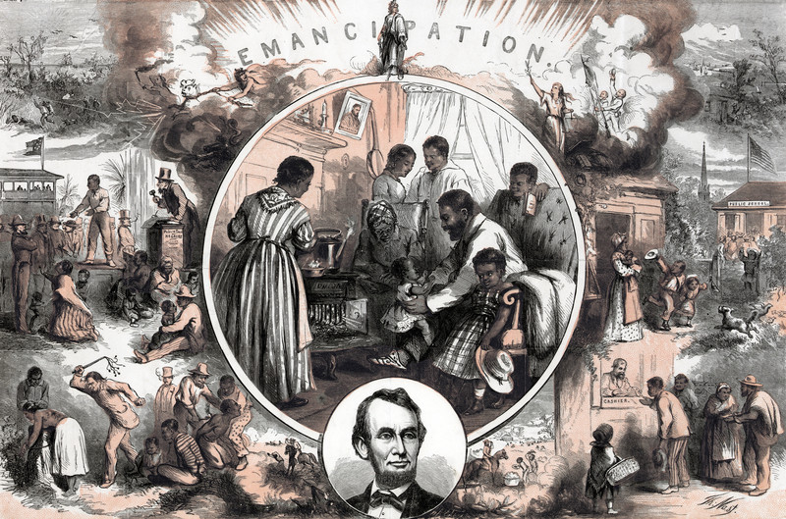
Thomas Nast's celebration of the emancipation of Southern slaves at the end of the American Civil War. Centre: A freedman's home. Left: Conditions before Emancipation. Right: After Emancipation. Bottom: Abraham Lincoln. / Credit: Universal History Archive/Universal Images Group / Copyright © Universal Images Group / For Education Use Only. This and millions of other educational images are available through Britannica Image Quest. For a free trial, please visit www.britannica.co.uk/trial

Questions to consider:
- How does Thomas Nast contrast the life of African Americans before and after emancipation?
- Nast was a New Yorker who had always supported the abolition of slavery. How might this have affected his view of emancipation?
Source F: A cartoon from 1874 called `Worse than Slavery`

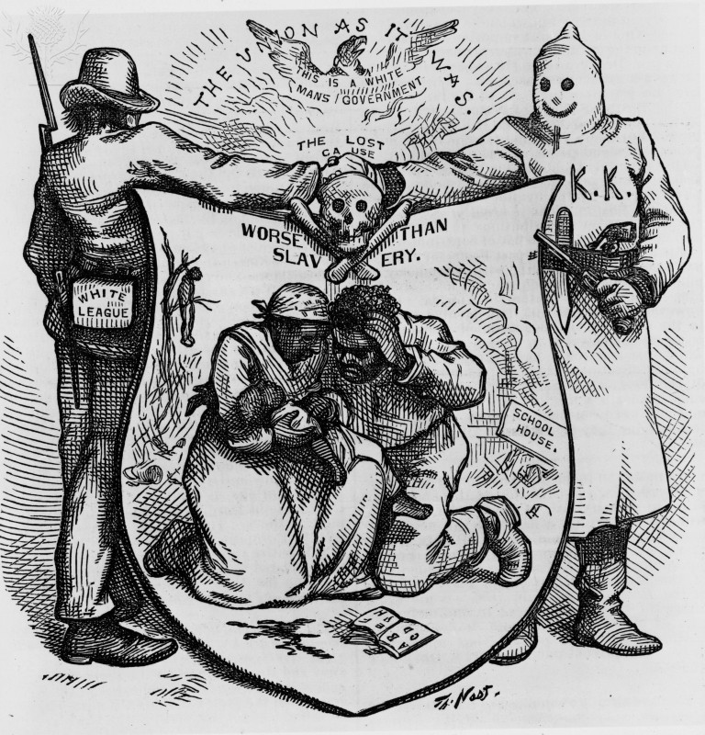
NAST: KU KLUX KLAN, 1874. - 'Worse Than Slavery.' A cartoon, 1874, by Thomas Nast showing post-Civil War harassment by the Ku Klux Klan and the White League as less tolerable for African-Americans than slavery / Credit: The Granger Collection / Universal Images Group / Copyright © The Granger Collection / For Education Use Only. This and millions of other educational images are available through Britannica Image Quest. For a free trial, please visit www.britannica.co.uk/trial

Questions to consider:
- Why did the cartoonist call his cartoon about African Americans `Worse than Slavery`?
- How does the cartoonist show this?

Source G: The front cover of Harper’s Weekly on 16th November 1867. It was called ‘The First Vote’

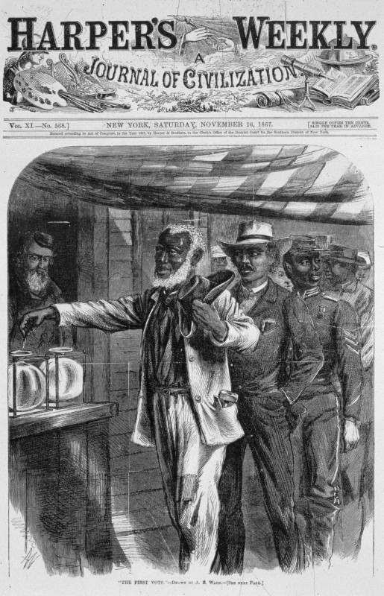
1st Black Vote / Credit: MPI / Getty Images / Universal Images Group / Copyright © Getty Images / For Education Use Only. This and millions of other educational images are available through Britannica Image Quest. For a free trial, please visit www.britannica.co.uk/trial

Questions to consider:
- Harper`s Weekly was a political magazine based in New York City. How might that affect its view of what happened to African Americans after the Civil War?
- Which three groups in society are the first three African Americans meant to represent?
Source H: A woodcut showing events in Memphis, Tennessee, on 2nd May 1866

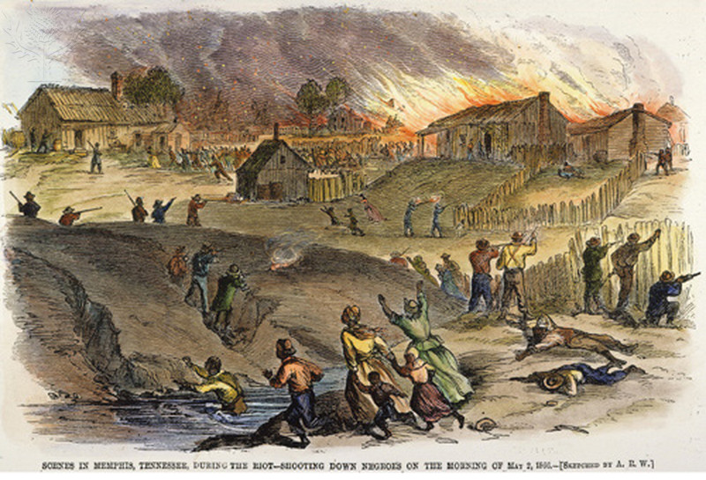
TENNESSEE: RACE RIOT, 1866. - The race riot at Memphis, Tennessee, on 1-2 May 1866. Contemporary American wood engraving. / Credit: The Granger Collection / Universal Images Group / Copyright © The Granger Collection / For Education Use Only. This and millions of other educational images are available through Britannica Image Quest. For a free trial, please visit www.britannica.co.uk/trial

Question to consider:
- What happened to African Americans in Memphis, Tennessee, in November 1866?

