Teaching notes

These are two practice interpretation questions. It is intended that students use the example answer (about an interpretation of Hereward the Wake – pp.2-3) and analyse it against the mark scheme to see what makes an effective answer. They can then use the second question (about William’s consolidation of power – p.4) to put what they’ve learned into action.

Question stem

How convincing is Interpretation A about …? Explain your answer using Interpretation A and your contextual knowledge. (8 marks)

Assessment objectives

Analyse individual interpretations (AO4a)
Evaluate interpretations and make substantiated judgements in the context of historical events studied (AO4d)

General mark scheme

Level | Description | Marks
1 | Analysis of interpretation based on contextual knowledge/understanding.  Answers show understanding/support for interpretation but the case is made by assertion/recognition of agreement. | 1–2
2 | Simple evaluation of interpretation based on contextual knowledge/understanding.  Candidates may progress from a basic analysis of interpretation by reasoning supported with factual knowledge and understanding based on one aspect of the interpretation. | 3–4
3 | Developed evaluation of interpretation based on contextual knowledge/understanding (extends Level 2).  Candidates may progress from a simple evaluation of the interpretation by extended reasoning supported by factual knowledge and understanding of more than one aspect of the interpretation. | 5–6
4 | Complex evaluation of interpretation with sustained judgement based on contextual knowledge/understanding (extends Level 3).  Candidates may progress from a developed evaluation of interpretation by complex analysis of the interpretation supported by factual knowledge and understanding. | 7–8

Example one

How convincing is Interpretation A about the rebellion led by Hereward the Wake in 1070?
- Read the model answer to this question.
- Then highlight and/or use the letter coding to show how this visual interpretation has been used effectively in the example answer.

Letter coding
- Points out a relevant feature in the interpretation
- Explains a potential inaccuracy
- Uses a short introduction to show understanding of the question
- Uses knowledge to analyse the interpretation
- Uses a conclusion to sum up points made and address the question directly
- Explains why something is accurate

Interpretation A
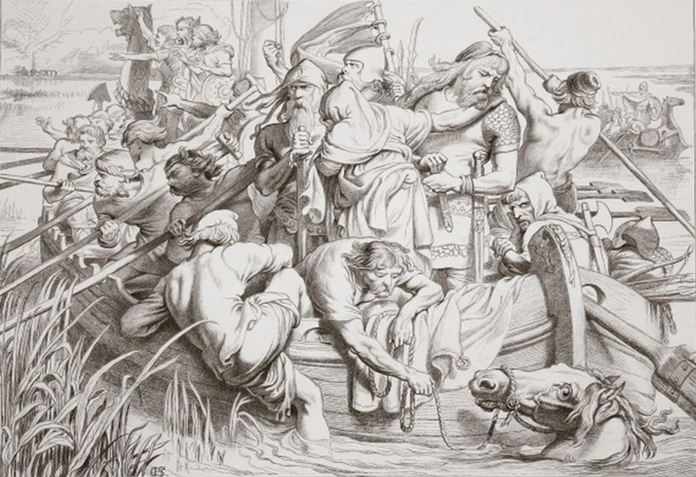
How Hereward departed from Ely, and how he killed the mare, Swallow, illustration from Hereward the Great by Charles Kingsley, pub. 1870, engraved by C.G. Lewis (steel plate engraving) / Credit: Private Collection / The Stapleton Collection / Bridgeman Art Library / Universal Images Group / Copyright © Bridgeman Art Library / For Education Use Only. This and millions of other educational images are available through Britannica Image Quest. For a free trial, please visit www.britannica.co.uk/trial
Interpretation A: Hereward the Wake

Example answer

Interpretation A shows Hereward the Wake and his followers on a boat in what looks like the Fens in East Anglia. It has some accurate points but it also leaves out or exaggerates some key features of the rebellion.
The rebellion in 1070 began when King Swein of Denmark invaded. He led his armies to the Fens where he was joined by Hereward, a warrior from Peterborough whose family had been dispossessed by William I; many of Hereward’s family had been killed by Normans. With the help of the Danes, Hereward captured the island of Ely in the Fens and began to fortify it against the expected Norman counter-attack. Interpretation A is accurate in that it shows Hereward and a group of warriors, some of whom were armed, making their way around Ely. Many of them are looking around, perhaps on the lookout for Norman soldiers about to attack. William was well-known for putting down rebellions swiftly and brutally, as he had recently done in York and Durham, so Hereward’s followers were right to be watchful, as shown here. In the background is a boat carrying soldiers who appear to be better equipped with armour. They may be Danish soldiers who were better trained and more likely to be professional than Hereward’s English supporters.
A key point against the Interpretation is that is suggests that the rebels were on the move as they waited for William’s forces to come to them. This is inaccurate because once Hereward and his followers reached Ely they set about turning it into a base: they held the island for over a year. The Normans’ efforts to reach the rebels were therefore considerable. They built a causeway, and then a stronger one when that collapsed, as well as four siege towers A Norman cavalry attack was needed before the rebellion was finally over. Also, the inclusion of what could be Danish soldiers in the Interpretation is misleading. They actually abandoned the English rebels, probably taking with them the treasures of Peterborough Abbey which Hereward had taken to Ely for safekeeping. This left Hereward and his forces weaker and more exposed to the Norman attack, although more local English people did flock to his cause as his stay on Ely continued.
Overall the Interpretation is only partially convincing. Despite some accurate features it is misleading about the methods used by the rebels and also the support of the Danish.

Example two

Interpretation B shows London in late November 1066.

How convincing is Interpretation B about William’s consolidation of power immediately after the Battle of Hastings in 1066?

Annotate the image to help you plan a full answer to this question. Use the letter coding from the example answer to help you.

Interpretation B
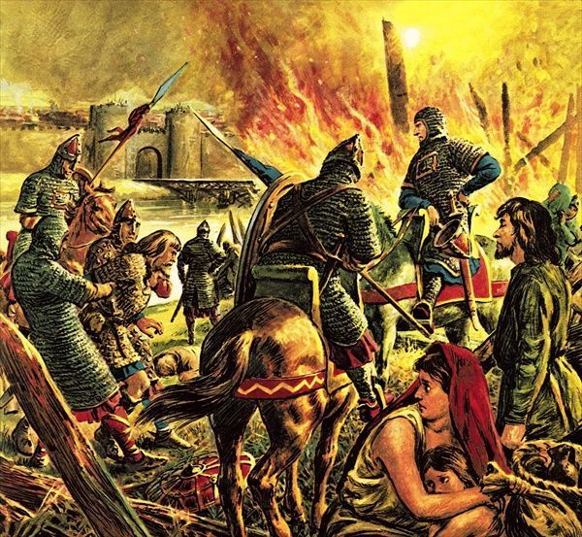
The Conqueror Comes to London / Credit: Private Collection / Look and Learn / Bridgeman Images / Copyright © Bridgeman Art Library / For Education Use Only. This and millions of other educational images are available through Britannica Image Quest. For a free trial, please visit www.britannica.co.uk/trial
William the Conqueror arrives in London

Things to think about
Is there anything about this interpretation which is inaccurate, compared to your knowledge of the topic?
What other knowledge about this topic could you include that isn’t shown or suggested in the interpretation?

