Syngman Rhee  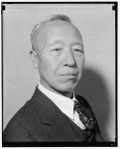 | Guess who? | Mao Zedong  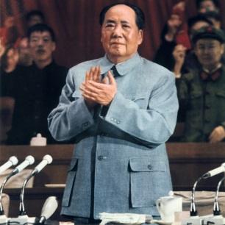  Mao Tse-Tung (Mao Zedong) 1893-1976, Chinese Communist leader. Mao addressing a meeting. / Credit: Universal History Archive/Universal Images Group / Copyright © Universal Images Group | Guess who?
Kim Il Sung  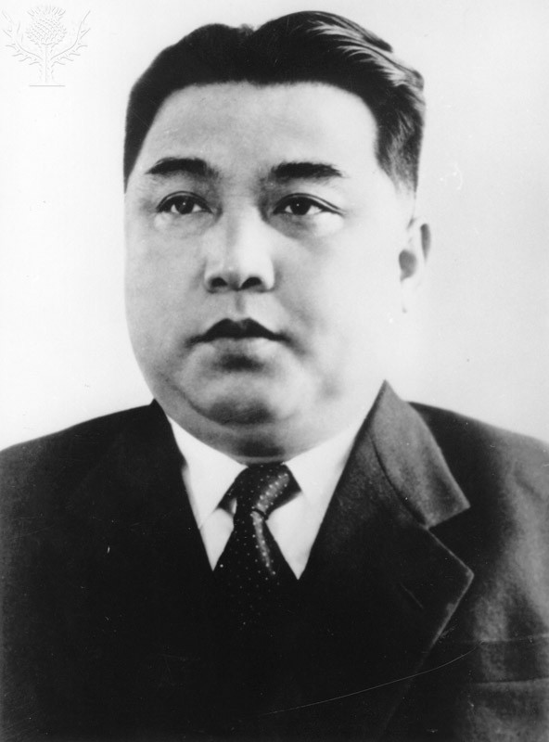  Red Premier / Credit: Three Lions / Hulton Archive Editorial / Getty Images / Universal Images Group / Copyright © Getty Images | Guess who? | Harry Truman  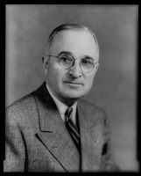 | Guess who?
Joseph Stalin  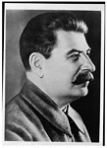 | Guess who? | Joseph McCarthy  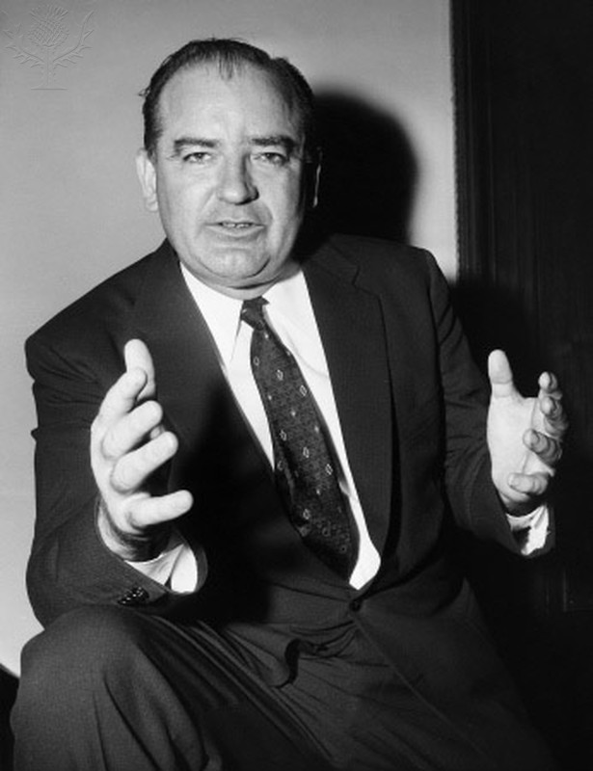  JOSEPH McCARTHY (1908-1957). - American politician. Photograph, c1955. / Credit: The Granger Collection / Universal Images Group / Copyright © The Granger Collection | Guess who?
Douglas MacArthur  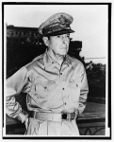 | Guess who? | Dwight D. Eisenhower  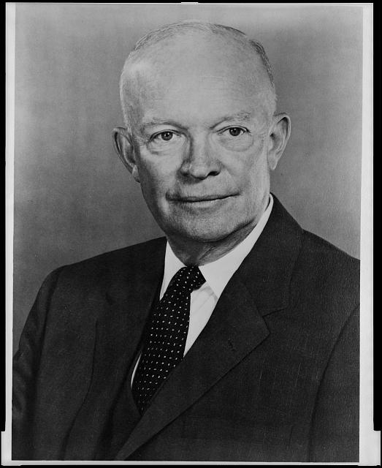 | Guess who?
Chiang Kai-shek  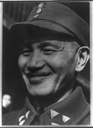 | Guess who? | Ngo Dinh Diem  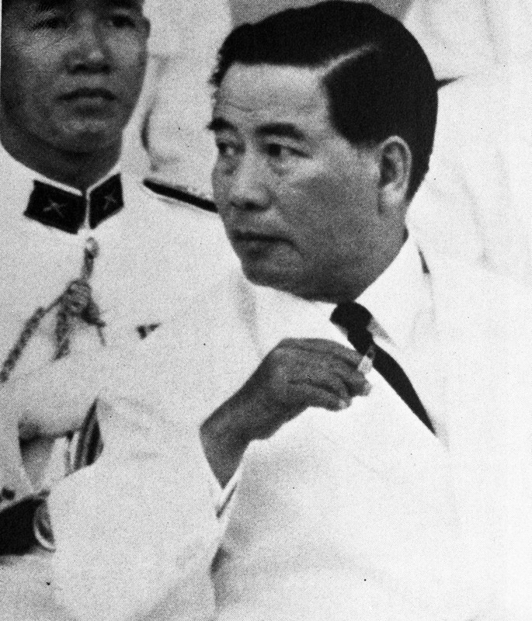  President Ngo Dinh Diem / Credit: Universal History Images\UIG / Copyright © Universal Images Group | Guess who?
Ho Chi Minh  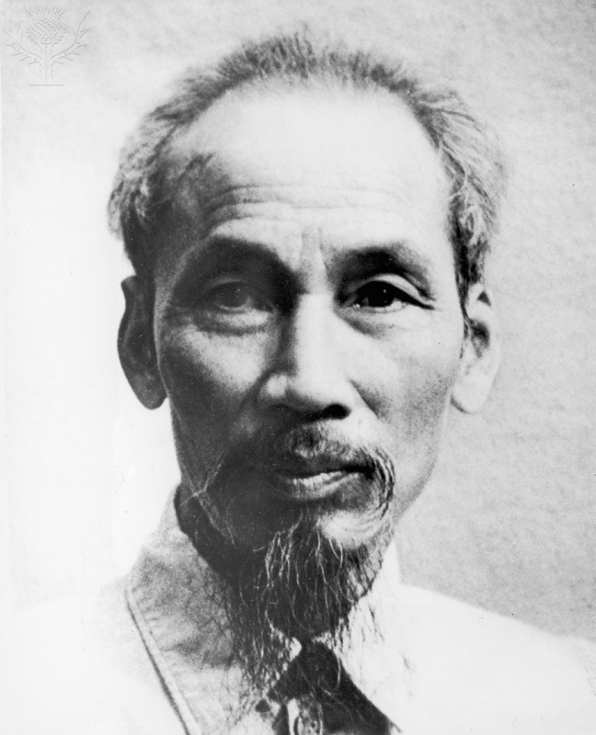  Ho Chi-Minh / Credit: Hulton Archive / Archive Photos / Getty Images / Universal Images Group / Copyright © Getty Images | Guess who? | John F. Kennedy  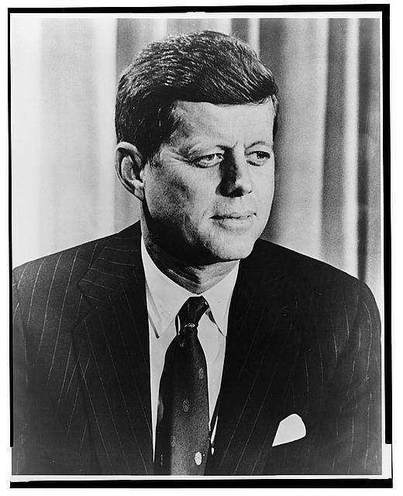 | Guess who?
Robert McNamara  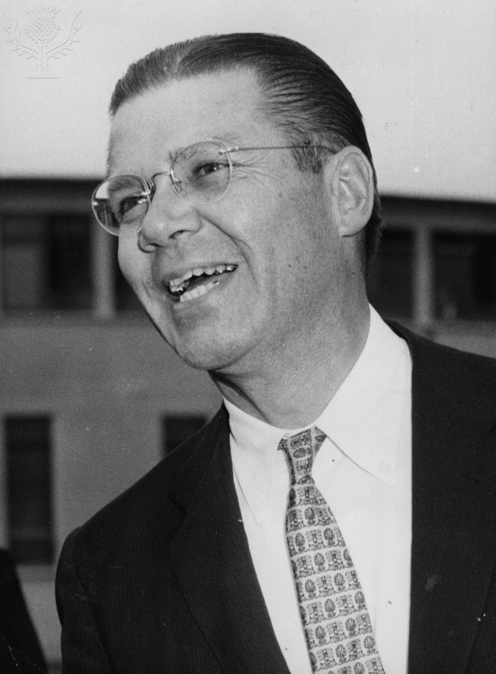  Robert McNamara / Credit: Keystone / Getty Images / Universal Images Group / Copyright © Getty Images | Guess who? | Henry Kissinger  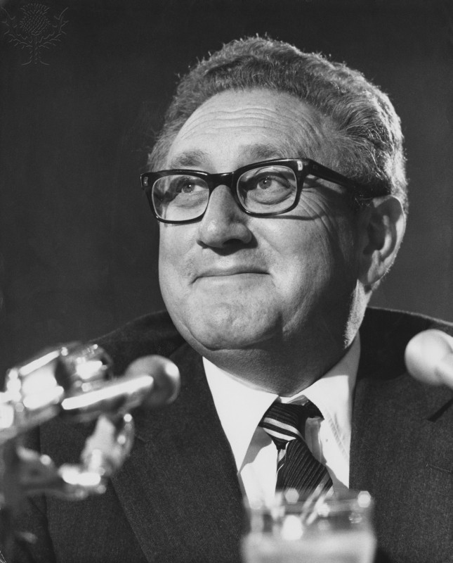  Henry Kissinger / Credit: Keystone / Hulton Archive / Getty Images / Universal Images Group / Copyright © Getty Images | Guess who?
Lyndon B. Johnson  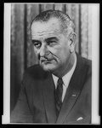 | Guess who? | Richard Nixon  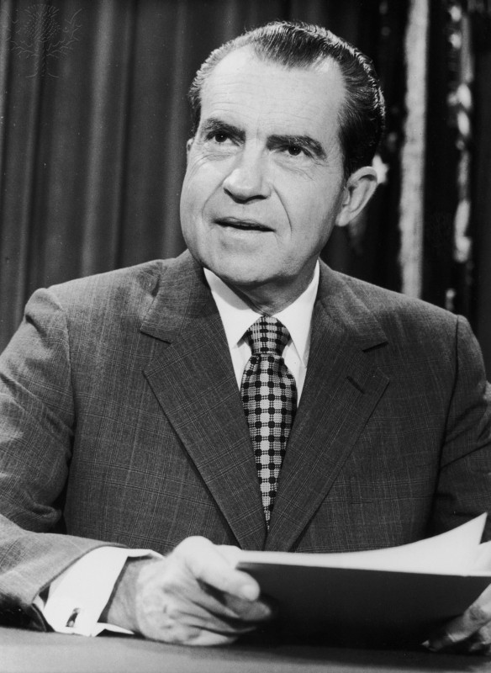  Richard Nixon / Credit: Hulton Archive / Getty Images / Universal Images Group / Copyright © Getty Images | Guess who?

Syngman Rhee | Guess who? | Mao Zedong  Mao Tse-Tung (Mao Zedong) 1893-1976, Chinese Communist leader. Mao addressing a meeting. / Credit: Universal History Archive/Universal Images Group / Copyright © Universal Images Group | Guess who?
Kim Il Sung  Red Premier / Credit: Three Lions / Hulton Archive Editorial / Getty Images / Universal Images Group / Copyright © Getty Images | Guess who? | Harry Truman | Guess who?
Joseph Stalin | Guess who? | Joseph McCarthy  JOSEPH McCARTHY (1908-1957). - American politician. Photograph, c1955. / Credit: The Granger Collection / Universal Images Group / Copyright © The Granger Collection | Guess who?
Douglas MacArthur | Guess who? | Dwight D. Eisenhower | Guess who?
Chiang Kai-shek | Guess who? | Ngo Dinh Diem  President Ngo Dinh Diem / Credit: Universal History Images\UIG / Copyright © Universal Images Group | Guess who?
Ho Chi Minh  Ho Chi-Minh / Credit: Hulton Archive / Archive Photos / Getty Images / Universal Images Group / Copyright © Getty Images | Guess who? | John F. Kennedy | Guess who?
Robert McNamara  Robert McNamara / Credit: Keystone / Getty Images / Universal Images Group / Copyright © Getty Images | Guess who? | Henry Kissinger  Henry Kissinger / Credit: Keystone / Hulton Archive / Getty Images / Universal Images Group / Copyright © Getty Images | Guess who?
Lyndon B. Johnson | Guess who? | Richard Nixon  Richard Nixon / Credit: Hulton Archive / Getty Images / Universal Images Group / Copyright © Getty Images | Guess who?

Syngman Rhee | Guess who? | Mao Zedong  Mao Tse-Tung (Mao Zedong) 1893-1976, Chinese Communist leader. Mao addressing a meeting. / Credit: Universal History Archive/Universal Images Group / Copyright © Universal Images Group | Guess who?
Kim Il Sung  Red Premier / Credit: Three Lions / Hulton Archive Editorial / Getty Images / Universal Images Group / Copyright © Getty Images | Guess who? | Harry Truman | Guess who?
Joseph Stalin | Guess who? | Joseph McCarthy  JOSEPH McCARTHY (1908-1957). - American politician. Photograph, c1955. / Credit: The Granger Collection / Universal Images Group / Copyright © The Granger Collection | Guess who?
Douglas MacArthur | Guess who? | Dwight D. Eisenhower | Guess who?
Chiang Kai-shek | GUESS WHO? | Ngo Dinh Diem  President Ngo Dinh Diem / Credit: Universal History Images\UIG / Copyright © Universal Images Group | GUESS WHO?
Ho Chi Minh  Ho Chi-Minh / Credit: Hulton Archive / Archive Photos / Getty Images / Universal Images Group / Copyright © Getty Images | GUESS WHO? | John F. Kennedy | GUESS WHO?
Robert McNamara  Robert McNamara / Credit: Keystone / Getty Images / Universal Images Group / Copyright © Getty Images | GUESS WHO? | Henry Kissinger  Henry Kissinger / Credit: Keystone / Hulton Archive / Getty Images / Universal Images Group / Copyright © Getty Images | GUESS WHO?
Lyndon B. Johnson | GUESS WHO? | Richard Nixon  Richard Nixon / Credit: Hulton Archive / Getty Images / Universal Images Group / Copyright © Getty Images | GUESS WHO?

Teaching notes

Aim: To help students consolidate their understanding of the entire topic by reviewing key individuals from the Korean and Vietnam Wars.

To make the cards: There are 16 cards in each colour set. Cut round the picture and backing then fold over and stick the two halves together to make a card with a picture on one side and a coloured backing on the other. To play the game, each pair will need a set of pink, blue and purple cards.

To play the game: The game should be played in pairs. Each player needs to lay either the pink or blue cards face up in a 4X4 grid in front of them. Then the purple deck needs to be shuffled. Each player picks a card from the purple deck and keeps it a secret − this is the character that the other player is searching for. The players then take it turns to ask questions in order to find out the mystery person. E.g. Player 1: ‘Was this person the president of the USA?’ Player 2: ‘No’. Player 1 turns over their cards with a US president on them as they have been ruled out. This continues until the mystery person has been found. The player that does this the quickest is the winner.

Image references: Unless otherwise stated, images have been sourced from the Library of Congress and had no known restrictions on publication. Images with restrictions are for education use only. These and millions of other educational images are available through Britannica Image Quest. For a free trial, please visit www.britannica.co.uk/trial

